Figure 1: Effects of wheat genotypes on days to heading and days to maturity. Means for each treatment followed with the same letter are not significantly different at P-value 0.05 using LSD.

Figure 2: Effects the experimental locations on days to heading and days to maturity of wheat. Means for each treatment followed with the same letter are not significantly different at P-value 0.05 using LSD

Figure 3: Effects of wheat genotypes on plant height trait. The means for each treatment followed by the same letter are not significantly different at a P value of 0.05 using LSD.

Figure 4: Effects of experimental locations on plant height. The means for each treatment followed by the same letter are not significantly different at a P value of 0.05 using LSD.

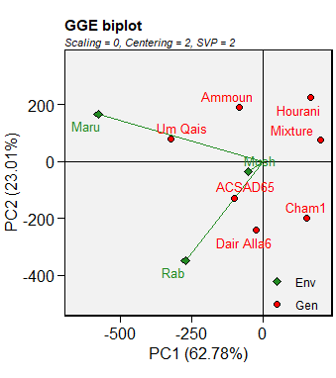
Figure 5: Grain yield environment-centered GGE biplot in the three locations

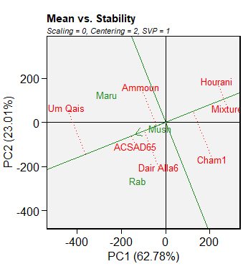
Figure 6: Mean performance and stability of genotype for grain yield in the three locations

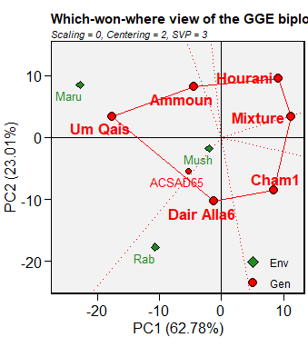
Figure 7: Which-Won-Where Pattern in Multi-Environments

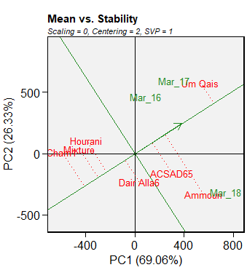
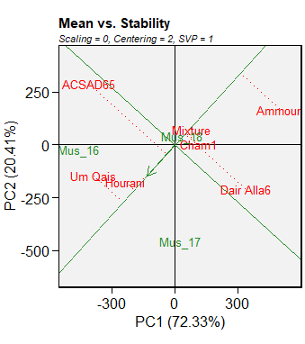
a) Maru b) Mushager
Figure 8: Mean performance and stability of genotype for grain yield in Maru and Mushager

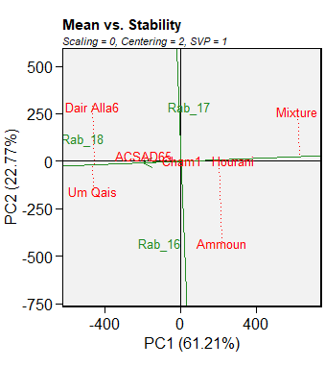
Figure 9: Mean performance and stability of genotype for grain yield in Rabba

