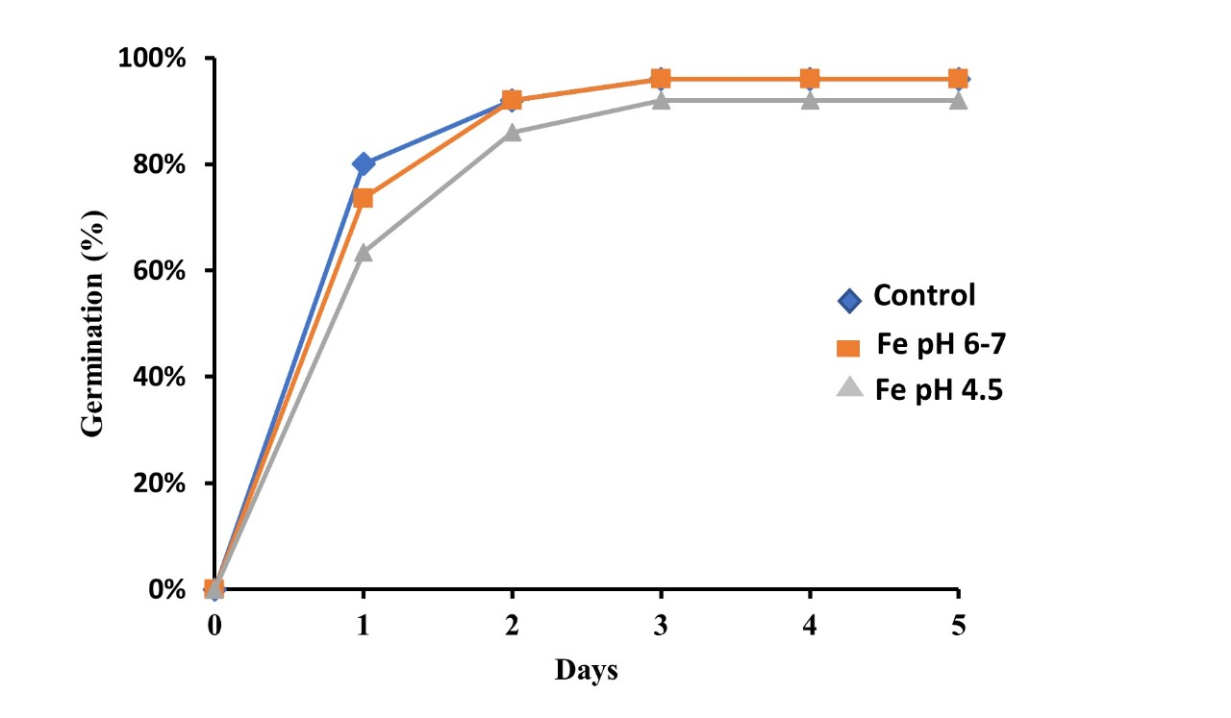
Figure 1. Germination of seven varieties of soybeans on a medium without Fe and contains Fe with a pH of 6-7 and 4-5

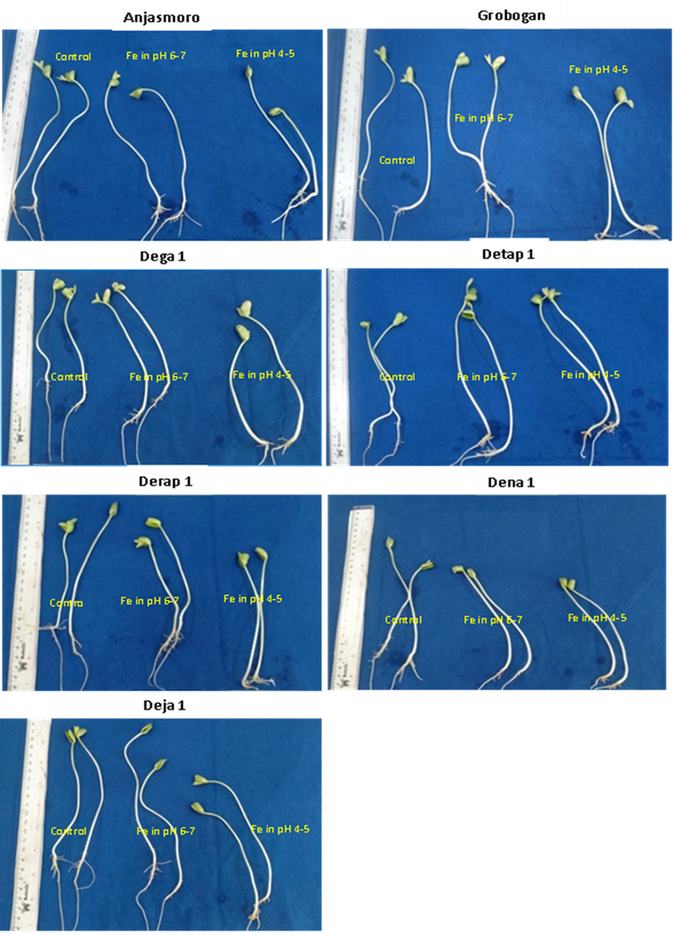

Figure 2. Visualization of tolerance levels of 7 soybean varieties tested to the influence of media without heavy metals Fe and with metal-containing media Fe with pH 4.5 and 6-7

