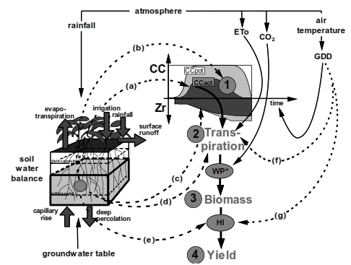
Figure 1. Description of AquaCrop model and data requirements

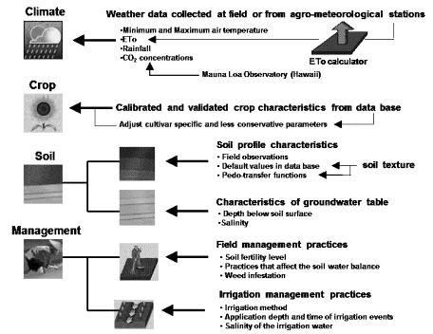

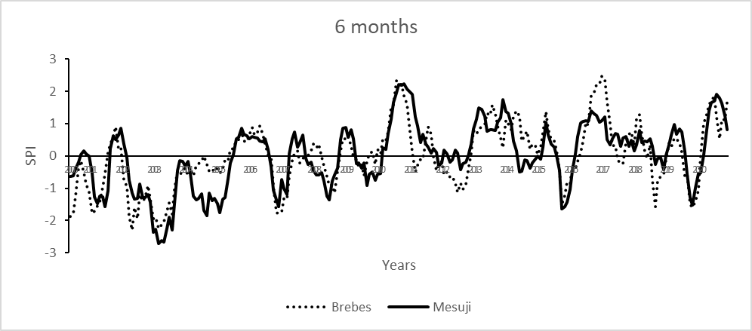
Figure 2. Standardized Precipitation indices of Mesuji (research area) and Brebes (central producers)

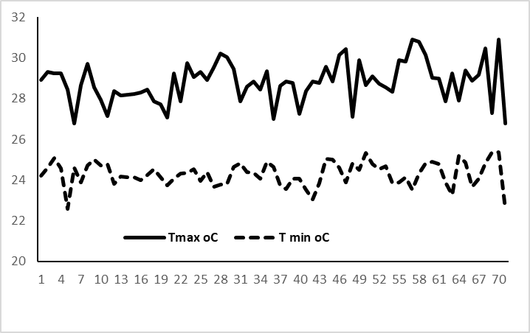 | 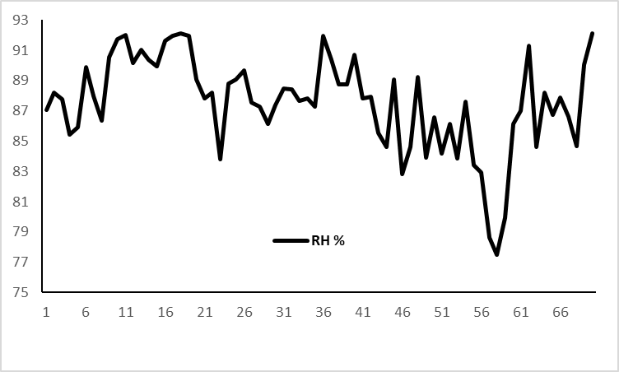
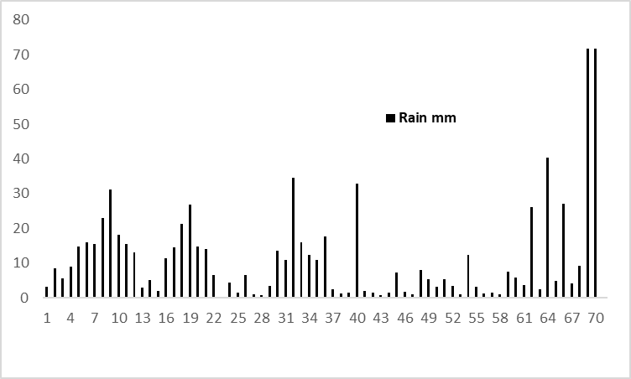 | 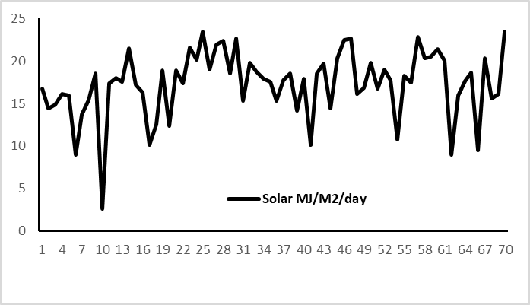
Figure 3. Mesuji main climate data (rainfall, air temperature, and evapotranspiration) as inputs to AquaCrop model

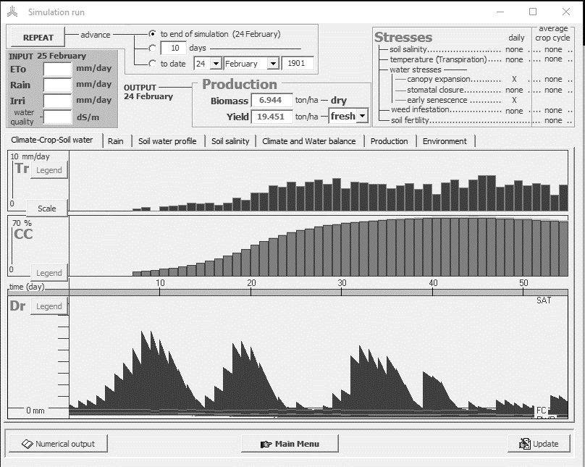
Figure 4. AquaCrop simulation for prospect shallot yield in Mesuji, Lampung

