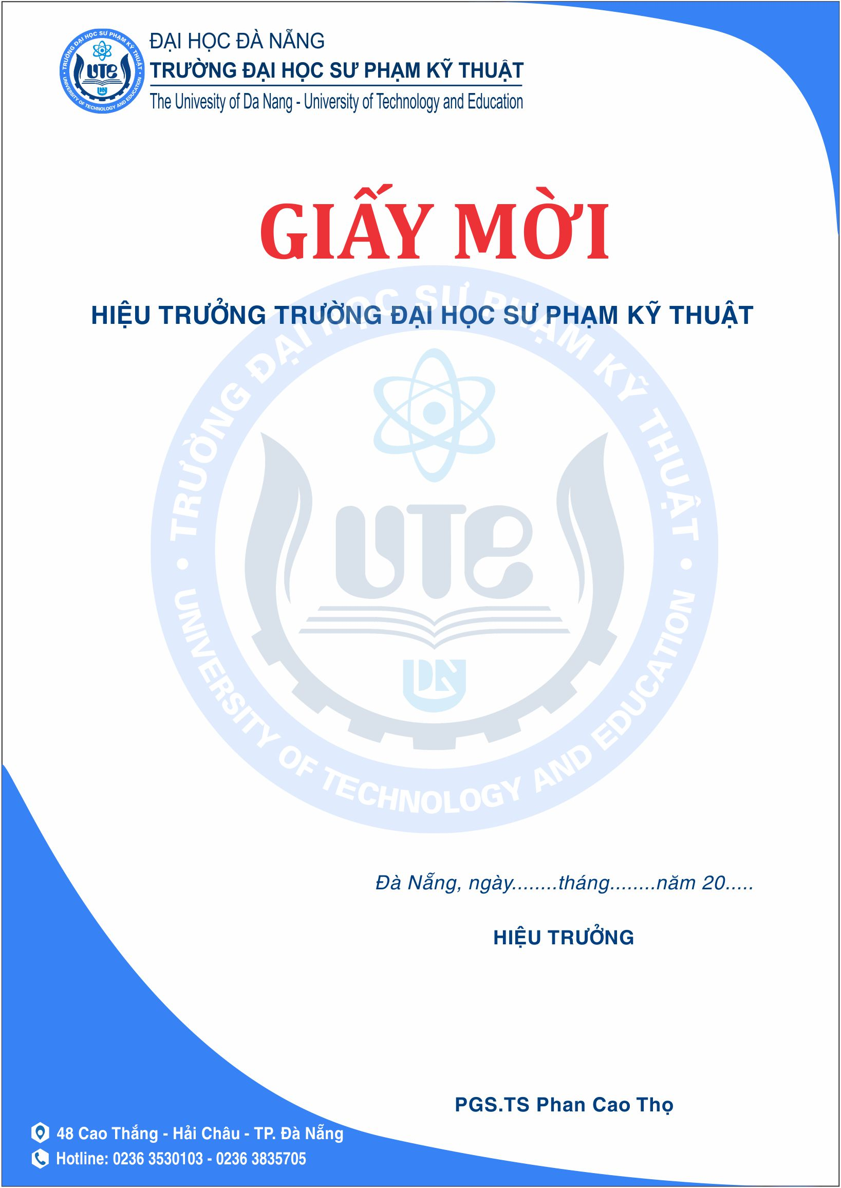
Cover letter
Dear Editor-in-Chief:
We would like to submit the enclosed manuscript entitled “Effects of rice straw and indigenous garbage enzyme (GE) addition on soil and plant growth at seedling stage”, which we wish to be considered for the publication on Sains Tanah – Journal of Soil Science and Agriclimatology. We believe that two main aspects of this manuscript will make it attractive to the readers of Sains Tanah – Journal of Soil Science and Agriclimatology. Although there are research using garbage enzyme for cleaning purposes, there was less attention on applying GE on agriculture. Furthermore, rice straw is a serious problem in post-harvest worldwide due to its slow decomposition speed. Therefore, it is necessary to investigate the interaction between GE and rice straw in agriculture, especially in the rice paddy. Using GE could be environmentally friendly for improving rice growth and treating rice straw residue post-harvest. We certify that the submission is original work and has not been published in whole or part, nor is it considered for publication elsewhere. No conflict of interest exists in the submission of this manuscript, and all authors approve the manuscript for publication. Moreover, we have read and have abided by the statement of ethical standards for manuscripts submitted to Sains Tanah – Journal of Soil Science and Agriclimatology.
We sincerely appreciate your consideration of our manuscript and look forward to receiving comments from the editor and reviewers.
Thank you and best regards.
Yours sincerely,
Nguyen-Sy Toan on behalf of all co-authors

