COVER PAGE

- Manuscript Title

glyphosate adsorption in INCEPTIsOLS Amended with rice husk Biochar
- First author:
- Name : Herviyanti
- Afiliation : Department of Soil Science, Agriculture Faculty Andalas University
- E-mail : herviyanti@agr.unand.ac.id
- Orcid ID : https://orcid.org/0000-0002-7853-2264
- Phone/HP/WA : +6285274337168
- Second author:
- Name : Amsar Maulana
- Afiliation : Ph.D Students of Agricultural Science Postgraduate Andalas University
- E-mail : 2031612003_amsar@student.unand.ac.id
- Orcid ID : 0000-0002-7056-4405
- Third author:
- Name : Arestha Leo Lita
- Afiliation : Magister Students of Soil Science Postgraduate Andalas University
- E-mail : arestha1708@gmail.com
- Orcid ID : https://orcid.org/0000-0002-1275-8308
- Fourth author:
- Name : Teguh Budi Prasetyo
- Afiliation : Department of Soil Science , Agriculture Faculty Andalas University
- E-mail : teguh160395@yahoo.com
- Orcid ID : https://orcid.org/0000-0002-9486-0989
VI. fifth author:
- Name : Sandra Prima
- Afiliation : Department of Soil Science, Agriculture Faculty Andalas University
- E-mail : sasaprima@yahoo.com
- Orcid ID :

2. The main findings and why they are important and useful.
The application of rice hush biochar into the soil (especially those cultivated in Inceptisols) is expected to increase the adsorption of pesticide residues that occur in horticultural cultivation.
3. Why the readers of the journal would be interested in the work.
The use of pesticides on horticultural crops, is already at a level of pollution that exceeds the recommendations given. This is important to study as a form of testing the ability of Inceptisols and Inceptisols ameliorated with biochar to improve and simultaneously adsorption of pesticides so they do not reach the food chain. Soil as a natural adsorbent has the capacity and charge activity that can absorb the pollutants in it.
4. Suggested Reviewers : (2 reviewers from different country with authors, and Scopus H-index minimum 2 )
No | Name | Affiliation | Review Interests | E-mail address  And  Phone contact number (if any) | ORCID ID/ Scopus ID/ Linkedin ID/ Google Scholar Profile Address
1

glyphosate adsorption in INCEPTIsOLS Amended with rice husk Biochar

ABSTRACT

Rice husk biochar as an ameliorant can improve soil quality and long-term carbon absorption and interaction with glyphosate described in the adsorption process. The purpose of this study was to study the ability of Inceptisol and RH_{B} 40 t ha⁻¹ amended Inceptisol (RH_{B}/Ept) in adsorption of glyphosate. The adsorption process isotherm of glyphosate sequentially occurs in the Langmuir and Freundlich (RH_{B}/Ept > Ept) models, where the Langmuir model (R² = 0.27) is dominated by the adsorption process of glyphosate on soil amelioration with RH_{B}/Ent with a value of Q_{m} (0.06 mg g⁻¹) and K_{L} (0.068 L mg⁻¹) at an adsorption efficiency of 86.93%, while the Freundlich model (R² = 0.25) with a value of n (1.00) and K_{F} [42.94 (mg g⁻¹ L mg⁻¹)^{1/n}] at an adsorption efficiency of 86.93% at a concentration level of 100 ppm and pH 5.20 units. The adsorption process of glyphosate was strongly supported by the charge activity and the number of pores on the surface of each adsorbent, where the FT-IR showed a decrease in transmittance in the O-H; C=C; C-O; C-H and minerals group that explain the absorption capacity during the adsorption process of glyphosate. Inceptisols ameliorated with RH_{B}/Ent showed an increase in charge activity of 0.15 (ΔpH), where the charge activity was supported by an increase in pH H₂O, EC, CEC, SOM/C_{Org}, The effect of RH_{B} as an ameliorant on glyphosate absorption depends on the physicochemical properties of Inceptisols.

Keywords: Adsorption, Biochar, Inceptisols, Glyphosate, Rice Husk

INTRODUCTION
Environmental contamination causes a reduction in soil quality by affecting the bio-physicochemical characteristics of the soil system. The existence of xenobiotic chemicals in soil bodies as pollutants is caused by various actions of farmers with excessive concentrations that are not within their normal values. The major cause of expanding urbanization of pollutant compounds that should be accountable for pollution of water bodies - soils by xenobiotic compounds that are extensively distributed to the environment, including pesticides and other chemicals (Varjani et al., 2019).
Pesticides and other xenobiotic substances have been and will continue to be used to manage plant-disturbing organisms such as insects, weeds, and diseases in a variety of agricultural operations. Improper usage as indicated by the manufacturer has a greater impact on non-target species via direct and indirect exposure. Around 2 million tonnes of pesticides are used globally, accounting for 65 percent of the pesticide market (De et al., 2014), with herbicides dominating the global market. Glyphosate (N-(phosphonomethyl)-glycine) as the active ingredient of herbicide is one that farmers frequently employ in agricultural operations (Fig. 1). The annual global usage of glyphosate is estimated to be 600-750 thousand tons, with a projected increase to 740-920 thousand tons by 2025 (Maggi et al., 2020; Caceres-Jensen et al., 2019).
The World Health Organization (WHO) has identified the teratogenicity of glyphosate chemicals in cultivated plants and people as a probable type of carcinogen development by application and metabolite ingestion (Tsamo et al., 2019; Flores et al., 2018). Glyphosate is extremely harmful, it must be removed from the water-soil system as soon as possible. Chemical oxidation, electrolysis, biochemistry, adsorption, evaporation, and other standard procedures are presently employed to remove glyphosate from soil. It should be noted, however, that it must be based on an applicable and cost-effective of adsorption, where adsorption has the potential to remove all types of pollutants at any concentration and, most importantly, utilizing local waste such as rice husks as an ameliorant in the form of biochar for the adsorption process.
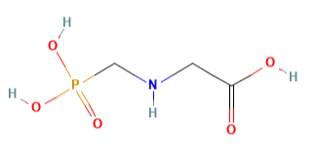
Molecular formula: C₃H₈NO₅P or HOOCCH₂NHCH₂PO(OH)₂
Molecular Weight: 169.07 g mol⁻¹
Topological Polar Surface Area: 107 Å²
Figure 1. Structure and physicochemical properties of glyphosate (N-(phosphonomethyl)-glycine)

Biochar is created by pyrolyzing waste or biomass in the absence or presence of oxygen, resulting in a carbon-rich charcoal composition (Shaaban et al., 2013). Biochar can be utilized as an ameliorant in amelioration technology for a variety of purposes, one of which being the rehabilitation of contaminated soil (Rajapaksha et al., 2016). Biochar has a lot of negative surface charge, surface functional groups, and other structural and textural qualities including high specific surface area, big pore volume, and high cationic exchange capacity, which is supported. These study as the foundation for studying biochar and are indicative of its significant binding ability for organic and inorganic contaminants such as glyphosate. The physicochemical characteristics of biochar are greatly controlled by the kind of raw material, which is subsequently modified by parameters such as technique (Herviyanti et al., 2022; Maulana et al., 2022), particles (Lita et al., 2022), temperature (Trigo et al., 2016), and others throughout the pyrolysis process. The utilization of waste and biomass as raw materials for biochar synthesis aids in the indirect and long-term management of waste. The goal of amelioration technology is to improve the qualities soil and ultilitions of waste as a ameliorant (organic and anorganic).
Soil is the most plentiful growth medium on the planet and a natural adsorbent for pollutants, but its adsorption qualities and power must be improved. Soil's physical and chemical qualities as an adsorbent are highly reliant on its structure and content, which are characterized by large surface area, abundant surface hydroxyl and silanol groups, high cationic exchange capacity, and chemical and mechanical stability (Wang et al., 2019; Viglasova et al., 2018). In the agriculture sector, this potential is being developed in a sustainable manner. Soil and biochar are geo-biosorption with adsorbent that may be used for soil restoration and provide an inexpensive procedure while reducing the environmental effect of waste disposal and agricultural and industrial biomass. The purpose of this research is to investigate and characterize of geo-biosorption (Inceptisols-biochar), where biochar is made from local rice husk (RH) , and to explain the adsorption capacity and effictivity of geo-biosorption in glyphosate.
MATERIAL AND METHODS
The research was conducted at the Laboratory of Chemistry and Soil Fertility, Faculty of Agriculture, Andalas University, Padang from April until June 2021.

3.1 Soil Samples and Analyses
The soil utilized was Inceptisol from Nagari Sariak, Sungai Pua, Agam, which is a horticultural crop producing hub in West Sumatra, Indonesia. Soil samples collected in the field were air-dried for 2*24 hours before being crushed and sieved using a 2 mm sieve. The soil sample was then weighed at 500g absolute dry equivalent, composited with 40 t ha⁻¹ rice husk biochar, and incubated for 2 weeks. After the incubation procedure, the soil analysis process is carried out in the laboratory. Soil analysis refers to goal of studying the loading activity of geo-biosorption (Inceptisols - biochar) and Inceptisols using the following parameters: clay content, active pH, EC, CEC, ash, soil organic matter (SOM), soil PZC, and pH. The FTIR reflectance spectrum was collected between 500 and 4000 cm⁻¹ (Singh et al., 2017; Balai Penelitian Tanah. 2012).

3.2 Rice Husk Biochar Productions
Rice husk is a waste from the rice milling industry. Rice husk biochar (RH_{B}) is produced by the Drum method through a pyrolysis process. Pyrolysis was carried out in iron drums with a diameter of 58 cm, a height of 86 cm, and a capacity of 200 liters and combined with the Kon-Tiki method at a heating rate of up to 650⁰C, the maximum pyrolysis temperature was kept constant for 45 minutes to ensure completion in the final process.

3.3 Glyphosate Solution
The glyphosate solution was prepared with 5 concentration levels (0; 1, 5, 10, 50, 100 mg L⁻¹) was prepared by dissolving the herbicide (Roundup Biosorb 486 SL) in 0.01 M CaCl₂, wherein the concentration of 100 mg L⁻¹ glyphosate was obtained by added 0.14 mL of herbicide (Roundup Biosorb 486 SL) in 500 mL of 0.01 M CaCl₂. Meanwhile, for the manufacture of concentrations of 1, 5, 10, and 50 mg L⁻¹ glyphosate was obtained from the volume of each concentration of 3.5 mL; 17.5 mL; 35 mL, and 175 mL in 500 mL 0.01 M CaCl₂.

3.4 Batch Adsorption Experiments
The adsorption performance was carried out by mixing 0.5g of adsorbent with 20 mL of glyphosate solution in a closed 25 mL glass cylindrical tube in an isothermal test, where the concentrations varied from 1, 5, 10, 50 and 100 mg L⁻¹and stirred on a rotary shaker at a speed of 250 rpm for 24 hours at laboratory temperature (25⁰C). Samples were centrifuged at 4000 rpm for 30 minutes. The sample was filtered using Whatman No. 1 filter paper, where the pH of the filtrate solution was measured at each concentration and the equilibrium concentration of glyphosate remaining in the solution was determined in a UV-Vis spectrophotometer at a wavelength of 830 nm with complexing (Robert, 1981).
The amount of glyphosate adsorbed by different adsorbents was calculated by Eq. (1) to calculate the adsorption capacity (Q_{e}) and removal efficiency (% R) from Eq. (2).
Q_{e} = $\frac{(C_{o}-C_{e})}{m}*V$ (1)
% R = = $\frac{(C_{o}-C_{e})}{C_{o}}*100\%$ (2)
Where: Q_{e} (mg g⁻¹) is the adsorption capacity, C_{o} and Ce (mg L⁻¹) are the initial and final concentrations of glyphosate, m (g) is the mass of RH_{B}; Inceptisols and RH_{B}/Inceptisols and V (L) is the volume of the glyphosate solution.
Two isothermal models Langmuir and Freundlich were used to adjust the experimental data. Correspondingly, the following linearized forms of these models are applied for the adsorption isotherm Langmuir (Eq. 3) and Freundlich (Eq. 4).
$\frac{1}{Q_{e}}$ = $\frac{1}{Q_{m}C_{e}K_{L}}+\frac{1}{Q_{m}}$ (3)
${In}_{Q_{e}}$ = ${In}_{K_{F}}+\frac{1}{n}{In}_{C_{e}}$ (4)
Where: Ce (mg L⁻¹) is the equilibrium concentration of glyphosate solution, Q_{e} and Q_{m} (mg g⁻¹) are the amount adsorbed and maximum adsorption capacity respectively, K_{L} is the Langmuir constant (L mg⁻¹ ); K_{F} [(mg g⁻¹ )/(mg L⁻¹)^{n}] is the Freundlich affinity coefficient and n is a measure of adsorption linearity.

RESULTS

4.1 Characteristics of Infrared Spectroscopy
The FT-IR spectrum obtained from Inceptisols and RH_{B}/Ept can be seen in Figure 2, 3 and Table 1. The FT-IR spectrum of Inceptisols revealed a band at 1022.11 cm⁻¹/66.40% could be attributed to at 3282.05 cm⁻¹/ 88.44% which could be assigned to the internal and internal hydroxyl group strain vibrations The band at 1629.91 cm⁻¹/ 88.95% is associated with deformation vibrations of water absorbed at the clay interlayer and is associated with strain vibrations of C-O and C-C, corresponding to carbonyl and aromatic rings. The FTIR band at 546.79 cm⁻¹/50.50% was associated with the stretching of Si-O-Al bonds (Mineral e.g kaolinite and smectite). The functional group that appeared the alcoholic C-O strain and aromatic C-H bending vibrations.
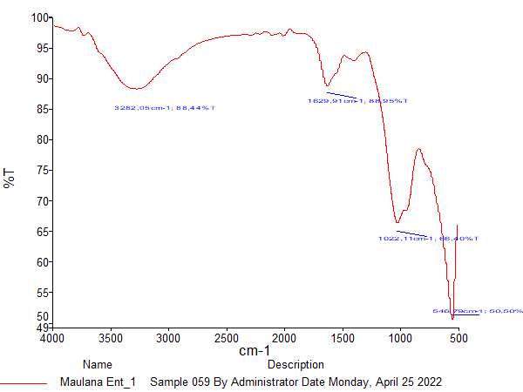  A1  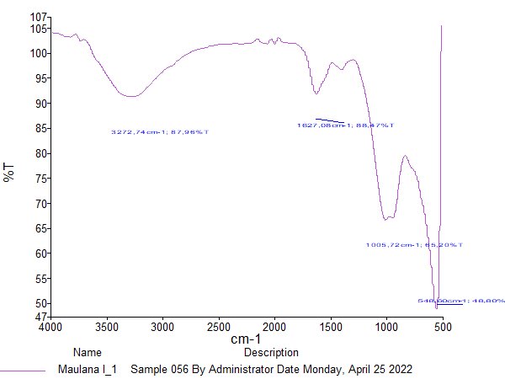  A2 | 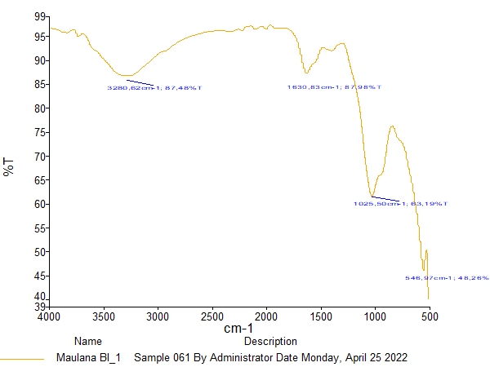  B1  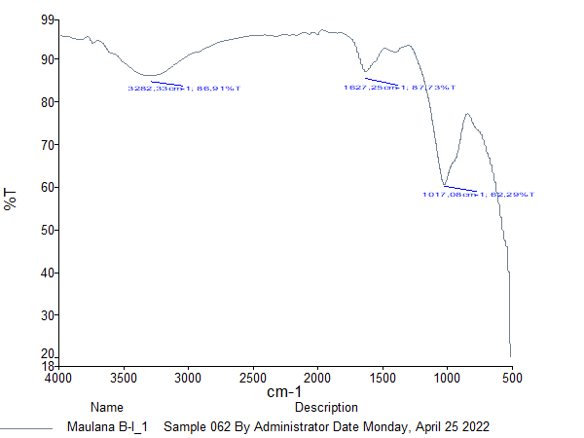  B2
Figure 2. FTIR spectra of Inceptisols (A) and rice husk biochar amended Inceptisols (B), before (1) and after (2) adsorption.

The FT-IR spectrum of RH_{B}/Ept showed the same vibrations as Inceptisols which were in the band 3280.62 cm-1/ 87.48%; 1630.83 cm-1/ 87.98%; 1025.50 cm-1/ 63.19% and 546.97 cm-1/ 48.26%. The RH_{B}/Ept showed a decrease in transmittance in each band which indicated an increase in adsorption capacity through the administration of rice husk biochar amended Inceptisols. The FT-IR spectrum of RH_{B}/Ept, due to the addition of 40 t ha of biochar into the Inceptisols, revealed a band at 3280.62 cm-1/87.48% that could be assigned to the internal and internal hydroxyl group strain vibrations. The band at 1630.83 cm-1/87.98% is associated with the water deformation vibrations absorbed in the clay interlayer and is associated with the C-O and C-C strain vibrations, corresponding to the carbonyl and aromatic rings. On the other hand, an absorption band of 1025.50 cm-1/ 63.19% also appears which is associated with C-O (alcohols, ethers, carboxylic acid, esters) and aromatic C-H bending vibrations. The FTIR band at 546.97 cm-1/48.26% was associated with the Si-O-Al bond strain (kaolinite and smectite).

Table 1. Spectral band assignments of Inceptisols, and rice husk biochar amended soil, before and after adsorption.
Before Adsorption |  | After Adsorption |  | Description of Bond (Type of Compound – Intensity)
Ept | RH_{B}/Ept | Ept | RH_{B}/Ept | Description of Bond (Type of Compound – Intensity)
Wavenumbers / Transmittance (cm⁻¹/ %) |  |  |  | Description of Bond (Type of Compound – Intensity)
3282.05/ 88.44 | 3280.62/ 87.48 | 3272.74/ 87.96 | 3282.33/ 86.91 | O-H (Hydrogen-bonded alcohols, phenols) – Variabel, sometimes broad
1629.91/ 88.95 | 1630.83/ 87.98 | 1627.08/ 88.47 | 1627.25/ 87.73 | C=C (Alkenes ) - Variabel
1022.11/ 66.40 | 1025.50/ 63.19 | 1005.72/ 65.20 | 1017.08/ 62.29 | C-O (Alcohols, ethers, carboxylic acid, esters) - Strong
- | - | - | - | C-H (Alkenes, Aromatic rings) - Strong
546.79/ 50.50 | 546.97/ 48.26 | 548.60/ 48.80 | - | Mineral (e.g kaolinite, CaO, MgO, and others)

The pesticide adsorption process carried out affected changes in the absorption bands of the adsorbents in glyphosate adsorption. The FT-IR spectrum of Inceptisol there was only a decrease in transmittance which indicated that the intensity of each group that appeared was 3272.74/87.96 (O-H: Hydrogen-bonded alcohols, phenols); 1627.08/ 88.47 (In C=C: Alkenes); 1005.72/ 65.20 (C-O: Alcohols, ethers, carboxylic acid, esters) and 548.60/ 48.80 (Minerals), after the adsorption process of glyphosate. The loss of mineral groups after the adsorption process on RH_{B}/Ept, but high-intensity power in the O-H, C=C, and C-O groups with a decrease in transmittance to 3282.33 cm-1/86.91%; 1627.25 cm-1/ 87.73% and 1017.08 cm-1/ 62.29%.

4.2 Physicochemical of Inceptisols and Rice Husk Biochar Amended Inceptisols
RH_{B} is used for soil amendment in amelioration technology and adsorbent in glyphosate adsorption, where the clay content of the soil is 5.90% of main component of the negative charge (coloids). Table 2 shows the Inceptisol pH value of 4.97 units and an increase of 5.67 units with an increase of 0.70 units with the application of RH_{B} 40 t ha⁻¹ on Inceptisol (RH_{B}/Ept). It can be seen that the EC value of the soil increased by 0.03 dS m⁻¹, whereas the EC of Inceptisol was 0.08 dS m⁻¹ and increased by 0.11 dS m⁻¹ after administration of 40 t ha⁻¹ RH_{B} amended Inceptisols. The amelioration on 40 t ha⁻¹ of RH_{B} amended Inceptisols can increased CEC of 2 times from Inceptisol, which was 46.06 cmol kg⁻¹ (from 30.25 to 76.27 cmol kg⁻¹ (Table 2). Table 2 show that mineral composition and SOM will change with the addition of organic or inorganic materials into the soil in amelioration technology, where the application of RH_{B} 40 t ha⁻¹ (RH_{B}/Ept) reduces ash content and increases SOM/C_{Organic}, respectively -/+ 7.4%.
Table 2. Negative change activity of Inceptisols and rice husk biochar amended Inceptisols
Soil | Clay | pH_{active} | EC | CEC | Dry-ashing Method
 |  |  |  |  | Mineral | SOM | ªC Organic
Soil | % | unit | dS m⁻¹ | cmol₍₊₎ kg⁻¹ | %
Inceptiols | 5.90 | 4.97 | 0.08 | 30.25 | 70.80 | 29.20 | 16.94
Inceptisols + 40 t ha⁻¹ RH_{B} | 5.90 | 5.67 | 0.11 | 76.27 | 63.40 | 36.60 | 21.23
Remarks: ªC Organic = %SOM * 0.58; ^{b}ΔpH = pH_{a} – pH₀; EC = Electrical conductivity; CEC = Cation exchange capacity; SOM = Soil organic matter.

A | B
Figure 4. Point of Zero Charge (PZC) of Inceptisols (A) and rice husk biochar amended Inceptisols (B).

The pH_{PZC} values ​​for all adsorbents in the adsorption process are presented in Figure 4. The pH_{PZC} Inceptisol and Inceptisol which are ameliorated with RH_{B} 40 t ha⁻¹ with a value of 4.30 units (y = 0.2001x - 0.8605; R² = 0.767) and 4.78 units (y = 0.4035x - 1.9305; R² = 0.9625). It can be seen that the pH_{PZC} increased by 0.48 units with the addition of RH_{B} of 40 t ha⁻¹ (RH_{B}/Ept) which indicates that the surface charge on both of them is negatively charged with a charge length formed of 0.67 units and 0.82 units, respectively, where the ΔpH = RH_{B}/Ept > Ept. Thus, it can be assumed that the glyphosate adsorption process will be optimal at pH₀ = 4.30 (Ept) < 4.78 (RHB/Ept) (Fig. 4).

4.3 Glyphosate Adsorption Behaviour
The equilibrium concentration of glyphosate increased with increasing concentration glyphosate, but the pH solution decreased (Fig 5). The highest concentration of glyphosate for Ent and RH_{B}/Ept had the same capacity at 100 ppm. The pH of the solution during the adsorption process is important to analyze because it affects the adsorption of glyphosate in CaCl₂ solution. The decrease in pH was influenced by an increase in the concentration of glyphosate with stability at concentrations of 1 to 50 ppm in Ent and RH_{B}/Ept (Fig. 5A).
(A) | (B)
Figure 5. (A) Equilibrium concentration glyphosate (C_{e}) and pH during the adsorption process on RH_{B}; Inceptisols and rice husk biochar amended Inceptisols and (B) Glyphosate adsorpstion capacity (Q_{e}) and removal effictivity (R) of of RH_{B}; Inceptisols and RH_{B}/Inceptisols, where : C₀ = 1–100 mg L⁻¹; HR_{B} mass = 0.5g; adsorption temperature = 25⁰C; Glyphosate volume = 5 mL; particle size = 500µm and agitation speed/time = 250 rpm/24 hour.

The adsorption of glyphosate on Ept, and RH_{B}/Ept at different initial concentrations with the equilibrium adsorption amount of glyphosate increased rapidly at low concentrations. Then, the adsorption capacity increases slowly and finally reaches stabilization. This is also seen in the adsorption efficiency that occurs in the three types of adsorbents. The best performance in adsorption capacity of glyphosate than Ept and RH_{B}/Ept, while the best adsorption effictivity on RH_{B}/Ept, compared to Ept (Fig. 5B).
A | B
Figure 6. Linear plot of equilibrium concentration glyphosate (C_{e}) with glyphosate adsorption capacity (Q_{e}) of Inceptisols (A) and rice husk biochar amended Inceptisols (B).

The correlation between the equilibrium concentration of glyphosate and the adsorption capacity of glyphosate is shown in Figure 6, where the value of R² determines the strength of the relationship between the two in the adsorption process. The correlation results show that the R² value of RH_{B}/Ept is higher than that of an Ept, each with a value of R² = 0.8098 > R² = 0.7845. This shows that the equilibrium concentration of glyphosate is strongly correlated with the results of the adsorption capacity of glyphosate in Inceptisol which is ameliorated with 40 t ha⁻¹ RH_{B} (RH_{B}/Ept), compared to pure Inceptisols.

4.4 Adsorption Isotherms
The isotherm model that is suitable for the adsorption process is selected in the model which has an R² value. The linear equation of the isotherm model can be seen in Fig. 7 and Table 3. The R² values ​​for each model can be ordered as follows. : Langmuir > Freundlich on Ept and RHB/Ept for each equation with a value of y = -22.739x + 337.97; R² = 0.2474 > y = 0.9739x - 1.6885; R² = 0.1872 and y = -17.182x + 245.39; R² = 0.2655 > y = 1.0003x - 1.6329; R² = 0.2143.
A1 | A2
B1 | B2
Figure 7. Linear plot of Freundlich (A) and Langmuir (B) isotherm on the adsorption of glyphosate with Inceptisols (1) and RH_{B}/Inceptisols (2).

The Langmuir model (R² = 0.27) is dominated by the adsorption process of glyphosate on soil amelioration with RH_{B}/Ent with a value of Q_{m} (0.06 mg g⁻¹) and K_{L} (0.068L mg⁻¹) at an adsorption efficiency of 86.93%, while the Freundlich model (R² = 0.21) was dominated by the adsorption process of glyphosate on RH_{B} with a value of n (1.00) and K_{F} (42.94 (mg g⁻¹ L mg⁻¹)^{1/n} at an adsorption efficiency of 86.94% at a concentration level of 100 ppm and pH 5.20 unit.
Table 3. Langmuir and Freundlich model parameters on adsorption glyphosate in Inceptisols and rice husk biochar amended Inceptisols.
Models | Adsorbent | Isotherm parameters
Langmuir |  | Q_{m} (mg g⁻¹) | K_{L} (L mg⁻¹) | R²
Langmuir | Inceptiols | 0.04 | 0.074 | 0.25
Langmuir | Inceptisols + 40 t ha⁻¹ RH_{B} | 0.06 | 0.068 | 0.27
Freundlich |  | n | K_{F} (mg g⁻¹)  (L mg⁻¹)^{1/n} | R²
Freundlich | Inceptiols | 1.03 | 48.81 | 0.19
Freundlich | Inceptisols + 40 t ha⁻¹ RH_{B} | 1.00 | 42.94 | 0.21
Remaks : Q_{m} = 1/b; K_{L} = (1/a)/Q_{m}; n = 1/b; K_{F} = 10ª
DISCUSSION
The characteristics of the charge activity of Inceptisols and amendments with 40 t ha⁻¹ RH_{B} are shown in table 2, where clay is the main component of negative charge on clay minerals (Preocanin et al., 2016). The increase in soil pH and CEC due to RH_{B} administration through amlioration technology occurs due to the influence of OH ions donated by RHB to the soil and according to Mindari et al., (2014) that the complexation of H⁺ and OH⁻ on the surface of soil particles can affect the absorption of other cations and anions. On the other hand, there is an increase in EC where According to Aydin et al., (2012) that the increase in EC in the soil by RHB carries a negative charge, so it can move in an electric field externally with an increase in single charged ions that cause an electric field. Changes in the electrochemical properties of clays are closely related to the amount of aluminum hydroxy complexes incorporated in the clays and their chemical composition and charge properties. Many hydroxy-AI species are known to exist in partially neutralized Al ion solutions used to coat clays and their loads can vary. The effect of the number of interlayers on the cation exchange capacity affects the zero charge point on each adsorbant used in the adsorption process.
This charge activity becomes very important in the adsorption process to determine the type of charge on the ameliorant surface at a certain pH and its interaction with pollutants (pesticides). Analysis of the pHpzc value is also important to determine the optimal pH range for the adsorption process, where pH_{PZC} describes the surface charge of the ameliorant at an active pH above pHPZC (pH H₂O > pH_{PZC}) then a negative surface charge appears, and vice versa if pH H₂O > pH_{PZC} then the charge is negative ameliorant surface will be positive. The pH of the solution at the time of adsorption describes the shape of the charge that occurs on the glyphosate (Fig 8).
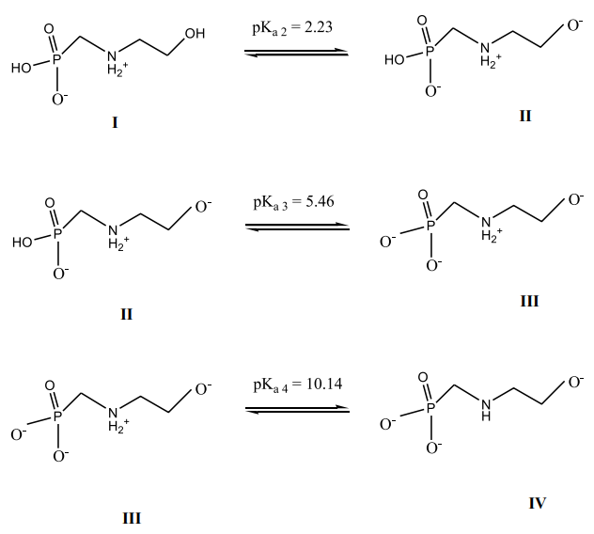 | 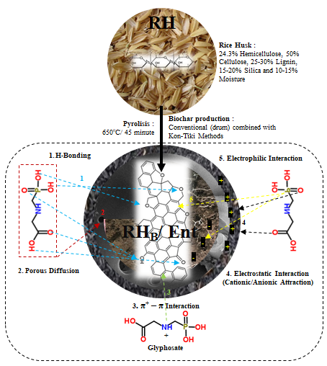
(A) | (B)
Figure 8. (A) Ionic state of glyphosate as a function of pH and (B) Prediction of glyphosate adsorption mechanism on rice husk biochar amended Inceptisols.

Therefore, the adsorption process can occur with the formation of a surface complex through the three phosphonate groups and the coordination of OH, O, NH and P with the adsorbent surface (Tevez and Afonso, 2015). All of this is influenced by the density of the active site of the adsorbent used and the specific surface area that can affect the adsorption capacity of glyphosate. This increase in adsorption may be due to an increase in the surface area, and hence the number of active sites (Premarathna et al., 2019).In the soil, biochar undergoes various oxidation reactions that increase oxygen-containing functional groups such as phenol and carboxyl groups on the biochar surface. Thus, after aging in the soil, biochar has the potential to have more glyphosate adsorption sites than fresh biochar. This explains that the incubation process of biochar in the soil also determines the adsorption capacity that occurs and also affects variations in soil properties such as pH, CEC, SOM, and FT-IR (Tables 1, 2 and Figure 2). This may play a role for the observed increase in adsorption capacity of glyphosate in adsorbents (Inceptisols-biochar). According to Kumari et al., (2016) The high prevalence of mineral-biochar interactions which include absorption sites in clay and amorphous oxides at higher levels of biochar application play an important role in biochar-mineral interactions in the glyphosate adsorption process.
The adsorption isotherm was studied to determine the type of adsorbate layer formed on the surface of the adsorbent, the adsorption mechanism, and to provide information about the maximum adsorption capacity (Gupta et al., 2019). This study uses two adsorption isotherm models, namely the Freundlich and Langmuir models. The isotherm model that is suitable for the adsorption process is selected on a model that has an R² value close to one (Drakhshan et al., 2013). The Langmuir model describes the adsorbent and adsorbate that form a single layer in the adsorption process. Therefore, all sites are the same, the adsorbent surface is homogeneous, and the heat of adsorption is independent of the closure of the surface active sites (El et al., 2021), whereas the Freundlich model explains that the adsorbent surface is heterogeneous form a multilayer between the adsorbate molecules and the adsorbent surface. The adsorption of glyphosate to Ept and RH_{B}/Ept is shown in the linearized Freundlich and Langmuir model as described in Figure 7, and the isotherm constants and correlation coefficients extracted from the plots are listed in Table 3. Based on all the previous explanations, the mechanism of glyphosate adsorption on Ent, and RH_{B}/Ent can be illustrated in Figure 8B. Based on the order of R² values, the Langmuir model seems to be the most suitable model to describe the adsorption of glyphosate by Ept and RHB/Ept. Thus, it can be assumed that a layer is formed on the Ept and RH_{B}/Ept surfaces by glyphosate molecules during adsorption. This shows that the process of adsorption of glyphosate by Ept, and RHB/Ept is quite good and can adsorb glyphosate at the concentrations in this study.

CONCLUSION
The adsorption isotherm of glyphosate sequentially occurs in the Langmuir (RH_{B}/Ept > Ept) and Freundlich (RH_{B}/Ept > Ept) models, where the Langmuir model (R² = 0.27) is dominated by the adsorption process of glyphosate on soil amelioration with RH_{B}/Ent with a value of Q_{m} (0.06 mg g⁻¹) and K_{L} (0.068L mg⁻¹) at an adsorption efficiency of 86.93%, while the Freundlich model (R² = 0.21) was dominated by the adsorption process of glyphosate on RH_{B} with a value of n (1.00) and K_{F} (42.94 (mg g⁻¹ L mg⁻¹)^{1/n} at an adsorption efficiency of 86.94% at a concentration level of 100 ppm and pH 5.20 unit. The adsorption process of glyphosate was strongly supported by the charge activity and the number of pores on the surface of each adsorbent, where the FT-IR showed a decrease in transmittance in the O-H; C=C; C-O; C-H and minerals group that explain the absorption capacity during the adsorption process of glyphosate on each adsorbent. Meanwhile, the highest loading activity occurred in Inceptisols ameliorated with RH_{B} 40 t ha⁻¹ (RH_{B}/Ept) showed an increase in charge activity of 0.15 (ΔpH), where the charge activity was supported by an increase in pH H₂O (0.70 units), EC (0.30 dS m⁻¹), CEC (40.01 cmol kg⁻¹), SOM/ C_{org} (7.40%).

Acknowledgments
We were thankful for the financing of this research, which was provided by PNBP Andalas University (PDU-KRPGB) under Research Contract No: T/4/UN.16.17/PP.Pangan-KRP1GB/LPPM/2021 – 30th March 2021.

REFERENCES
A. Shaaban, S. Se, N.M.M. Mitan, M.F. Dimin, (2013). Characterization of biochar derived from rubberwood sawdust through slow pyrolysis on surface porosities and functional groups, Procedia Eng. 68
Aydin. A. (2012). Humic acid application alleviates salinity stress of bean (Phaseolus vulgaris L.) plants decreasing membrane leakage. African Journal of Agricultural Research, 7(7). https://doi.org/10.5897/ajar10.274
Balai Penelitian Tanah. 2012 Analisis Kimia Tanah, Tanaman, Air dan Pupuk.Badan Penelitian dan Pengembangan Pertanian Departemen Pertanian pp 211
C. Trigo, L. Cox, K. Spokas, (2016). Influence of pyrolysis temperature and hardwood species on resulting biochar properties and their effect on a zimsulfuron sorption as compared to other sorbents, Sci. Total Environ. 566
C. Tsamo, M. Assabe, J. Argue, S.O. Ihimbru, (2019). Discoloration of methylene blue and slaughterhouse wastewater using maize cob biochar produced using a constructed burning chamber: a comparative study, Sci. Afr. 3
De A, Bose R, Kumar A, Mozumdar S. (2014) Worldwide pesticide use. In Targeted delivery of pesticide using biodegradable polymeric nanoparticles. Springer, Berlin, pp 5-6
Derakhshan, Z.; Baghapour, M. A.; Ranjbar, M.; Faramarzian, M. (2013). Adsorption of Methylene Blue Dye from Aqueous Solutions by Modified Pumice Stone: Kinetics and Equilibrium Studies. Heal. Scope.. 2. 136–144. DOI: 10.17795/Healthscope-12492.
E.Viglasova, M. Galambos, Z. Dankova, L. Krivosudský, C.L. Lengauer, R. HoodNowotny, G. Soja, A. Rompel, Ma. Matík, J. Briancin, (2018). Production, characterization and adsorption studies of bamboo-based biochar/montmorillonite composite for nitrate removal, Waste Manag. 79
El, K. A. Achour, Y.; El, H. M.; Laamari, M. R.; El, H. M. (2021). High Efficiency of Natural Safiot Clay to Remove Industrial Dyes from Aqueous Media: Kinetic, Isotherm Adsorption, and Thermodynamic Studies. Biointerface Res. Appl. Chem., 11, 12717–12731.
F. Maggi, D. la Cecilia, F.H.M. Tang, A. McBratney. (2020). The global environmental hazard of glyphosate use, Sci. Total Environ. 717.
F.M. Flores, R.M.T. Sanchez, M.d.S. Afonso, (2018). Some aspects of the adsorption of glyphosate and its degradation products on montmorillonite, Environ. Sci. Pollut. Contr. Ser. 25
Gupta, N. K.; Gupta, A.; Ramteke, P.; Sahoo, H.; Sengupta, A. (2019). Biosorption-A Green Method for the Preconcentration of Rare Earth Elements (Rees) from Waste Solutions: A Review. J. Mol. Liq. 274, 148–164. DOI: 10.1016/j.molliq.2018.10.134
Herviyanti, Maulana, A., Lita, A.L., Prasetyo, T.B., Ryswaldi, R. (2022) Characteristics of biochar methods from bamboo as ameliorant. IOP Conference Series: Earth and Environmental Science, X, 959(1), 012036
Kumari K. G. I. D., Per M. Marcos P. Lars E. Lis W. de Jonge. (2016) . Soil Properties Control Glyphosate Sorption in Soils Amended with Birch Wood Biochar. Water Air Soil Pollut 227:174 DOI 10.1007/s11270-016-2867-2.
L. Caceres-Jensen, J. Rodríguez-Becerra, P. Sierra-Rosales. (2019). Electrochemical method to study the environmental behavior of Glyphosate on volcanic soils: Proposal of adsorption-desorption and transport mechanisms, J. Hazard Mater. 379
Lita,A.L., Maulana,A., Yulnafatmawita, Herviyanti, Ryswaldi, R. (2022) Characteristics Biochar from Young Coconut Waste based on Particle Size as Ameliorant. IOP Conference Series: Earth and Environmental Science, 959(1), 012034
Maulana, A., Herviyanti, Prasetyo, T.B., Harianti, M., Lita, A.L. (2022) Effect of Pyrolysis Methods on Characteristics of Biochar from Young Coconut Waste as Ameliorant. IOP Conference Series: Earth and Environmental Science, 959(1), 012035
Mindari, W., Aini, N., & Kusuma, Z. (2014). Effects of humic acid-based buffer + cation on chemical characteristics of saline soils and maize growth. Journal of Degraded and Mining Lands Management, 2(1), 259–268. https://doi.org/10.15243/jdmlm.2014.021.259
Premarathna, K.S.D. A.U. Rajapaksha, N. Adassoriya, B. Sarkar, N.M.S. Sirimuthu, A. Cooray, Y.S. Ok, M. Vithanage, (2019). Clay-biochar composites for sorptive removal of tetracycline antibiotics in aqueous media, J. Environ. Manag. 238
Preocanin, T., Abdelmonem, A., Montavon, G., & Luetzenkirchen, J. (2016). Charging Behavior of Clays and Clay Minerals in Aqueous Electrolyte Solutions Experimental Methods for Measuring the Charge and Interpreting the Results. Clays, Clay Minerals, and Ceramic Materials Based on Clay Minerals. https://doi.org/10.5772/62082
Robert L. Glass. (1981). Colorimetric Determination of Glyphosate in Water after Oxidation to orthophosphate. Analytical Chemistry, Vol 53. 923 – 924.
S. Liu, J. Li, S. Xu, M. Wang, Y. Zhang, X. Xue, (2019). A modified method for enhancing adsorption capability of banana pseudostem biochar towards methylene blue at low temperature, Bioresour. Technol. 282
Singh, B., Camps-Arbestain, M., and Lehmann, J. (2017). Biochar: A Guide to Analytical Methods. Boca Raton: CRC Press.
Tevez, R. M. Afonso, (2015). pH dependence of Glyphosate adsorption on soil horizons, Bol. Soc. Geol. Mex. 67 (3) 509–516
Varjani, S. G. Kumar, E.R. Rene. (2019). Developments in biochar application for pesticide remediation: current knowledge and future research directions, J. Environ. Manag. 232
X. Wang, Y. Gu, X. Tan, Y. Liu, Y. Zhou, X. Hu, X. Cai, W. Xu, C. Zhang, S. Liu, (2019). Functionalized biochar/clay composites for reducing the bioavailable fraction of arsenic and cadmium in river sediment, Environ. Toxicol. Chem. 38

