AUTHOR DECLARATION FORM
Full Name : Ir. Beny Harjadi, MSc
Affiliation : Balai Penelitian dan Pengembangan Teknologi Pengelolaan Daerah Aliran Sungai (Watershed Management Technology Center)

Email : adbsolo@yahoo.com; adbsologm@gmail.com.
Title of Manuscript : THE POTENTIAL LANDSLIDES CLASSIFICATION USING SHUTTLE RADAR TOPOGRAPHY MISSION (SRTM) IMAGERY IN TULIS WATERSHED, INDONESIA

As the Corresponding Author, hereby declare that:
- This manuscript is original, has NOT been published before and is currently considered for publication elsewhere, and during peer review process by this journal will not be withdrawn and sent to other journals to be assessed.
- I/We would like to improve the manuscript that has been assessed and not withdrawn unilaterally without informing the editors, especially if the manuscript is in the peer review process.
- I/We affirm that the manuscript does not violate the intellectual property rights of any third party. I/We agree to indemnify and hold harmless the SAINS TANAH - Journal of Soil Science and Agroclimatology in respect of any claim on account of violation of intellectual property rights.
- I/We have no known competing financial interests or personal relationships that could have appeared to influence the work reported in this manuscript.
- I/We hereby confirm that all the authors have made a significant contribution to the manuscript.
I/We made this statement to be used properly.

Surakarta, 23 April 2021
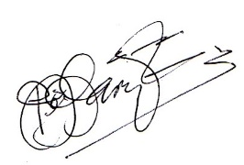
Beny Harjadi

PLEASE UPLOAD THE SIGNED FORM AS SUPPLEMENTARY FILE IN THE OJS

