COVER PAGE

- Manuscript Title
THE CHARACTERISTICS OF UTLTISOLS FROM ANDESITE-BASALT MATERIALS AND THEIR ASSOCIATIONS
ON THE OLD VOLCANIC LANDFORM IN INDONESIA

- First author:
- Name : Setiyo Purwanto
- Afiliation : Indonesian Center for Agricultural Land Resource Research and Development - ICALRRD
- E-mail : teteptio@gmail.com
- Orcid ID :
- Phone/HP/WA : 081398957410

- Second author:
- Name : Rachmat Abdul Gani
- Afiliation : Indonesian Center for Agricultural Land Resource Research and Development - ICALRRD
- E-mail : ganisoil79@gmail.com
- Orcid ID : https://orcid.org/0000-0002-1563-2700

- … author:
- Name : Erna Suryani
- Afiliation : Indonesian Center for Agricultural Land Resource Research and Development - ICALRRD

- E-mail :
- Orcid ID :

- The main findings and why they are important and useful.
Ultisols order is a soil that has an advanced level of development and a low fertility rate. This research is important because it considers the type of parent material in characterizing ultisols. Finally, it can provide effective solutions to the ultisols problem ..

- Why the readers of the journal would be interested in the work.
This paper aims to study the characteristics of ultisols derived from andesite and andesite-basalt parent materials

- Suggested Reviewers : (at least 2 reviewers)
No | Name | Affiliation | Review Interests | E-mail address  And  Phone contact number (if any) | ORCID ID/ Scopus ID/ Linkedin ID/ Google Scholar Profile Address
1
2

THE CHARACTERISTICS OF UTLTISOLS FROM ANDESITE-BASALT MATERIALS AND THEIR ASSOCIATIONS
ON THE OLD VOLCANIC LANDFORM IN INDONESIA

ABSTRACT

A common problem with ultisols is the low level of soil fertility. Liming and fertilizing is common solutions to overcome these problems in their management for the benefit of agricultural crops. Assessment of ultisols problems seen from the parent material that forms them as part of finding solutions to soil fertility problems has not been taken into consideration. This study aims to study the characteristics of ultisols derived from andesite and andesite-basalt parent materials. In the range of 2016 - 2017, 5 pedons (P8, P9, P10, P11 and P15) ultisols derived from andesite - basalt and other associations were taken 5 pedons along with 19 soil samples for chemical analysis of soil and total sand minerals. The results of the study obtained the color of ultisols derived andesite - basalts (and their associations) varied from 2.5 YR to 10 YR, grades 3-5 and chroma 2-8. The mineral content of sand was dominated by opaque minerals, zircon, quartz, weathering, rock fragments and hiperstine. Mineral reserves vary from very low to very high. The results of this study are expected to be used as recommendations for ultisols governance for future agricultural development.

Keywords: pedons, minerals, parent materials, weathering, soil fertility.

INTRODUCTION
Ultisols is a type of soil with a further level of development, characterized by the presence of the argillic or candic horizon and there is an increase in the content of clay (iluviasi) in the soil pedon. In general, this land has problems of agricultural governance, namely low fertility rates due to cation exchange capacity (CEC) and low base saturation (KB) and low soil pH. This land has a fairly wide distribution in Indonesia. The Center for Soil and Agro-Climate Research (PPTA) in 2000 stated that Ultisols land area in Indonesia reached 45.8 million hectares or 24% of the total area of Indonesia. According to Hardjowigeno 2003, Ultisols are the widest part of dry land in Indonesia.
The general solution in the governance of Ultisols land for agricultural purposes is the concept of liming and balanced fertilization. This is done to increase soil pH and provide additional nutrients for agricultural crops. The solution has limitations, namely not considering the various aspects of soil-forming materials in the field (Prasetyo and Suriadikarta 2006)
In-depth research on various types of parent materials in the process of ultisols forming will be very interesting. In general, Ultisols can be formed from several parent materials, including volcanic materials (andesite, basalt and andesite - basalt), sedimentary materials (claystones and sandstones). The same land with different parent materials will certainly have different characters.
Ultisols land assessment in this study follows the rules of determination of the Soil Survey Staff (2014), namely the land has a characteristic in the form of epipedon okhrik, clay accumulation (argillic), reddish soil color in the lower layer, visible color washing and low of base saturation.
This study focuses on studying the character of Ultisols from andesite - basalt and their associations, so that the content and character of the soil can be identified. Andesite is igneous rock, including intermediate rock groups. According to Hardjowigeno (1993) andesite belongs to a group of dark rocks with a low SiO₃ content, besides that these rocks contain large amounts of Fe and Mg, later in the process of soil formation will produce soil with clay texture to clay clay. The results of this study are expected to be used as recommendations for the management of Ultisols land for agricultural development.

MATERIAL AND METHODS
This study used 5 pedons of Ultisols derived from andesite - basalt and other associations from 4 provinces (Central Java, West Java, South Sumatra and South Sulawesi). Soil samples were taken from the soil mapping survey between 2016 and 2017. Figure 1 shows the location of land sampling in 5 districts. The locations, landforms and types of parent materials are presented in

Table 1. Pedons, landforms, parent materials and location for Ultisols sampling
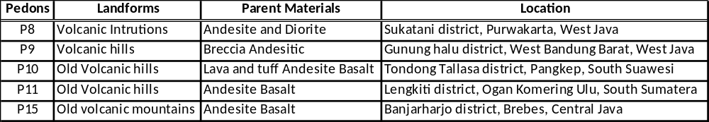
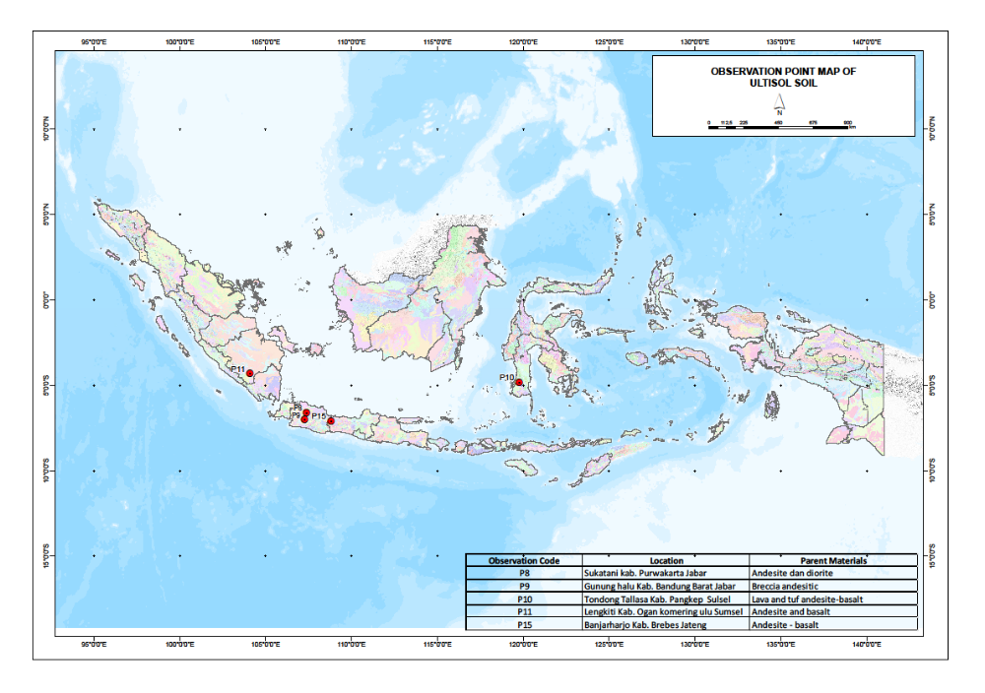
Fig. 1. Distribution of research observation points of Ultisols derived from basalt andesite

Table 2. Pedons, depth, soil color, texture and classification of Ultisols
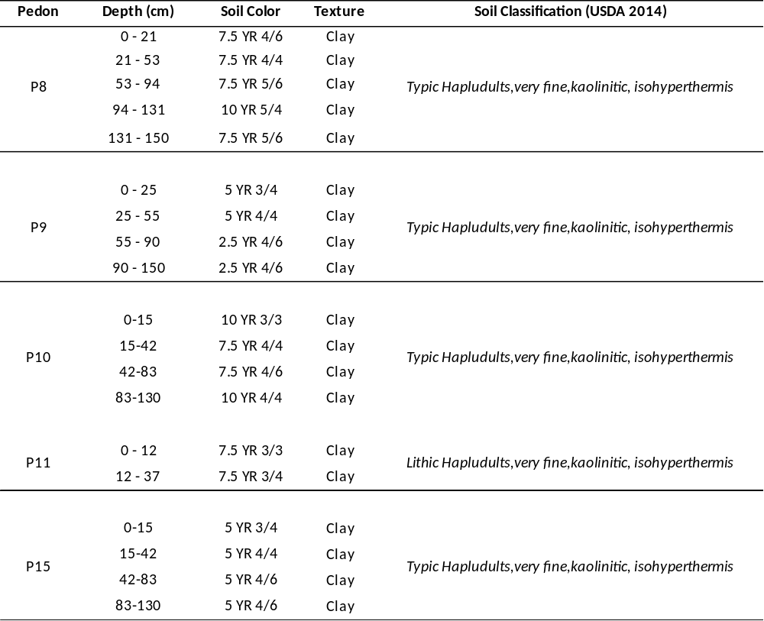

As a laboratory test material, 19 soil samples from 5 pedons were taken and examined to obtain data on mineralogy and soil chemistry. Testing of soil samples was carried out in the Soil Research Center laboratory. Testing of physical and chemical properties includes texture, organic matter, pH (H₂O and KCl), potential P and K (25% 1N HCl), available P (Olsen), exchangeable cation capacity and exchangeable cations (1 N NH₄OAc, pH 7.0). The analysis follows the Kellogg Soil Survey Laboratory Methods Manual (2014) method. Mineralogical analysis, including examination of total sand fractions and clay fractions. Mineral sand fraction was identified using a polarizing microscope using the counting line method. Sand mineral testing for total fraction and chemical properties using 19 soil samples from 5 pedons (P8, P9, P10, P11 and P15).

RESULTS
The P8 to P15 Pedons (Table 2) are taken from 4 different provinces, namely from West Java, Central Java, South Sulawesi and South Sumatra, with an elevation of altitude ranging from 160 to 1,045 meters above sea level, in order ultisols according to soil taxonomy system (Soil Survey Staff, 2014), made from andesite basalt, andesite diorite, breccia andesite, lava and tuff of basalt andesite (Atlas Peta Tanah, 2017). Soil samples were taken from 5 different types of land use are shrubs, rubber gardens, bamboo, tea and mahogany.
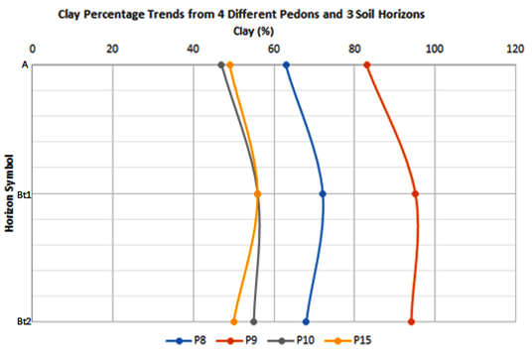

Fig 2. Clay content of five pedons (P8, P9, P10 and P15) at A, Bt1 and Bt2 horizon

The five pedons cross sections show entry into the ochric horizon (epipedon) in terms of soil color (hue / chroma> 3/3) and A horizon depth (<25 cm), P10 and P11 pedons have a matrix color of 3/3 but the depth is less than 25 cm, so that it cannot be inserted into mollic or umbric epipedon. The sub soil horizon (endopedon) of the five pedons can be entered into argillic, where there is an increase in clay (iluviation) at the Bt1 horizon (Figure 2). The two markers showed that the soil was classified as Ultisols (Table 2).

Table 3. The composition of primary minerals (sand) in some Ultisols pedons
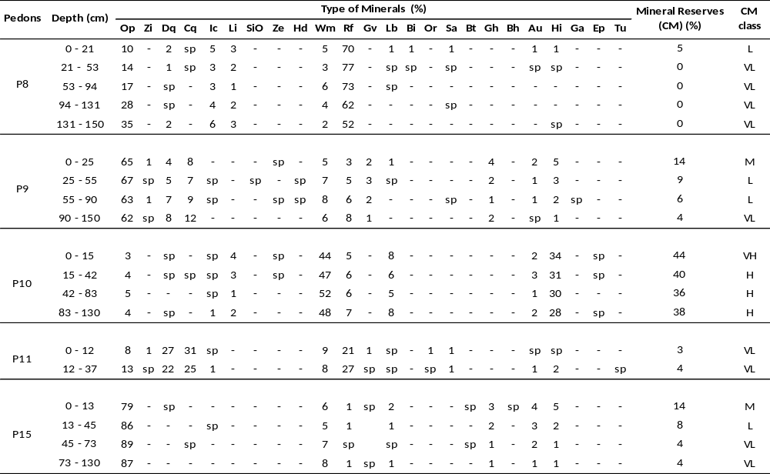

Remarks:
Op=Opak, Zi=Zirkon, Dq=Cloudy quartz, Cq=Clear quartz, Ic=Iron concretion, Li=Limonit, SiO= SiO₂ organic, Ze=Zeolit, Hd=Hidragilit, Wm=Weathering mineral, Rf=Rock fragmen, Vg= Volcan glass, Al=Albit, Ol=Oligoklas, An=Andesin, Lb=labradorit, Bi=Bitownit, At=Anortit, Or=Ortoklas, Sa=Sanidin, Mu=Muskovit, Bt=Biotit, Gh=Green horblende, Bh=Brown horblende, Au=Augit, Hi=Hiperstine, Ga=Garnet, Ep=Epidot, Tu=Turmalin, Ad=Andalusit, Sm=Siimanit, Es=Enstatit, sp=sporadic, VL= very low, VH= very high, L= low, H= high, M= moderate

DISCUSSION
Morphological Properties
The results showed that ultisols from andesite basalt (and their associations) had a deep solum (> 120 cm) and fine texture/clay (table 2), a similar matter was revealed in Prasetyo research (2006) which stated that ultisols soil developed from andesite materials has a fine texture (clay). In general, fine-textured soil will have a low micro pore space, so that infiltration of water to the deeper horizons will be hampered, this will be closely related to the increase in surface erosion (run off).
Ultisols colors derived from andesitic - basalts (as well as their associations) were seen to vary from 2.5 YR to 10 YR, values (hue) 3 -5 and chroma 3 - 6 (Table 2). Soil color is strongly influenced by organic matter, rainfall and weathering rate of parent material, black color comes from the composition of organic matter. Grayish white is a contribution of quartz minerals and several feldspar plagioclase groups, brownish red color is the influence of goetite and hematite rich minerals for iron oxide, in general the more intense the brown color of the soil shows the higher composition of gutite, the more intense the red color of the soil is usually accompanied by the abundance of hematite mineral compositions (Eswaran and Sys 1970; Allen and Hajek 1989; Schwertmann and Taylor 1989).

Sand mineral properties and character
According to Hobart (2005), andesite is an igneous rock that is often found in the lava flow region of the strato volcan process. Andesite undergoes a rapid cooling process from lava, so it generally has a small crystal composition. Andesite and diorite have compositions between basalt and granite rocks, this is because the parent material comes from basalt material which melts on the oceanic plate. Andesite is rich in felsdfar plagioclase mineral, biotite, pyroxine and amphibole. Andesite usually does not contain quartz minerals and olivine. So that the presence of quartz minerals in the composition of the sand minerals in the total fraction is likely to contribute to the basalt material.
A total of 5 pedons with a total of 19 samples have been analyzed for the composition of primary minerals (sand) using a polarizing microscope with line counting techniques. In table 3, the results of analysis of the mineral sand are displayed. The analysis shows that the soil is dominated by opaque minerals, zircon, quartz weathering mineral, rock fragments and hiperstine.
According to Best, 2002; Gill, 2010; Winter, 2010; in Szmanski and Szkaradek, 2018 the main sand minerals that comprise andesite stone materials consist of plagioclase, pyroxine and hornblende groups and additional accessories consisting of magnetic (Fe), biotite, apatite, ilmenite and zircon. The results of the mineral sand examination showed the same thing as the research.
Rock fragments are complex mineral entities that are composed of more than one type of mineral, so that the types of minerals cannot be determined precisely when carried out visually. Rock fragments (Fb) were found on examination in all pedons (P8 - P15) with sporadic amounts of up to 70 percent. The largest number of rock fragments found in pedon P8 is made of andesite and diorite. Golman 1982 which states that rock fragments are found in sand minerals from andesite rocks, this fact is strong evidence of physical and chemical weathering, followed by hornblende and augite minerals as a feature of the Fe oxidation process.
A weathering mineral (Wm) identified in the whole pedon (P8 - P15) with amounts of 2 to 52 percent. The largest amount of weathered minerals found in pedon P10 observations derived from lava and tuffs andesite - basalt. A weathering minerals are residual minerals from the weathering of their main constituent minerals, where the main mineral constituents have decomposed into the soil. The occurrence of mineral dilution is often used as an indicator of advanced soil (Ultisols), in addition to other mineral types, namely magnetite (iron concretion and limonite), this is also explained by Ninuk (1999) that soil with advanced weathering (Ultisols) is often characterized by the presence of large quantities of magnetite minerals.

Resistant Mineral (Advanced Weathering Minerals)
Resistant minerals categorized are minerals that are very difficult to decay in nature, this is due to the hardness of the constituent crystals (SiO₂) and their formation process. In general, the resistant minerals have a hardness level of 6.5 to 7.5 on the Mohs scale. Resistant minerals (Opak, Quartz and Zircon) in table 3, were found in all pedons observed. The amount of resistant minerals is quite large, ranging from 3 to 89 percent in the five pedons observed. The presence of resistant minerals in the five study areas shows that the soil in the study area has developed. The three resistant minerals (Opak, Quartz and Zircon) cannot provide nutrient reserves for plant growth.
The results of the analysis showed that the soil in 5 research locations was dominated by minerals which were resistant to weathering (resistance), namely Opak, Quartz and Zircon. An opaque mineral was found in the identification of 2 samples of andesite basalt (P11 and P15) ranging from 8 - 89%, 1 sample derived from lava and andesite-basalt (P10) ranging from 3-5%, 1 sample derived from andesite diorite (P8) ranging from 10 to 35 % and in 1 sample made of breccia andesite (P9) ranged from 62 - 67%. Quartz (clear and cloudy) is seen in 2 samples of andesite basalt (P11 and P15) with a range of sporadic (sp) - 58%, 1 pedon derived from andesite diorite (P8) with a (sp) range - 2%, 1 sample derived from lava and tuff andesite basalt with sporadic range and 1 sample derived from breccia andesitic (P9) ranged from 12-20%. Zircon was found in 1 pedon derived from andesite - basalt (P11) with amounts ranging from sp - 1% and found in 1 pedon derived from breccia andesitic (P9) with a range of sp - 1%.

Early Weathering Minerals
An early weathering mineral is a type of mineral that has a low level of hardness, is easily subjected to mechanical and chemical weathering processes. According to Goldschmidt (1958) that the minerals which form crystals at high temperatures (1200ᵒ C) quickly, are relatively easy to decay compared to minerals that form slowly at low temperatures (600ᵒ C), this has also been commonly explained in Bowen's reaction to the weathering process minerals in nature. Minerals in this group play a role in providing nutrient supply for plant growth. Several types of easily/early minerals are found in the study area, namely: groups of feldspar minerals (feldspar alkaline and feldspars plagioclase), Pyroxine and Amphibole group (hornblende).

Feldspars Alkali
Minerals in the feldspar alkali group can be found in the study area, namely Sanidine and Orthoclasts. Sanidin was found in 1 pedon (P11) made from andesite basalt with 1%, 1 pedon (P8) made from andesite diorite sp - 1%, 1 pedon (P9) made from breccia andesitic in sporadic amounts.
Orthoclasts were found in 1 pedon (P11) made from andesite basalt ranging from sp - 1%. Mineral sanidine and orthoclasts have a hardness level of 6 on the Mohs scale. Both minerals are easy to decay, then become a source of K elements for plant growth. Some literature states that feldspar minerals group is a source of potassium for plants (David, 2010) According to Skinner (1984) Potassium is one of the three essential elements needed by plants, besides it is a regulator of 60 enzymes working systems in plants (CPHA, 2003).

Feldspars Plagioclase
Minerals in the feldspar plagioclase group found in the study area were types of labradorite and bitownit. Labradorite was found in 2 pedons (P11 and P15) made from andesite - basalt ranged from sp - 2%, 1 pedon (P8) made from andesite diorite sp - 1%, 1 pedon (P9) made from breccia andesitic around sp - 1% and 1 pedon (P10) made from lava and tuff andesite basalt ranging from 5 - 8%. Labradorite is a mineral source of Ca and Na. Bitownit was found in 1 pedon (P8) made from andesite diorite sp - 1%. Bitownite as well as minerals from other feldspar plagioclase groups has an elemental composition of Ca and Na.

Pyroxine Group
Pyroxine group is a sand mineral including Augit, Hiperstin and Enstatite. Augit was found in 2 pedons (P11 and P15) made from andesite - basalt ranging from sp - 4%, 1 pedon (P10) made from lava and tuff andesit - basalt ranged from 1 - 3%, 1 pedon (P8) made from andesite diorite sp - 1 % and 1 pedon (P9) made from breccia andesite around sp - 2%.
Hiperstine was found in 2 pedons (P11 and P15) made from andesite - basalt ranging from sp - 5%, 1 pedon (P10) made from lava and tuffs andesite basalt ranging from 28 - 34%, 1 pedon (P8) ranging from sp - 1%, and 1 pedon (P9) ranges from 1 - 2%. Generally hiperstine is rich in Mg and Fe elements, so its presence in the soil can be made as a source of these elements for plant growth.

Amphibole Group
Sand mineral included in the amphibole group is hornblende, both hornblende green and brown. Both have chemical compositions that are rich in Fe, Mg, Ca, Al and Si elements. The results of microscopic analysis showed that hornblende could be identified in 1 pedon (P15) made from andesite - basalt ranged from sp - 3%, 1 pedon (P9) made from breccia andesitic amounting to 1 - 4%. Hornblende according to its chemical structure is rich in elements of Ca, Na, Mg, Fe, and Al so that the presence of these minerals in large quantities will have a positive effect on plant growth.

Mineral Reserves
According to Van der Plas (1996) in Poeloengan (1980), natural soil fertility is a fertility that is derived from the mineral content in the soil. Knowing the mineral content and mineral deposits in the soil can direct us in soil governance as a medium for growing plants.
Mineral reserves are minerals that are still available or stored in the sand fraction which will later be released (weathering process) into the soil and used to meet the nutritional needs of plants. Calculation of mineral reserves is done by summing the types of weatherable minerals.
The results showed that pedon made from andesite basalt (P11 and P15) had a number of mineral reserves ranging from 3-14 percent, the range of values included in the class of mineral reserves from very low to moderate. Mineral reserves in P11 pedon originating from the Brebes Regency area are relatively better than P15 pedon from Ogan komering Ulu District, but both still require external sources of nutrient supply for plant growth.
Pedon made from lava and tuffs basalt andesite (P10) originating from Pangkep Regency, South Sulawesi, has mineral reserves ranging from 36 - 44 percent, entering the high to very high class. This pedon is quite capable of supplying minerals for plant growth.
The pedon made from diorite andesite (P8) from Purwakarta Regency, West Java has a mineral reserve in the first layer (A) of 5% percent, entering into the lower class. This pedon certainly requires nutrient supply from outside the soil if cultivated for agriculture.
The pedon made from breccia andesitic (P9) from the West Bandung regency, West Java, has mineral reserves varying from each soil layer, ranging from 4-14 percent, entering into very low to moderate classes. The top layer has higher mineral reserves than the lower layers, but overall this pedon still requires nutrient input from outside if it will be cultivated for agriculture.
Most of the research soil samples are taken from old volcanic landforms, so that the soil has developed well, it is also reflected from the results of texture analysis (table 4) which is dominated by clay texture. In general, ultisols are considered as a soil that is poor in mineral reserves (nutrient). Research shows that ultisols in the research area are not all included in the category of poor mineral reserves (P8, P9, P11 and P15), there are still other parts that have very high mineral reserves (P10), which may occur due to differences in the mineral weathering rates of each research site. The rate of mineral weathering both chemically and mechanically is closely related to rainfall conditions, and land cover (land conservation).

Table 4. Texture, organic C, pH and P content of several Ultisols pedons
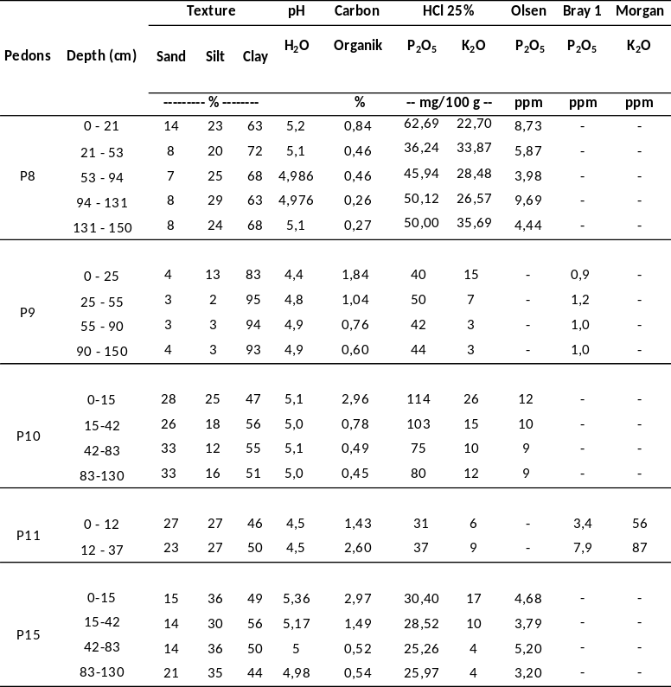

Chemical Properties of Soil
Some chemical properties have been tested in the laboratory, namely CEC, base saturation, C/N ratio, P, K₂O, Ca, Mg, K and Na. Status of organic matter was identified through C and N analysis (Table 4). Organic carbon content in pedons made from andesite - basalt (P11 and P15) ranged from very low to low, then in pedon made from lava and tuffs andesite basalt (P10) ranged from very low to moderate, the upper layer has a higher organic value, this can occur because the input of the upper organic material is supplied from the remaining litter of vegetation leaves. Pedon made from breccia andesite (P9) has a value of organic carbon content ranging from very low to low. Pedon made from andesite diorite (P8) has very low organic carbon values. In general, ultisols have low organic matter, according to BH Prasetyo 2006, the low content of organic matter is probably related to the large erosion rate (run off) in ultisols, this occurs because the pore space is narrow because it is filled with fine (clay) fractions.
The available P content is reflected in the Olsen analysis (Table 4). Pedon made from andesite basalt (P11 and P15) has a P value available very low to low. The lava and tuffs andesite basalt (P10) has a P value ranging from low to moderate. Pedon made from breccia andesite (P9) has an available P value very low to low. The pedon made from andesite diorite (P8) has a P value available in the medium range. In general, the five pedons have a low available P value, according to Wirjodihardjo 1953, it can occur because P is strongly bound to Fe from advanced weathering minerals.
The results of the analysis of Cation Exchange capacity (CEC) (Table 5) show that ultisols from andesite basalt (P11 and P15) have CEC values ranging from low to moderate. The lava and tuffs andesite basalt (P10) have CEC values in the high to very high ranges. Andesite - diorite (P8) pedon has moderate CEC values. Pedon made from breccia andesitic (P9) has a moderate CEC value. There is a close link between mineral reserves and CEC values. Pedon P10 has a high to very high mineral reserve class, the class value is in line with the high to very high CEC class values.
Base saturation (KB) on pedon made from andesite basalt (P11, and P15) have a KB value varying from very low to low. The pedon made from Lava and tuffs andesite basalt (P10) has a low KB value. Andesite - diorite (P8) pedon has a low KB value. Pedon made from breccia andesitic (P9) has a low KB value. The results of the analysis showed that ultisols made from andesite basalt and their associations had a low KB value. The low value of base saturation (KB) is likely due to the further weathering process of minerals which leaves many minerals rich in Fe. Low KB values are in line with one characteristic of ultisols (2014 Soil Survey Staff; National Soil Classification, 2016).
Exchangeable cations are Ca, Mg, K, Na analyzed in the laboratory (Table 5). Pedon made from andesite basalt (P11 and P15) have Ca values ranging from very low to low, lava and tuffs andesite basalt (P10) has a low Ca values , pedon made from breccia andesitic (P9) and pedon made from andesite - diorite (P8) having Ca exchangeable cation in a low rate.
The cation value can be exchanged (Mg) in each pedon as follows, pedon made from andesite basalt (P11 and P15) have values ranging from low to high, lava-tuffs andesite basalt pedon (P10) has a high Mg exchange rate, pedon made from breccia andesite (P9) has an Mg exchange rate ranging from medium to high, pedon made from andesite - diorite (P8) has a medium Mg exchange rate. In general, 3 pedons have high Mg values that can be exchanged. This is related to the constituent of sand minerals, which having a Mg-based chemical structures, namely hiperstine and hornblende minerals.
The value of cations can be exchanged (K) on pedon from andesite basalt (P11 and P15) ranging from very low to low, pedon made from lava and tuffs andesite basalt (P10) ranging from low to moderate, pedon made from breccia andesite (P9) ranging from very low to low , pedon made from andesite diorite (P8) ranges from low to moderate. The value of cations can be exchanged (Na) on pedon made from andesite basalt (P11 and P15) is low, three other pedons which is pedon made from lava and tuffs andesite basalt (P10), pedon made from breccia andesite (P9) and pedon made from andesite diorite (P8) have very low value.

Table 5. Cations can be exchanged and cation exchange capacity (CEC) of several Ultisols
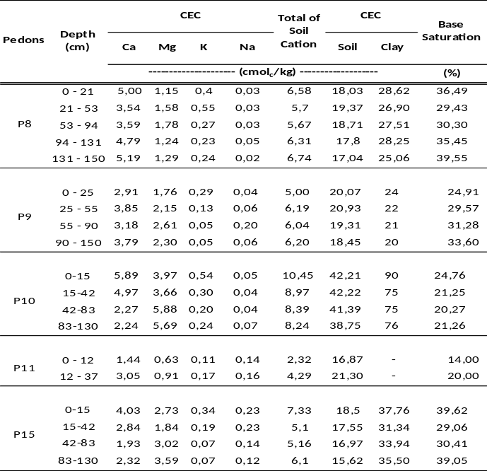
Conclusion
The results of the study obtained the color of andesite - basalts (as well as their associations) varied from 2.5 YR to 10 YR, values 3 - 5 and chroma 2 - 8. The sand mineral content were dominated by opaque minerals, zircon, quartz, weathering minerals, rock fragments and hiperstine. Mineral reserves that vary from very low to very high. The highest amount of mineral reserves is from lava and tuffs andesite basalt pedon (P10), especially rich in Mg elements derived from hiperstine minerals. Ultisols derive from andesite basalt materials at five pedons observed generally have low macro (N, P, K) nutrient content. P-absorption in ultisols from andesite basalt (as well as its acetyl) due to binding of Fe from advanced weathering processes on sand minerals should be of particular concern, so that effectiveness occurs in the application of P fertilizers.

Acknowledgement
The author would like to thank all the ICALRRD soil mapping survey team (2016 - 2017) and colleagues who have provided assistance in perfecting this paper
References
Allen, B. L. & B. F. Hajek. (1989). Mineral occurence in soil environment. p. 199−278. In J.B. Dixon and S.B. Weed (Eds.). Mineral in Soil Environments. 2nd ed. Soil Sci. Soc. Am. Madison, Wisconsin, USA.
Best, M. G. (2002). Igneous and metamorphic petrology. 2nd edition, Wiley, 752 pp.
Badan Penelitian dan Pengembangan Pertanian Kementerian Pertanian. (2017). Atlas Peta Tanah Semidetail Skala 1:50.000 Kabupaten Purwakarta.
Badan Penelitian dan Pengembangan Pertanian Kementerian Pertanian. (2017). Atlas Peta Tanah Semidetail Skala 1:50.000 Kabupaten Bandung Barat.
Badan Penelitian dan Pengembangan Pertanian Kementerian Pertanian. (2017). Atlas Peta Tanah Semidetail Skala 1:50.000 Kabupaten Pangkep.
Badan Penelitian dan Pengembangan Pertanian Kementerian Pertanian. (2017). Atlas Peta Tanah Semidetail Skala 1:50.000 Kabupaten Ogan Komering Ulu.
Badan Penelitian dan Pengembangan Pertanian Kementerian Pertanian. (2017). Atlas Peta Tanah Semidetail Skala 1:50.000 Kabupaten Brebes.
CPHA. (2003). Plant nutrients Potassium. Natural Resources Fact Sheet, California.
David, A. C. & Manning. Mineral sources of potassium for plant nutrition. A review. Agronomy for Sustainable Development, Springer Verlag/EDP Sciences/INRA, 2010, 30 (2).
Eswaran, H. & C. Sys. (1970). An evaluation of the free iron in tropical andesitic soil. Pedologie 20: 62−65.
Goldschmidt, V. M. (1958). Geochemistry. Oxford University Press. 730p. Skinner, B.J. (1984) Sumberdaya bumi (terjemahan). Gadjah Mada University Press, Yogyakarta, 189 h.
Gill, R. 2010. Igneous rocks and processes. A practical guide. Wiley-Blackwell, 428 pp.
Hardjowigeno, S. (2003). Klasifikasi Tanah Dan Pedogenesis. Jakarta, Indnesia: Akademika Pressindo. 250 hlm.
Hobart, M. King. (2005). Andesite Retrieved from https://geology.com/rocks/andesite.shtml
Ninuk, C. A. (1999). Model Estimasi Katerikatan Mineral Fraksi Pasir Dengan Kadar Hara Tanah dan Tanaman. Jurusan Tanah Fakultas Pertanian Institut Pertanian Bogor.
Poeloengan, L. Y. (1980). Kesuburan Alami Latosol Nanggung dan Ciampea, Departemen Ilmu-Ilmu Tanah. Fakultas Pertanian Institut Pertanian Bogor.
Prasetyo, B.H. & Suriadikarta, D. A. (2006). Karakteristik, Potensi dan Teknologi Pengelolaan Tanah Ultisols untuk Pengembangan Pertanian Lahan Kering di Indonesia, Jurnal Litbang Pertanian, vol. 25 (2).
Subardja D. S., et al. (2016). Petunjuk Teknis Klasifikasi Tanah Nasional. Badan Penelitian dan Pengembangan Pertanian Kementerian Pertanian.
Schwertmann, U. and R. M. Taylor. (1989). Iron oxides. p. 379−438. In J.B. Dixon and S.B.Weed (Eds.). Mineral in Soil Environments. 2nd ed. Soil Sci. Soc. Am Journal. Madison, Wisconsin, USA.
Skinner, B. J. (1984). Sumberdaya Bumi (terjemahan). Yogyakarta, Gadjah Mada University Press, 189 h.
Soil Survey Staff. (2014). Kellogg Soil Survey Laboratory Methods Manual. Soil Survey Investigations Report No. 42, Version 5.0. R. Burt and Soil Survey Staff (ed.). U.S. Department of Agriculture, Natural Resources Conservation Service.
Soil Survey Staff. (2014). Illustrated guide to soil taxonomy. U.S. Department of Agriculture, Natural Resources Conservation Service, National Soil Survey Center, Lincoln, Nebraska.
Szmanski, W. & Szkaradek, M. (2018). Andesite Weathering and Soil Formation in a Moderately Humid Climate a Case Study from the Western Carpathians (Southern Poland). Carpathian Journal of Earth and Environmental Sciences, February 2018, Vol. 13, No. 1, p. 93 – 105.
Wirjodihardjo & M. Wisaksono. (1953). Ilmu Tubuh-Tanah, jilid II. Jakarta: Noordhoff Kolff.
Winter, J. D. (2010). Principles of Igneous and Metamorphic Petrology. Prentice Hall, 720 p.

