AUTHOR DECLARATION FORM
Full Name : Mohamad Agus Salim
Affiliation : Biology department of Science & Technology Faculty
of State Islamic University (UIN SGD Bandung)
Email : agus.salim@uinsgd.ac.id

Title of Manuscript : Effect of Glomus manihotis Inoculation and Salt Stress on Physiological
Properties of Chia (Salvia hispanica L.)

As the Corresponding Author, hereby declare that:
- This manuscript is original, has NOT been published before and is currently considered for publication elsewhere, and during peer review process by this journal will not be withdrawn and sent to other journals to be assessed.
- I/We would like to improve the manuscript that has been assessed and not withdrawn unilaterally without informing the editors, especially if the manuscript is in the peer review process.
- I/We affirm that the manuscript does not violate the intellectual property rights of any third party. I/We agree to indemnify and hold harmless the SAINS TANAH - Journal of Soil Science and Agroclimatology in respect of any claim on account of violation of intellectual property rights.
- I/We have no known competing financial interests or personal relationships that could have appeared to influence the work reported in this manuscript.
- I/We hereby confirm that all the authors have made a significant contribution to the manuscript.
I/We made this statement to be used properly.

Bandung, 21st Oct 2022
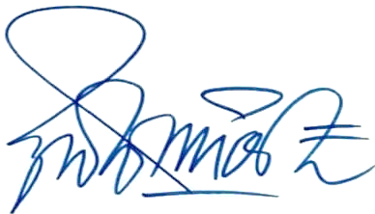
Mohamad Agus Salim

PLEASE UPLOAD THE SIGNED FORM AS SUPPLEMENTARY FILE IN THE OJS

