Data Perhitungan Kontribusi
 | Nama Responden | Pendapatan Keluarga |  |  |  |  | Kerja Sampingan (Wanita) | TPK | Kontribusi
 |  | Istri | Suami |  | Anak |  |  |  | (%)
 |  |  | Usaha Tani | Non Usaha Tani | Usaha Tani | Non Usaha Tani
1 | Nur Arofah | 1050000 | 500000 |  |  | 1500000 | 288000 | 2288000 | 45.892
2 | Nur Hawati | 900000 | 900000 |  |  |  | 560000 | 1460000 | 61.644
3 | Shofiyah | 780000 | 456000 |  |  | 1500000 | 600000 | 2556000 | 30.516
4 | Juwaeriyah | 900000 |  | 900000 |  |  | 450000 | 1350000 | 66.667
5 | Siti Alifah | 900000 |  | 450000 |  |  | 360000 | 810000 | 111.111
6 | Mudrikah | 780000 |  | 900000 |  | 2700000 |  | 3600000 | 21.667
7 | Ngatiyah | 780000 | 1690000 |  |  | 7100000 |  | 8790000 | 8.874
8 | Nur Iyanah | 780000 |  | 1500000 |  |  |  | 1500000 | 52.000
9 | Sharwen | 780000 |  | 4200000 |  |  |  | 4200000 | 18.571
10 | Istianah | 780000 |  | 4700000 |  |  | 150000 | 4850000 | 16.082
11 | Tumini | 900000 |  | 900000 |  |  | 420000 | 1320000 | 68.182
12 | Simtiyah | 900000 | 550000 |  |  |  |  | 550000 | 163.636
13 | Murip | 900000 | 900000 |  |  | 1050000 |  | 1950000 | 46.154
14 | Khaeroti | 900000 | 1250000 |  |  | 4200000 |  | 5450000 | 16.514
15 | Rianah | 900000 |  | 4200000 |  | 2200000 | 180000 | 6580000 | 13.678
16 | Sutinayah | 900000 |  |  |  |  | 360000 | 360000 | 250.000
17 | Shopiyah | 1050000 |  | 3600000 |  |  |  | 3600000 | 29.167
18 | Mistiyah | 900000 |  |  |  | 1950000 |  | 1950000 | 46.154
19 | Patoyah | 900000 |  | 1000000 |  | 1800000 |  | 2800000 | 32.143
20 | Sardiyah | 900000 |  |  |  |  | 360000 | 360000 | 250.000
21 | Tasmiah | 900000 | 1500000 |  |  |  |  | 1500000 | 60.000
22 | Jumiah | 900000 |  |  |  | 1500000 |  | 1500000 | 60.000
23 | Yatimah | 780000 |  |  |  | 2200000 |  | 2200000 | 35.455
24 | Sumiah | 780000 |  |  |  | 1500000 |  | 1500000 | 52.000
25 | Alfiyah | 780000 | 500000 |  |  |  | 180000 | 680000 | 114.706
26 | Ruroh | 780000 |  | 1500000 |  | 1050000 | 420000 | 2970000 | 26.263
27 | Nur Aenah | 780000 |  | 1050000 |  | 1500000 |  | 2550000 | 30.588
28 | Nur Aisyah | 780000 | 1500000 |  |  |  |  | 1500000 | 52.000
29 | Khotimah | 780000 |  | 3600000 |  |  |  | 3600000 | 21.667
30 | Tiyah | 780000 |  | 900000 |  |  | 126000 | 1026000 | 76.023
31 | Siti | 900000 | 800000 |  |  |  |  | 800000 | 112.500
32 | Surip | 900000 |  | 750000 |  | 700000 |  | 1450000 | 62.069
33 | Warti | 900000 |  |  |  | 900000 |  | 900000 | 100.000
34 | Toyah | 900000 |  | 600000 |  |  |  | 600000 | 150.000
35 | buwati | 900000 |  | 900000 |  | 4200000 |  | 5100000 | 17.647
36 | Khotijah | 900000 |  | 900000 |  |  |  | 900000 | 100.000
37 | komariyah | 900000 | 1000000 |  |  |  | 210000 | 1210000 | 74.380
38 | harti | 900000 |  | 500000 |  |  |  | 500000 | 180.000
39 | Naimatun | 900000 | 304000 |  |  | 4200000 |  | 4504000 | 19.982
40 | Muslimah | 900000 |  | 2400000 |  | 3500000 |  | 5900000 | 15.254
41 | Hidayah | 900000 |  | 1050000 |  | 1200000 |  | 2250000 | 40.000
42 | Khaeriyah | 900000 |  | 4500000 |  |  |  | 4500000 | 20.000
43 | Sunarti | 900000 |  | 400000 |  | 800000 | 156000 | 1356000 | 66.372
44 | Munawaroh | 900000 |  | 3600000 |  |  |  | 3600000 | 25.000
45 | Hamdiyah | 900000 |  | 750000 |  | 6500000 |  | 7250000 | 12.414
 | Rata-rata | 869333 | 911539 | 1830000 |  |  |  | 2581556 | 46,12

Data Perhitungan Regresi Data Logaritma Natural
NO | LnY | LnX1 | LnX2 | LnX3
1 | 3.83 | 13.86 | 13.12 | 1.39
2 | 4.12 | 13.71 | 13.71 | 1.10
3 | 3.42 | 13.57 | 13.03 | 1.39
4 | 4.20 | 13.71 | 13.71 | 0.69
5 | 4.71 | 13.71 | 13.02 | 0.69
6 | 3.08 | 13.57 | 13.71 | 1.39
7 | 2.18 | 13.57 | 14.34 | 1.39
8 | 3.95 | 13.57 | 14.22 | 1.10
9 | 2.92 | 13.57 | 15.25 | 1.10
10 | 2.78 | 13.57 | 15.36 | 0.69
11 | 4.22 | 13.71 | 13.71 | 0.69
12 | 5.10 | 13.71 | 13.22 | 0.69
13 | 3.83 | 13.71 | 13.71 | 1.39
14 | 2.80 | 13.71 | 14.04 | 1.10
15 | 2.62 | 13.71 | 15.25 | 1.39
16 | 5.52 | 13.71 |  | 0.00
17 | 3.37 | 13.86 | 15.10 | 1.39
18 | 3.83 | 13.71 |  | 0.69
19 | 3.47 | 13.71 | 13.82 | 1.10
20 | 5.52 | 13.71 |  | 0.00
21 | 4.09 | 13.71 | 14.22 | 0.69
22 | 4.09 | 13.71 |  | 0.69
23 | 3.57 | 13.57 |  | 1.10
24 | 3.95 | 13.57 |  | 0.69
25 | 4.74 | 13.57 | 13.12 | 0.69
26 | 3.27 | 13.57 | 14.22 | 1.10
27 | 3.42 | 13.57 | 13.86 | 1.10
28 | 3.95 | 13.57 | 14.22 | 0.69
29 | 3.08 | 13.57 | 15.10 | 1.39
30 | 4.33 | 13.57 | 13.71 | 0.69
31 | 4.72 | 13.71 | 13.59 | 1.10
32 | 4.13 | 13.71 | 13.53 | 1.10
33 | 4.61 | 13.71 |  | 0.00
34 | 5.01 | 13.71 | 13.30 | 0.69
35 | 2.87 | 13.71 | 13.71 | 1.39
36 | 4.61 | 13.71 | 13.71 | 0.69
37 | 4.31 | 13.71 | 13.82 | 1.10
38 | 5.19 | 13.71 | 13.12 | 0.69
39 | 2.99 | 13.71 | 12.62 | 1.39
40 | 2.72 | 13.71 | 14.69 | 1.39
41 | 3.69 | 13.71 | 13.86 | 1.10
42 | 3.00 | 13.71 | 15.32 | 1.10
43 | 4.20 | 13.71 | 12.90 | 0.69
44 | 3.22 | 13.71 | 15.10 | 0.69
45 | 2.52 | 13.71 | 13.53 | 1.39

Hasil Output Analisis Regresi Menggunakan SPSS 16.00

Model Summary^{b}
Descriptive Statistics
 | Mean | Std. Deviation | N
LN_Y | 3.7016 | .79464 | 38
LN_X1 | 13.6731 | .08071 | 38
LN_X2 | 13.9362 | .74931 | 38
LN_X3 | 1.0401 | .29245 | 38

Correlations
 |  | LN_Y | LN_X1 | LN_X2 | LN_X3
Pearson Correlation | LN_Y | 1.000 | .186 | -.563 | -.667
 | LN_X1 | .186 | 1.000 | -.163 | .084
 | LN_X2 | -.563 | -.163 | 1.000 | .158
 | LN_X3 | -.667 | .084 | .158 | 1.000
Sig. (1-tailed) | LN_Y | . | .132 | .000 | .000
 | LN_X1 | .132 | . | .165 | .307
 | LN_X2 | .000 | .165 | . | .172
 | LN_X3 | .000 | .307 | .172 | .
N | LN_Y | 38 | 38 | 38 | 38
 | LN_X1 | 38 | 38 | 38 | 38
 | LN_X2 | 38 | 38 | 38 | 38
 | LN_X3 | 38 | 38 | 38 | 38

Model Summary^{b}
Model | R | R Square | Adjusted R Square | Std. Error of the Estimate | Change Statistics |  |  |  |  |  |  |  | Durbin-Watson
 |  |  |  |  | R Square Change |  |  | F Change |  | df1 | df2 | Sig. F Change
1 | .828ª | .686 | .658 | .46438 | .686 |  |  | 24.781 |  | 3 | 34 | .000 | 1.740
a. Predictors: (Constant), LN_X3, LN_X1, LN_X2
b. Dependent Variable: LN_Y

ANOVA^{b}
Model |  | Sum of Squares | df | Mean Square | F | Sig.
1 | Regression | 16.032 | 3 | 5.344 | 24.781 | .000ª
 | Residual | 7.332 | 34 | .216
 | Total | 23.364 | 37
a. Predictors: (Constant), LN_X3, LN_X1, LN_X2
b. Dependent Variable: LN_Y

Coefficientsª
Model |  | Unstandardized Coefficients |  | Standardized Coefficients | t | Sig. | 95% Confidence Interval for B |  | Correlations |  |  | Collinearity Statistics
 |  | B | Std. Error | Beta |  |  | Lower Bound | Upper Bound | Zero-order | Partial | Part | Tolerance | VIF
1 | (Constant) | -10.407 | 13.498 |  | -.771 | .446 | -37.837 | 17.024
 | LN_X1 | 1.634 | .965 | .166 | 1.693 | .100 | -.327 | 3.594 | .186 | .279 | .163 | .961 | 1.040
 | LN_X2 | -.466 | .105 | -.440 | -4.448 | .000 | -.680 | -.253 | -.563 | -.606 | -.427 | .944 | 1.060
 | LN_X3 | -1.661 | .266 | -.611 | -6.242 | .000 | -2.201 | -1.120 | -.667 | -.731 | -.600 | .963 | 1.039
a. Dependent Variable: LN_Y

Residuals Statisticsª
 | Minimum | Maximum | Mean | Std. Deviation | N
Predicted Value | 2.4123 | 4.8220 | 3.7016 | .65825 | 38
Std. Predicted Value | -1.959 | 1.702 | .000 | 1.000 | 38
Standard Error of Predicted Value | .084 | .252 | .145 | .041 | 38
Adjusted Predicted Value | 2.2916 | 4.8974 | 3.7044 | .66894 | 38
Residual | -.85887 | .89760 | .00000 | .44516 | 38
Std. Residual | -1.849 | 1.933 | .000 | .959 | 38
Stud. Residual | -1.929 | 1.970 | -.003 | 1.014 | 38
Deleted Residual | -.96671 | .93266 | -.00276 | .49956 | 38
Stud. Deleted Residual | -2.014 | 2.062 | -.007 | 1.037 | 38
Mahal. Distance | .240 | 9.884 | 2.921 | 2.186 | 38
Cook's Distance | .000 | .182 | .031 | .049 | 38
Centered Leverage Value | .006 | .267 | .079 | .059 | 38
a. Dependent Variable: LN_Y
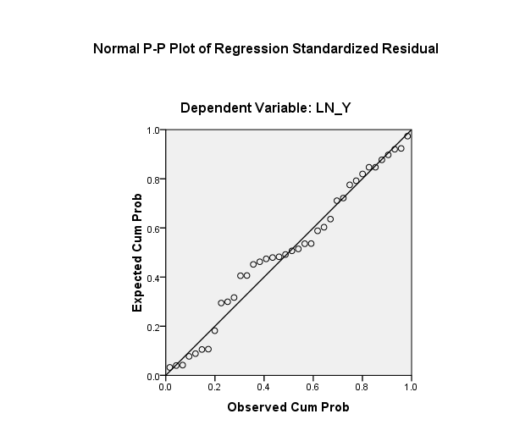
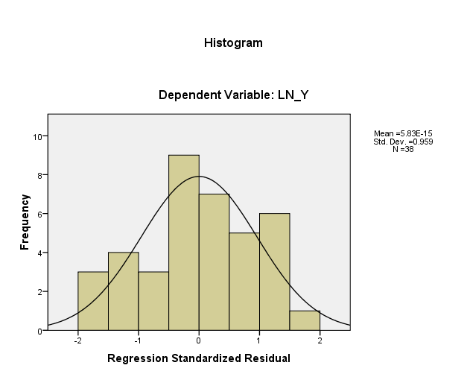

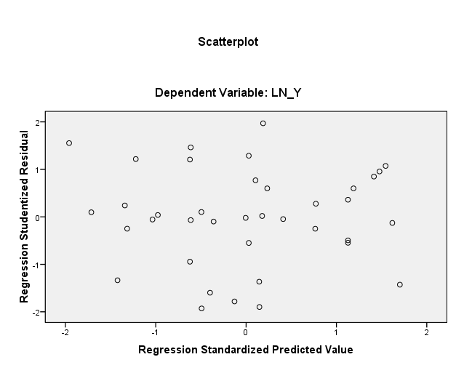

One-Sample Kolmogorov-Smirnov Test
 |  | Unstandardized Residual
N |  | 38
Normal Parametersª | Mean | .0000000
 | Std. Deviation | .44515661
Most Extreme Differences | Absolute | .112
 | Positive | .087
 | Negative | -.112
Kolmogorov-Smirnov Z |  | .690
Asymp. Sig. (2-tailed) |  | .728
a. Test distribution is Normal.

