**UNIT 1**

**EXPRESSING**

**CONGRATULATIONS**



PICTURE 1

(www.pictures88.com)



There are some common situations that require congratulations. There are when your friends win a competition, in graduation day, for a happy moment, or for your colleagues’ success. In this unit you will learn how to congratulate and how to response to it both in formal and less formal situation.

**LEAD IN**

***Watch and listen a video that will be played by your teacher.***



PICTURE 2

(www.real.com)



**TASK 1**

***Below are some words you are going to find in Task 2. Find their Indonesian equivalents in the dictionary and then repeat after your teacher.***

|  |  |  |
| --- | --- | --- |
| **Words** | **Pronunciation** | **Indonesian** |
|  |  | **Equivalent** |
|  |  |  |
| accepted(Adj) | /əkˈsep.tɪd/ |  |
| canteen (N) | /kæn ˈtiːn/ |  |
|  |  |  |
| congratulation (N) | /kənˌgræt.j ʊˈleɪ.ʃ ə n/ |  |
|  |  |  |
| glad(Adj) | /glæd/ |  |
|  |  |  |
| hear (V) | /hɪr/ |  |
|  |  |  |
| pleased(V) | /pliːzd/ |  |
|  |  |  |
| satisfied(Adj) | /ˈsæt. ɪs.faɪd/ |  |
| university(N) | /ˌjuː.nɪˈvɜː.sɪ.ti/ |  |
|  |  |  |



**TASK 2**

***Below are the conversation transcripts from the video. Indentify the expressions of congratulations and the responses from the video.***

**Situation: Mi, day, and their friend talking about Maulidya. And then Maulidya comes. All of them congratulate her for accepting in University of Lampung.**

Boy

: Hi, Mi.

Mi

: Hi, how are you?

Boy

: I’m fine. Where is Mualidya?

Mi

Day

Boy

Mi

Boy

Mi

Mauw

Boy

Mauw

Boy

Mauw

Boy

Mauw

Boy



: She is in the canteen.

: I hear any happy news from Maulidya.

: Oh really? What’s that?

: Yes, it’s true. Mauw is accepted in Universit y of Lampung.

: Oh, that’s a relief.

: Hi Mauw, congratulation.

: Emm, congratulation for what?

: We hear you are accepted in University of Lampung.

: Oh yes, it’s true.

: I’m very glad to hear that.

: Yes, I’m very satisfied with that.

: Yes, we’re pleased with you.

: OK, thank you.

: Never mind.

**TASK 3**

***Answer the questions bellow orally based on the video.***



1. What is the topic of the conversation?
2. How many people are there in the video? Who are they?
3. What is the relationship between them?
4. Where do you think the setting of the video?
5. What did Mi say to congratulate Maulidya?
6. Where will Maulidya continue her study?



**TASK 4**

***Read and study the expressions bellow.***

|  |  |  |  |  |  |
| --- | --- | --- | --- | --- | --- |
|  | **Expression of Congratulation** | |  | **Response** | |
|  | Please accept my heartiest congratulations. |  |  | Thank you. |  |
|  | I must congratulate you on your success. |  |  | Thanks. |  |
|  | Congratulations on your…… (promotion) |  |  |  |
|  |  |  |  |  |
|  | Congratulation! |  |  | Thank you very much. |  |
|  | Well done. |  |  |  |
|  |  |  |  |  |
|  | Fantastic! |  |  | Thanks a lot. |  |
|  | Terrific! |  |  |  |  |
|  |  |  |  |  |  |



**TASK 5**

***Complete the following dialogues below with relevant expressions and then act them out in pairs.***



1. Andre : Congratulation on getting a free coupon to borrow movies from “LEGEND” DVD rental.

Susan :__________________________________________________

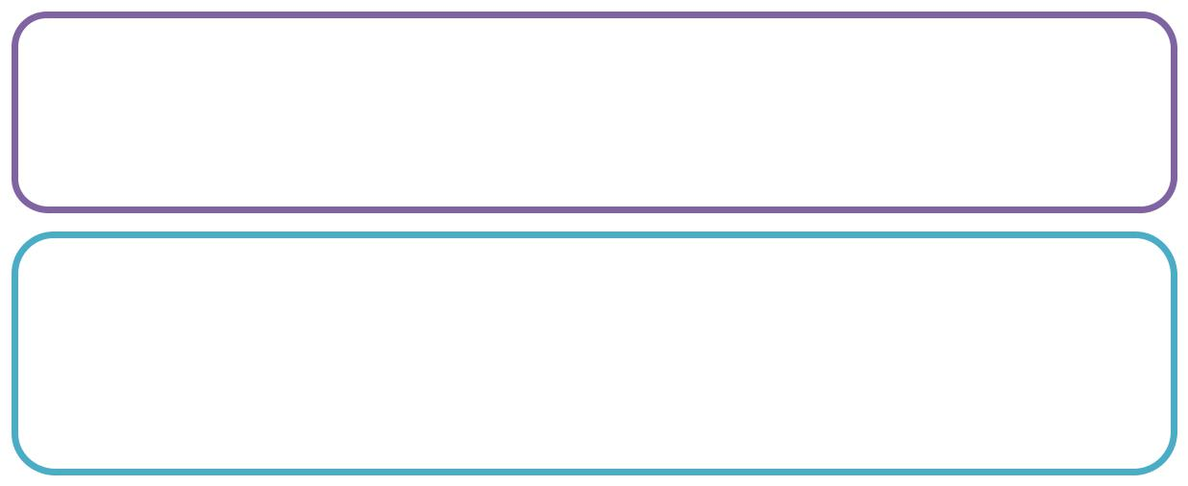

1. Sarah : I like your job. Congratulation you will be the manager now.

Bona :__________________________________________________

3. Doni : _________________everybody in the club loves your work.

Anita : Thank you.

Doni : Where did you get the idea?

Anita : A scene in the “Pirates of the Caribbean” i nspired me.



4. Bayu : I saw your performance on TV yesterday. _______________

you have inspired the jury.

Nino : Thanks. I worked hard to prepare anything.



5. Maya : Cit seems that your diet programme works on you. You are looking good

Intan :__________________________________________________



**TASK 6**

***Give the most appropriate expression and response based on the picture below.***

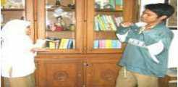

1. Sekar congratulates Aji for becoming the winner in science Olympiad.

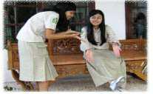

2. Intan congratulates Bella for getting new shoes as her prize in the dance competition.

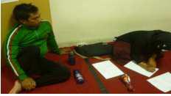

1. Doni congratulates Ayu who is writing next to him. Ayu became the winner in the poetry reading competition.

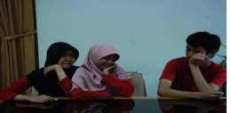

1. Maya and Dona congratulate David. He is the champion in debate competition in Jakarta.



**TASK 7**

***Work in pairs to complete the following dialogues with the suitable expression in the box and then perform it with your pair.***

Retno : Congratulation on your seventeen birthdays.

Wulan : Thank you.

Nurul : _____________________________

Wulan : Thank you for saying so. You look so sweet in that

red vest.

Nurul : Thanks. Look Doni is coming

_________________________

Wulan : Yes, you are right.

Doni : Hi Wulan, _____________________________

Retno : Thanks. By the way, congratulation on winning the

first prize on photography competition.

Doni : _____________________________

Nurul : Your idea was brilliant. I think you are genius.

Doni : Oh, not really.

Wulan : Anyway, let’s start the party.

1. You look charming in that white gown.
2. What a gregarious boy!
3. Congratulation on your birthday.
4. Thank you.



**TASK 8**

***Choose one of these role play cards then make a dialogue based on the situation below. Work in group of four and then act it out.***

**Card 1**

Your brother wins a

free ticket to watch

Simple Plan’s

concert in Canada.

You, your father,

and your mother

congratulate him.

**Card 2**

Your cousin wins the first prize on the Movie Festival. You, your brother, and your sister congratulate him.

**Card 3**

You and your close

friend congratulate

your classmates

who get the best

mark on the Poetry

class.

**UNIT 2**

**EXPRESSING COMPLIMENTS**

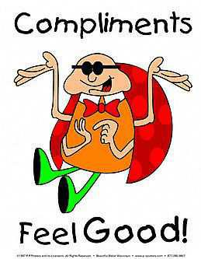

PICTURE 1

(skcyberbullies.blogspot.com)



Compliments express approval, and their main purpose is to show that you like some aspects of the other person’s appearance, belongings, or works. This reassures the other person that his or her taste, appearance, etc., is appreciated by other people. In this section, you will learn how to compliment and respond to compliment both in formal and informal situation.

**LEAD IN**

***Watch and listen a video that will be played by your teacher.***



PICTURE 2

(www.real.com)



**TASK 1**

***Complete the following table.***

***Your teacher will tell you the topics and situation of the video. Predict and then list some words you are going to hear and mention some things you are going to see in the video.***

**Words** **Things**



**TASK 2**

***Below are some words you are going to find in Task 2. Find their Indonesian equivalents in the dictionary and then repeat after your teacher.***

|  |  |  |
| --- | --- | --- |
| **Words** | **Pronunciation** | **Indonesian** |
|  |  | **Equivalent** |
|  |  |  |
| clinch (V) | /klɪn *t*  ʃ/ |  |
| fashionable(Adj) | /ˈfæ ʃ. ə n.ə.bl ̩/ |  |
| flatter(V) | /ˈflæt .̬ɚ/ |  |
|  |  |  |
| modest (Adj ) | /ˈmɑː.dɪst/ |  |
|  |  |
| notice (V) | /ˈnoʊ.t ̬ɪs/ |  |
|  |  |  |
| outfit (N) | /ˈaʊt.fɪt/ |  |
|  |  |  |
| perfume(N) | /pɝːˈfjuːm/ |  |
|  |  |  |
| style(N) | /staɪl/ |  |
|  |  |
| suitable (Adj) | /ˈs *j* uː.tə.bl ̩/ |  |
|  |  |  |
| wear (V) | /wer/ |  |



**TASK 3**

***Match the words and phrases in the table to their definition.***

|  |  |  |
| --- | --- | --- |
| a. | by the way | f. I appreciate that |
|  |  |  |
| b. | clinch | g. modest |
|  |  |  |
| c. | deal | h. notice |
|  |  |  |
| d. | high street | i. outfit |
|  |  |  |
| e. | I’m flattered | j. pay(someone)a compliment |
|  |  |  |
|  |  | k. you wear it well |
|  |  |  |

1. a business arrangement
2. a set of clothes
3. where the most important businesses and shops in a town are located (British English)
4. expression used to introduce a new subject or add information
5. it suits you, it is right for you
6. not willing to talk too much about one’s achievements and abilities
7. to say something (to someone) to express approval or admiration for things that someone does
8. to see or become aware of something
9. used to express that you are very pleased after receiving a compliment
10. used to thank someone or to show that you are grateful
11. win (informal)



**TASK 4**

***Fill in the blank with the suitable words or phrase and then identify the expressions of compliments and the responses from the video.***

**Man**

**Woman**

**Man**

**Woman**

**Man**

**Woman**

**Man**

**Woman**

**Man**

**Woman**

**:** Good morning!

**:** Morning!

**:** By the way, I just 1) .... to say well done on clinching that deal!

**:** Oh, thanks. It wasn’t too difficult.

**:** You’re being 2) ....! You 3) .... really well.

**:** Thank you.

**:** You’re a great manager, you know.

**:** Do you think so?

**:** Oh yeah.

**:** I appreciate that.

*(pause)*

|  |  |  |
| --- | --- | --- |
| **Man** | **:** Have you cut your hair? | |
| **Woman** | **:** Oh yes, I did actually. Thanks 4) ...! | |
| **Man** | **:** Where did you get it 5) ....? | |
| **Woman** | **:** Oh, just that place on the high street. | |
| **Man** | **:** They did a 6) .... and it looks great with the outfit. | |
| **Woman** | **:** Do you think so? | |
| **Man** | **:** Oh yeah. Very fashionable. | |
| **Woman** | **:** Oh, it’s just 7) .... | |
| **Man** | **:** Well, 8) .... of style. | |
| **Woman** | **:** Thank you, you too. | |
| **Man** | **:** Thank you. | |
| *(pause)* |  |  |
| **Man** | **:** Nice perfume, too. 9) ....? | |
| **Woman** | **:** Well, yes it is, actually. | |
| **Man** | **:** You wear it well. | |
| **Woman** | **:** 10) ...... |  |
| **Man** | **:** My pleasure. | |
| **Woman** | **:** Listen, do you want something? | |
| **Man** | **:** No. I’m just being polite, you know. | |
| **Woman** | **:** Hmmm. | |
|  | Taken from: http://learnenglish.britishcouncil.org | |
|  |  |  |



**TASK 5**

***Answer the questions bellow orally based on the video.***

1. How many people are there in the video? Who are they?
2. What is the relationship between them?
3. Where did the woman cut her hair?
4. What perfume that wear by the woman?
5. What did the man say about the woman’s perfume?



**TASK 6**

***Read and study the expressions bellow.***

|  |  |  |  |  |  |  |  |  |  |  |
| --- | --- | --- | --- | --- | --- | --- | --- | --- | --- | --- |
|  | **Degree** | |  | **Expressions Compliments** | |  | **Responses** |  | **Returning** | |
|  | **Formality** | |  |  |  |  |  |  | **Compliment** | |
|  |  |  |  |  |  |  |  |  | **(Optional)** | |
|  | **More** |  |  | I would like to compliment |  |  | Thank you. It’s |  | (You inspired me) |  |
|  | **Formal** |  |  | you on.... |  |  | nice of you to say |  |  |  |
|  |  |  | I think your (hair) is very nice |  |  | so. |  | It’s nice to hear |  |
|  |  |  |  |  |  |  |  |
|  |  |  |  | I just love your .... |  |  | Thank you, yours |  | that from someone |  |
|  |  |  |  | The (pizza) is delicious |  |  | is even nicer. |  | with your |  |
|  |  |  |  | I really like your .... |  |  | I’m glad you like |  | experience |  |
|  |  |  |  | This (cheese) is super. |  |  | it |  |  |  |
|  |  |  |  | That’s not bad (bike) you’ve |  |  | Thank you |  | Yours is nice too. |  |
|  |  |  |  | got |  |  |  |  |  |  |
|  | **Less** |  |  | That’s nice |  |  | Thanks |  |  |  |
|  | **Formal** |  |  | That’s not bad |  |  |  |  |  |  |
|  |  |  |  | Terrific |  |  |  |  |  |  |
|  |  |  |  |  |  |  |  |  |  |  |



* Formal: when you are talking with someone who is older than you (someone in the first meeting, your boss, your manager, etc).
* Less formal: when you are talking with someone who knows about you (your friend, your sister or brother, etc).
* Compliments express approval, and their main purpose is to show that you like some aspects of the other person’s appearance, belongings, or works. This reassures the other person that his or her taste, appearance, etc., is appreciated by other people.

Three ways to give a compliment:

* 1. By saying something nice about the object
  2. By asking how the person made it or where it was bought (but not how much it cost)
  3. By asking for another look or another serving, if it is food.

In certain case, you may accept the compliment but deny what the person has said to

compliment you. Some people do this to appear modest:

Example:

Joseph : That was a great dinner. You must have spent all day cooking.

Maya : Thanks. But it really only took an hour.



**TASK 7**

***Match the following situations with the appropriate compliments.***

|  |  |  |  |  |
| --- | --- | --- | --- | --- |
| ***NO*** | ***Situation*** |  | ***Compliments*** | |
| ***1*** | You compliment someone on their appearance. |  | What a nice dress! |  |
| ***2*** | You say nice thing about your friends' dress. |  | You look great! | |
|  |  |  |  | |
| ***3*** | Your colleague is very fashionable and well dress. |  | You're looking glamorous. |  |
| ***4*** | Your friend has just passed an important exam |  | Fantastic! | |
|  |  |  |  | |
| ***5*** | You compliment your brother for his new car |  | Well, Done! |  |
| ***6*** | You give response to your friend compliment. |  | Thank you very much for your | |
|  |  |  | compliment. | |
|  |  |  |  |  |



**TASK 8**

***Complete the following dialogue with the suitable expressions provided in the box. And then act it out with your partner.***

(The doorbell rings)

George Burns : Come in!

Jack Palmer : Hey, George. Thank you.

Mary Palmer : Hey, George. How are you?

George Burns : Just fine, thanks, Mary. And you?

Mary palmer : Fine.

Donna Burns : (coming to greet them) Sorry, last-minute things in the oven.

Jack : These are for you.

George : Oh, thank you! They are beautiful!

Marry : 1) ____________

Donna : Why, thank you. I’m so glad you could come. Let’s sit here so we can see

the garden as the sun is going down.

Mary : 2) ____________

Donna : Thank you.

Mary : What are those tall flowers in the back?

Donna : Those are salvias. Would you like some?

Marry : 3) ___________, but I don’t have a spot of sun to grow them in.

Donna : That’s right. George mentioned that you and Jack are specialists in shade

flowers. Aren’t you two illustrating a book? That must be very interesting.

Mary : 4) ____________. Yes, we are doing a book for the Wildlife Federation.

Donna : Well, I’ve got this one shady corner that I have trouble with. Maybe you

can give me some advice.

Mary : 5) ____________ .

Donna : We’ll just have time for a look before dinner. Back in a minute, dear.

George : Ok. Jack and I will admire the view from here.



I’ll try.

It’s nice of you to remember.

Thanks so much.

What a lovely home you have!

Your garden is beautiful, Donna.



**TASK 9**

***Give the most appropriate expressions of compliments based on the pictures below.***

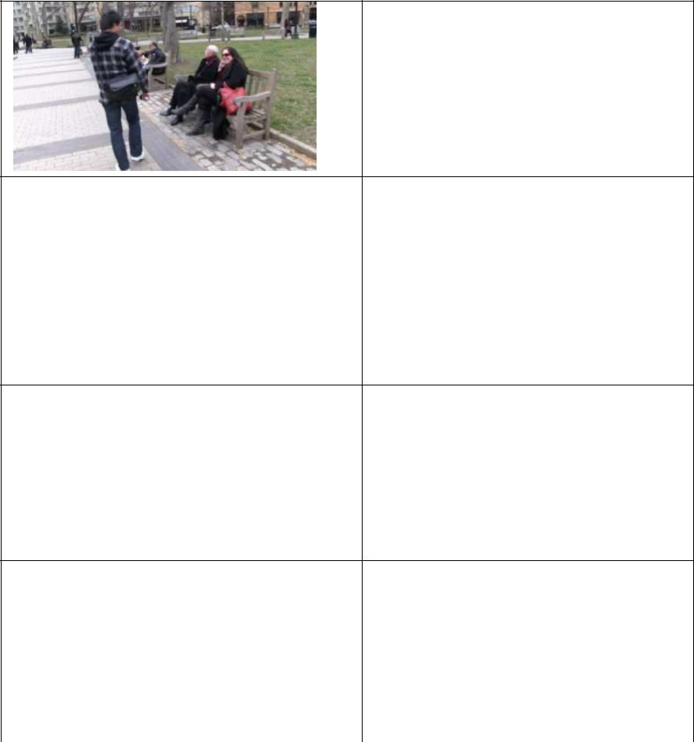

Michael compliments Sandra

on her beautiful sun glasses.

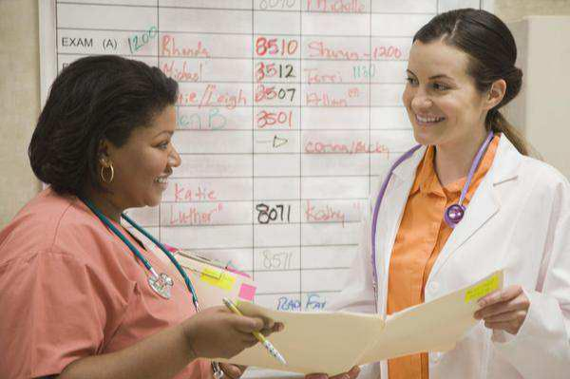

Bella compliments her

partner on her new hair cut.

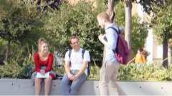

Andre compliments Adam on

his new bag.

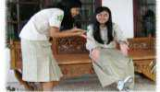

Maya compliments on

Shinta’s new shoes.

**UNIT 3**

**ACCEPTING AND REFUSING INVITATIONS**

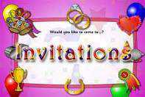

PICTURE 1

(matthewsm1th.com)



This unit focuses on social invitations—how to make them and how to accept and decline them. After completing the exercises, you should feel comfortable in making and replaying to invitations in various situations.

**LEAD IN**

***Watch and listen a video that will be played by your teacher.***



PICTURE 2

(WWW.REAL.COM)



**TASK 1**

***Complete the following table.***

***Your teacher will tell you the topics and situation of the video. Predict and then list some words you are going to hear and mention some things you are going to see in the video.***

**Words** **Things**



**TASK 2**

***Below are some words you are going to find in Task 2. Find their Indonesian equivalents in the dictionary and then repeat after your tutor.***

|  |  |  |
| --- | --- | --- |
| **Words** | **Pronunciation** | **Indonesian** |
|  |  | **Equivalent** |
|  |  |  |
| apartment (N) | /əˈpɑːt.mənt/ |  |
|  |  |  |
| birthday (N) | /ˈbɜːθ.deɪ/ |  |
|  |  |  |
| call (V) | /kɑːl/ |  |
|  |  |  |
| celebrate (V) | /ˈsel.ɪ.breɪt/ |  |
|  |  |  |
| invite (V) | /ɪnˈvaɪt/ |  |
|  |  |  |
| night (N) | /naɪt/ |  |
| parent (N) | /ˈper. ə nt/ |  |
|  |  |  |
| party (N) | /ˈpɑːr.t ̬i/ |  |
|  |  |  |
| wonderful (Adj) | /ˈwʌn.də.f ə l/ |  |
|  |  |  |



**TASK 3**

***Below are the conversation transcripts from the video. Indentify the expressions of invitation and responses from the video.***

**Situation: Himena is calling her best friend, Sicilia to come to her birthday**

**party.**

Himena

Sicilia

Himena

Sicilia

Himena

Sicilia

Himena

Sicilia

Himena

Sicilia

Himena

Sicilia



: Hello.

: Hello, this is Sicilia.

: Hi Sicilia, I’m Himena

: Ow, Hi Himen

: We are calling you because I’m going to celebrate my birthday. And I

want to invite you to my party at my parent’s apartment.

: Wonderful. When was that?

: Saturday night on August 27.

: Great, I’ll be there.

: I invite a lot of friend and also some new guys.

: I won’t miss it.

: See you ten o’clock. Bye.

: Bye. Thanks for the invitation.

**TASK 4**

***Answer the questions below orally.***

1. How many people are there in the video? Who are they?
2. What is the relationship between them?
3. Why did Himena call Sicilla?
4. Will Sicillia come to Himena’s party?
5. When will Himena celebrate her birthday party?
6. Where will Himena celebrate her birthday party?
7. How many people were invited to come to the party?



**TASK 5**

***Match the words and phrases in the column A to their definition in column B. It will help you to understand the content of the video.***

|  |  |  |
| --- | --- | --- |
| **A** |  | **B** |
|  |  |  |
| 1. | formal | a. A plan made before you received the invitation |
| 2. | RSVP | b. A doctor for animals |
| 3. | Appointment | c. Used at the end of letters to mean ‘please replay’ |
| 4. | Vet | d. Upset and angry |
| 5. | Prior engagement | e. A formal arrangement to meet someone |

|  |  |
| --- | --- |
| 6. Offended | f. Serious and correct |



**TASK 6**

***Below are the conversation transcripts from the video. Indentify the expressions of invitations and the responses from the video.***

**Man**

**Woman**

**Man**

**Woman**

**Man**

**Woman**

**Man**

**Woman**

**Man**

**Woman**

**Man**

**Woman**

**Man**

**Woman**

**Man**

**Woman**

**Man**

**Woman**

**Man**

**Woman**

**Man**

**Woman**

**Man**

: Oh no!

: What is it?

: “Josh and Henrietta would like to have the pleasu re of your company

at a drinks party, next Saturday evening...”

: Oh no, Josh and Henrietta... they’re not that couple who...?

: Yeah exactly! And it gets worse...

: How?

: “Formal dress...”

: Argh.... it means you’ve got to wear a suit....

: At the bottom it says “RSVP”. What does it mean?

: You’ve got to reply.

: But I don’t want to go, so what can I say?

: Tell them you’ve got a dentist’s appointment.

: Josh is my dentist!

: Tell them it’s your grandmother’s 100th birthday party.

: But they know my granny died ages ago.

: Tell them your dog’s sick and you’ve got to take him to see the vet.

: It’s no use – I’m just going to have to tell them the truth...

: The truth? “I’m not coming to your birthday party because I think

you’re boring and stupid?”

: Maybe not then...

: Tell them this: “I’m unable to attend because I h ave a prior

engagement.”

: “Prior engagement”?! And… they won’t be offended?

: Absolutely not.

: Perfect!



**TASK 7**

***Read the questions and select the right answers.***

1. What type of event has the man been invited to?
   1. A wedding
   2. A drink party
   3. A dinner party
2. RSVP means…
   1. You have to go to the event.
   2. The invitation is only for you.
   3. You should reply to the invitation.
3. What is the dress code for the party?
   1. Formal dress
   2. Casual dress
   3. Fancy dress
4. The woman suggests using a dentist’s appointment as an excuse. Why is this not possible?
   1. The man has no teeth.
   2. The invitation is from the man's dentist.
   3. His dentist died a long time ago.
5. Why don’t they want to go to the party?
   1. Josh and Henrietta are not good company.
   2. Josh and Henrietta are mean.
   3. Josh and Henrietta are a bit scary.
6. What excuse do they decide to use?
   1. They are getting engaged.
   2. The man’s dog is sick.
   3. The man has an appointment that he made before.

*Read and study the expressions bellow.*

|  |  |  |  |  |  |  |  |  |  |  |  |
| --- | --- | --- | --- | --- | --- | --- | --- | --- | --- | --- | --- |
|  | **Degree** | |  | **Making** | |  | **Accepting** | |  | **Declining** | |
|  | **Formality** | |  | **Invitations** | |  |  |  |  |  |  |
|  |  |  |  |  |  |  |  |  |  |  |  |
|  | **More formal** |  |  | - I’d like to invite |  |  | - Thank you. I’d |  |  | - I’m awfully sorry, but |  |
|  |  |  |  | you to dinner this |  |  | love to |  |  | I have other plans. |  |
|  |  |  |  | Saturday. |  |  |  |  |  | - I’d really like to, but |  |
|  |  |  |  | - I was wondering if |  |  | - Yes, thank you. |  |  |  |
|  |  |  |  |  |  |  |  | ... |  |
|  |  |  |  | you’d like to ... |  |  | What time? |  |  |  |
|  |  |  |  |  |  |  |  |  |  |
|  |  |  |  | - Are you free on |  |  |  |  |  |  |  |
|  |  |  |  | Saturday? Would |  |  | - Thanks. I’d love to |  |  | - Sorry. I’ve already |  |
|  | **Less Formal** |  |  | you like to ... |  |  |  |  |  | made plans for |  |
|  |  |  |  | - How about dinner? |  |  | - Sounds great |  |  | Saturday. |  |
|  |  |  |  | - How about coffee? |  |  | - Ok |  |  |  |
|  |  |  |  |  |  |  |  | - Oh darn! Have to ... |  |
|  |  |  |  |  |  |  | - Alright |  |  |  |
|  |  |  |  |  |  |  |  |  |  |  |
|  |  |  |  |  |  |  |  |  |  |  |  |





**TASK 8**

***Accept each of the following invitation by using the expressions we have discussed and then act it out with your pairs.***

**1.** James, your best friend : Why don’t you go with me to visit my family next

weekend? I know you’d enjoy meeting them.

You : _________________________________________

1. Your father: How about playing golf this weekend?

You : ______________________________________________________

1. Your teacher: Do you want to join Maria and me for lunch? We are going to talk about the plans for the International Festival.

|  |  |  |  |
| --- | --- | --- | --- |
|  | You | : ______________________________________________________ | |
| 4. | Your friend: Can you come with Joe and me to the museum on Sunday? | | |
|  | You | : ______________________________________________________ | |
| 5. | Your neighbor | | : Would you like to come over for dinner next Saturday night? |
|  | You |  | : ________________________________________________ |



**TASK 9**

***Work in pairs and then choose one of these situations and then make a conversation based on the cues given. Act it out in front of the class.***

A. Situation 1

|  |  |  |  |  |
| --- | --- | --- | --- | --- |
|  |  | **A** |  | **B** |
|  | 1. | Greets B | 1. | Greets A |
|  | 2. | Invites B to housewarming | 2. | Accepts invitation, asks about time |
|  | 3. | Gives time | 3. | Offers to bring something |
|  | 4. | Accepts or reject the offer | 4. | Express happiness and thanks A for |
|  |  |  |  | the invitation |
|  |  | |  | |
| Housewarming: party to celebrate moving into a new house | | | | |
| B. Situation 2 | | |  |  |

|  |  |  |  |
| --- | --- | --- | --- |
|  | **A** |  | **B** |
| 1. | Greets B | 1. | Greets A |
| 2. | Invites B to barbecue party | 2. | Asks about time |
| 3. | Gives time | 3. | Accepts invitation |
| 4. | Expresses pleasure | 4. | Expresses reasons and sorry |
|  |  | 5. | Expresses thanks |

C. Situation 3

|  |  |  |  |  |  |  |
| --- | --- | --- | --- | --- | --- | --- |
|  | **A** |  |  | **B** |  |  |
| 1. | Greets B | 1. | Greets A |  |  |  |
| 2. | Invites B to dinner | 2. | Accepts invitation | |  |  |
| 3. | Gives time and location | 3. | Disagrees | With | the | time, |
| 4. | Agrees |  | suggests alternate time | | |  |
| 5. | Responds to thanks | 4. | Expresses thanks | |  |  |

D. Situation 4

|  |  |  |  |
| --- | --- | --- | --- |
|  | **A** |  | **B** |
| 1. | Greets B | 1. | Greets A, asks what A wants |
| 2. | Invites B to dinner | 2. | Accepts the invitation, ask the |
| 3. | Gives time and place |  | time and place |
| 4. | Expresses thanks | 3. | Agrees |
|  |  | 4. | Responds to thanks |

**REFERENCES**

Blundell Jon, Higgens Jonathan, and Middlemiss Nigel. 1982. Function in English.

Hong Kong: Oxford University Press.

Tillitt Bruce, B. Mary Newton. 1985. Speaking Naturally: Communication Skill in

American English. United States of America: Cambridge University Press.

W. Allie Pattricia. 1998. Say It Naturally: Verbal Strategies for Authentic

Communication. United States of America: Heinle & Heinle Inc. Thomson Learning

[www.youtube.com/dialogues/modernday](http://www.youtube.com/dialogues/modernday)

www.youtube.com/dialogues/pleasure