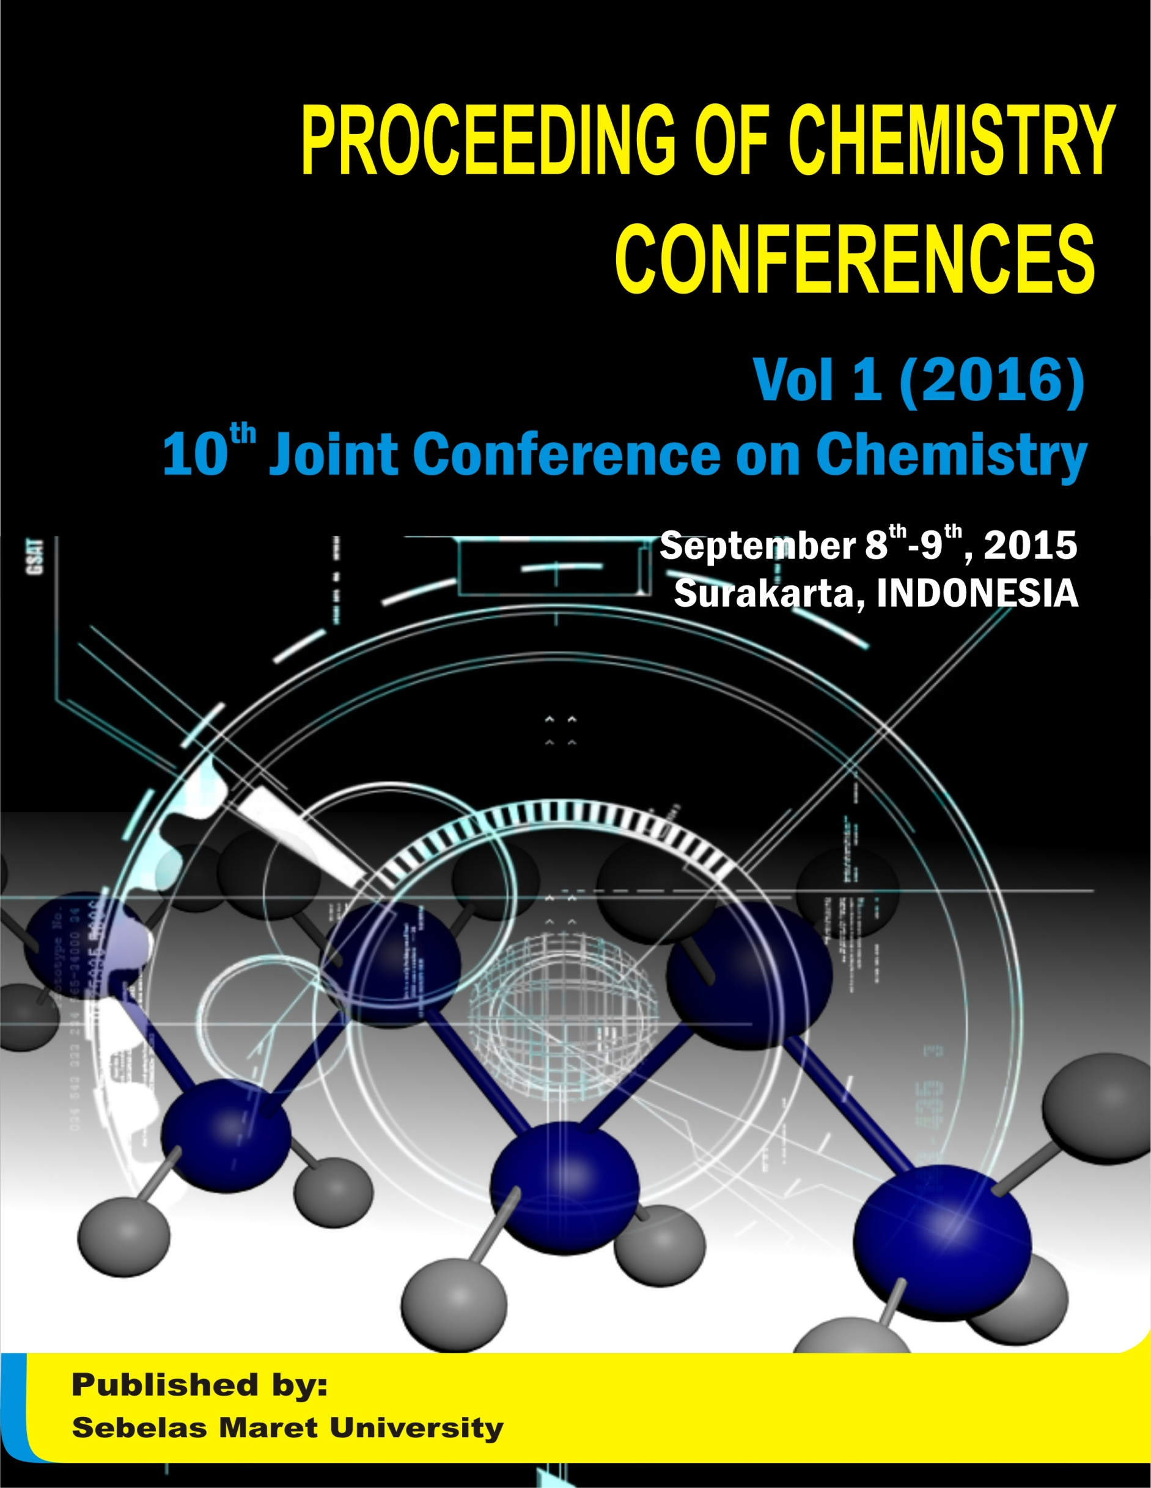
CONTENTS

Cover | i
Contents | ii
Preface | iii
Welcoming speech | iv
Organizing committee | viii
List of article in IOP | x
List of article In Alchemy | xvi
List of article in prosiding | xvii
PREFACE
Welcome to Surakarta (Solo) - Indonesia
It is our pleasure to welcome you to participate in the 10th Joint Conference on Chemistry 2015 (JCC-2015). JCC-2015 is annual conference, jointly organized by Chemistry Department, Faculty of Mathematics and Natural Sciences, Sebelas Maret University;, Semarang State University;, Diponegoro University; and, Jenderal Soedirman University. JCC was aimed at bringing together researchers and scientist from Central Java and other region in Indonesia to discuss the problems and solutions related to chemistry. Starting from 9th JCC in 2014 we extend the conference toward International forum in order to contribute more to the latest development in chemistry and related field.
JCC-2015 will be held at Lor International Hotel Solo (Lor In Solo), Indonesia from 8-9 September 2015. Chemistry Department, Faculty of Mathematics and Natural Sciences, Sebelas Maret University as the conference host has decided to take “Chemistry For Sustainable Development” as the main theme of JCC-2015. Selected papers will be published in IOP series: Material Science and Engineering which is indexed by Scopus. The coverage of MSE extends across all materials science disciplines, encompassing analysis, development and application. Research areas covered by the journal include: Processing, engineering and applications, Analysis and characterization, Functional materials, Polymer science, Glasses and ceramics, Thin films and surfaces, Nanostructures and nanomaterials, Composites, Biomaterials, Environment and energy, Computation and simulation, Crystalline structure and microstructure, Structural and mechanical, Metals, alloys and and metallurgy.
We were fortune to have generous support from many organizations, an commercial enterprise, which include Sebelas Maret University; Faculty of Mathematics and Natural Sciences, Sebelas Maret University; PT PERTAMINA (Persero); PT. Metrohm Indonesia; and Edulab Bengkel Furnace & Reaktor. However, it was mainly through the committed and untiring efforts of staff and students of Chemistry Department, Faculty of Mathematics and Natural Sciences, Sebelas Maret University that this event has become possible.
We hope that all participants have great time throughout this conference.

Dr. rer. nat. Witri Wahyu Lestari, M.Sc  Secretary Chairman Organizing Committee | Dr. rer. nat. Fajar Rakhman Wibowo, M.Si  Chairman Organizing Committee

Welcome Speech from Head of Chemistry Department
Sebelas Maret University
We are very pleased to introduce The 10th Joint Chemistry Conference held by Chemistry Dept. of Sebelas Maret University on behalf of the Chemistry Consortium in Central Java, Indonesia. The 10th Joint Chemistry Conference was held on the Lor International Hotel (Lor In Hotel) in Solo during 8- 9th of September 2015. Solo as "The Spirit of Java," a Javanese culture and heritage center, batik capital, and tourist-friendly city. To promote the Solo City as the spirit of Java, this international conference is arranged in short days before international cultural events, the Solo International Performing Art (SIPA) and Indonesian Umbrella Festival.
The conference will emphasize the multidisciplinary chemical issue and impact of today’s sustainable chemistry which covering the following topics: Material science & engineering, Energy & sustainability, Medicinal chemistry, Catalysis, Green chemistry, Natural products, Environmental chemistry, Nanotechnology, Theory, characterization, modeling, Chemistry education and General : chemistry-related studies.
We hope that this conference can initiate UNS cooperation with various parties to contribute our science for the benefit of society. Finally, we hope this seminar can take place smoothly and successfully, and its results can be implemented and bring benefit to the wider community.
Surakarta, September 8th 2015
Head of Chemistry Department UNS

Dr.Triana Kusumaningsih, M.Si

Welcome Speech from Head of Chemistry Department
Jenderal Soedirman University
Praise to Allah SWT for His favors and gifts that the 10th Joint Conference on Chemistry with the theme of Chemistry for Sustainable Development in 2015 can be held. This activity is a form of cooperation between the Department of Chemistry of Sebelas Maret University, Jenderal Soedirman University, Diponegoro University and Semarang State University. We hope that seminar can promote conducive cooperation among colleges and institutions, to further optimize the use of abundant natural resources of Indonesia for the advancement of science and sustainable development.
On this occasion we would like to express our appreciation and gratitude to Sebelas Maret University along with the organizing committee for their hard work and all parties in the success of this event. Congratulation on carrying the seminars, may we get benefit from this activity.
Purwokerto, September 8th 2015
Head of Chemistry Department UNSOED

Dr. Suwandri, M.Si
Welcome Speech from Head of Chemistry Department
State University of Semarang
Assalamualaikum wr wb.
Our honorable guest and seminar participant,
All Praises to Allah SWT who has bestowed his grace and guidance to all of us so that we can together participate in the 10th Joint Conference on Chemistry in 2015 at LOR IN Hotel,Solo, Indonesia.
The whole family from Chemistry department of Semarang State University would like to give highest appreciation to the keynote speaker, speakers, participants and invited guests who have great contribution to successful of this seminar.
Through this meeting we hope: 1) a scientific interaction between academics, researchers and practitioners from both inside and outside the country in the field of chemistry and applied research as well as chemical education will be created, 2) researchers and academics will be facilitated and developed in order to achieve the international level, 3) the results of research and theoretical studies may have impact and contribution in solving the problems in the field of chemistry and chemical education in the society.
Finally, we would like to deliver our gratitude to the committee for their hard work and dedication for this important seminar. Thank you very much.
Wabillahitaufik wal hidayah .
Wassalamu alaikum warahmatullahi wabarakatuh
Semarang, September 8th 2015
Head of Chemistry Department UNNES

Dra. Woro Sumarni, M.Si

Welcome Speech from Head of Chemistry Department
Diponegoro University

Assalamualaikum wa Rahmatullahi wa Barakatuhu,
Dear Distinguished Delegates, Colleagues and Guests,
All praises to Alloh SWT who gives us abundance blessing and allow us to organize the 10th Joint Conference on Chemistry (JCC) 2015. On behalf of the Chemistry Department, Diponegoro University, I would like to Welcome You to this conference.
The JCC is an annual conference which organized by the consortium of Chemistry Department of four Universities in Central Java : Diponegoro University (UNDIP), Semarang State University (UNNES), Sebelas Maret University (UNS) and Jenderal Soedirman University (UNSOED) since 2006. The conference will provide an interactive International forum to provide for sharing and exchance information on the latest research on Chemistry and related sciences, to enhance the capacities for creating innovation system, to stimulate future collaborations among industries, researchers, governments and other stakeholders who aplly science and technology for better live.
We would like to thanks the organizers, the plenary speakers and the researchers for their hard work and full commitment. For all of the participants, we are thankful for your cooperation, contribution and very valuable support for this event. Finally, we hope that you enjoy the conference.
Wassalamualaikum wa Rahmatullahi wa Barakatuhu

Semarang, September 8th 2015
Head of Chemistry Department UNDIP

Dr. Khairul Anam, M.Si

ORGANIZING COMMITTEE OF
10th JOINT CONFERENCE ON CHEMISTRY (JCC) 2015

Conference Advisory Board:
- Prof. Takuji Ogawa (Osaka University, Japan)
- Prof. Dr. Evamarie. Hey-Hawkins (Leipzig University, Germany)
- Dr. Henning Störz (Johann Heinrich Von Thuenen Institute, Braunschweig Germany)
- Dr. Zaheer -ul-Haq Qasmi (Karachi University, Pakistan)
- Dr. Leny Yuliati (Ibnu Sina Institute, University Teknologi Malaysia)
- Prof. Ir. Ari Handono Ramelan, M.Sc., PhD (Sebelas Maret University)
- Prof. Drs. Sutarno, MSc, PhD (Sebelas Maret University)
- Prof. Drs. Sentot Budi Rahardjo, PhD (Sebelas Maret University)
- Prof. Dra. Neng Sri Suharty, MS, PhD (Sebelas Maret University)
- Prof. Effendy, PhD (Malang State University)
- Dr. Eddy Heraldy (Sebelas Maret University)

Scientific Committee:
PUBLICATION, PROCEEDING AND DOCUMENTATION:
- Dr. Fitria Rahmawati, Sebelas Maret University
- Teguh Endah saraswati, PhD, Sebelas Maret University
- Dr. Is Fatimah, Indonesian Islamic University
- Dr. rer.nat Rino Mukti, Bandung Institute of Technology
- Dr. Dwi Hudiyanti, MSc (Diponegoro University)
- Adi Darmawan, MSi, PhD (Diponegoro University)
- Prof. Dr. Sudarmin, MSi (Semarang State University)
- Samuel Budi Wardana Kusuma, SSi, MSc (Semarang State University)
- Dadan Hermawan, PhD (Jenderal Soedirman University)
- Dr. Ponco Iswanto, M.Si. (Jenderal Soedirman University)
Organizing committee:
General Chair | Dr. rer. nat. Fajar Rakhman Wibowo, MSi (Sebelas Maret University)
Co-chairman | Rahmad Nuryanto, SSi., MSi, (Diponegoro University)  Dr. Anung Riapanitra (Jenderal Soedirman University)  Dr. Agung Tri Prasetya (Semarang State University)
Secretary | Dr.rer.nat. Witri Wahyu Lestari, MSc
Treasurer, Venue & Facilities | Dr. Desi Suci Handayani  Dr. Khoirina Dwi Nugrahaningtyas, MSi,  Ponimah SPt  Hantisha Oksinata SPd  Nanik Subekti Amd
Secretariat and registration | Teguh Endah Saraswati, PhD  Candra Purnawan, MSc  Dr. Abu Masykur, MSi,  Anang Kuncoro, SSi, Apt
Technical program committee | Venty Suryanti, M.Phil, Ph.D  Dr. rer. nat. Maulidan Firdaus, M.Sc  Dr. rer. nat. Atmanto Heru Wibowo, M.Si
Web & information system | Edi Pramono, M.Si
Instrument Workshop | Dr. Sayekti Wahyuningsih  M. Widyo Wartono, MSi
Sponsorship & Cultural Event | Dr. Pranoto, M.Sc  Dr. Triana Kusumaningsih, M.Si,  Dra. Tri Martini, MSi
List of published articles in
IOP Conference Series: Materials Science and Engineering
Vol 107 (2016)
(http://iopscience.iop.org/issue/1757-899X/107/1)

Catalysis

Photocatalytic removal of phenol over titanium dioxide- reduced graphene oxide photocatalyst
Nor Shuhada Alim, Hendrik O. Lintang and Leny Yuliati

The shape conversion of silver nanoparticles through heating and its application as homogeneous catalyst in reduction of 4- nitrophenol
H A Ariyanta and Y Yulizar

Preparation of TiO₂-ZnO and its activity test in sonophotocatalytic degradation of phenol
Is Fatimah and Novitasari

Chitosan and N-Alkyl chitosan as a heterogeneous based catalyst in the transesterification reaction of used cooking oil
T S Julianto and R A Mumpuni

High photocatalytic activity of mixed anatase-rutile phases on commercial TiO₂ nanoparticles
Wai Ruu Siah, Hendrik O Lintang, Mustaffa Shamsuddin and Leny Yuliati

Enviromental Chemistry

Synthesis of α-Bismuth oxide using solution combustion method and its photocatalytic properties
Y. Astuti, A. Fauziyah, S. Nurhayati, A.D. Wulansari, R. Andianingrum, A.R. Hakim and G. Bhaduri

Aliphatics hydrocarbon content in surface sediment from Jakarta Bay, Indonesia
M YAzis, L Asia, A Piram, P Doumenq and A D Syakti

Occurrence of aliphatic and polyaromatic hydrocarbons (PAHs) in Mytillus galloprovincialis from the traditional market in Marseille, France, by Gas Chromatography triplequadropole tandem Mass Spectrometry (GC-QQQ/MS)
M Y Azis, Yelmiza, L Asia, A Piram, B. Bucharil, P Doumenq and A D Syakti

Synthesis of thiazole silica hybrid from waste glass for adsorption of cadmium(II)
C. Azmiyawati and TaslimahVirkyanov

Alginate cryogel based glucose biosensor
Amin Fatoni, Dian Windy Dwiasi and Dadan Hermawan

Adsorption of remazol yellow FG from aqueous solution on chitosan-linked P-T-Butylcalix[4]Arene
Desi Suci Handayani, Candra Purnawan, Pranoto, Sri Hastuti and Diniyah Hilmiyana

Photocatalytic removal of 2,4-dichlorophenoxyacetic acid herbicide on copper oxide/titanium dioxide prepared by co-precipitation method
Shu Chin Lee, Norhasnita Hasan, Hendrik O. Lintang, Mustaffa Shamsuddin and Leny Yuliati

Analysis of diazinon pesticide using potentiometric biosensor based on enzyme immobilized cellulose acetate membrane in gold electrode
Mashuni, L O A N Ramadhan, M Jahiding and Herniati

Cross-linking of succinate-grafted chitosan and its effect on the capability to adsorb Pb(II) ion
Abu Masykur, Sri Juari Santosa and Dwi Siswanta dan Jumina

Development of electrokinetic remediation for caesium: A feasibility study of 2D electrode configuration system
Rudy Syah Putra

Improving quality of textile wastewater with organic materials as multi soil layering
Supriyadi, H Widijanto, Pranoto and AK Dewi

Adsorption and desorption of Zn(II) and Cu(II) on Ca- alginate immobilized activated rice bran
A Suratman, N Z Kamalia and W A Kusumawati

Optimization of biosurfactant production in soybean oil by rhodococcus rhodochrous and its utilization in remediation of cadmium-contaminated solution
Venty Suryanti, Sri Hastuti and Dewi Andriani

Development of inorganic composite material based TiO₂ for environmental application
Sayekti Wahyuningsih, Ari Handono Ramelan, Edi Pramono, Candra Purnawan, Velina Anjani, Puji Estianingsih, Ludfiaastu Rinawati and Khusnan Fadli

Modification of chitosan by swelling and crosslinking using epichlorohydrin as heavy metal Cr (VI) adsorbent in batik industry wastes
B Hastuti, A Masykur and S Hadi

Material Science and Engineering

Solubility dynamic of methyl yellow and carbon black in microemulsions and lamellar liquid crystal of water, non ionic surfactants and cyclohexane system
A Amran, R Harfianto, W Y Dewi, D Beri and A Putra
Synthesis and characterization of geopolymer from bottom ash and rice husk ash
Ufafa Anggarini and Ndaru C Sukmana

Electrical conductivity of zirconia and yttrium-doped zirconia from Indonesian local zircon as prospective material for fuel cells
Karima Apriany, Ita Permadani, Dani G. Syarif, Syoni Soepriyanto and Fitria Rahmawati

Optical simulation of surface textured TCO using FDTD method
I L Elviyanti, H Purwanto and Kusumandari

Effect of reaction time and (Ca+Mg)/Al molar ratios on crystallinity of Ca-Mg-Al layered double Hydroxide
E Heraldy, K D Nugrahaningtyas, F B Sanjaya, A A Darojat, D S Handayani and Y Hidayat

Intercalation of diclofenac in modified Zn/Al hydrotalcite-like preparation
E Heraldy, R W Suprihatin and Pranoto

Detection of nitrite and nitrate ions in water by graphene oxide as a potential fluorescence sensor
Ing Hua Tang, Rita Sundari, Hendrik O Lintang and Leny Yuliati

The study of FTO surface texturing fabrication using Argon plasma etching technique for DSSC applications
Lindha Jayanti, Kusumandari, Tjipto Sujitno and Risa Suryana

Degradation of self-compacting concrete (SCC) due to sulfuric acid attack: Experiment investigation on the effect of high volume fly ash content
S A Kristiawan, Sunarmasto and G P Tyas

Solvothermal and electrochemical synthetic method of HKUST-1 and its methane storage capacity
Witri Wahyu Lestari, Marisa Adreane, Candra Purnawan, Hamzah Fansuri, Nurul Widiastuti and Sentot Budi Rahardjo

Changes in grammage, tearing resistance, and water vapor transmission rate of active paper incorporated with Cinnamaldehyde during storage at various temperatures
G J Manuhara, L U Khasanah and R Utami

Design of reflective optical fiber sensor for determining refractive index and sugar concentration of aqueous solutions
Ahmad Marzuki, Nila Wulan Sari and Riatun

Synthesis of LiNi_{x}Mn_{2-x}O4 by low-temperature solid-state reaction and its microstructure
D Purwaningsih, R Roto and H Sutrisno

Synthesis and characterization of bis-(2-cyano-1-methyl-3-{2- {{(5-methylimidazol-4-yl)methyl}thio}ethyl)guanidine copper(II) sulfate tetrahydrate
Sentot B Rahardjo, Teguh Endah Saraswati, Edy Pramono and Nur Fitriana

The single cell of low temperature solid oxide fuel cell with sodium carbonate-SDC (samarium-doped ceria) as electrolyte and biodiesel as fuel
F Rahmawati, A Nuryanto and K D Nugrahaningtyas

Physical and optical properties of lead doped tellurite glasses
Riyatun, Lita Rahmasari and Ahmad Marzuki

The influence of the composition of P3HT:TiO₂ on the characteristics of hybrid polymer solar cell
Erlyta Septa Rosa, Shobih, Hanik Munawaroh and Pranoto

Effect of cyclical thermal to mechanical properties of Hybrid Laminate Composites (HLC) with skin recycle polypropylene/natural fiber/halloysite and core PP/KF composites
Neng Sri Suharty, Hanafi Ismail, Desi Suci Handayani, Kuncoro Diharjo, Fajar Rachman Wibowo and Margaretha Arnita Wuri

Physical characteristics of chitosan-silica composite of rice husk ash
Woro Sumarni, Retno Sri Iswari, Putut Marwoto and Endah F Rahayu

Study of the acidic properties of ZrO₂-pillared bentonite
Ahmad Suseno, Priyono, Karna Wijaya and Wega Trisunaryanti

Effect of glycerol on mechanical and physical properties of silver-chitosan nanocomposite films
E Susilowati, I Kartini, S J Santosa and Triyono

Functionalization of C-4-methoxyphenylcalix[4]resorcinarene with several ammonium compounds
Suryadi B Utomo, Agung N C Saputro and Yudi Rinanto

The Effects of plasticizers and palmitic acid toward the properties of the carrageenan Film
Atmanto Heru Wibowo, Oktaviana Listiyawati and Candra Purnawan

Synthesis H-Zeolite catalyst by impregnation KI/KIO₃ and performance test catalyst for biodiesel production
W. Widayat, Adit Rizky Wicaksono, Lukman Hakim Firdaus and Ndaru Okvitarini

Nanocellulose prepared by acid hydrolysis of isolated cellulose from sugarcane bagasse
W T Wulandari, A Rochliadi and I M Arcana

Laboratory investigation on the role of tubular shaped micro resonators phononic crystal insertion on the absorption coefficient of profiled sound absorber
I Yahya, J I Kusuma, Harjana, R Kristiani and R Hanina
Preparation and properties of arenga starch-chitosan based edible film
Putri Rahmawati, Dwi Ni'maturrohmah, Putri Luthfiana Sari, Putri Puspita Sari, Tetty Nur Indah Sari and Venti Suryanti

Synthesis and characterization of free-isocyanate polyurethane as renewable coating materials
O A Saputra, K Apriany, F R Putri and M Firdaus

Yeast fuel cell: Application for desalination
Ummy Mardiana, Christophe Innocent, Marc Cretin, Buchari Buchari and Suryo Gandasasmita

Fabrication of organic solar cells with design blend P3HT: PCBM variation of mass ratio
Agus Supriyanto, Amrina Mustaqim, Maya Agustin, Ari H Ramelan, Suyitno, Erlyta Septa Rosa, Yofentina and Fahru Nurosyid

X-ray Absorption Improvement of Single Wall Carbon Nanotube through Gadolinium Encapsulation
Alimin, I Narsito, Kartini and S J Santosa

Medicinal Chemistry

HLA-DP, HLA-DQ, and HLA-DR-restricted epitopes in GRA5 of toxoplasma gondii strains
S Haryati, Y Sari, A APrasetyo and R Sariyatun

Virtual screening of Indonesian flavonoid as neuraminidase inhibitor of influenza a subtype H5N1
A A Parikesit, B Ardiansah, D M Handayani, U S F Tambunan and D Kerami

In silico modification of Zn²⁺ binding group of suberoylanilide hydroxamic acid (SAHA) by organoselenium compounds as Homo sapiens class II HDAC inhibitor of cervical cancer
Usman Sumo Friend Tambunan, Ridla Bakri, Arli Aditya Parikesit, Titin Ariyani, Ratih Dyah Puspitasari and Djati Kerami

Strain-specific variations in Toxoplasma gondii GRA1, GRA5, GRA6, GRA8, and GRA14
S Haryati, Y Sari, A A Prasetyo and R Sariyatun

Natural Product

Screening of Marine Actinomycetes from Segara Anakan for Natural Pigment and Hydrolytic Activities
A Asnani, D Ryandini and Suwandri

Characterization of active paper packaging incorporated with ginger pulp oleoresin
T Wiastuti, L U Khasanah, W Atmaka Kawiji, G J Manuhara and R Utami

Biological evaluation of certain substituted hydantoins and benzalhydantoins against microbes
Ika-Wiani Hidayat, Yee Yee Thu, David St. C Black and Roger W Read

Ethyl-2-(3,5-Dihidroxyfenol): Phloroglucinol derivatives as potential anticancer material
Triana Kusumaningsih, Maulidan Firdaus, Muhammad Widyo Wartono, Anif Nur Artanti, Desi Suci Handayani and Angga Eryanto Putro

Acidity-controlled selective oxidation of alpha-pinene, isolated from Indonesian pine's turpentine oils (pinus merkusii)
Masruri, Mohamad Farid Rahman and Bagus Nurkam Ramadhan

The co-pigmentation of anthocyanin isolated from mangosteen pericarp (Garcinia Mangostana L.) as Natural Dye for Dye- Sensitized Solar Cells (DSSC)
H Munawaroh, G F adillah, L N M Z Saputri, Q A Hanif, R Hidayat and S Wahyuningsih

Addition reaction of methyl cinnamate with 2-amino-4- nitrophenol
Venty Suryanti, Fajar Rakhman Wibowo, Pranoto, Siti Robingatun Isnaeni, Meiyanti Ratna Kumala Sari and Sekar Handayani

Isolation and identification of curcumin and bisacurone from rhizome extract of temu glenyeh (Curcuma soloensis. Val)
Rista A Vitasari, Fajar R Wibowo, Soerya D Marliyana and M Widyo Wartono

Physical characteristics of cinnamon oil microcapsule
R F Hermanto, L U Khasanah, Kawiji, W Atmaka, G J Manuhara and R Utami

O-methylation of natural phenolic compounds based on green chemistry using dimethyl carbonate
N I Prakoso, P H Pangestu and T D Wahyuningsih

The effect of polyethylene glycol on shellac stability
Khairuddin, Edi Pramono, Suryadi Budi Utomo, Viki Wulandari, W A'an Zahrotul and Francis Clegg

Theory, Characterization, Modelling

The langmuir isotherm adsorption equation: The monolayer approach
Patiha, E Heraldy, Y Hidayat and M Firdaus

Theoretical study of adsorption and dissociation of NH₃ on pentanuclear Fe(111) surface
G Purwiandono, Triyono and K Wijaya

The effects of sintering temperature on dielectric constant of Barium Titanate (BaTiO₃)
Dianisa Khoirum Sandi, Agus Supriyanto, Anif, Jamaluddin and Yofentina Iriani

List of published articles in
Alchemy, Jurnal Penelitian Kimia vol 12 (2016) no 1
(https://jurnal.uns.ac.id/index.php?journal=alchemy&page=issue&op=view&path[]=100&path[]=showToc)

SYNTHESIS OF ACTIVATED CARBONS ORIGINATED FROM ORANGE PEEL BY SUBCRITICAL CO₂ ACTIVATION METHOD
Arenst Andreas Arie, Emerentina Maerilla Puspaningrum, Henky Muljana

BACTERIAL CELLULOSE FROM RICE WASTE WATER AND ITS COMPOSITE WHICH ARE DEPOSITED NANOPARTICLE AS AN ANTIMICROBIAL MATERIAL
Eli Rohaeti, Endang W Laksono, Anna Rakhmawati

ANTI-HYPERCHOLESTEROLEMIA ACTIVITY OF ETHANOL EXTRACT Peperomia pellucid
Chasanah Mazroatul, Glar Donia Deni, Nur Ahmad Habibi, Gita Febri Saputri

ASSESSING THE CHEMICAL PROPERTIES OF DAMMAR ASPHALT USING FOURIER TRANSFORM INFRARED SPECTROSCOPY
Ary Setyawan, M Fachri, A Sumarsono

DEVELOPMENT OF THE HPLC METHOD USING C8 COLUMN FOR DETERMINATION OF MICONAZOLE IN THE PHARMACEUTICAL SAMPLE
Suwandri, Dadan Hermawan, Uyi Sulaeman, Arifatin Istiqomah, Hassan Y. Aboul- Enein

List of published articles in
Proceeding of Chemistry Conferences Vol 1 (2016)
(https://jurnal.uns.ac.id/index.php?journal=pcc&page=issue&op=archive)

Chemistry

Antibacterial Studies of α-Terpineol Derived from α-Pinene | 1-6
Wijayati N., Mursiti S., Pranowo H.D., Jumina, Triyono, Utomo A.B.
Extraction Method of Sarang Semut (Myrmecodia pendens) Plants With Ultrasonic Techniques for Preduce Alternative Cancer Drugs | 7-12
Suharyanto, Hartono, Winarto Haryadi, Bambang Purwono
Characteristics of Mesopore Silica Synthesized Using Bovine Bone Gelatin as A Template | 13-17
P M Pattiasina, W Trisunaryanti, I I Fallah, Sutarno, I Kartini, and K Wijaya
Clay/Andisol Soil Adsorption Effectiveness Testing on Copper (Cu) Metal Ion and Its Applications to Metal Crafts Waste Using Column Method | 18-34
Pranoto, Candra Purnawan, Tri Martini, Ashadi, Arton Harmawan Aji Saputro
Gendruwo’s oil (Sterculia foetida Linn.) as Biofuel’s Raw Material | 35-42
Endang Yuniastuti

Chemistry Education

Visualising and Exploring Molecular Shape Using Origami for Simple Chemical Structures | 43-51
Teguh Endah Saraswati, Sulistyo Saputro, Murni Ramli, and Danar Praseptiangga
Development Performance Assessment Instrument with Estimating the Reliability Using Generalizability Theory | 52-56
E Susilaningsih, S N Suwaibah and Sudarmin
Relevance of Improvement of Items Domination with  Students Character Values Through Chemical Environmental Lecturing Base on Problems | 57-66
M Nuswowati
Pedagogical Content Knowledge Debriefing for Chemistry Teacher Candidates | 67-75
Sri Haryani, Sri Wardani, and Agung Tri Prasetya
Inquiry in the Laboratory to Improve the Multiple Intelligences of Student as Future Chemistry Teacher | 76-81
Sri Wardani and Sri Susilogati S

Antibacterial Studies of α-Terpineol Derived from α-Pinene

Wijayati N.^{1*}, Mursiti S.¹, Pranowo H.D.², Jumina², Triyono², Utomo A.B.³

¹ Department of Chemistry, Semarang State University, Jl. Raya Sekaran Gunungpati Semarang
² Department of Chemistry, Faculty of Mathematics and Natural Sciences, Universitas Gadjah Mada, Yogyakarta
³ STIFAR, “Yayasan Pharmasi”, Jl.Letjen Sarwo Edhi Wibowo Km 1, Plamongansari, Semarang

*E-mail: nanikanang@gmail.com

Abstract. α-Terpineol, a monoterpenoid alcohol is a product used in cosmetic industry as perfume, and in pharmaceutical industry as a disinfectant, α-Terpineol was investigated for antimicrobial activity. Trichloro acetic acid (TCA) was used as a catalyst for the hydration of α-pinene to terpineol using water as hydroxyl donor. The reaction was performed in a batch reactor at 65-70ºC, using aqueous acetone as a solvent. The catalyst converted α-pinene into limonene, camphene, terpinolene and α-terpineol. The products were analyzed by GC, FT-IR, NMR and GC-MS. The antimicrobial activity of α-terpineol was tested against Gram-negative and Gram-positive bacteria. The results of the bioassays showed the interesting antimicrobial activity, in which the Gram-positive bacteria, Bacillus megaterium, was the most sensitive to the α-terpineol.

- Introduction
Turpentine oil has components that vary depending on the species, age, tapping season, and how isolation. The main component of turpentine oil having a pinene, which has two isomeric forms, namely α-pinene and β-pinene. The main component of 70-90% α-pinene and the rest is composed of β-pinene (5-10%), 3-carene (4-10%) and δ-longifolen (0.2 to 5%) [1-2].
Isolation of α-pinene has meaning in making derivatives more useful and to have a higher economic value. Derivatization α-pinene from turpentine oil is done by changing the α-pinene into α-terpineol. Alpha-terpineol is formed by means of hydration of α-pinene [3-5].
Hydration reaction of reactions that occur with the addition of water, if there is an acid catalyst, water will mengadisi as O-OH, and the product is an alcohol [6-8]. Alpha -terpineol is derived compound α-pinene, which is one of the three types of flavored alcohol isomers, namely monoterpenoid alcohol (C₁₀H₁₈O).
α-pinene reaction with trichloroacetic acid catalyst to produce compounds α-terpineol which is a compound of monoterpenes with the other side that is the result of limonene, camphene, terpinolene, and terpinene [7]. Synthesis terpineol can be done from the hydration crude sulfate turpentine, the main products obtained α-terpineol with a yield of 67%, the study uses 15% sulfuric acid catalyst. Compounds synthesized from α-pinene in the analysis by gas chromatography (GC), IR and GC-MS spectrophotometer [9-12]. This compound subsequently tested whether there is inhibition of antibacterial. Alpha-terpineol is a volatile compound that has the ability as an agent for inhibiting the activity of bacteria. OH group on the α-terpineol is possible can damage cell membranes and denature proteins, resulting in damage to critical components in cell bacterium that causes cell growth inhibition or death of the bacterial cell. The alpha-terpineol study was conducted to determine the antibacterial activity [13].
Antibacterial activity test carried out on B.megaterium and P. aeruginosa. B.megaterium is a type of Gram-positive bacteria, these bacteria are found in soil, water, air, so that these bacteria can easily get into the food we eat and cause disease digestive disorders, whereas the P.aeruginosa types of Gram-negative bacteria, these bacteria are the cause of the infection primarily to a decrease in the immune system of individuals. P. aeruginosa can cause urinary tract infections and respiratory tract infections. Bacteria planted in the media in accordance with the growth of each bacterium, Bacillus and Pseudomonas to be planted on media Mueller Hinton Agar. Alpha-terpineol resulting in drops in the media that have been planted bacterium B. megaterium and P. aeruginosa. Antibacterial activity of α-terpineol seen with the clear zone area on the media [14].

- Methods
Materials used are: Alpha-pinene obtained from Perum Perhutani Unit 1 Central Java, anhydrous sodium sulfate (NaSO4), sodium bicarbonate (NaHCO₃), dichloromethane, distilled water, acetone, trichloroacetic acid (TCA), the bacteria B. megaterium and P.aeruginosa, media for oblique (NA), media Mueller Hinton Agar (MHA), media Nutrient Broth (NB).
Apparatus: glassware, thermometer, reflux tool stir bar, digital balance sheets, plastic tubing, vials, petri dish, ose, tweezers, laminar air flow (LAF), incubator, autoclave, micropipette, GC, GC-MS, and FT-IR.

Procedures
2.5 g α-pinene, 5 mL of distilled water, and 5.27 g of TCA put three neck round bottom flask 100 mL, refluxed for 30 minutes with the temperature variations 50ºC, 60ºC, and 70ºC. The filtrate cooled, put in a separating funnel formed two layers. The water layer is extracted with 10 mL Samples were cooled and then neutralized to pH (7-8). The filtrate was washed distilled water and added to anhydrous Na₂SO₄ then analyzed GC-MS, and spectrophotometric infrared (IR).

Antibacterial activity test
Antibacterial activity test by the paper disc method. Each petri dish contains 6 discs of paper, namely α-terpineol with a concentration of 25%, 50% and 100% v/v, the positive control (amikacin), and a negative control (PEG 400). Dripped on a number 5 μl each concentration, then incubated at 37^{ο}C for 24 hours. Antimicrobial activity were measured based on the inhibition zone around the impregnated well.

- Results and Discussion
Hydration of α-pinene with TCA catalyst will produce monocyclic terpenes and alcohol with α-terpineol as the main product. Alpha-pinene will absorb the acid in the TCA that will be used to react with water. The increased influence of temperature on the reaction results is presented in Table 1.

Table 1 The effect of Temperature on the synthesis of α-terpineol
T ⁰ C | Concentration (%) | Conversion (%) | Selectivity (%)
50 | 51.33 | 97.76 | 52.50
60 | 53.48 | 88.05 | 60.74
70 | 74.13 | 99.11 | 74.79

The increased reaction temperature can affect the rate of reaction, when the temperature is raised from the initial temperature, the faster the reaction rate. It is caused by raising the reaction temperature will increase the kinetic energy of the colliding particles reactant substances resulting in greater levels of product. Comparison of the amount of the catalyst solution and a solution of α-pinene is able to accelerate the hydration reaction and to improve the results obtained due to the addition of the catalyst solution also means an increase in the amount of reactants in the form of water so as to shift the reaction to the right (product) produced more increased.
At the time of hydration for 30 min with the appropriate mole ratio of water will make the hydration of α-pinene more leverage and product formation will take place more quickly. At a mole ratio of 1: 15 obtained α-terpineol peak at a retention time 10 min with a percentage of 74.79%. Retention time is one of the parameter identification, which describes the length of a compound retained in the column, the retention time for each peak compared to the standard retention time in which the retention time of α-pinene and α-terpineol in each comparison was presented in Table 2.

Table 2 The effect of Ratio Mole Reactant on the synthesis of α-terpineol
Compound | Concentration (%)
Compound |  | 1 : 5 | 1 : 10 | 1 : 15
α-Pinene |  | 4.08 | 9.04 | 11.79
α-Terpineol |  | 36.96 | 44.98 | 74.79

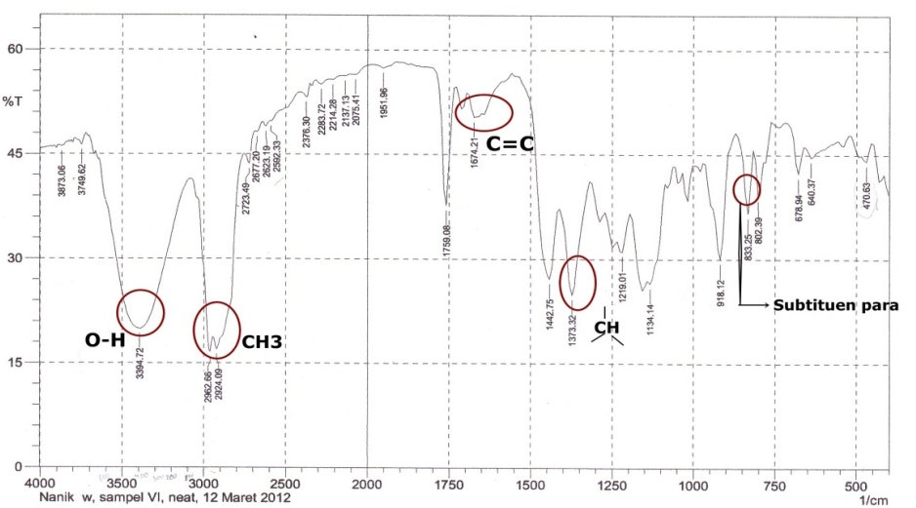
Fig 1. Spektrum FT-IR of product reaction (Terpineol as a major product).

Alpha-pinene hydration products can be seen from the graph that shows that at a temperature of 50ºC, 60ºC, 70ºC and most hydration products are compounds α-terpineol. Mass spectroscopic analysis of the compound α- terpineol having a relative molecular mass of 154 fragments with m/z = 154 detachment OH molecule produces a peak at m/z = 136, breaking -CH₃ and produce fragments with m/z = 121, breaking -C₂H₄ produce fragments m/z = 93, with the release of C₇H₁₂ produce fragment with m/z = 59, this fragment is relatively stable because it has a low ability to undergo further fragmentation.
Results of the reaction products of compounds band on the wave number 3394 cm⁻¹ shows the stretching group OH (hydroxyl). On the wavenumber 1674 cm⁻¹ indicate the presence of clusters of carbon with double bonds (C = C) to alkenes and the wave number 1373 cm⁻¹ indicate the presence of a methyl group (-CH₃), whereas in the band 1134 cm⁻¹ show the bond only between the CO at tertiary alcohols. The comparison between the standard compound reaction products with terpineol allows that compound the reaction product is a compound terpineol. Pictures infrared spectrum is presented in Figure 1.

The antibacterial activity
Alpha-terpineol having a hydroxyl group on the structure of the compound, the hydroxyl group is a group that plays a role in inhibiting the growth of bacteria B. megaterium and P. aeruginosa. Bacterial inhibition occurs due to complex formation between hydroxyl groups to proteins in the cell membrane, causing clotting proteins, these proteins undergo denaturation, causing decreased cell wall permeability consequently transport of nutrients into cells to be disrupted so that bacterial growth is inhibited [13-14].
Antimicrobial activity test of terpineol basil doing by two bacteria they were B. megatherium and P. aeruginosa with well technique diffusion method. The controls that were used on this methods are negative control (PEG 400) and positive control (amikacin). The antimicrobial activities of terpineol were showed activity with concentration were 25%, 50%, and 100%) to B. megatherium and P. aeruginosa, it was known by the absence of diameter zone of inhibition. Mechanism bacteria resistance was deactivate antibiotics by producing enzymes. One of the enzymes that could inactivate antibiotic was β-glucoronidase. B. megatherium and P. aeruginosa were bacteria which was able producing β-glucoronidasethat allegedly active compounds in the terpineol of basil by β-glucoronidase be other compounds that were toxic for bacteria.
Diameter zone of inhibition increased it means that the increasing of the terpineol concentration showed correlation with the increasing of active compounds serves as an antibacterial, so that the ability to inhibit bacterial growth in B. megatherium and P. aeruginosacoli also bigger. It was because the higher yield of compound bioactive is a bactericide (deadly microbes) and the lower yield was a bacteriostatic (inhibitng the growth, no deadly microbes). The diameter zone of inhibition of terpineol presented in Table 3 and 4.

Table 3. Diameter zone of inhibition (mm) α-terpineol to B. megaterium
Sample | Control - | Consentration |  |  | Standar terpineol | Control +
Sample | Control - | 25% | 50% | 100% | Standar terpineol | Control +
I. | 0 | 14.54 | 19.00 | 19.56 | 20.80 | 26.88
II. | 0 | 16.12 | 21.87 | 22.25 | 23.06 | 27.75
III. | 0 | 15.14 | 19.19 | 19.37 | 19.50 | 25.62
IV. | 0 | 15.56 | 20.06 | 20.56 | 22.06 | 28.50
V. | 0 | 17.34 | 20.81 | 22.62 | 25.87 | 26.81
Average | 0 | 15.74 | 20.19 | 20.87 | 22.02 | 27.11

Table 4. Diameter zone of inhibition (cm) α-terpineol to P. aeruginosa
Sample |  | Control - |  | Consentration |  |  |  |  |  | Standar terpineol |  | Control +
 |  |  |  | 25% |  | 50% |  | 100% |  |  |  | Control +
I. | 0 |  | 9.50 |  | 10.62 |  | 10.67 |  | 11.56 |  | 22.37
II. | 0 |  | 9.19 |  | 10.44 |  | 12.42 |  | 11.92 |  | 21.87
III. | 0 |  | 8.87 |  | 11.31 |  | 10.87 |  | 12.00 |  | 21.62
IV. | 0 |  | 9.69 |  | 9.31 |  | 10.25 |  | 11.69 |  | 22.12
V. | 0 |  | 9.42 |  | 9.58 |  | 9.81 |  | 10.05 |  | 17.25
Average |  |  | 9.93 |  | 10.25 |  | 10.68 |  | 11.44 |  | 22.16

The test results showed that the antibacterial activity of α-terpineol inhibition was more effective against the bacteria B. megaterium (positive Gram bacteria ) than P. aeruginosa (negative Gram bacteria). It was because of the sensitivity antibacterial affected by the bacterium wall. Gram positive bacteria more sensitive to antibacterial because the structure of the cell walls Gram positive bacteria simpler than the structure of the cell walls of Gram negative bacteria, which eases antibacterial compound to enter into a bacterial cell Gram of the structure of the cell wall of Gram positive bacteria (Fig. 2).

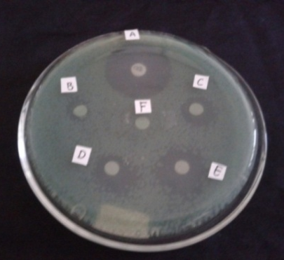
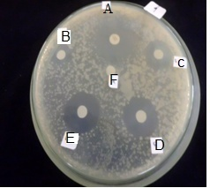

Fig. 2. Diameter zone of inhibitionstem terpineol to B. megatherium and P. aeruginosa Notes : A) Positif Control B) 25%, C) 50%, D) 100 %, E) Standar Terpineol, F) Negative Control
- Conclusion
The main products of α- pinene hydration reaction catalyzed TCA was α-terpineol optimum temperature is at a temperature of 70ºC with the conversion of α-terpineol result obtained is 91.11% with a selectivity of 74.79%. The test results showed inhibition of antibacterial activity increases with increasing concentration. The average area better inhibition against B. megaterium than P. aeruginosa.
References
- Arias D, Guillen Y., Carmen M., Lopez and Francisco J.M., 2000, React.Kinet.Catal.Lett, 69 (2) 305-309.
- Sastrohamidjojo, H. 2004. Yogyakarta : Gajah Mada University Press
- Chibiryaev AM., Yermakova A., and Kozhevnikov IV., 2010, J. Of Supercritical Fluids, 51, 295-305.
- Neuenschwander U., 2010, ChemSusChem, 3(1), 75–84, doi:10.1002/cssc.200900228.
- Li Y., Wang C., Chen., Hua W., Yue Y. Gao Z., 2009, Catal Lett., 131:560–565.
- Wijayati, N., Pranowo, H. D., Jumina, Triyono, 2011, Indo. J. Chem., 11 (3), 234-237.
- Avila, M. C., Nora A. C., Castellon E. R., Lopez A. J., 2010, J.Mol. Catal. A: Chemical, 322(1-2),:106-112.
- Mochida T., Ryuichiro O., Naoto H., Yuichi K., Toshio O., 2007, Micropor.Mesopor. Mat., 101: 176-183.
- Pakdel, H., Sharron, S., and Roy, C., 2001, J. Agric. Food. Chem., 49( 9), 4337–4341.
- Rachwalik, R., Olejniczak, Z.,Jiao,J ., Huang,J., Hunger,M.,Sulikowski,M 2007. J. Catal. 252 161-170.
- Wijayati, N., Pranowo, H. D., Jumina, Triyono, 2013, Indo. J. Chem., 13(1), 59-65.
- Wijayati, N., Pranowo, H. D., Jumina, Triyono, G.K., Chuah, 2013, International Journal of Chemical Engineering and Applications, 4 (4), 178-182.
- Rezvani, S., Rezai, M.A., Mahmoodi, N. 2009. Iran : Rashr University
- Tenover ,C. F. 2006. The american journal of Medicine, 119 (6A) S3-S10
Extraction Method of Sarang Semut (Myrmecodia pendens) Plants With Ultrasonic Techniques for Preduce Alternative Cancer Drugs

Suharyanto^{1*}, Hartono², Winarto Haryadi³, Bambang Purwono⁴

^{1,2} National Pharmaceutical Academy, Surakarta, Indonesia
^{3,4}Department of Chemistry Gadjah Mada University, Yogyakarta,Indonesia

*E-mail: suharyanto294@yahoo.com

Abstract. Cancer is a growing cells of any type of cell and tissue in the body anywhere , a large number of diseases are characterized by tissue and cell type of origin . Each year found nearly 6 million new patients known to have cancer , and more than 4 million of them died . Until now cancer treatment is done by 3 ways: surgery , radiation , and drug delivery of anti -neoplastic or anti- cancer . However , all three treatments over a lot of side effects to the patient .The specific objective of this research is to extract Sarangsemut plant ( Myrmecodia pendens ) derived from -Irian Jaya Papua Indonesia . This research aims to produce cancer drugs using plants Sarangsemut (Myrmecodia pendans). This research was conducted by plant extraction Sarangsemut with Ultrasonic technique with solvent methanol with various ratio and extraction time. The results showed that with a time of 50 minutes with a solvent ratio of 1:10 gave 14% yield.. From antioxidant activity assay showed that water fractions have IC₅₀ 47.50 ppm . Histopathology test showed that at a dose of 750 mg / kg body weight Sarangsemut extract can improve the condition of the lung cells of mice that have suffered damage due to induction of DMBA 20 mg / kg body weight. From these parameters, water fraction of Sarangsemut extracts were potential as an alternative medicine cancer.

- Introduction
Cancer is a major cause of the death of two which contributed 13%. Cancer is a disease with complex causes that are formed in the long term. Cancer is a major public health problem in the world. One in 4 deaths in the United States is due to cancer. Death rates continue to decline for all 4 major cancer sites (lung, colorectum, breast, and prostate) [1,6-7]. The most common types of cancer treatment, such as surgery, chemotherapy, radiatin therapy, and many others. Surgery can be used to diagnose, treat, or even help prevent cancer in some cases. Most people with cancer will have some type of surgery. It often offers the greatest chance for cure, especially if the cancer has not spread to other parts of the body. Chemotherapy (chemo) is the use of medicines or drugs to treat cancer. The thought of having chemotherapy frightens many people. Radiation therapy uses high-energy particles or waves to destroy or damage cancer cells. It is one of the most common treatments for cancer, either by itself or along with other forms of treatment [1,8,11].
All drugs used to treat cancer cause side effects. Side effects are unwanted things that can happen as a direct result of medical treatment – in this case, taking a cancer treatment drug. Different drugs have different side effects – for example, they don't all cause hair loss or sickness. The side effects of each drug vary for different people though. Some people find that they get only very mild side effects [3 – 5,11].
Medicinal plants (herbals) are considered to be the main sources of biologically active compounds that can be used for the treatment of various ailments including cancer [12]. Herbal treatment is a treatment using a wide variety of plant extracts, herbal medicine more and more in demand, even according to the WHO country in Africa, Asia and Latin America have been using herbal remedies as complementary medicine. Sarangsemut (Myrmecodia pendans) is a plant from Papua, Indonesia, which has the potential as an anti-cancer drug [9,10,11]. Sarangsemut ability empirically for the treatment of various types of cancer allegedly associated with its flavonoid. Suharyanto, 2013 has made the isolation of plant Sarangsemut by maceration method using methanol [10] Furthermore partitioned using n-butanol-water at a ratio of 1: 1 In this study the isolation Sarangsemut using methanol solvent with ultrasonic technique. The results showed that with a time of 50 minutes with a solvent ratio of 1:10 gave the 14% yield. From antioxidant activity assay showed that water fractions have IC₅₀ 47,50 ppm . Histopathology test showed that at a dose of 750 mg / kg body weight Sarangsemut extract can improve the condition of the lung cells of mice that have suffered damage due to induction of DMBA 20 mg / kg body weight. From these parameters, water fraction of Sarangsemut extracts were potential as an alternative medicine cancer [3-4].

- Materials and Methods
2.1 Chemical Materials
Methanol was used for extraction, buthanol PA is being used for partition the sample after extraction. DPPH (1,1-diphenyl-2 picrylhydrazyl) is used to test Antioxidant Activity. And Dimethyl [a]Benz anhtracene (DMBA) as a trigger cancer substance.

Á2.2 Sample Materials:
Sarangsemut (Myrmecodia pendens) used comes from Papua Irian Jaya. White rats as cancer models.

2.3 Sample Preparation
Sara ngsemut powders was made using a blender and then dried in an oven at 50⁰C for 24 hours.
2.4 Extraction
Extraction was done by ultrasonic techniques. Furthermore, the fractionation using butanol and water at a ratio of 1: 1. Water Fraction was taken and butanol fraction was not used. Fraction of water used to test the antioxydant activity and in vivo tests using white rats.

2.5 Antioxidan Activity dan Histopathology
The antioxidant activity test conducted by 1,1-diphenyl-2-picryl hydrazyl (DPPH) method. Parameters resulting test of the antioxidant activity is IC₅₀ , while of Histopathology test illustrated the ability of sarangsemut extracts against cancer cells. Research scheme is presented in Figure 1

Srangsemut Plant

POWDER

Ultrasonic method with methanol solven

Buthanol fraction

Water fraction

Fractination with
n-buthanol -water 1:1

Antioxidan Test

Unused

Hiytophatologi Test

Conclusion

Figure 1. Research scheme of Sarangsemut
- Results and Discussion
3.1 Extraction
The results of ultrasonic extraction is presented in table 1

Table 1 Results and yealds extraction with ultrasonic

No. Time Degree. sample.Weight Yealds
(mnt) Smp.:Solv (gram) (%)

- 30 1:6 2.6 6.5
- 40 1:6 2.9 7.25
- 50 1:6 3.4 8.5
- 60 1:6 2.0 5.0
- 30 1:8 4.0 10.0
- 40 1:8 5.2 13.0
- 50 1:8 5.2 13.0
- 60 1:8 2.6 6.5
- 30 1:10 2.3 5.75
- 40 1:10 3.9 9.79
- 50 1:10 5.6 14.0
- 60 1:10 4.1 10.25

From Table 1 it can be stated that the number of solvent 10 times with a time of 50 minutes produced the greatest yield. Whereas in previous studies Suharyanto 2012 by maceration method with a time of 5 days or 120 hours produced only 10% yield. At maceration method the opening of the cell nucleus is much less effective than the ultrasonic method. The yield difference was due to the timing and amount of solvent. In general, the major solvent and time increased causing the yield to rise, but at a certain point where saturation occurs a decline in the yield. In the solvent ratio 1:10 with a time of 60 minutes a decline in the yield of this possible dissolution process occurs at the saturation point.
3.2 Antioxidan Activity
The results of antioxidant activity test is presented in table 2

Table 2 Antioxidan Activity results of water fractions

No. Time Equations IC₅₀(ppm) Conclusion

- 6/30 Y=0.126X + 10.50 313.492 weak
- 6/40 Y = 0.168X+12.16 225.239 weak
- 6/50 Y=0.440X -2.143 118.492 medium
- 6/60 Y=0.3X+ 31.51 61.630 strong
- 8/30 Y=0.114X+2.292 418.412 weak
- 8/40 Y=0.315X+11.25 123.0158 medium
- 8/50 Y=0.277X+29.76 73.0685 strong
- 8/60 Y=0.64X+6.645 67.7421 strong
- 10/30 Y=0.225X + 12.97 164.578 medium
- 10/40 Y=0.183X+21.15 157.650 medium
- 10/50 Y=0.173X+16.65 47.28 very strong
- 10/60 Y=0.093X+19.55 327.419 weak

From table 2 can be stated that the sample with the extraction time of 50 minutes with 10 times the amount of solvent has the best antioxidant activity with IC₅₀ 47.828 ppm.In the previous research produced IC₅₀ of 37.5 ppm with maceration method, whereas the ultrasonic method produced greater yields with shorter time.
3.3 Hystophatologi
Histopathology test results of rats are presented in the following figures:

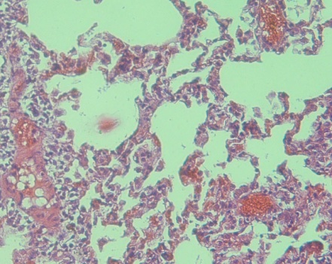
Alveolus normal

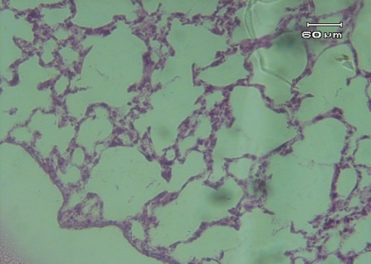
conggestion
Thickening of
the alveolus
mass due to necrosis

Figure 2. Normal Lung Cells Figure 3. Lung cells induced by DMBA dose of 20 mg / kg

Thickening of the alveolar septa periatritis it is suspected inflammation as early cancer formation. The conggesti outside of the alveoli (red) indicates that the blood circulation is not smooth. Necrosis characterized by mass outside of the alveoli. This necrosis caused by the presence of compounds DMBA induced. DMBA is a carcinogen which is activated by cytochrome P450 enzymes to become active as epoksid reactive compounds to bind to DNA (Wulan PR, et al, 2012).

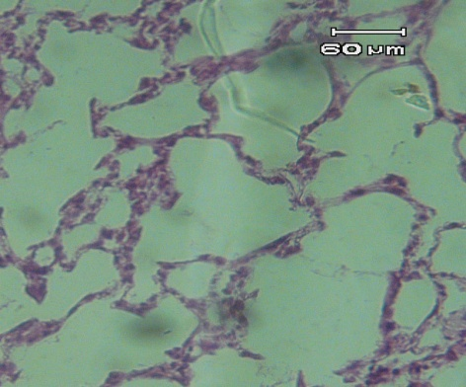
The thickening is reduced

Alveolus getting better

Figure 4. Lung cell induced by DMBA dose of 20 mg / kg and treated with sarangsemut extracts dose of 750 mg / kg oral injection

From the above picture in general has undergone many changes. Conggestion is diminishing and alveolar became thinning, approaching normal. In general it can be stated that at a dose of 750mg / kg Sarangsemut extract can improve the condition of the lung cells that have been damaged by DMBA induced.
- Conclusion
- Comparison 1:10 the amount of solvent extraction, time of 50 minutes has the best yield ie 14%
- The same time of number and ratio solvent extraction has the highest IC₅₀ 47.828 ppm
- Fraction of water plants Sarangsemut has the potential as an anticancer drug.
- Sarangsemut extract dose of 750 mg / kg of body weight was well enough in the treatment of rats that suffered damage lung cells.
Acknowledgment
Thank you to DITLITABMAS-DIKTI through Kopertis VI Central Java who have financed research in “Hibah Pekerti” scheme.

References
- Asmino, Diponegoro MH, dan Soendoko R. Masalah Kanker di Indonesia, Yayasan Kanker Wisnu Wardhana, 1985.
- Belleville-Nabet, F. 1996. "Substance-Fighting Antioxidants Nutrition Food Compound Radicals in Biological Systems," in: Proceedings of the Seminar Compound Radicals and Food Systems: Reactions Biomolecular Engineering, Impact on Health and deterrence.CFNS-IPB dan Kedutaan Besar Prancis-Jakarta.
- Demple, B. dan L. Harrison. 1994. Annual Review Biochemistry. 63: 915-948.
- Edy Meiyanto,dkk (2007), Penghambatan karsinogenesis kanker payudara tikus terinduksi DMBA pada fase post inisiasi oleh ekstrak etanolik daun Gynura procumbens (Lour), Merr, Majalah Farmasi Indonesia, 18(4), 169 – 175
- Friedberg, E. C., G. C. Walker, dan W. Siede. 1995. DNA Repair and Mutagenesis American society and Microbiology. Washington DC.
- Harborne, J. B. 1987. Modern methods of Phytochemicals guide How to Analyze Plants. Translation: K. Padmawinata. ITB: Bandung.
- Hidaka, K., Matsuda, T. and Takea, T. 1999. “chemical studies on Antioxydant Mechanism of Curcuminoid: Analysis of Radical Reaction products from Curcumin, Jurnal Agriculture and Food Chem, Vol. 47.
- McCord, J. M. 1979. “Superoxide, Superoxide Dismutase and Oxygen Toxicity.” dalam: Reviews in Biochemical Toxicology. E. Hodgson, J. R. Bend, R.M. Philpot (Eds.). Elsevier Amsterdam, the Netherlands. p. 109-124.
- Risser. Cancer Incidence and Mortality in urban vs rural areas of Texas 1980-1985, Texas Medical, 1996,92(1);58-61
- Subroto, Ahkam dan Hendro, S. 2008 Against all diseases with Sarangsemut t. Penebar Swadaya: Jakarta.
- Soeksmanto,A 2010 , Pakistan Journal of Biological Science 13 (3) :I 48-151,2010
- Suharyanto, Siska 2010, Antioxidant Activity Test of Sarangsemut (Myrmecodia pendans) with DPPH Method, Akfarnas, Surakarta
- Winarsi, H. 2007. Antioksidan Alami dan Radikal Bebas Potensi dan Aplikasinya dalam Kesehatan.\Kanisius: Yogyakarta.

Characteristics of Mesopore Silica Synthesized Using Bovine Bone Gelatin as A Template

P M Pattiasina¹, W Trisunaryanti^{2*}, I I Fallah², Sutarno², I Kartini², and K Wijaya²
¹Department of Chemistry, Faculty of Mathematic and Natural Sciences, Universitas Pattimura, Ambon 97233, Republic of Indonesia
²Department of Chemistry, Faculty of Mathematic and Natural Sciences, Universitas Gadjah Mada, Jl Sekip Utara 15, Yogyakarta 55281, Republic of Indonesia
*E-mail: wegatri@yahoo.com

Abstract. The utilization of bovine bone gelatin as a template for the synthesis of mesopore silica by hydrothermal and sonochemical methods have been studied. The gelatin was obtained from bovine bond by treatment using NaOH, citric acid, and HCl for 24 h followed by hydrolysis at 80 °C. The synthesis of mesopore silica was conducted under hydrothermal and sonochemical methods. The gelatin was analyzed by FT-IR and the mesopore silica was characterized by Surface Area Analyzer and TEM. The results showed that the gelatin consisted of Amida A, Amida I, II and III. The two methods produced silica material with meso scale pore diameter and showed wormhole-like pores shape material in their TEM images. The hydrothermally synthesized silica has a pore diameter of 5.14 nm with surface area of 356.18 m2/g, and that of the sonochemically synthesized silica has a pore diameter of 3.13 nm and surface area of 451.39 m2/g.
- Introduction
Template is the main thing in mesoporous silica synthesis process. A non ionic template like gelatin showed a good biocompatability, non toxic, and biodegradable [1]. Gelatin is a polypeptide, a nature polymer of collagen. It contains a lots of N-H functional groups which trends to strongly interact with silanol groups (Si-OH) on the silicate species via multiple hydrogen bonds. There are few studies that investigated the utilization of gelatin as a template [1-3]. However, the gelatin used was still limited as a synthetic gelatin. Therefore, better idea is to use gelatin from bovine bone as a template. Bovine bone is a waste and contains a lot of collagen, so it can be used to produce gelatin. The most commonly reported method for the synthesis of mesoporous materials is a hydrothermal method [1, 2, 4]. This method can produce mesoporous materials with high pore diameter. But, its greenless because needs high temperatur when synthesis proccess. In order to avoid this disadvantage, there is a green method that can be used is sonochemical method [5]. Sonochemical method performed at room temperatur using ultrasonic wave with frequency of above 20 kHz.
Based on the above consideration the authors undertaken to synthesis mesoporous silica with bovine bone gelatin as a template using hydrothermal and sonochemical methods. The results were discussed below.

- Materials and Methods

Materials
Bovine bone were obtained from Jangkang, Widodomartani market, Ngemplak, Sleman, Yogyakarta. HCl, NaOH, citric acid, H2SO4, Na2SiO3.

Instruments
Fourier Transform Infrared Spectroscopy (FTIR, Shimadzu Prestige FTIR 21), Surface Area Analyzer (SAA, Quantachrome NovaWin2), Transmission Electron Microscope (TEM, JEOL JEM-1400.

Extraction of gelatin
Bones were washed with tap water to remove superfluous material and degreasing at 80 °C. After that, the bovine bone were treated with NaOH (4%) for 1, 12, and 24 h to remove the non-collageneous protein. They were washed thoroughly with tap water, and treated with citric acid (1,2%) for 1, 12, and 24 h, followed by washed with tap water and treated with HCl solution (4%) for 1, 12, and 24 h to increase swelling. The final extraction was carried out with distilled water at weight ratio of water/bone = 3 at 60 and 80 °C for 5 h. The extract was filtered through Whattman No.42 filter paper under vacuum. The yield of the gelatin was characterized using FTIR.

Synthesis of mesoporous silica
Gelatin with distribution value of molecular weight around 120-160 kD was used as a template in synthesis of mesoporous silica. Typical synthesis procedure for the mesoporous silicas with bovine bone gelatin as template using hidrotermal method according to the method of Hsu et al. [2] with some modifications as following: 1.0 g of gelatin was dissolved in 25.0 g of water to form a clear solution. A solution of a 4.0 g of sodium silicate and a 25.0 g of water added with a drop of 0.1 M H₂SO₄ until pH value was adjusted to about 5.0 at 40°C was prepared. Then, the gelatin solution was poured directly into the silicate solution under stirring and precipitate was generated within seconds. After stirring for 1 h, the pH value of the gel solution was adjusted to 6.0-3.0. Finally, the gel solution was transferred into an autoclave, and hydrothermally treated at 100°C for 24 h. The solid obtained was then washing, drying and calcining at 550°C produced the mesoporous silica. The mesoporous silica was characterized using FTIR, GSA, TEM. Typical synthesis procedure for the mesoporous silicas with bovine bone gelatin as a template using sonochemical method was carried out in the same procedure as the hydrothermal method but the step of hydrothermally treated was changed into sonication using sonicator for 90 min.
- Results and discussion
The gelatin’s major peaks occurred in the FT-IR spectrum were shown in figure 1. Four main regions were identified: 3448–3400 cm–1 (amide A), , 1651–1635 cm–1 (amide I), 1550–1527 cm–1 (amide II) and 1095–670 cm–1 (amide III). These peaks were similar to those reported by Muyonga et al. [6]. The amide A peak absorption was due to N–H stretching, amide I peak to C=O stretching, amide II peak to N–H bending and C–N stretching vibrations, while the amide III peak is a complex system mainly associated to CH₂ residual groups from glycine and proline [7-8].

Figure 1. FT-IR Spectra of gelatin

Bovine bone gelatin which is selected as the template is gelatin that obtained from pretreatment with NaOH, citric acid, and HCl for 24 h and followed by hydrolysis at 80 °C. Gelatin from this variation has the distribution value of molecular weight around 120-160 kD. The value of molecular weight distribution indicated that the gelatin result was constituted by α chains.

  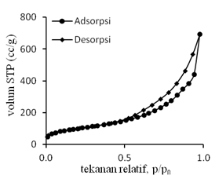  Relative pressure, p/p₀  Adsorption  Desorption |  | 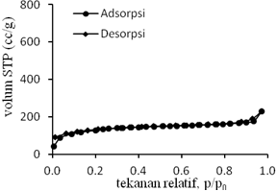  Relative pressure, p/p₀  Adsorption  Desorption
Figure 2. Adsorption-desorption N2 of mesoporous silica synthesized by hydrothermal method |  | Figure 3. Adsorption-desorption N2 of mesoporous silica synthesized by sonochemical method

The result of BET-BJH analysis in figure 2 and 3 showed that mesoporous silica with hydrothermal method has a pore diameter size of 5.14 nm with surface area of 356,18 m²/g and mesoporous silica with sonochemical method has a pore diameter size of 3.13 nm with surface area of 451,39 m²/g. These results indicated that these two synthesis methods (hydrothermal and sonochemical) were capable of producing mesoporous silica with meso scale pore diameter. Both of mesoporous silica has a type IV isotherm with H3 hysterisis type. These data indicated that both of mesoporous silica has a slit shape pore.

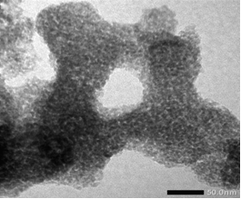 |  | 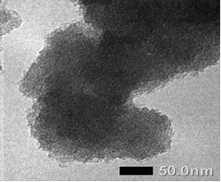
Figure 4. TEM micrograph of mesoporous silica synthesized by hydrothermal method |  | Figure 5. TEM micrograph of mesoporous silica synthesized by sonochemical method

TEM result in figure 4 and 5 showed that the both mesoporous silica have the wormhole-like pores shape. This result was also shown by Hsu et al. (2007) in their synthesis of silica mesopore.
- Conclusion
Gelatin from bovine bone can be used as a template for synthesis of mesoporous silica using hidrotermal and sonochemical methods. Mesoporous silica with hydrothermal method has a pore diameter size of 5.14 nm with surface area of 356,18 m²/g and mesoporous silica with sonochemical method has a pore diameter size of 3.13 nm with surface area of 451,39 m²/g. Both of mesoporous silica have pores shape of wormhole-like.

Acknowledgments
The authors thank The Indonesian Ministry of Education and Culture for the financial supported under Hibah Penelitian Unggulan Perguruan Tinggi 2015 (Contract number: 232/LPPM UGM/2015).
References
- Wang X, Zhou G, Zhang H, Du S, Xu, Y and Wang C 2011 Immobilization and Catalytic Activity of Lipase on Mesoporous Silica Prepared from Biocompatible Gelatin Organic Template J. Non-Cryst. Solids. 357, 3027–3032
- Hsu C H, Lin H P, Tang C Y and Lin C Y 2007 Synthesis of Mesoporous Silica and Mesoporous Carbon Using Gelatin as Organic Template Mesostructur. Mater. 385-388
- Setyawan B and Balgis R 2011, Mesoporous Silicas Prepared from Sodium Silicate Using Gelatin Templating Asia-Pac. J. Chem. Eng. 1-7
- Zhao D, Feng J, Huo Q, Melosh N, Fredrickson G H, Chmelka B F and Stucky G D 1998 Triblock Copolymer Syntheses of Mesoporous Silica with Periodic 50 to 300 Angstrom Pores Science 279 548-552
- Vetrivel S, Chen C T and Kao H M 2010 The Ultrafast Sonochemical Synthesis of Mesoporous Silica MCM-41 New J. Chem. 34 2109–2112
- Muyonga J H, Cole C G and Duodu K 2004 Extraction and physico-chemical characterisation of Nile perch Lates niloticus, skin and bone gelatin Food Hydrocolloid 184 581–592
- Zhou P and Regenstein J M 2005 Effects of alkaline and acid pretreatments on Alaska pollock skin gelatin extraction J. Food Sci. 706 392-396
- Muyonga J H, Cole C G B and Doudu K 2007 Food Chemistry Fourier transform infrared FTIR spectroscopic study of acid soluble collagen and gelatin from skins and bones of young and adult Nile perch Lates niloticus Food Chem. 86 325–332

Clay/Andisol Soil Adsorption Effectiveness Testing on Copper (Cu) Metal Ion and Its Applications to Metal Crafts Waste Using Column Method

Pranoto*, Candra Purnawan, Tri Martini, Ashadi, Arton Harmawan Aji Saputro

Department of Chemistry, Sebelas Maret University, Ir. Sutami No. 36 A, Kentingan Surakarta Indonesia 57126

*Email: pak_pran@yahoo.com

Abstract. The objectives of this study is to determine the effectiveness of clay/andisol soil adsorption toward copper (Cu) metal ions with varied composition of clay/andisol soil, calcination temperature, flow rate, and type of isotherm. The study was conducted with varied composition of clay/andisol soil: (0:100), (25:75), (50:50), (75:25), and (100:0); calcination temperatures: 100, 200, and 400 °C; and flow rate: 1.3, 2.2, and 3.6 mL/min. Clay was used without chemical activation process, while andisol soil was used with chemical activation process by soaked in 3M NaOH for 5 hours. The Langmuir and Freundlich adsorption isotherm equation was used to determine the adsorption type. The amount of adsorbed Cu metal ions was analyzed by AAS spectrophotometer. The adsorbent characterization was analyzed by FTIR, XRD, ammonia adsorption method, and SAA. The FTIR spectrum shows the changes of the peak intensity of the adsorbent after adsorption. It indicates the absorption of Cu ions. The adsorption of the Cu metal ion was optimum at the ratio of clay/andisol soil 25:75. Meanwhile, the optimum calcination temperature is 400 °C, and the optimum flow rate is 1.3 mL/min. The optimum adsorption capacity is 0.344 mg/g. The types of adsorption in this study follow the Freundlich and the Langmuir isotherm.
- Introduction
The rapid development of metal craft in various regions will increase waste that caused environmental pollution. If there were no waste processing, increased number of craft will be followed by number of waste in the form of solids, liquids and gases. Most of metal craft produce wastewater containing heavy metals. Heavy metal waste may cause various disorders and diseases on humans (Permanasari et al., 2010). The waste of heavy metals such as copper is an example of contaminants that has potential to damage human’s physiology system and other biological systems if it passed the tolerance level. The liquid waste of heavy metals copper itself affects human for long periods which can lead to nervous system disorders, paralysis, and early death as well as a decrease in children intelligence levels (Widaningrum et al., 2007).
There were several studies in the literature which reports processing methods to process heavy metal copper in the industrial waste (Sivaiah et al., 2004; Wisnubroto, 2002; Slamet et al., 2003; Purwaningsih, 2009), such as chemical reduction, precipitation, ion exchange and adsorption. Among all of the methods, adsorption is commonly used due to its simple process and easy obtained ingredients. Either column or batch system can be used in adsorption process. Setiaka et al. (2010), pointed that column system is more beneficial than batch system, because the solution always contacted with adsorbent caused adsorbent to adsorb optimally until the saturated condition. Column system has two flows: down flow and up flow (Setiaka et. al., 2010). The adsorbent are frequently used such as Andisol soil, clay, activated carbon, and humic acid. Adsorption which uses activated carbon requires high energy (Slamet et al., 2003). In the other hands, Nurmasari et al. (2013) mentioned that humic acid can easily dissolve in water. The soil adsorbent has vast research and low cost that caused this adsorbent to minimize costs (Potgeiter et al., 2005).
Clay has good adsorption. Moreover, the advantages of clay as an adsorbent are also supported by its characteristics include high specific surface area, chemically and mechanically stable, various surface structure, and high ion exchange capacity (Gupta and Bhattacharyya, 2008). However, clay gives less optimal result without been modified first. This is due to clay’s characteristic, which is easily adsorb water and various kinds of pores (Suarya, 2012). The various studies had been done on clay resulted that the activity of non-modified clays generally is not so high, so it’s necessary to modify clays both physically and chemically in order to increase the clay activity (Negara, 2005).
Indonesia as one of the most active volcanic countries in the world has abundant of Andisol land. Isoyama and Wada (2005) in their research mentioned volcanic Andisol soil containing allophane under acidic conditions have metal ion absorption of lead (Pb). Parfitt (2009) showed that physical and chemical characteristic of Andisol soil are well used as an adsorbent of heavy metal and pathogens. Andisol soil of Lawu Mountain is containing allophone, which has ability in absorbing Cd metal electroplating waste 0.0386 ± 0.0008 (Nugroho, 2008). In order to improve the absorption level of natural Andisol soil, a chemical activation is required to activate the cluster of Andisol soil and increases the acidity and the specific surface area.
According to the specific characteristic of clay and Andisol soil, therefore it is possible to increase the active group if the andisol soil and clay are mixed. Due to the clay and Andisol soil have the same Si-OH, Al-OH, and –OH groups. In this research the mix of clay and andisol soil at various compositions was used to adsorb Cu ions int the waste metak craft.
- Research methods
Electric analytical balance (Mettler PB 300 Type ER-182 A), a set of column tool, Fourier Transform Infra-RedSpectrophotometer (FT-IR) (type Shimadzu FT-IR 8201 PC), Atomic Absorption Spectroscopy (AAS) (Shimadzu type AA- 6650 F), X-Ray Diffractometer (XRD) (Shimadzu type 600), Surface Area Analyzer (SAA), Shaker (Ogawa Seiki type OSK 6445), hotplate and Stirer (Thermolyne type 1000 Stirer plate), Furnace, Mortar and Mortal, sieve size 150 mesh, pH meter, pliers clamp, desiccators, Crucible, set of glassware, universal Indicator

Materials
Materials used here are liquid waste from metal craft in Tumang, (Boyolali - Central Java), distilled, aquabidest, clay from Sokka area (Kebumen - Central Java) Andisol soil from Cemoro Kandang ( Lawu - East Java), HNO₃, the core liquor Cu 1000 ppm, NaF powder, filter paper (Whatman 40), CH₃COOH, CH₃COONa

Adsorbent Preparation
Clay which was used in this study came from Sokka Central Kebumen, Central Java, Indonesia. The clay was collected by using a hoe. The obtained clay then dried and crushed until it’s smooth. Sieve clay with 150 mesh sieve. The powder which passes 150 mesh was soaked in distilled water and filtered then dried at a temperature of 105 ºC for 4 hours. Dried clay powder then characterized.
Furthermore, Andisol soil which was used in this study came from Cemoro Kandang, Lawu mountain East Java. Andisol soil collected by using a shovel. The obtained Andisol soil were washed with water and dried with aerated to dry and dissolved until finely crushed. Andisol soil sieved to 150 mesh sieve. The powder which passes 150 mesh were soaked in distilled water and filtered then dried at a temperature of 105 ºC for 4 hours (Sulistyarini, 2012). Dried Andisol soil powder chemically activated by 5 grams of Andisol soil put into a glass beaker of 50 mL then added 25 mL of NaOH at 3 M concentration. The mixture was stirred at temperature of 70 ºC with stirring hour 5 hours, then cooled. After the mixture turned cool then it was filtered and washed with distilled water until the filtrate pH reach neutral or similr withsolven pH. Furthermore, natural Andisol soil dried in an oven for 4 hours at a temperature of 105 ºC (Sulistyarini, 2012). Chemically activated dried Andisol Oil then characterized.

Adsorbent Activation
Physical activation of adsorbent was done by heating process. Before physically activated, the adsorbents made by variations of composition between clay and nature ndisol Oil, such as 100: 0, 25:75, 50:50, 75:25, and 0:100. Mixture of each variation of adsorbent composition which carried out by stirrer stirring for 1 hour and then sonicated for another 1 hour and then separated between the residue and the filtrate. The residue washed with aquabidest, followed by drying the rest of the solution in a drying oven at 105ºC for 4 hours. Clay / dried Andisol soil then crushed with a mortar and again sieved with a 150 mesh sieve. Furthermore each adsorbent with variation composition activated physically by calcination. The calcination was done with a temperature variation of 100 ºC, 200 ºC, and 400 ºC for 3 hours.

Creating Cu standard curve
In creating Cu solution with a concentration of 0 ppm; 1 ppm; 2 ppm; 4 ppm; 8 ppm; 12 ppm, the adsorbance of solution then measured by AAS and made the connection curve between absorbance with metal concentration.

Creating blanko solution
4.2 mL of saturated HNO₃ solution was put in 1000ml flask then added aquades to the limit.

Creating 100 ppm CU the core liquor
10 mL of standar Cu solution 1000 ppm put in a 100 ml flask then added the HNO₃ blanko solutions to the limit.

Creating buffer solution with pH 6
The buffer solution was made by puting CH₃COOH acid solution and its salts CH₃COONa.100 mL of 0.1 N CH₃COOH was added with 400 mL of 0.5 N CH₃COONa while pH was checked by using pH meter.

Creating 10 ppm Cu solution on pH 6 (model solution)
100 mL of 100 ppm Cu was put into the 1000 mL flask then was added buffer solution pH 6 to the limit.

Adsorption of Cu metal ion in Cu standard solution using coloumn methods.
0.5 grams adsorbent (each composition and heating temperature) put into a column with 2 cm diameter already given 0.25 grams of glaswol. Then flowed with 25ml of 10 ppm Cu solution (pH 6) with variation flow rate 1.3mL/min; 2.2mL/min; 3.6mL/min. Then filtered filtrate Whatman paper No.40. Then, measured solution by Atomic Absorption Spectroscopy (AAS) to determine the concentration after adsorption. The adsorped Cu metal ion calculated from the concentration of initial Cu reduced concentration after adsorption process and obtained the best flow rate.

Determination of Adsorption isotherm
Obtained the best results of adsorbent performance tests then adsorped with vary adsorbate concentration to determine the type of adsorption isotherm. 0.5 grams of adsorbent (bestcomposition and heating temperature) put into column already given 0.25 grams glaswol. Then flowed by 25 mL of Cu solution (pH 6) (2, 4, 6, 8, 10, 12 ppm) with the best flow rate. Then the filtrate is filtered with Whatman paper No.40. Solution then measured by Atomic Absorption Spectroscopy (AAS) to determine the concentration after adsorption. The results obtained were analyzed by Langmuir and Freundlich isotherm.

Cu metal ion adsorption in copper industrial waste with column method.
0.5 gram of adsorbent (best composition and temperature) put into column that already given 0.25 grams glaswol. Then, it was flowed by 25mL of waste (pH 6) with the best flow rate. Then filtered the filtrate with Whatman paper No.40 and destructed it with saturated HNO₃ until the solution became colorless. The solution then measured by Atomic Absorption Spectroscopy (AAS) to determine concentration after the adsorption. Adsorped Cu Metal calculated from the initial concentration reduced by concentration after adsorption process.
- Results and discussion
Adsorbent characterization
Adsorbent characterization include NaF test, FTIR, XRD, surface area and acidity. NaF test aims to determine allophane, which contained in andisol soil of Lawu Mountain. Allophane is contained in andisol soil known by pH measurement from 1 gram of soil in 2 minutes of 50 mL 1M NaF solution and if pH value is bigger than 9.4 showed that soil contained high allophane minerals (Munir, 1996). From the measurement of NaF test resulted the Mh is 11.67 showed that the sample of mountain Lawu’s andisol soil contain high allophane minerals.
Adsorbent was used in this study initially characterized by FTIR aimed to determine the major functional groups within the structure of clay and Andisol soil. The sample observations were conducted at the wave number between 400 and 4000 cm⁻¹. The functional group of clay and Andisol soil are shown in Figure 1.
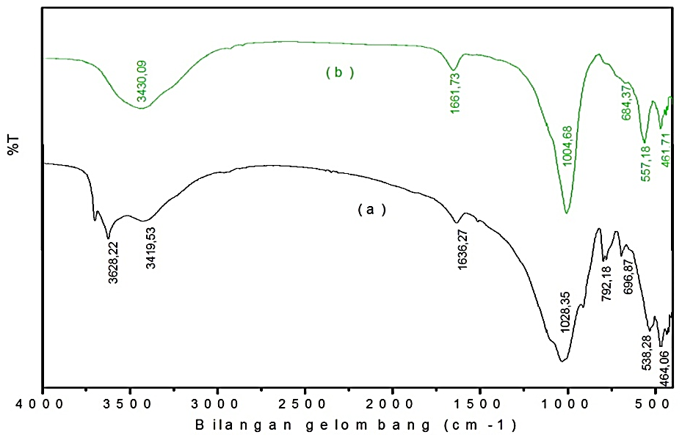
Figure 1. (a) Functional Groups of Clay, (b) Functional Group of andisol soil

Table 1 shows that there is no difference adsorption between clay and Andisol soil, both have gropus –OH, Si-O, Al-O. The absorption based on the literature shows that there are some minerals in clays include kaolinite, calcite, gibsit, feldspar, and allophane. While Andisol soil indicates mineral of kaolinite, gibsit, feldspar, and allophane. In addition, another adsorption possible taken is organic impurities contained in clay and Andisol soil. These results are supported by XRD characterization.
XRD characterization was conducted to determine mineral content which is found in clay and Andisol soil. Clay was used in this study had no chemical activation. Based on the previous research by Lihin et al. (2012) in which chemically activated clay and clay without chemical activation has no significant difference adsorption capacity values. Therefore, in this study the clays were not chemically activated. As clay, Andisol soil analysis results using X-rays showed that Andisol soil has some mineral deposits. Before characterized Andisol soil first chemically activated to the addition of 3M NaOH for 5 hours. According Widjonarko (2003) activation of Andisol soil containing allophane using NaOH is more effective than H₂SO₄. The Andisol soil after chemical activated characterized using XRD. Diffractogram of clay minerals and soil Andisol shown in Figure 2 and Figure 3.

Table 1. Analysis data of clay FTIR and Andisol soil
Functionl group | Wave Number (cm⁻¹)
Functionl group | Reference | Clay | Andisol soil
Reach –OH | 3700-3000 (⁴)  3455(²) | 3628.22  3419.53 | 3430.09
Asymmetric span of  Si-O or Al-O | 1039.6 (⁴)  973.1108 (²) | 1028.35 | 1004.68
Bending Vibrations of  Si-O or Al-O | 470.6 (¹)  485. 579 (²) | 538.28  464.06 | 557.18  461.71
Bending vibrations of H-O-H | 1640 (⁵) | 1636.27 | 1661.73
Kaolinite | 3600-3800 (¹)  1030 (³) | 3628.22  1028.35 | 1004.68
Calcite | 713.82 (⁶) | 789.84 | -
Gibbsite | 3400-3500 (¹)  1030 (¹) | 3419.53  1028.35 | 3430.09
Feldspar | 647 (³) | 673.43 | 684.37
Allophane | 1640; 1040; 470 (²) | 1028.35  464.06 | 1661.73  461.71
Explanation:
(¹) : Tan (1982) | (⁴) : Wijaya in Wogo et al., (2013)
(²) : Devnita et al.,(2005) | (⁵) : Permanasari et al., (2010)
(³) : Hemamalini et al., (2011) | (⁶) : Plasvic et al., (1999)

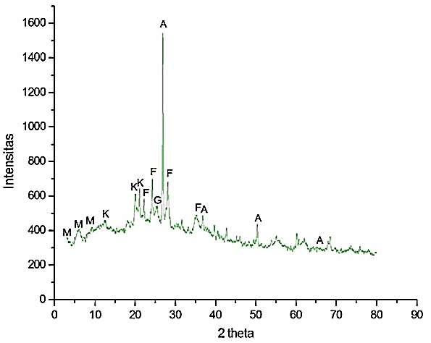  Figure 2. Diffractogram of clay XRD | 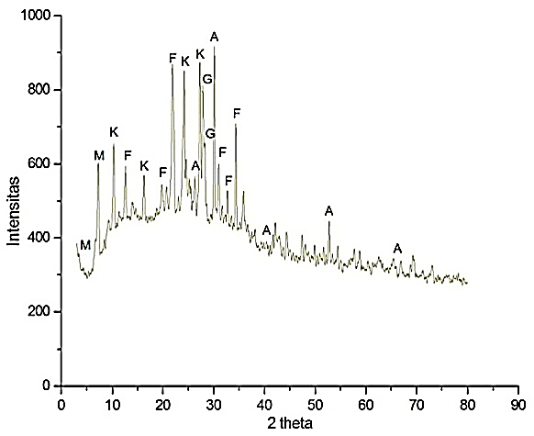  Figure 3. Diffractogram of Andisol soil XRD
Explanation: A=Alofan, F=Feldspar, G=Gibbsit, K=Kaolinite, M=Montmorillonite

Clay and Andisol soil analysis resulted with X-ray diffraction method showed that clay and Andisol soil were used in this study contained several minerals as proofed by the appearance of characteristic diffraction peaks at 2θ. XRD analysis data result of clay and Andisol soil are shown in Table 2.

Performance Test of Adsorbent to Copper Metal Ion (Cu)
Adsorbent test performance for Cu metal ions conducted to determine the most optimum adsorbent to absorb Cu metal ions. Adsorbent that would be used for adsorption process is made of variation composition first. The composition used ratio between clay and Andisol soil include 100:0, 75:25, 50:50, 25:75, 0:100. Each of adsorbent was physically activated. Physical activation used variation in temperature of 100 °C, 200 °C and 400 °C. Activation adsorbent aimed to dissolve organic and inorganic impurities that fills the cavity. With the reduction of impurities on the surface, the solid element become clean and surface area as well as acidity increase.
Adsorption process is influenced by several factors, including particle size of adsorbent, contact time between adsorbent and adsorbate, acidity (pH), and temperature. In this study, we want to determine the influence factor include composition of adsorbent, adsorbent calcination temperature and flow rate. Activated adsorbent, then used for adsorbed 10 ppm Cu metal ions. The adsorption process was done by varying the flow rate of 1.3 mL / min; 2.2 mL / min; 3.6 mL / min at pH 6 of solution with a column method. In this study, the reason of using pH 6 because at pH greater than 6.28 can result in the deposition of Cu becomes Cu(OH)₂ affect adsorption process (Sajidu et al., 2006). Cu metal ion adsorption analysis was done based on the concentration absorbed.
Test performance adsorbent for the most optimum absorption of Cu metal ions capacity is determined by absorption of highest copper metal ion. The results of adsorption with column method, adsorbent that can absorb Cu metal ions effectively is adsorbent with composition of clay / Andisol soil at 25:75 temperature of 400 ºC with a flow rate of 1.3 mL / min. In these conditions adsorbent having adsorption capacity of 0.344 mg / g, it means that 0.344 mg Cu metal ions can be absorbed by 1 gram of adsorbent on the composition (C / A) 25:75 at a temperature of 400 ºC, with an average concentration 6.889 ppm and percentage of absorption at 70.08% of initial concentration 10 ppm Cu standard. Statistical test using single variation factor analysis Duncan method with confidence level of 95% has also been done to support the results of which can be seen in Appendix 4. Graphic of the results of adsorption of the metal ions Cu with a column method can be shown in Figure 4.

Tabel 2. Data Analysis of cly and Andisol soil
d (Å) |  |  | Type of Mineral
Reference | Clay | Andisol Soil | Type of Mineral
3.300; 2.250; 1.800; 1.400 1.230 (¹) | 3.3183; 2.2689; 1.8111; 1.48424 | 3.3914; 2.9661; 2.2601; 1.8081; 1.4152 | Allophane
4.0-4,2; 6.3-6.45 (²) | 4.0086 | 4.0046; 4.0662; 4.1297; 4.1681; 4.2881; 6.3338 | Feldspar
3.7800; 3.6200; 3.2400; 2.8940; 2.7670; 2.6000; 2.5160 (³) | 3.6736; 3.1752 | 3.6907; 2.8862; 2.7358; 2.6096; 2.50325 | Feldspar
3.30 (²) | 3.2782 | 3.1597 | Gibbsit
4.35-4.36 (²) | 4.4318; 4.3541 | 3.7858 | Kaolinite
5.4342; 3.2865; 3.1961 (⁴) |  | 5.4483; 3.2693; 3.1986 | Kaolinite
12.0-15.0 (²) | 13.8860; 14.7183; 15.6017 | 13.7137; 13.0652; 12.1259 | Montmorillonite
Explanation: (¹) = JCPDS 38-0449, (²) = Tan (1982), (³) = JCPDS 22-1212, (⁴) = JCPDS 72-2300

Table 2 show that clay containing minerals allophane (45.97%), feldspar (31.74%), gibbsit (1.93%), kaolinite (15.79%), and montmorillonite (4.55%). While the Andisol soil containing mineral allophane (14.53%), feldspar (46.74%), gibbsit (4.87%), kaolinite (24.85%), and montmorillonite (10.50%).

Figure 4 shows adsorbent with flow rate 1.3 mL / min had more effective adsorption capacity than adsorbent with flow rate 2.2 mL / min and 3.6 mL / min. The comparison of clay / Andisol soil adsorbent (100: 0), (75:25), (50:50), (25:75), and (0: 100) having optimum flow rate 1.3 mL / min compared with flow rate 2.2 mL / min and 3.6 mL / min. Since at flow rate 1.3 mL / min occurs annealing process at Cu metal ion in adsorbent active group with long time period and resulted optimization in adsorption process compared with flow rate of 2.2 mL / min and 3.6 mL / min. Meanwhile, at flow rate of 2.2 mL / min and 3.6 mL / min decreasing due to attachment of Cu metal ion in the adsorbent active group occurs for long enough to make adsorption capability less optimal and cause small adsorption capacity. The comparison of composition variation adsorbent, calcination temperature and flow rate on the adsorption capacity can be shown in Figure 5.

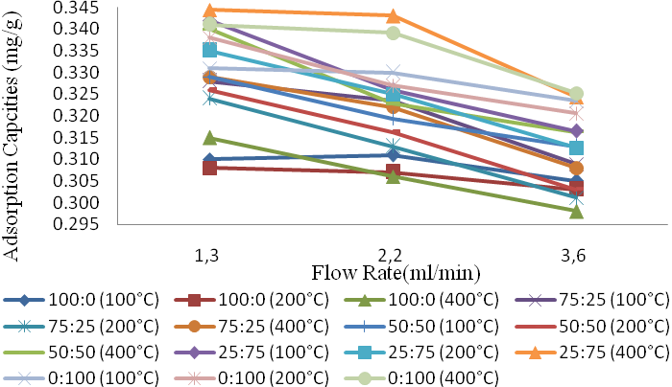
Figure 4. Result Graph of adsorption to Cu metal ions with column method

In addition, calcination temperature plays crucial role in adsorption process. Figure 5 shows that clay / soil Andisol adsorbent (100: 0), (75:25), (50:50), (25:75), and (0: 100) shows at temperature of 400 °C has bigger adsorption capacity than temperature of 100 and 200 °C. This may indicate that at temperature of 400 °C impurities on adsorbent surface disapeear and provide more area for adsorption process. Meanwhile, when calcination temperature of 100 and 200 °C, the adsorbent surface still covered by impurities which make the adsorption capability not optimal.
This is supported by a results of SAA (Surface Area Analyzer) that ​​clay / Andisol soil surface area (25:75) of 400 °C is greater than surface area of pure clay and Andisol soil. Since clay / Andisol soil (25:75) 400 °C conducted mixing between clay and Stiring chemically activated Andisol soil and both sonication respectively for 1 hour. There was chemically activation for clay in this study. Based on the previous research by Lihin et al. (2012) in which chemically activated clay and clay without chemical activation has no significant difference of adsorption capacity values. However, Andisol soil chemically activated by addition of 3M NaOH for 5 hours. According Widjonarko (2003) the activation of Andisol soil containing allophane using NaOH increases more effective surface area (1.62%) compared with only using H₂SO₄ (0.97%). Stiring mixing and sonication is expected to be a homogeneous mixture. Furthermore, physically mixture of clay / Andisol soil activated by calcination temperature variations on adsorbent. Chemical and physical activation of clay / Andisol soil lead active groups on adsorbent becomes active and larger of adsorbent surface area. The surface area provides size of area on clay surface, Andisol soil, and clay / Andisol soil (25:75) to 400 °C in adsorption process of Cu metal ions.

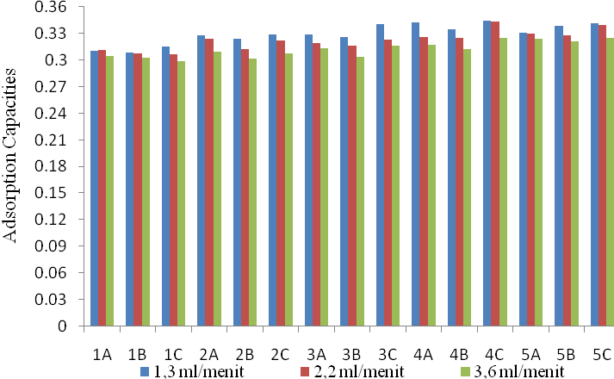
Compotition / Temperature
Explanation: Clay/Andisol Soil (1=100:0, 2=75:25, 3=50:50, 4=25:75, 5=0:100); Calcination Temprature (A=100, B=200, C=400)
Figure 5. Comparison of Adsorbent, calcination temperature and Flow Rate Compotition Variation on Adsorption Capacity

Table 3. The results of Surface Area Measurement
Adsorbent | Surface area (m²/g)
Clay | 245.790
Active Andisol Soil | 257.841
L/A (25:75) 400 °C | 312.775

Based on the results of IR spectra, it was stated interactions of Cu metal ions compound with an adsorbent. Compounds Cu metal ions in aqueous solutions is {Cu(NO₃)₂.4H₂O}. The formation of complex allows interaction of hydrogen bonds with adsorbent. It is indicated dilation and increased intensity at the wave number 3400 cm⁻¹(OH stretching) of 12.58% T and the wave number 1600 cm⁻¹(OH bending) of 8.64% T. The differences of increase %T at OH stretching vibration is greater than OH bending vibrations, due to hydrogen bonding presence OH stretching vibration occurs easier than the OH bending vibration. In addition, coordination covalent bonds with adsorbent have shown a decrease in intensity at wave number region in 1000 cm⁻¹amounted to 9.39% T which showed reduced group O-Si-O/O-Al-O and shift of adsorbent peak before adsorption on 516.92 cm⁻¹wave numbers to 532.35 cm⁻¹on adsorbent after adsorption. Shift wave number becomes 532.35 cm⁻¹ is closer to the wave number of 527 cm⁻¹ which is a Cu-O uptake by Basu (2010). The IR spectra before and after Cu adsorption can be shown in Figure 6.

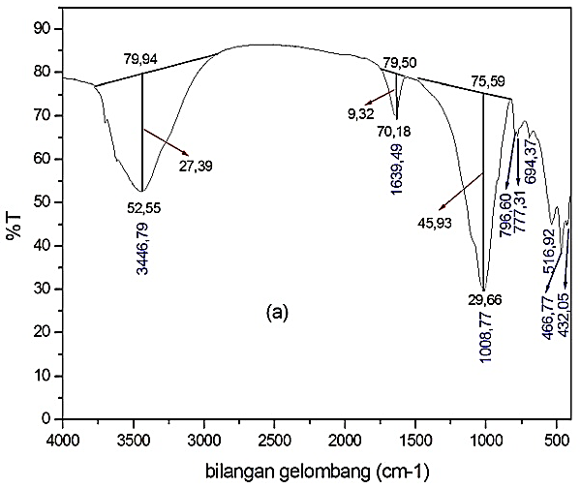 | 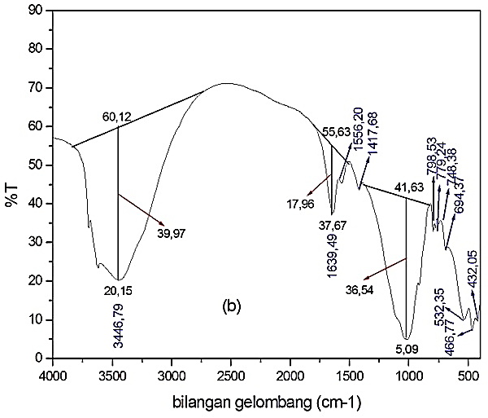
Figure 6. (a) Adsorbent Before Adsorption, (b) Adsorbent After Adsorption

Furthermore, analysis result of clay/Andisol soil (25:75) 400 ºC before and after adsorption with X-ray diffraction methods shows that it contains of some minerals that play role in adsorption process and is proofed by appearance of characteristic diffraction peaks at 2θ. XRD results clay / Andisol soil (25:75) 400 ºC before and after adsorption can be shown in Figure 7 (a) and (b).

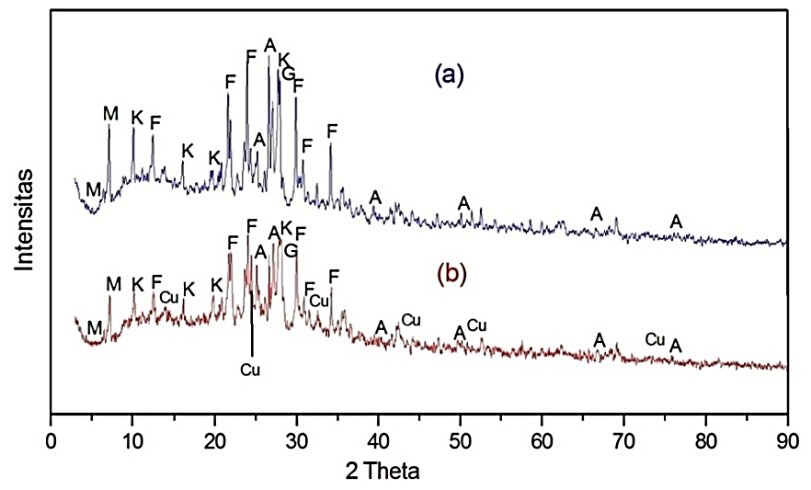
Explanation: A=Allophane, F=Feldspar, G=Gibbsit, K=Kaolinite, M=Montmorillonite

Figure 7. (a) The results of XRD adsorbent Before Adsorption, (b) Adsorbent After Adsorption
Table 4. Results XRD data of clay / Andisol soil (25:75) 400 °C
d (Å) |  |  | Type of Minerals
Reference | Clay/Andisol soil (25:75) 400 °C |  | Type of Minerals
Reference | Before Adsorption | After Adsorption | Type of Minerals
3.300; 2.2500; 1.800; 1.400; 1.230 (¹) | 3.348; 2.245; 1.857; 1.403; 1.224 | 3.339; 1.816; 1.489; 1.401; 1.254 | Allphane
4.0-4.2; 6.3-6.45 (²) | 4.262 | 4.255; 4.275 | Feldspar
3.7800; 3.6200; 2.9910; 2.7670; 2.6000; 2.5160 (³) | 3.711; 3.653; 2.985; 2.559 | 3.761; 3.641; 2.963; 2.748; 2.563 | Feldspar
3.30 (²) | 3.186 | 3.140 | Gibbsit
4.35-4.36 (²) | 4.307; 4.354 | 4.476 | Kaolinite
5.4342; 3.2865; 3.1961 (⁴) | 3.2937; 3.1863 | 3.2843; 3.1745 | Kaolinite
12.0-15.0 (²) | 12.355; 13.1039; 13.6057 | 12.275; 13.5856 | Montmorillonite
Explanation: (¹) = JCPDS 38-0449, (²) = Tan (1982), (³) = JCPDS 22-1212, (⁴) = JCPDS 72-2300

The high enough amount of allophane on adsorbent of clay/Andisol soil (25:75) 400 °C showed that allophane mineral plays role in the process of Cu metal ions adsorption. This is proffed by the decreasing amount of clay/andisol soil minerals adsorbent after adsorption. Moreover, after adsorption uptake appears at d = 6.443; 3.606; 2.732 (JCPDS 87-1663); 2.0411; 1.276; and 1.092 Å(JCPDS 85-1326) indicate the presence of Cu metal ions successfully absorbed by clay / Andisol soil adsorbent (25:75) to 400 °C. XRD data results data of clay / Andisol soil (25:75) to 400 °C before and after adosrpsi shown in Table 4.
Table 4 indicated that the samples of clay / Andisol soil (25:75) 400 °C before adsorption containing allophane minerals (15.28%), gibsit (3.75%), feldspar (43.22%), kaolinite (26.60%), and montmorillonite (11.77%). Whereas samples of clay / Andisol soil (25:75) 400 °C after adsorption containing allophane minerals (14.82%), gibsit (5.25%), feldspar (39.18%), kaolinite (31.67%), and montmorillonite (9.06%).
The occurrence of Cu ion adsorption by the adsorbent is also corroborated by acidity number using alkaline ammonia adsorption method. Adsorbent acidity values after adsorption decrease compared adsorbent before adsorption; these conditions stated that there has been an interaction between Cu metal ions with adsorbent. The data of acidity numerical values are shown in Table 5.

Table 5. Data Value of Adsorbent Acidity Number Before and After Adsorption.
L/A 25:75 (400 °C) | Acidity Number (mmol/g)
Before Adsorption | 2.059
After Adsorption | 1.471

The possible reaction occurs during adsorption process by column method is shown by Figure 8.

+ Cu²⁺ + 2H⁺

Figure 8. Possible reactions occur on Adsorption Process Column Method (Ghoneim et al., 2006)

The adsorbent has maximum adsorption capacity at Cu standard solution used to determined adsorption type and applications on industrial waste of copper craft.

Determination of Adsorption isotherm
Adsorption isotherm used to determine the type of adsorption occurred according to Langmuir or Freundlich equation. Isotherm determination based on R² value of each, R² value is close to 1, which means less error rate. This determination is made by adsorption of Cu metal ions with the best adsorbent include adsorbent with composition of the clay / Andisol soil (25:75) at temperature of 400 °C and flow rate of 1,3 mL/min. Variations of Cu concentration was used were 2, 4, 6, 8, 10 ppm. Based on the data, the test used a simple linear regression equation of Langmuir and Freundlich. Langmuir isotherm equation is determined by using the Langmuir isotherm equation $\frac{Ce }{Qe}$ = $\frac{1}{K Qmax}$ + $\frac{Ce}{Qmax}$and made curve Ce vs Ce/Qe.
Furthermore, the Freundlich isotherm equation is determined using Freundlich isotherm equation Log Qe = Log K + $\frac{1}{n}$ Log Ce then made curve Log Ce vs Log Qe.
Langmuir isotherm showed that adsorption process occurs chemically is adsorbent active group that will interact with Cu metal ions in solution by forming coordination covalent bond and form a compound. Adsorption process according to Langmuir suggests that the interaction between Cu with adsorbent surface on the formation of monolayer.
Freundlich is an isotherm which describes physically adsorption process. Physical adsorption occurs when intermolecular force is greater than attractive force between molecules. The interaction occurs when heavy metals entering adsorbent pores without forming a bond or interact with a weak binding energy include through van der Waals bonding. The weak pull forces cause adsorbate to move from one surface to another adsorbent’s surface. Van der Waals bonding happened between the adsorbent and Cu metal. In accordance with calculated adsorption isotherms is showed the presence of physical adsorption process does not occur electron transfer so that is only a weak bonds.
Langmuir and Freundlich isotherm curves for Cu metal ions can be seen in Figure 9 and Figure 10. Based on R²value of Langmuir and Freundlich isotherm above, it can be seen that R² value from Freundlich isotherm at 0.999 with line equation y = 0.909x – 0.906, while the Langmuir isotherm at 0.952 with line equation y = 0.51x + 7.471. Based from both R² value, Freundlich equation R² value is higher than Langmuir equation R² value although both approaches value of 1 with no significantly difference. It can be concluded that this study follows the Freundlich isotherm and Langmuir isotherm or adsorption processes occur in physics and chemical.

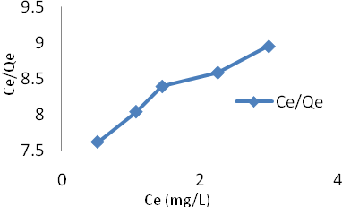  Figure 9. Langmuir Isotherm Curve for Cu Metal Ion | Figure 10. Freundlich Isotherm Curve for Cu Metal Ion

Adsorbent Adsorption Effectiveness test against Cu Metal Ions in Solution Model and Waste Metal Crafts
This adsorbent adsorption effectiveness test used optimum composition includes adsorbent clay / Andisol soil 25:75 (400 °C) with flow rate of 1.3 mL/min. The waste which was used was the waste of metal craft from area Tumang, Boyolali, Central Java. To determine adsorbent ability adsorbed Cu metal ion, then we made adsorption comparison with best adsorbent on solution model and waste. Comparison of Cu metal ion adsorption capacity in Solutions model and metal crafts are shown in Table 6.

Table 6. Capabilities Data of Cu Metal Ion Adsorption in Model Solutionand Waste Metal Crafts
Cu Metal Ion | Initial Concentrations (ppm) | Residue Concentrations (ppm) | % adsorbed
Waste Metal Craft | 582.450 | 449.000 | 22.91
Model Solution | 9.830 | 2.941 | 70.08

From table, it can be seen that the ability of adsorbent adsorbing Cu metal ions in waste metal craft smaller than the model solution with a difference of 47.17%. This happened because a lot of element ions and other matrix in the waste solution. The presence of element ions such as aluminum and zinc as well as other matrix competing in the waste cause smaller adsorbed Cu metal ions. In the other hand, the formation of complex Cu metal ions in the water resulting larger moleculer so the interaction with adsorbent become small. While o model solution only consists of Cu ions, so that there is no other components which interfere in adsorption process.

- Conclusion
The greater amount of Andisol soil used in clay / Andisol soil adsorbent composition the higher calcination temperature is used, the adsorption capacity of the Cu metal ion become greater. The most optimum adsorbent composition in this study is adsorbent clay / Andisol soil 25:75 with heating temperature of 400 °C. Smaller flow rate between adsorbent and adsorbate results in better adsorption process. The most optimum time flow rate to the effectiveness of adsorbents (clay / Andisol soil) in the absorption of Cu is at flow rate of 1.3 mL / min with the adsorption capacity of 0.344 mg/g. The best type of Cu metal ion adsorption isotherm was generated by adsorbents (clay / Andisol soil) used column methods followed Langmuir and Freundlich isotherm. The percentage of adsorbent in absorbing Cu metal ions in solution model is more effective than the model of waste metal crafts ie 70.08% and 22.91%.

References
Alberty, R. A., and Daniel, F., 1983, Physical Chemistry, Canada, John Willey and Sons Inc.
Apsari, A. T., dan Fitriasti, D., 2010, Studi Kinetika Penjerapan Ion Khromium dan Ion Tembaga menggunakan Kitosan Produk dari Cangkang Kepitin, Skripsi FT UNDIP Semarang.
Astuti, P., 2007, Adsorpsi Limbah Zat Warna Tekstil Procion Red MX 8B Oleh Kitosan dan Kitosan Sulfat Hasil Deasetilasi Cangkang Bekicot (Achatina fullica), Skripsi Jurusan Kimia FMIPA UNS, Surakarta.
Auliah, A., 2009,Lempung Aktif Sebagai Adsorben Ion Fosfat Dalam Air,Jurnal Chemica, Makasar : Kimia FMIPA UNM.
Atkin, P.W., 1999, Phisycal Chemistry, Oxford University Press: London.
Bahri, S., Muhdarina, dan Fitrah, A., 2010,Lempung alam termodifikasi sebagai adsorben larutan anorganik : kesetimbangan adsorpsi lempung terhadap in logam Cu²⁺,Jurnal Sains dan Teknologi.
Barr, T. L., and Klinowski, J., 1995,ESCA and Solid-State NMR Studies of Allophane,Journal Clay Minerals, Cambridge.

Barrow, G. M., 1988, Physical Chemistry, Mc Graw Hill International, Singapura.

Brugnerotto, J., Lizardi, J., Goycoolea, F. M., Arguelles, M. W., Debrieres, J., and Rinaudo, M., 2001, An infrand Investigation with Chitin and Chitosan Characterization, Polymer.
Dahlgren, R., S. Shoji, and M. Nanzyo, 1993, Mineralogical Characteristics of Volcanic Ash Soils. Developments in Soil Science 21, Elsevier, Amsterdam.
Devnita, R., 2005, Penggunaan Metoda Selektive Disolution dan Spektroskopi Inframerah dalam Menentukan Kadar Alofan Andisol,Skripsi, Fakultas Pertanian UNPAD.
Djaenudin, P., 2004, Beberapa Sifat Spesifik Andisol untuk Pembeda Klasifikasi pada tingkat Seri: Studi Kasus di Daerah Cikajang dan Cikole Jawa Barat, Jurnal Tanah dan Lingkungan.
Ghoneim, A., Matsue, N and Henmi, T., 2006, Effect of Copper Adsorption on Some Charge Characteristics of Nano-Ball Allophane, International Journal of Soil Science.
Gupta, S.,and Bhattacharayya, G.K., 2008,Immobilization of Pb(II), Cd(II), Ni(II) ions on kaolinite and montmorillonite surfaces from aqueos medium.Journal of Enviromental Management.
Gustafsson, J. P., Karltun, E., and Bhattacharya, P., 1998, Allophane and Imogilite in Swedish Soils, Sweden, Division of Land and Water Resource, Department of Civil and Environmental Engineering, Royal Institut of Technology (KTH).
Hamdan, 1992, Introduction to Zeolite Synthesis, Characterization, and Modifications, Universitas Teknologi, Malaysia.
Han, X.,Wang, W., and Ma, Xi., 2011,Adsorption characteristics of methylene blue onto low cost biomass material lotus leaf, Journal Chemical Engineering, Elsevier.
Hashimoto, I., and Jackson M. L., _____ , Rapid Dissolution of Allophane and Kaolinite-Halloysite After Dehydration, Department of Soils, University of Wisconsin, Madison, Wisconsin.
Heraldy, E.,Pranoto, dan Prowida, D.,2004,Studi Karakterisasi dan Aktivasi Alofan Alam serta Aplikasinya sebagai Adsorben Logam Berat Zn Menggunakan Metode Kolom, Jurnal Alchemy, Jurusan Kimia FMIPA Universitas Sebelas Maret.
Hermamalini, R., and Velraj, G., 2011, FT-IR X-Ray Diffraction and Thermal Analysis to Estimate The Firing Temperature of The Archeological Samples Excavated Recently at Banahalli in Karnataka, South India,Journal of Chemical and Pharmaceutical Sciences.
Isoyama, M. and Wada, S.I., 2005, Effect of Reaction Time on Pb Removal from Allophanic Ash Soil by Acid Washing, Soils and Foundations.
Khan, T. A., Peh, K. K., and Chang, H. S., 2002, Reporting degree of deacetylation values of Chitosan: The influence of analytical methods, J. Pharm. Pharmaceut.
Khasanah, E. N., 2009, Adsorpsi Logam Berat, Oseana.
Kasmudi, M., 2010,Pemanfaatan Cadangan Gas Stranded untuk Pembangkit Listrik ke Pabrik Pengolahan Mineral, Skripsi S-1 FT UI, Jakarta.
Kundari, A.N.,dan Slamet, W., 2008,Tinjauan Kesetimbangan Adsorpsi Tembaga dalam Limbah Pencuci PCB dengan Zeolit,Seminar Nasional IV SDM Teknologi Nuklir, Yogyakarta.
Lestari dan Edward, 2004,Dampak pencemaran logam berat terhadap kualitasAir laut dan sumberdaya perikanan,Makara, Sains.
Lihin, S., Nurhayati, dan Erman, 2012, Kinetika Adsorpsi Kation Pb(II) oleh Lempung Alam Desa Talanai yang Diaktivasi NaOH pada Kalsinasi Suhu 600 °C,Fakultas Matematika dan Ilmu Pengetahuan Alam Universitas Riau.
Munir, 1996, Tanah-Tanah Utama Indonesia,Pustaka Jaya, Jakarta.
Negara, I. M. S., 2005,Preparasi Komposit Krom Oksida-Montmorillonit dan Aplikasinya untuk Sorpsi Benzena,Tesis Program Pasca Sarjana Univesitas Gadjah Mada, Yogyakarta.
Nugroho, S., 2008, Penggunaan Biosurfaktan yang Diimobilisasikan pada Alofan Sebagai Adsorben Ion Logam Cd, Skripsi Jurusan kimia MIPA, Universitas Sebelas Maret Surakarta.
Nurmasari, R., Mujiyanti, D. R., dan Fitra H., 2013, Sintesis dan Karakterisasi Adsorben Asam Humat Terimobilisasi pada Hibrida Merkapto Silika dari Abu Sekam Padi. Jurnal Sains dan Terapan Kimia
Oscik, J., and Cooper, L.L., 1982, Adsorption, Ellis Hordwood Limited John Willey and Sons, New York.
Parfitt, R. L., 2009, Allophane and Imogolite: Role in Sole Biogeochemichal Processes, Clay and Clay Minerals, New Zealand.
Permanasari, A., Siswaningsih, W., dan Wulandari, I., 2010, Uji Kinerja Adsorben Kitosan-Bentonit terhadap Logam Berat dan Diazinon secara Simultan, Jurnal Sains dan teknologi Kimia.
Plasvic, B., Kobe, S., and Orel, B., 1999, Identification of Crystallization Forms of CaCO₃ with FT-IR Spectroscopy, Kovine, Zlitine, Tehnologije.
Potgeiter, J.S., Potgeiter-Vermaak, and Kalibatonga, 2005, Heavy Metals Removal from Solution by Paligorskite Clay, Minerals Engineering, PWS Publishing Company : USA.
Purwaningsih, D., 2009, Adsorpsi Multi Logam Ag(I), Pb(II), Cr(III), Cu(II) dan Ni(II) pada Hibrida Etilendiamino-Silika dari Abu Sekam Padi, Jurnal penelitian Saintek.
Qodari, M. T., 2010, Karakterisasi Lempung dari Daerah Pagedang Kecamatan Turen Kabupaten Malang dan Daerah Getaan Kecamatan Pagelaran Kabupaten Malang, Skripsi Fakultas Sains dan Teknologi UIN Malang, Malang.
Sajidu, S. M. I., I. Persson, W. R. L. Masamba, E. M. T. Henry, and D. Kayambazinthu, 2006, Removal of Cd²⁺, Cr³⁺, Cu²⁺, Hg²⁺, Pb²⁺ and Zn²⁺Cations and AsO₄³⁻ Anions from Aqueous Solutions by Mixed Clay from Tonolulu in Malawi and Characterisation of the clay.Water SA. Malawi
Setiaka, J., Ulfin, I., dan Widiastuti, N., 2010, Adsorpsi Ion Logam Cu(II) dalam Larutan pada Abu Dasar Batubara menggunakan Metode Kolom. Prosiding Skripsi FMIPA ITS, Surabaya.
Sivaiah, M. V., Venkatesan, K. A., Sasidhar, P., Krishna, R. M. and Murthy, G. S., 2004,Ion Exchange Studies of Cerium(III) on Uranium Antimonate,Journal of Nuclear and Radiochemical Science.
Slamet, Syukur, R., dan Danumulyo W., 2003,Pengolahan Limbah Logam Berat Chromium(VI) dengan Fotokatalis TiO₂,Jurnal Makara Teknologi.
Shoji, S., and Ono, T., 1987, Physical and chemical properties and claymineralogi or andosol from Kitakami, Japan Soil Sci.
Suarya, P., 2012, Karakterisasi adsorben komposit alumunium oksida pada lempung teraktivasi asam. Jurusan Kimia FMIPA Universitas Udayana, Bukit Jimbaran.

Sukmawati, 2011, Beberapa Perubahan Sifat Kimia Alofan dari Andisol Setelah Menjerap Asam Humat dan Asam Silikat, Media Litbang Sulteng IV.
Sulistyarini, A., 2012, Identifikasi, Karakterisasi, dan Aktivasi Alofan Gunung Arjuna Jawa Timur Sebagai Penjerap Logam Tembaga (Cu), Skripsi, Universitas Sebelas Maret Surakarta.
Sumanagara, D. A., dan Widjajanto, H., 2004. Masalah dan Solusi yang dihadapi BUMN Pertambangan di Era Otonomi Daerah, Skripsi FP IPB, Bogor.
Tan, K. H., 1982, Dasar – Dasar Kimia Tanah, Terjemahan Didiek Hadjar Goenardi, Gadjah Mada University Press, Yogyakarta.
Wada, K., Wada, S. I., and Kakuto, Y., 1985, Small-Angle X-Ray Powder Diffraction, Morphology, and Structure of Allophane and Imogolite. Journal Clays and Clay minerals.
Widaningrum, Miskiyah, dan Suismono, 2007,Bahaya Kontaminasi Logam Berat dalam Sayuran dan Alternatif Pencegahan Cemarannya,Jurnal Teknologi Pascapanen Pertanian.
Widihati, I. A. G., 2008, Adsorpsi Anion Cr (VI) oleh Batu Pasir Teraktivasi Asam dan Tersalut Fe₂O₃, Jurnal Kimia 2.
Widjonarko, D. M., Pranoto, dan Christina, Y., 2003,Pengaruh H₂SO₄ dan NaOH Terhadap Luas Permukaan dan Keasaman Alofan,Jurnal Alchemy.
Wisnubroto, D. S., 2002, Pengolahan Logam Berat dari Limbah Cair dengan Tannin,Jurnal Penelitian P2PLR.
Wogo, H. E., Nitbani, F. O., dan Tjitda, P. J. P., 2013, Sintesis Lempung Terinterkalasi Anilin dan Pemanfaatannya sebagai Adsorben Fenol, Jurnal Sains dan Terapan Kimia.

Gendruwo’s oil (Sterculia foetida Linn.) as Biofuel’s Raw Material

Endang Yuniastuti¹
¹Biodiversity and Biotechnology Center Institute for Research and Community Services (LPPM), Sebelas Maret University, Jl. Ir. Sutami No. 36 A Surakarta, Indonesia
Email: yuniastutisibuea@staff.uns.ac.id
Abstract. Indonesia has high plant diversity that enough with potency to utilize plant as alternative energy that base on harnessed and plant cultivation. Gendruwo (Sterculia foetida Linn.) constitute one of plant which can be utilized as biofuel's raw material. Energy from plant have miscellaneous form, then can be use or changed into another form depend on human requirement. Vegetation Fueled (BBN) development is a method or cultivates and plant / animal / organism exploitation that take its benefit from component in it and used as “biofuel”. Biofuel’s development as alternative energy gets to be grouped becomes 3 which are as bioethanol (premium substitution / gasoline), biodiesel (diesel fuel substitution), and bio oil (lubricating oil substitution). Gendruwo's plant (Sterculia foetida Linn) can result genderuwo's oil from its extract seed. Gendruwo's oil was pulled out from gendruwo's seed using pressure and esterification method. Gendruwo's oil rendemen was 65 % – 75 % laboratory level. Gendruwo's oil can be use straightforward as hydraulic fluid and also can be applied for vehicle machine and industry machine with purification gendruwo's oil to reduce acids contained.
- Introduction
The needs of energy is increasing day by day, together with the number of population and human’s needs. The increase in energy demand is not matched with the increase in energy source in nature, especially from the energy that derived from fossil fuels. There’s a basic theory which said that plants is a complex energy machine that has so many process and produced a huge energy in so many forms.
Indonesia is one of country with solid enough resident amount, so that requirement of energy is also high. Requirement of energi increased from year to year, while supply of energy decreasing. This situation push human being look for the source of new energi. Indonesia rich of natural resources and plants, owning big potency in searching alternative energy to fulfill requirement. Therefore, time has come to develop the source of alternative energy exploited natural resources and existing plant developed Fuel Vegetation ( BBN) or biofuel. One of the crops able to be developed for the fuel of vegetation and not yet recognized many like castors, coconut of sawit, and sugar cane are Gendruwo (Sterculia foetida Linn.).
Government regulation released push to get the source of new energy able to be exploited as alternative fuel. Inpres number 1 year 2006 expressing concerning ready and exploiting of vegetation fuel ( Biofuel) as alternative fuel and of Peraturan Presiden number 5 year 2006 concerning national energy that exploiting of year biofuel 2010 equal to 1.7 million litre kilo ( kl), year 2015 equal to 4.0 million kl, year 2025 equal to 22.0 million kl.
Gendruwo (Sterculia foetida Linn.) or a more regular recognized by the name of Kepuh is one of crop species in Indonesia coming from African East, Asian Tropic and Australian. This Crop in the form of big enough tree highly reach 30 metre. Crop of Gendruwo or Kepuh can grow swiftly and is species which each every the body organ shares of many be of benefit to human lives. According to Tirto Prakoso, ect. (2006) and Suprapto (2003), seed of Pranajiwa or kepuh oleaginous vegetation which consist of fat acid that is acid of sterkulat which was molecule formula of C₁₉H₃₄O₂. This fat acid can be used as ingredient various industrial product like cosmetic, soap, shampoo, cloth softening, paint, and plastic. Fat oil acid of Pranajiwa or of kepuh also can be used as adaptif biodiesel owning dot decant 18ºC becoming 11.25ºC.
Zanzibar and Siskasari (2001), express that fruit, seed, cortex, and leaf of Gendruwo can be used upon which medical herbs or medicine. Cortex and leaf of gendruwo can be used as medicine for a few diseases for example rheumatic, diuretic, and diaphoretic. Fruit skin of Gendruwo also can be used upon which ingredient to make the seed and cake of can be eaten. Wood of Gendruwo tree can be used as house building construction, shipbuilding materials, container box, and paper of pulp.
This research aims to determine the chemical content in gendruwo seeds which can be used as a biofuel raw ingredient, especially for bio-oil and biodiesel.

- Method
Before the analysis, the gendruwo seeds was selected by their physiologically ripe marked with the black skin of the seeds. Pranajiwa seeds roasted to reduce the water content. The oil content observation is conducted in the laboratory. Type of observation and analysis the billowing seed is to determine:
- Percentage of fat amount (KL)
Fat amount known for knowing the percentage of fat amount in the billowing seed from each accessions. The fat amount can be known by doing the Soxhlet method of fat extraction. The fat amount calculated by the formula:
KL =
Weight of beginning sample
(weight of filter paper + weight of sample)- weight after extraction
x 100 %

- Water amount (KA)
Water amount known for knowing the percentage of water amount in the billowing seed from each accessions. The water calculated by the formula:
KA =
Weight of seed before oven
Weight of seed before oven – weight of seed after oven
x 100 %

- Percentage of oil yield (R)
Oil yield (R) known for knowing the percentage of oil yield in the billowing seed from each accessions. The oil yield can be known by doing the Soxhlet method of fat extraction (Woodman, 1941). The oil yield calculated by the formula:
R =
Weight of sample
Extract volume – fat density
x 100 %

The working procedure for the extraction of billowing seeds is:
Insert the perfect ripe billowing seed to the oven with the temperature between 70-80°C for 2x24 hours. Weighing and look carefully for 2-3 grams of the substance that already smoothed, wrap with the fat free filter paper for the sample of fat amount and weigh 80-100 grams of the substance for the yield sample. Dry inside the 105°C oven for 5 hours, chill it and weigh (H). Install the reservoir flask, soxhlet extraction tools and a cooling tools. Pour the organic solvent (Petroleum Ether) through the chiller hole until the solvent down into the reservoir flask and filled again until half the extraction tool. Flush the cooling water and turned on the heater for 2-3 hours or until the solvent looks clear (about 8-10x circulation). Turn off the heater when the solvent inside the extraction tool flow down to the reservoir flask. Put out the wrapped sample, aerated and dried in the oven until all the ether evaporate and weigh when it still hot. Reheat the fat inside the reservoir flask extraction process for 30 minutes to separate the fat and the ether. Put inside the bottle and dried and aerated it until the ether is totally evaporate the measure the extract volume.
The extraction process of gendruwo oil is using the press method and esterification method (ether purification).
- Press Method
Press method is a simple method which can be used to squeeze the gendruwo seed to get its oil. The working procedures are:

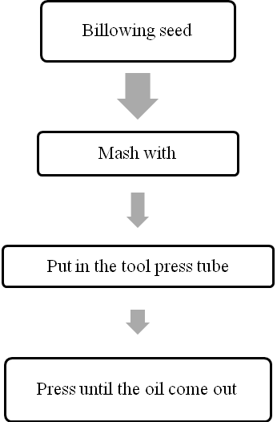

- Esterification Method
The esterification method is a gendruwo oil extraction method which used ether to get the oil from gendruwo seed. The working procedures are:
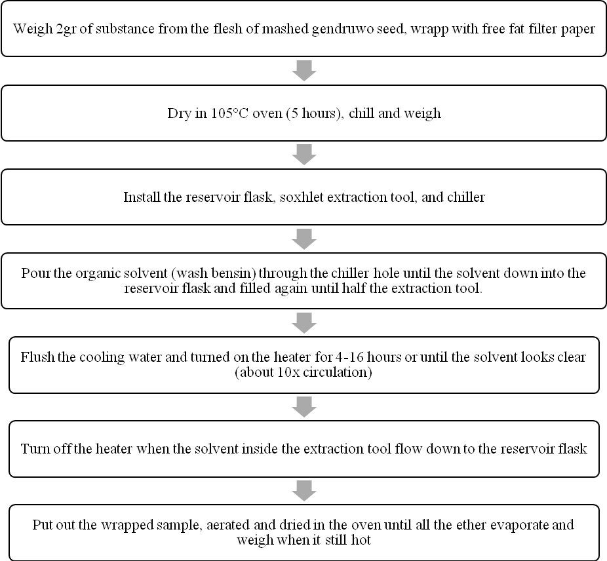

As the result from the extraction process we get 65%-75% gendruwo oil yield.

3. Result and Discuccion
The Gendruwo oil as the result of press method can be applied directly as hydraulic fluid and can be applied in vehicle machine and industrial machine by reducing the amount of its existing acid. As the result of the analysis especially viscosity, show that the pranajiwa oil that extracted directly from the pranajiwa seed (Sterculia foetida Linn.) has similarities with the SAE 10. The lubricant with SAE 10 can be used as hydraulic fluid. In addition to be used as hydraulic fluid, gendruwo oil can be used also as raw ingredient for lubricant (bio-oil) or as a raw ingredient for biodiesel. We can see the Gendruwo seed proximate analysis results as follows (Table 1):

Table 1. Analysis of Proximate Pranajiwa Seed (Sterculia foetida Linn.)
No. | Sample | Water (%) | Ash (%) | Fat (%) | Protein (%) | *Carbohydrate (%)
1. | Seed A | 5.5670 | 2.2314 | 35.6025 | 16.1808 | 40.3283
1. | Seed A | 5.5788 | 2.6956 | 35.0521 | 16.3836 | 40.2899
2. | Seed B | 8.0300 | 3.2456 | 35.6784 | 16.7949 | 36.2511
2. | Seed B | 8.1300 | 3.1420 | 36.0934 | 16.7949 | 35.8397
*Carbohydrate measured by different: 100% - (% water + % ash + % fat + % protein)
Description: A= small seed; B= big seed

In the testing of the tannin content, saponin content, and alkaloid content will give the idea that the gendruwo oil produced from the extraction of gendruwo seed can be used as bio-oil and can be developed as biodiesel.

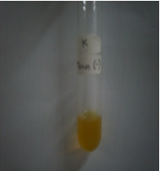  (i) | 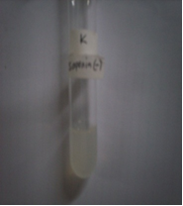  (ii) | 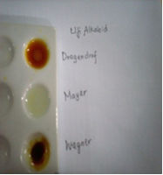  (iii)
Figure 1. Pranajiwa Oil (Sterculia foetida Linn.) (i) Test result of tannin content; (ii)Test result of saponin content; (iii) Test result of alkaloid content.

Table 2. The amount of fatty acid in Pranajiwa Seed (Sterculia foetida Linn.)
No | The type of fatty acid | Total chain | A-1 area | Fatty acid mg/g | A-2 area | Fatty acid mg/g | B-1 area | Fatty acid mg/g | B-2 area | Fatty acid mg/g
1. | Methyl Octanoate | 8:00
2. | Methyl Decanoate | 10:00
3. | Methyl Laurate | 12:00
4. | Methyl TriDecanoate | 13:00
5. | Methyl Myristate | 14:00 | 146 | 0.31419758 | 156 | 0.326635745 | 273 | 0.354104885
6. | Myristoleic Acaid Mathyl ester | 14:01
7. | Methyl PentaDecanoate | 15:00
8. | Methyl Palmitate | 16:00 | 32887 | 72.68029976 | 33791 | 72.65786424 | 50580 | 67.3737264 | 21155 | 70.59825358
9. | Palmitoleic Acid Methyl Ester | 16:01 | 314 | 0.740603662 | 331 | 0.759579671 | 476 | 0.676678615 | 197 | 0.701634459
10. | Methyl HeptaDecanoate | 17:00 | 3086 | 7.386759582 | 3084 | 7.182266964 | 5128 | 7.398187792 | 2002 | 7.236200507
11. | Methyl Stearate | 18:00 | 4209 | 9.828169336 | 4421 | 10.04392247 | 5313 | 7.477437864 | 2292 | 8.081589645
12. | Oleic Methyl Ester | 18:01 | 11831 | 27.93474193 | 12115 | 27.83144527 | 16732 | 23.81169753 | 5434 | 19.3745362
13. | Methyl Linoleate | 18:02 | 12404 | 40.7457482 | 13383 | 42.77235368 | 16436 | 32.54137984 | 5833 | 28.93350135
14. | Methyl Linolenate | 18:03 | 1690 | 8.092893372 | 2339 | 10.89774063 | 1330 | 3.838734243 | 1128 | 8.156703767
15. | Methyl Arachidate | 20:00 | 2101 | 5.34373368 | 2087 | 5.164524408 | 10648 | 16.32322954 | 3532 | 13.56525384
16. | Methyl Eicosenoate | 20:01 | 1318 | 3.290238027 | 1301 | 3.159936358 | 5335 | 8.027228453 | 2144 | 8.02117588
17. | Methyl Behenate | 22:00 | 1821 | 4.508490906 | 1910 | 4.600910142 | 23701 | 35.36773229 | 9188 | 34.35031431
18. | Eruric Acid Methyl Ester | 22:01 | 516 | 1.247349407 | 567 | 1.333554024 | 5049 | 7.356361896 | 1902 | 6.942844087

Table 3. Total chain of the fatty acid in Pranajiwa seed (Sterculia foetida Linn.)
No | Type of fatty acid | Total chain | Concentration | Area | RF
1. | Methyl Octanoate | 8:00 | 1.902 | 1045 | 1.016978
2. | Methyl Decanoate | 10:00 | 3.092 | 1935 | 0.892845
3. | Methyl Laurate | 12:00 | 6.554 | 4157 | 0.880935
4. | Methyl TriDecanoate | 13:00 | 3.195 | 1979 | 0.902075
5. | Methyl Myristate | 14:00 | 3.194 | 1985 | 0.899067
6. | Myristoleic Acaid Mathyl ester | 14:01 | 1.896 | 1082 | 0.979104
7. | Methyl PentaDecanoate | 15:00 | 1.896 | 1081 | 0.980009
8. | Methyl Palmitate | 16:00 | 12.978 | 7854 | 0.923282
9. | Palmitoleic Acid Methyl Ester | 16:01 | 6.391 | 3624 | 0.985367
10. | Methyl HeptaDecanoate | 17:00 | 3.2 | 1788 | 1
11. | Methyl Stearate | 18:00 | 6.486 | 3715 | 0.975519
12. | Oleic Methyl Ester | 18:01 | 22.156 | 12550 | 0.986427
13. | Methyl Linoleate | 18:02 | 12.978 | 5284 | 1.372342
14. | Methyl Linolenate | 18:03 | 6.384 | 1783 | 2.000595
15. | Methyl Arachidate | 20:00 | 1.896 | 997 | 1.062578
16. | Methyl Eicosenoate | 20:01 | 1.902 | 1019 | 1.042927
17. | Methyl Behenate | 22:00 | 1.903 | 1028 | 1.03434
18. | Eruric Acid Methyl Ester | 22:01 | 1.896 | 1049 | 1.009905

4. Conclusion
The gendruwo oil can be used directly as hydraulic fluid and also can be applied for motor vehicle engines and industrial engines through refining the gendruwo oil by reducing some existing acid content. Gendruwo's plant( Sterculia foetida Linn) can result genderuwo's oil from its extract seed. Gendruwo's oil was pulled out from gendruwo's seed using pressure and esterification method. Gendruwo's oil rendemen was 65 % – 75 % laboratory level. Gendruwo's oil can be use straightforward as hydraulic fluid and also can be applied for vehicle machine and industry machine with purification gendruwo's oil to reduce acids contained.

References
Anggraini, L. 2005. Hidrogenasi's Product characteristic Esters (Monoalkil) Oils Fat acids kepoh (Sterculia foetida) As Adaptif Biodiesel. http://ta's abstraction. fti. itb. ac. id . Date access 23th January 2008.
Anonymous. 2008. West Balinese national park; Flora and Fauna potency. http://www. tnbalibarat. com / potensi_flora_fauna. html. Date access 25th April 2008 .
Anonymous. 2007. Chromosome Counts for Malvaceae. http://www.malvaceae.info /Biology/Chromosomes.html. Date access 2th February 2008.
Damayanti, S. D., A. Purwanto, E. Sulistyaningsih. 2005. Analisis Kariotipe Severally kultivar Aglonema. Agrosains 18 (4 ) = 395 407.
Jurgen, Schuly Scaheffer. 1980. Cytogenetics, Plants, Animals, Humans. Springer Verlag is Inc.'s New York New York.
James, N. I. 1971. Yield Component In Random and Selected Sugarcane Population. Crop Sci. 11:906-908.
LI, C.C. 1956. The Concept of Path Coefficient and Its Impact On Population Genetic. Biometrics. University of Chicago Press. 12(2):190-210.
Pantone, D.J., J.B. Baker, dan P.W. Jordan. 1992. Path Analysis Of Red Rice (Oriza sativa, L) Competition With Cultivated Rice. Weed Science (402 : 313 – 319).
Parjanto, Sukarti Moeljopawiro, W. T. Artama, and Aziz Purwantoro. 2003. Kariotipe is Chromosome Yaps. Zuriat . 14 (2 ) = 21 27.
Suryo. 1995 . Sitogenetika . UGM Press. Yogyakarta.
Setyawan, A. D. and Sutikno. 2000. Karyotipe is Chromosome on Allium sativum L. (Garlic) and Pisum Sativum L (Kapri's bean). BioSmart . 2 ( 1) : 20–27.

Visualising and Exploring Molecular Shape Using Origami for Simple Chemical Structures

Teguh Endah Saraswati^{1,2*}, Sulistyo Saputro², Murni Ramli², and Danar Praseptiangga²

¹Department of Chemistry, Mathematic and Natural Science Faculty, Sebelas Maret University, Jalan Ir. Sutami 36A Kentingan, Surakarta 57126 Tel. (0271) 663375
²Center for Japanese Studies, Sebelas Maret University, Jl Ir. Sutarmi 36 A Kentingan, Surakarta Central Java-Indonesia

*E-mail: teguh@mipa.uns.ac.id

Abstract. The molecular shape has a vital role to study and explore the molecular function. The study of the molecular shape of the chemical structure should use an accessible and transferable modelling structure. Many ways of modelling structure can be implemented. One of them is by using origami technique. The present technique is simple, readily accessible and inexpensive compared with other sophisticated methods such as computer modelling/simulation and three-dimensional expensive commercial model kits. Here, we introduce the origami technique for visualising the molecular shape for simple chemical structures. This method is a ‘hands-on’ approach in building molecules expected more intention while gaining the building experiences. This method can be implemented in chemical education both at high school and university level studies.
- Introduction
Study of molecular shape or molecular geometry is an important chapter to investigate the molecular properties further. The arrangement of the atoms that constitute a molecule can be learnt in two-dimensional (2D) or three-dimensional (3D) models. The several properties determined by the atoms arrangement are its reactivity, polarity, the phase of matter, color, magnetism, and biological activities. To determine the shape of molecules, commonly, students apply valence-shell electron-pair repulsion (VSEPR) theory based on the Lewis electron dot structure.
The valence-shell electron-pair repulsion (VSEPR) theory described in the textbook of inorganic chemistry [1-3] explains that electron pairs will spread themselves as far from each other as possible to minimize repulsion. The number of the electron group used in bond (single, double or triple bonds) will determine the molecular structure. For example, if the molecule has two bonding groups of the electron, its molecular geometry will be predicted as linear. In addition, if the molecule has four bonding groups of the electron, its molecular geometry will be in tetrahedral. However, when the molecule has one or more nonbonding groups of electrons (lone pair electron), the molecular geometry will possibly change. For example, the water molecule has two bonding group of the electron and two more lone pair electron. The prediction of water molecules geometry will be neither linear nor tetrahedral. The atom arrangement in water molecules will be in the bent structure. The lone pairs are adjacent from each other in order to minimize repulsion between the bonding groups of the electron, thus verifying the VSEPR theory.
An interactive model should be used for stimulating the student perspective to recognize the molecular structure. An interactive model should three-dimensional (3D) view to help the student in learning the molecular shape. If the student drew in a two-dimensional (2D) way, the student might meet the difficulties to imagine the molecular structure. Applying what VSEPR theory that the electrons groups should get the position as far each other to minimize the repulsion, in the case of four group electrons in molecules, there is a possibility that the student will draw the molecule in square planar which has 90-degree angle between the bonds. Therefore, the three-dimensional (3D) model is expected to achieve better understanding.
The commercial 3D models used in the school, e.g. molymod, 3D simulation software, generally are limited accessible by few students due to its cost and its need for special learning computer skill. Hence, not all students could learn this chapter well. Another hand-made 3D molecular model generally introduced in the class was made by plasticine, straw, toothpick or matchstick. This model is quite cheap and accessible by all students, but relative fragility restrict.
Here, we introduce a molecular concept using an origami technique for visualising and exploring the molecular shape, especially for simple chemical structures. The origami is a modeling system that has traditionally been used in science and mathematics learning [4]. Davis et al. described the uses of origami as a versatile modelling system for visualising chemical structure and exploring molecular function [5]. The origami model presented in this article was adopted from the book of Molecular Origami published by University Science Book, USA, which was written by Hanson, Robert M. in 1995 [6]. This article describes how the three-dimensional (3D) model using origami provides a more reasonable explanation of the difference of geometric shapes of molecules which could not be described through two-dimensional (2D) drawing method.

- Predicting the molecular geometry
Molecular geometry is the three-dimensional arrangement of the atoms that constitute a molecule. The three-dimensional shape or configuration of a molecule is an important characteristic. This shape is dependent on the preferred spatial orientation of covalent bonds to atoms having two or more bonding partners. It determines several properties of a substance including its reactivity, polarity, the phase of matter, color, magnetism, and biological activity.
To determine the molecular geometries, ones should have a concept of bonding pair of electrons and non-bonding pairs of electrons. Bonding pairs of electrons are those electrons shared by the central atom and any atom to which it is bonded. Non-bonding pairs of electrons are those pairs of electrons on an individual atom that are not shared with another atom.
The term electron-pair geometry is the name of the geometry of the electron-pair/groups/domains on the central atom, whether they are bonding or non-bonding. Molecular geometry is the name of the geometry used to describe the shape of a molecule. The electron-pair geometry provides a guide to the bond angles of between a terminal-central-terminal atom in a compound. The molecular geometry is the shape of the molecule.
The general steps to determine the shape (molecular geometry) of a molecule are writing the Lewis structure which will be used to determine the number of bonding groups of electrons and the number of non-bonding pairs of electrons on the central atom. Lewis structures show the two-dimensional distribution of atoms and electrons. The molecular geometry or three-dimensional shape of a molecule or polyatomic ion can be determined using VSEPR (Valence Shell Electron Pair Repulsion) – pronounced “VES-per” approach, in which the basic principle is valence electrons around a central atom stay as far apart as possible to minimize the repulsion. Figure 1 summarizes the molecular and electron-pair geometries for different combinations of bonding groups and nonbonding pairs of electrons on the central atom.

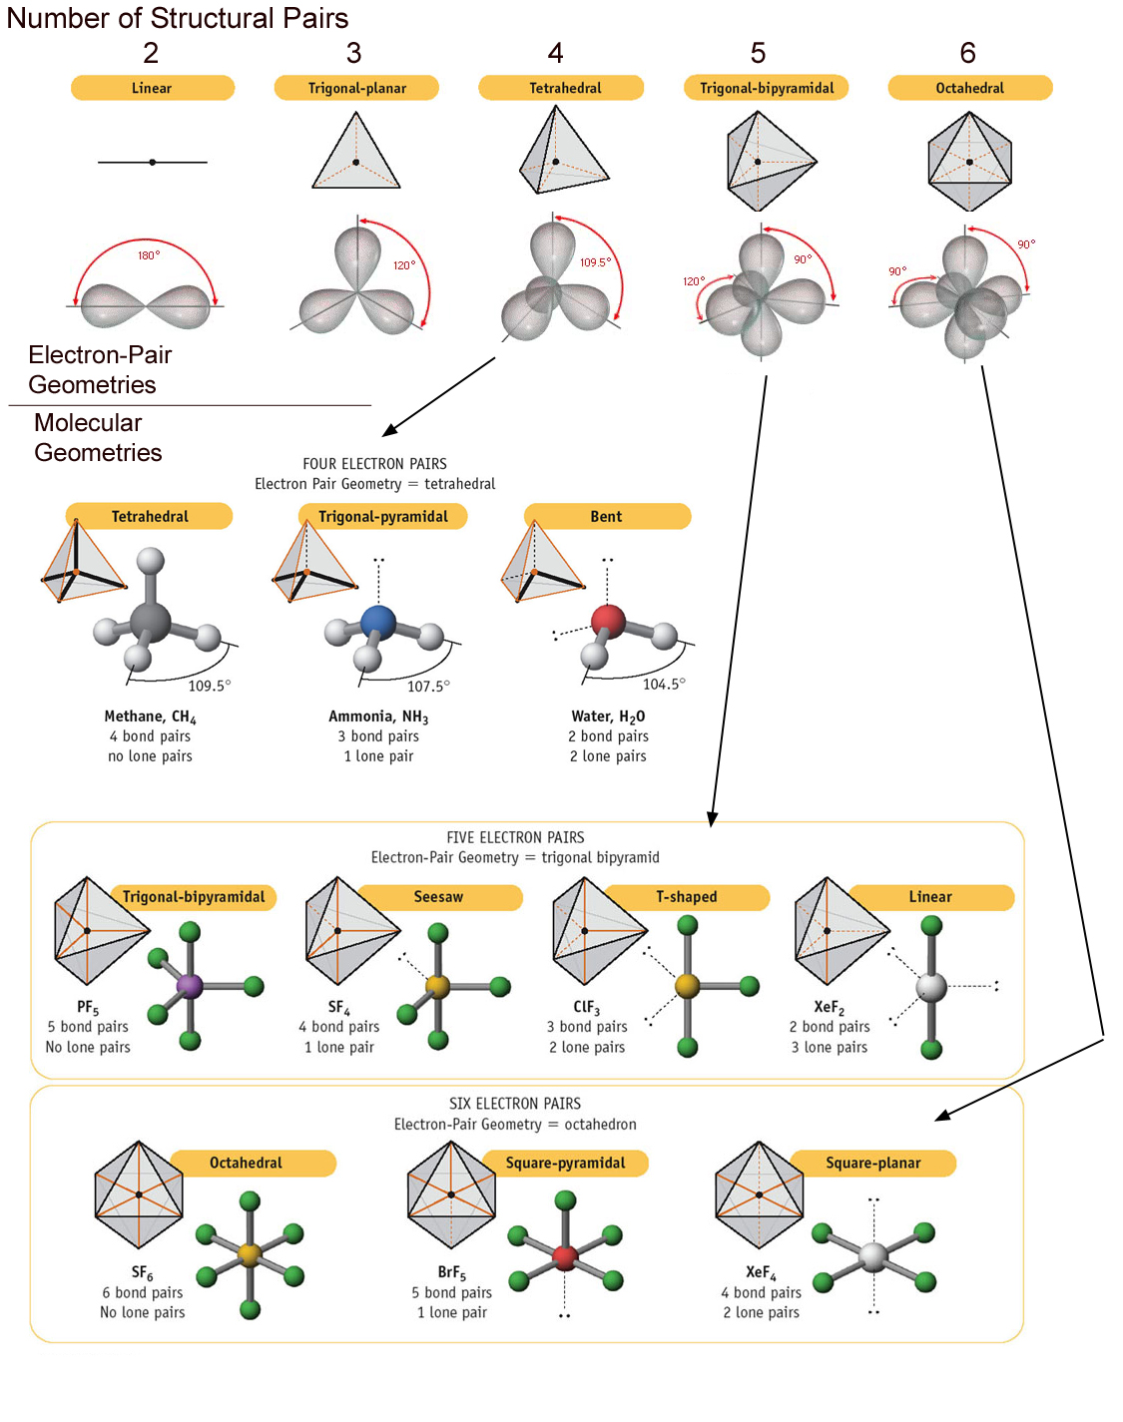
Figure 1. Electron pair geometries and molecular geometries [7]

- Two-dimensional (2D) models
In order to represent such configurations on a two-dimensional surface (paper, blackboard or screen), we often use perspective drawings in which the direction of a bond is specified by the line connecting the bonded atoms.
Figure 2 shows one of the examples of 2D perspective drawing of methane (CH₄) in tetrahedral molecular geometry. The convention is that the central atom of carbon is placed in the plane of the surface (paper/blackboard/screen). Bonds to this atom which also lie in this plane are represented by a line of normal thickness, whereas bonds lying off this plane are represented differently. Bonds directed out in front of this plane are wedged, with an atom/group at the thicker end of the wedge being interpreted as being nearer the viewer than the carbon to which the narrower end points. Bonds directed back behind this plane are hashed/broken .
Two-dimensional (2D) drawings inform us the positioning of atoms and bonds whether they are on the screen surface, behind it or in front of it. However, 2D drawing provides only a limited insight into the activity and molecular properties of a compound. These perspective structures have a limitation because it could not tell us the information about reasonably accurately the angles involved.

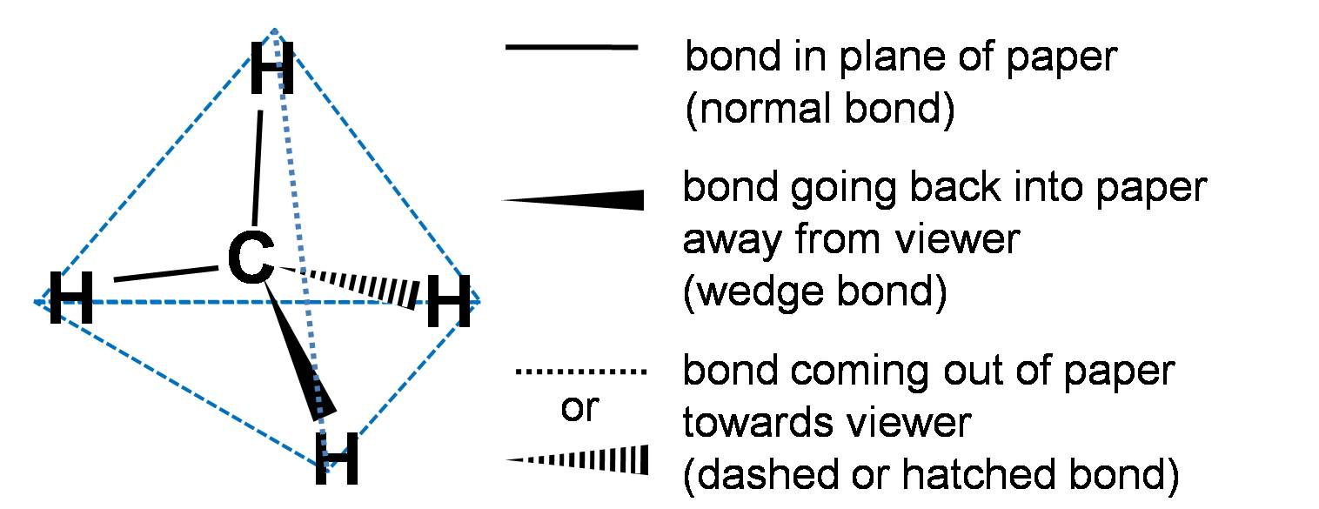

Figure 2. Perspective drawing in two-dimensional (2D) model of CH₄ in tetrahedral geometry

- Three-dimensional (3D) models using Origami technique for exploring molecular geometry
Aproper application such three-dimensional (3D) configurations are the best way to get the more realistic perspective views. Three-dimensional (3D) configurations can be viewed with the aid of models. Many 3D models for molecular geometry are available such as commercial molecular model kits, ball and stick models, software for molecular modeling, and computer simulation. However, many of commercial 3D models are expensive, while cheaper handmade model using plasticine, straw, toothpick or matchstick is easy to collapse (relative fragility restrict). Another model such computer simulation has also a limitation for its simulation learning difficulties by students.
Here we introduce one of the appropriate and simple 3D model, the origami technique for visualising the molecular shape method is a ‘hands-on’ approach in building molecules expected more intention while gaining the building experiences. Origami, the art of paper folding, is often associated with the Japanese culture. The word of origami is taken from ori meaning folding and kami meaning paper. Technical Origami transforms a flat sheet square of paper folded into intricate designs. This technique not only supports in designing but also in other fields such as a study in the field of engineering, mathematics, and science. In chemistry, origami might use as a model to approach the 3D molecular model.
Flinn scientific already develop origami pattern for several geometries such as trigonal pyramidal, tetrahedral, seesaw, square pyramidal, trigonal bipyramidal and octahedral. Another source of origami kit also was provided by Hanson, 1995 in his book of Molecular Origami published by University Science Book. USA. The patterns are drawn in Figure 3 are taken from the later source.
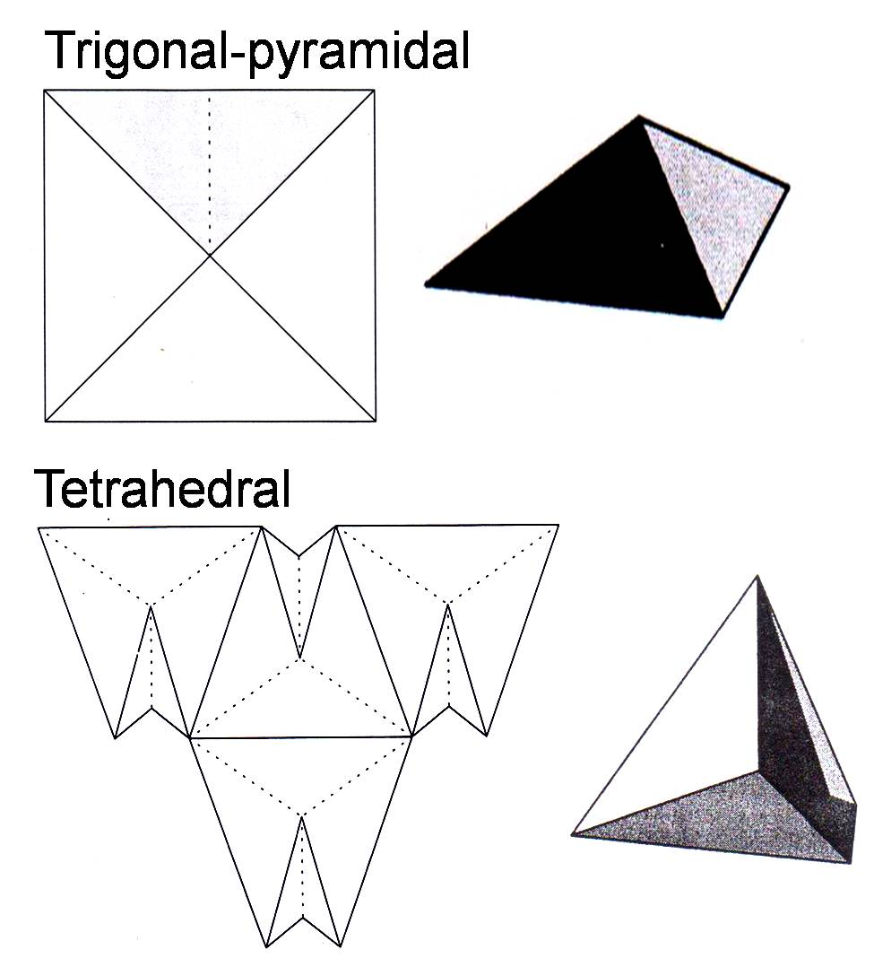
Figure 3. Origami patterns for trigonal-pyramidal and tetrahedral geometries.

The patterns were drawn by solid and dashed lines. They are represented to “mountain” folds, which fold away from the viewer and “valley” folds, which fold toward the viewer. The shaded regions can be either removed or simply folded back and tucked into the hidden recesses of the model.
The two basic 3D molecular shapes are trigonal-pyramidal and tetrahedral. The trigonal-pyramidal consists of four atoms with one central atom located above the plane of the other three atoms. The tetrahedral consists of five atoms, one central atom, and four surrounding atoms. An extra atom is situated above the other four atoms.

- Applied cases: H₂O, NH_{3,} and CO₂
In this article, we discuss the molecular geometry study focused on a simple chemical structure such as the molecular structure of H₂O, NH_{3,} and CO₂. To determine their molecular geometries, we started to write its Lewis structures shown in Figure 4.
To write the Lewis structure, the valence electrons for each atom in the molecule should be counted first. The number of valence electrons on each atom can be determined from the electron configurations of the elements. The electron configuration of hydrogen, carbon, nitrogen and oxygen are shown below:
H: 1s¹
C: [He] 2s² 2p²
N: [He] 2s² 2p³
O: [He] 2s² 2p⁴

Thus, hydrogen, carbon, nitrogen and oxygen have valence electrons of one, four, five and six valence electrons, respectively. Using these of electron valence numbers, the writing symbols that contain the correct number of valence electrons for the atoms in the molecule can be performed. Following this step, the electrons are then combined to form covalent bonds until a Lewis structure in which all of the elements (with the exception of the hydrogen atoms) have an octet of valence electrons can be achieved as shown in Figure 4.

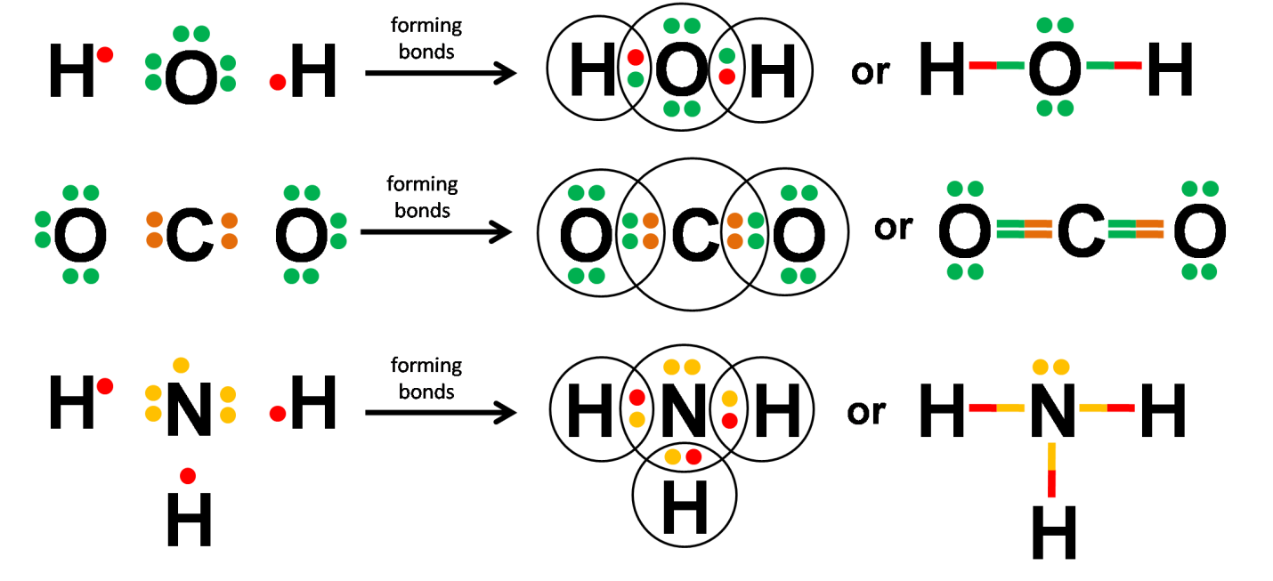
Figure 4. The Lewis structure of H₂O, CO₂, and NH₃

The Lewis structures could not satisfy the perspective of the molecular geometry. Using VSEPR theory, the molecular geometries are then can be predicted. For example, in H₂O molecules, it has two bond pair and two lone pair electrons. Thus, its molecular geometry predicted in bent structure. Another example for NH₃, it has three bond pairs and one lone pair electrons. Thus it has trigonal-pyramid structure. While for example of CO₂, all electron pairs in a multiple bond count as one bond and contribute to molecular geometry the same as a single bond does. The carbon atom in CO₂ has no lone pairs and participates in two double bonds. Each double bond counts as one for the purpose of predicting geometry, so the structure of CO₂ is linear.
Even though, using the VSEPR theory, students could well predict the molecular geometries, the visualization of molecular shapes are still required. The molecular shape of H₂O and NH₃ are one of the examples that need to be explained. Before applying the VSEPR theory, the student may have a question “why is the geometry of H₂O different from CO₂?”. CO₂ has a linear shape while H₂O has bent structures. The other come-out question might be “why is not NH₃ flat?”. To explain this well, it better to use the two- or three-dimensional (2D or 3D) model to visualize and explore the molecular shape of the molecules.
Using a ‘hands-on’ approach through origami technique, students will be also able to construct the molecular geometries of simple molecules and reasoning the causes of it. The hands–on origami technique only requires a few materials shown in Figure 5 (left) such as origami papers, pen, glue, balls and needle to attach the ball if needed. The balls will represent to the lone pair electrons which spend more space than the bonding electrons.
For example, in the case of ammonia, NH₃, at first using a Lewis structure, students might predict the structure in planar as shown in Figure 4. Even though, the lone pair electrons could be drawn; its 2D drawing shows the molecular shape was enough satisfied in a planar orientation. Through origami approach, ones could follow the folding using the trigonal pyramidal pattern as shown Figure 3. Before folding (Figure 5 (centre)), the position of nitrogen and hydrogen atoms enough satisfied in a planar orientation. However, realizing a lone pair electron exists in the nitrogen corner, the molecular geometry was then changing. As VSEPR theory predicted, there would be electron repulsions not only among the bonding pair electrons but also between bonding electrons and lone pair electron [1-3]. In the case of NH₃, three bonds of N-H were repelled by a lone pair electron on the nitrogen atom. Here, a lone pair electron on nitrogen atom was represented by a ball attached to the top corner of nitrogen. The existence of ball will reduce the satisfaction of planar orientation, due to the repulsion of bonding pair electron and lone pair electron is greater than repulsion among the bonding pair electrons [1-3].
Finally, using this origami approach, ones not only might predict the molecular shape but also could understand the reason for the change at the beginning of their study. Furthermore, they might directly describe the molecular shape in 2D drawing without doubtful with full understanding.

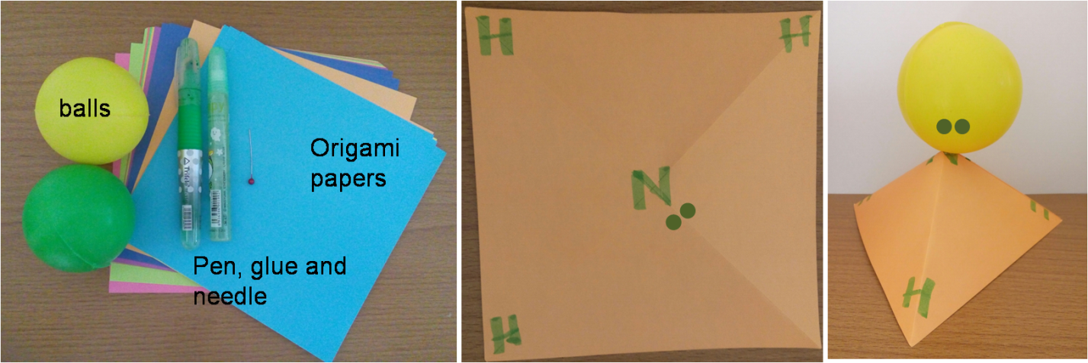
Figure 5. The origami materials (left); before (centre) and after folding (right)

The representation of the changing of molecular geometries of three of simple molecules, H₂O, CO₂, and NH₃, are shown in Figure 6. Ones (the students) should be able to explain the changing of the molecular geometries as a result of applying the VSEPR theory. Due to the presence of lone pair electron on the oxygen atom, the geometry of H₂O will not satisfy in a linear shape. H₂O has a steric number of 4, with two lone pairs and two bond pairs, making its molecular geometry "bent". As a result, the angle between the two oxygen-hydrogen bonds is approximately 104.5°, which is slightly smaller than the angle typically found in tetrahedral-shaped molecules. This is due to the particularly strong repulsions by the lone-pair electrons on the oxygen atom, which pushes the hydrogens closer together than usual.
Due to the same reason, the NH₃ geometry could not be fitted in planar shape. Meanwhile, the CO₂ structure is suited in linear geometry since no lone pair electron owned by a carbon atom.

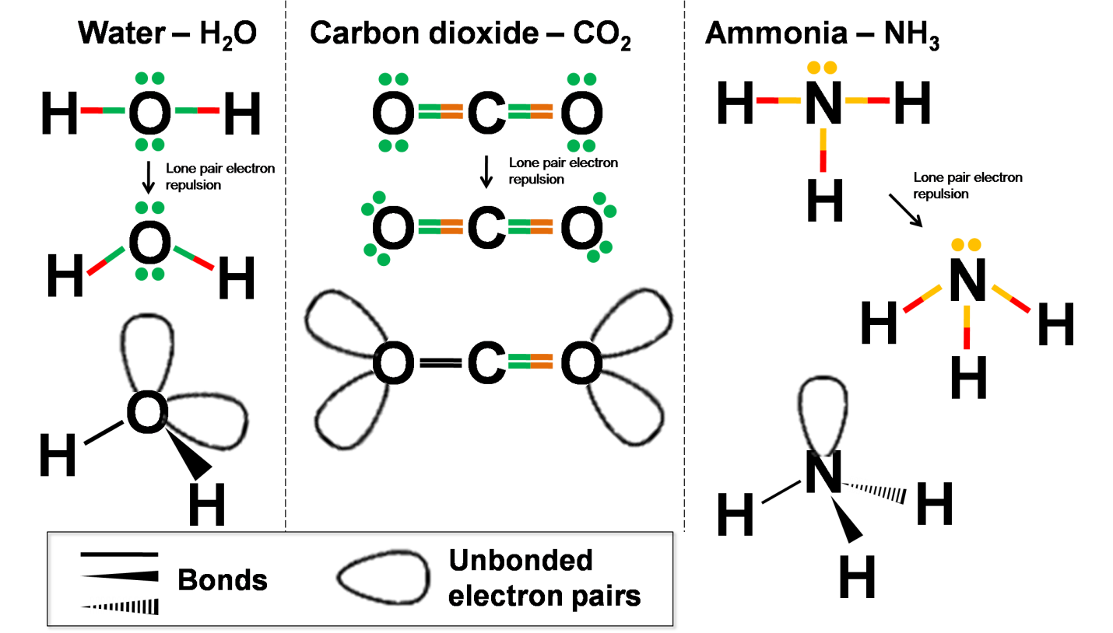

Figure 6. The representation of the changing of molecular geometries of three of simple molecules, H₂O, CO₂, and NH₃.

- Summary
One of the appropriate and simple 3D model, the origami technique for visualising the molecular shape method is a ‘hands-on’ approach in building molecules expected more intention while gaining the building experiences. The present technique is simple, readily accessible and inexpensive compared with other sophisticated methods such as computer modelling/simulation and three-dimensional expensive commercial model kits. This method can be implemented in chemical education both at high school and university level studies. Applying the origami technique at the beginning of the molecular shape study, the students not only might predict the molecular shape but also could understand the reason for the change at the beginning of their study. Furthermore, they might directly describe the molecular shape in 2D drawing without doubtful with full understanding.

Acknowledgment
This work was supported in part by Grants of PNBP 2015 in the scheme of Hibah Ipteks bagi Masyarakat provided by Sebelas Maret University.

References
- Rayner-Canham, G. and Overton, T. (2010) Descriptive Inorganic Chemistry, W. H. Freemen and Company, USA.
- Housecroft, C. E. and Sharpe, A. G. (2005) Inorganic Chemistry, 2nd edition, Ashford Colour Press Ltd., Gosport, England.
- Mȕller, U. (2006) Inorganic Structural Chemistry, 5th edition, John wiley & Sons Inc., USA
- Mitchell, D. (2005), Mathematical origami, Tarquin Publications, St Albans, UK.
- Davis, J. (2010) Origami: a versatile modelling system for visualising chemical structure and exploring molecular function, Chem. Educ. Res. Pract., 11, 43-47.
- Hanson, Robert M. (1995) Molecular Origami: Precision Scale Models from Paper. University Science Book. USA.
- http://employees.oneonta.edu/viningwj/chem111/molecular%20geometries.jpg [accessed on Sept 8, 2015]

Development Performance Assessment Instrument with Estimating the Reliability Using Generalizability Theory

E Susilaningsih*, S N Suwaibah and Sudarmin
Chemistry Department Matematics and Natural Sciences Faculty Semarang State University

*E-mail: endang.arkan@yahoo.com

Abstract. The aim of this research was to develop the performance assessment instrument of salt hydrolysis experiment on Senior High School with estimating the reliability used generalizability theory. The subjects of this research consisted of 35 students of Islamic Senior High School 1 Semarang. In this research pre-experimental one shoot case study was used. The stages of this research are need analysis, design instrument, validation and testing. The data analyzed by using quantitative descriptive analysis and the reliability estimated by using generalizability theory. Two-facet crossed G-study and D-study design were used where three rater graded 13 item student performance. Results of analyses showed there was interrater reliability coefficient of performance assessment was 0.717. The results showed instrument performance assessment on salt hydrolysis experiment were valid, reliable and practice.
- Introduction
The question “what is the better method to teach science?” is an essential thing of educator, especially on the chemistry lesson. There are some arguments about the better method on the chemistry teaching and learning process. Some educators judge that the transferring of knowledge to students must be not sufficient. They sure there are not only content, but skill students also should acquire, in the language art know “hand-on, minds-on” in sciences. Thus, the method which not only provide the content knowledge, but also student’s skill is needed.
This fact showed the constructive approach to learning was potential as a solution. One of the strategies of this teaching and learning solution is laboratory activities. Laboratory activities have suggested many benefit, this class engage the students in investigation, discoveries, inquiries and problem solving activities [1]. The laboratory activity also can develop the skill of student, science process skill. Beside it, this class provide conceptual development and can increase the scientific attitudes and scientific inquiry. In the chemistry lesson, the laboratory activities would help students to contruct the chemistry knowledge and develop the phicomotor skills [1].
The student’s achievement on the purpose of laboratory class needs to be assessed and evaluated to know the efectiveness of the laboratory class. An assessment also provide useful feedback to teacher in real student achievement. This is the function of assessment, to assess the student competences achievement and to improve the learning process. On the learning process, an assessment was to be part of learning (assessment for learning) and to improve the student on the study (assessment as learning).
Assessment is important part on the sciences learning, including the laboratory class. The assessment, teaching and learning are so closely. There were connection between teaching, learning and assessment. The effective assessment strongly linked to teaching and learning.
The traditional assessment provide conventional selected response test formats, like multiple choice, true/false, matching etc. This kind of assessment provide only a snap shooter a “one moment in time” picture learning. Traditionally, teacher assess the student’s performance in the laboratory on the basis of their reports, during and after the laboratory exercise [1]. But, this kind of assessment reglading the important component of student performance during the experiment exercise. The performance assessment gives opportunity to demonstrate their understanding of concept and skill as they would in the world outside of school [2].
Many reliability estimators have been developed the by the genereal definition: the ratio of the true score variance to the observed score variance. These conceptualizations of reliability can be classified into four groups: stability, internal consistency, interater reliability, and criterion reliability, where the first two represent classical definition of reliability and the latter two represent modern reliability [3]. One of the group of reliability is interrater reliability that measure the degree to which the ratings made by different raters evaluating the same test agree with each other [3]. The numerous existing utilizing measure interrater reliability, Generalizability Theory provide models and methods that allow an investigator to disentangel multiple sources of error (facets) [4].
The aim of this research was to develop the performance assessment instrument of salt hydrolysis experiment on Senior High School with estimating the reliability used generalizability theory. Instrument developed is kind of performance assessment instrument that assess the student performance on the salt hydrolysis experiment. This research gives literature on the developing the same performance assessment and can be used as instrument on assess the student achievement on the laboratory class.
- Method
This research are Research and Development, R & D. Development research use to developing performance assessment instrument to assess the student performance on salt hydrolysis experiment. The subject of this research is student of second grade of MAN 1 Semarang. In this research subject used were 15 students on first and 35 students on second testing of instrument.
In this research pre-experimental one shoot case study was used. The stages of this research are need analysis, design instrument, validation and testing. The data is analyzed by using quantitative descriptive analysis and the reliability is estimated by using generalizability theory. The reliability of this research is interrater reliability, that are agreement reached of the raters using generalizability theory [5]. Reliability of this research estimated using GENOVA (A Generalized Analysis of Variance System) computer application program [4]. Two-facet crossed G-study and D-study design were used where three rater graded 13 item student performance.
- Discussion
The performance assessment instrument that have been developed were the performance assessment on the salt hydrolysis experiment. The instrument contains the 13 task that help the student on the experiment process of salt hydrolysis. The performance assessment instrument used to guide the student through the explanation of the scoring process on the judge the student performance. This performance assessment instrument contains some skills that students must have/need to have on the experiment, they were consist of three parts: the skill must have by student, the description of the skill using sentences with or without the pictures, description to assess the student performance.
The skill that is used on the performance assessment instrument were observation, experiment, interpretation data and communication. Every science skill process developed as the step of the experiment that doing by students. The performance assessment instrument consist of the observation sheet and rubric.
The first of performance assessment instrument was the observation sheet. The observation sheet is the sheet used to collect the judge on the assess the performance student. Every student of the class is judged by the teacher on the experiment process. This sheet consists of column containing the names of the students and the table score of the judges students skills. The second instrument was rubric of performance assessment instrument that developed by researcher. This rubric is used to guide the teacher on the assess the students performance with some rating scale very good, good, neutral, bad, and very bad. The rubric of this instrument was developed to help teacher give objective score on the assess the students performance by using rating scale, it means every skill have by student observed and determined the scored they got.
The performance assessment developed validated by content validity produce the instrument that valid. The performance assessment instrument have been developed judge by expert that choosen. The expert of this judge is from the chemistry major of University of Semarang State. Content validity of this instrument have purpose to measure the instrument embrace the content that are what are part of the instrument on the developed instrument have been appropriate with the aspec or variable of assessment that assess. On this stage the instrument that developed evaluate and give comments of expert [6].
The instrument reliability that is analyzed by using generalizability study presented in Table 1. This table provides a summary of the final result the generalizability study on the first and second test. The reliability of the instrument analysis is the result of the performance assessment when the student doing the hydrolysis salt experiment. The reliability of the instrument showed by the value of generalizability coefficient that the minimal value of coefficient must equal or higher than 0.7. On the table showed both of the result of reliability analysis higher than 0.7. In contrast, the result showing the generalizability of the first test is higher than the second test.

Table 1. Summary of Final Result the G Study of the performance assessment on the hydrolysis salt experiment
Test | Item | Generalizability Coeffisient | Reliability  (≥ 0.70)
1 | 13 | 0.72* | > 0.70
2 | 13 | 0.71* | >0.70

Result of the estimating the reliability on the Table 1 shown that the performance assessment instrument achieved the level of interrater reliability for the scoring rubric of salt hydrolysis experiment. The result shown the coefficient index G study were 0.72 and 0.71. The G study coefficient shown that the coefficient are higher reliability estimates than the standar value G study coefficient, that is 0.70 [7]. This G study coefficient shown the relatively level of agreement of rater on use of the scoring rubric. High level of reliability shown that observed scored near the real observed scored, so that the observed scored represented the real observed scored. This level of reliability of rater only obtained when the rater agreement are high too.
According to the result from the student’s performance assessment used 35 subject. The table 1 showed the generalizability coefficient the result is 0.72, this result means the reliability of the instrument have been higher that minimum criteria of the generalizability coefficient. So that, the performance istrument developed reliable. Thus, performance instrument that developed on the assess the student performance on hydrolysis salt experiment can used by teacher to assess on the experiment class.
Each students performance is scored all five dimensions using rating scale 1 to 5. The performance assessment of the student process science skill performance focused on observed, interpreting data, experimental planning, using material and tools, doing experiment and communicating. the result of performance assessment of students process science skill on salt hydrolysis experiment on first present on Picture 1.

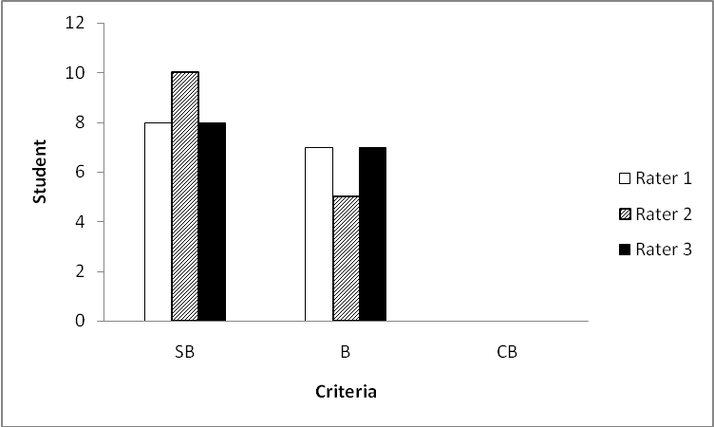
Picture 1. Comparison of Student Performance Assessment on the Second Test.

The picture shows that the first rater gave a very good mark to 8 students or 53.33% of the students and a good mark to 7 students or 46.67% of the students. The second rater gave a very good mark to 10 students or 66.67% of the students and a good mark to 5 students or 43.33% of the students. The third rater gave a very good mark to 8 students or 53.33% of the students and a good mark to 7 students or 46.67% of the students.
The result of performance assessment of students process saience skill on salt hydrolysis experiment on first present on Picture 2. The picture shows that the first rater gave a very good mark to 19 students or 54.28% of the students and a good mark to 16 students or 45.71% of the students. The second rater gave a very good mark to 21 students or 60% of the students and a good mark to 14 students or 40% of the students. The third rater gave a very good mark to 19 students or 54.28% of the students and a good mark to 16 students or 45.71% of the students.
The salt hydrolysis experiment using performance assessment instrument showed that the result of student performance assessment on skill observed, interpretation, experiment, and communication. The student performance assessment on the experiment of salt hydrolysis using performance showed that the experiment using performance assessment instrument showed the good performance, means that the instrument can help the student to doing experiment.

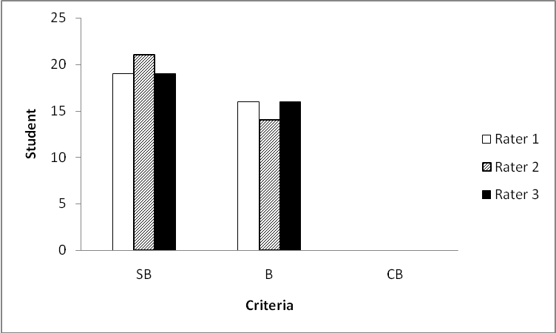
Picture 2. Comparison of Student Performance Assessment on the Second Test.
- Conclusion
This research are Research and Development, R & D. Development research use to developing performance assessment instrument to assess the student performance on salt hydrolysis experiment. The subject of this research is student of second grade of MAN 1 Semarang. In this research subject used were 15 students on first and 35 students on second testing of instrument.
References
- Hofstein A 2004 The Laboratory in Chemistry Education Thirthy Years of Experience with Developments Implementation, and Research Chemistry Education Research and Practice 5 247-264
- Marzano R J 1994 Assessing Student Outcomes Performance Assessmentt Using the Dimensions of Learning Model Alexandria Association for Supervisions and Curriculum Development.
- Gugiu M R, Gugiu P C and Baldus R 2012 Utilizing Generalizability Theory to Investigate the Reliablity of the Grade Assigned to Undegraduate Research Papers Journal of Multidiciplinary Evaluation 8 26-40
- Brennan R L 1983 Elements of Generalizability Theory. USA: The American College Testing Program
- Mardapi D 2012 Pengukuran, Penilaian, dan Evaluasi Pendidikan Yogyakarta: Nuha Medika
- Sudrajat A, Anna P S, Asmawi Z, & Buchari 2011 Pengembangan Rubrik Asesmen Kinerja untuk Mengukur Kompetensi Mahasiswa Melakukan Praktikum Kimia Analisis Volumetri Jurnal Chemica 12 1-8
- Panayides P 2013 Coefficient Alpha Interpret with Caution Europe’s Journal of Psichology 9 687-96

Relevance of Improvement of Items Domination with
Students Character Values Through Chemical Environmental Lecturing Base on Problems

M Nuswowati

Chemistry Departement of Mathematic and Science Faculty, Semarang State
University

E-mail: nuswowati@gmail.com

Abstract. This research is aim to improve student character values and items domination through environmental chemical lecturing base on problems. Our nation character values also include with taking care of environmental continuity which have seen progressively be worried. Require to be conducted an efforts to increase the character values through formal activity and also non formal. This research is conducted to student of program study of chemical education in a public campus in Semarang city who taking environmental chemical class at even semester. Experiment class (23 student) and for control class (23 student). Research result of experiment class show N-gain items domination is 40% (middle) and control class is 33% (middle), while N-gain character values for experiment class is 33% (middle) and control class is 22% (low). Result of correlation Product Moment analysis for the experiment class (n = 23) showing value r = 0,814 with value significant is 0,052 more than 5% = 0.05, hence told improvement of items domination and character values not significant. Improvement of character values require to be conducted continually with various strategy according to item subject and student needs.

1. Introduction
The universe is as a whole that can be separated into chemistry, physics and biology, but universe itself does not recognize this separation. The separation is merely to facilitate our understanding of events in nature [1]. Collage subject of environmental chemistry discusses environmental chemistry and its role, pollution of soil, air and water, the effect and how to cope, waste water treatment, additives in food and pesticides [2], as an optional course in the 6th semester, Environmental Chemistry became one of the subjects that must be taken for students majoring in chemistry Unnes. Each material consists of several chapters to be discussed one by one and as far as possible be applied in everyday life [3], as the reason that environmental education is also one important factor in achieving success in environmental management, a means which is very important in generating human resources to carry out the principles of sustainable development.
The continuation development principle of education in Indonesia needs to be supported with character education. Today, the character education has become a trend and an important issue in our education system. Efforts to revive the (reinventing) character education is certainly is not making it up, but it is the mandate outlined in Act No. 20 of 2003 on National Education System in Article 3, which states that national education serves to develop the capabilities and forming character and civilization of dignity in the context of the intellectual life of the nation. Character education goals referred currently perceived still inadequate. It is possible to integrate the principle that effective character education. If these issues raised in the study of learning chemistry would be very interesting and meaningful to learners, because the benefits are felt directly. Learning aimed at solving actual problems it was designed through a problem-based approach or PBL (problem based learning) [4]. Teaching strategies with the manufacture of paper every teaching materials with examples of enrichment material base learninng dominated problems increase the likelihood of students see the reality what is done, so that students feel kontens and context [5]. The advantages of PBL, designed especially to help students develop thinking, problem solving skills, intellectual skills: study the role of adults with experience through a variety of simulated situations; and independent learners and autonomous [6]. So the study was designed to develop a chemistry lecture-based environmental problems that can increase the values of character and mastery of the material.

2. Method
This research is a study of learning innovation with non-equivalent design (pretest and posttest) Control Group Design Nonequivalent Control Group Design [7]. At this design the experimental group and the control group was not chosen at random. The study was conducted at the Department of Chemistry, State UNNES education. Subjects were students of the second semester of chemistry department of education who signed the environmental chemistry courses. In this study were taken two classes of class E (23 students) for experiments, while the K classes (23 students) for control.
This study, both groups of experimental and control groups were compared, although the group is selected and placed without via random. Two groups that exist given the pretest, then given treatment, and given postes in the last, can be seen in Table 1.

Table 1. Non –equivalent (Pretes & Postest) Control Group Design in testing the effectiveness of lectures.

Groups Pretest Treatment Postest

Experiment O X1ª O
Control O X2^{b} O

ª Applying a Model Class Environmental Chemistry with problem-based learning approach.
^{b} Applying Environmental Chemistry Class model used to date.

Types of instrument that would be used to collect the data in the research plan can be seen in Table 2.

Tabel 2. Types of instruments needed to be prepared in research

Types of instrument Description

Student character marker test This test is used to measure the character of students, which includes the elaboration of indicators reason thought, attitude and action. This test is given in the pre-test and post-test.
Masteriy of subject test Multiple choice test and a subjective or essay of materials / environmental chemicals associated with environmental problems. This test is given in the pre-test and post-test
Student questionnaire Getting the student responses to the environmental chemistry lectures development
Student observation sheet Guidelines for the implementation of the observations of students in lectures
The data analysis was conducted simultaneously between quantitative and qualitative data Creswell (2008) [8] called triangulation mix-design method. Processing of quantitative data in this study were analyzed by Normalized-gain (N-gain). Whereas the qualitative data were analyzed using a generalized description of the research results.

3. Result and explanation
3.1. Characteristic of Environmental Chemistry lectures based problem
Environmental chemistry lectures designed to develop creative thinking skills students use the strategy of the stages of problem-based learning approach. Lectures orientation designed with environmental issues, the formation of the group, the investigation group. Lectures designed to combine problem solving that has been done by the government or previous investigators, searched their advantages and disadvantages. The environmental chemistry course consists of four topics, they are air chemistry, air pollution and how to overcome them; soil, polluting the land and how to cope; water, water pollution and how to cope as well as chemical and public health.
The steps done in this lecturing activity is environmental chemistry lectures to enhance the character values of students in participating resolve environmental problems particularly related to the chemical through problem-based learning approach to enhance the character values. Characteristics of environmental chemistry lectures with problem-based models are:
- Syntax-Based Environmental Chemistry Class Issues to improve the character values include Introduction, Planning, Investigation, Convirmation and Evaluation.
- Problem-based learning model in enhancing the value of character concerned with the stages of the course with an open-ended problems.
- Class centered on students by providing the widest possible opportunity to students to be involved actively in lectures and open-ended problems.
- Class begins with the presentation of environmental contaminants issues were resolved to the stages of problem based learning through group investigation conducted in the classroom, in the laboratory and in the field when perkuliaahan or outside the lecture schedule.
- The evaluation was performed to assess the increase in value- character and mastery of subject
matter the student in writing.

Table 3. Syntax Class with PBL Model to Improve Student Character Values

Study steps Description

Introduction 1. Lecturer conduct orientation problems to be solved by each group either in theory, open-ended problems and, investigative groups, discussions and ideas in order to trigger certain actions in participating in problem solving
2. Form a group, in a class made 6 groups. Each group determines the problems (open ended question) for each topic.
Planning 3. Students act quickly determine the essential problem, identify problems in lapangn especially in the neighborhood we all, classifying the issues, reviewing the information, literature, tools and materials needed to resolve the problem, also did the division of tasks within the group.
Investigation 4. Response, the advantages and disadvantages settlement of problems that have been taken by the government / previous researchers
5. Bring up the idea of settlement problems of environmental problems
6. Students do a group discussion to draft action
7. Perform the actions in solving environmental problems
8. To discuss the problem-solving action
9. Write down the results of the discussions associated with the study of theory
10. Prepare the presentation materials
Confirmation 11. Lecturer facilitate ongoing class discussion
12. Students present the results of the study of theory and action ideas
13. Students of other groups asking questions, comments and suggestions to clarify their understanding
14. Lecturer ask a few questions to direct the implementation of the presentation and give strengthening their understanding
15. Lecturer urges mindfully, each individual act upon the idea of the group even more benefits
Evaluation 16. Students do a group discussion to improve the results of the study of theory and classroom discussion results
17. Students create individual reports
18. Lecturers assess mastery of subject matter and increase the values of the characters.

3.2. Increasing character values
Character values marker revealed from character values response tests. The test consists of 14 questions, the scoring criteria is 1 to 4, a minimum of 14, maximum value is 56, so the average pretest marker character for the experimental and control classes are 35.00 and 36.04, before the lecturing activity in experimental or control class the character are categorized began to emerge character. It is based on grouping: Total score 14-24 = The values of character has not yet appeared; 25- 35 = values of character began to emerge; 32-45 = The values of the characters have already appeared; 46-56 = values are very good character. Post-tests were performed after application of the model as usual for control classes and lecture-based experimental class problem to get the average values of 40.04 and 45.04 characters, all belongs to the category of values and character has appeared and for the experimental class almost categorized as very good.
Through a written test marker character values, either experimental or control class class has increased. Pre-test mean score marker values character control class is 36.04, while his post-test 40.04, so we get its N-gain 22.00% is low. As for the experimental group mean scores of pre-test and posttest marker Nili character values are 35.00 and 45.04 to obtain its N-gain 48.00% were moderate. The results showed the application of the Class-Based Environmental Chemistry Problems can enhance the character values in the students behave in participating solve environmental problems. Figure 1 shows an increase in markers of character values or experimental class students who take the classes with pembeljaran based green chemistry problems better vision (N-gain = 48%) than the control class students (N-gain = 22%). This is due to the students in the class ekseperimen actively involved in the lectures and expressing ideas to participate resolve the existing problems, especially related to environmental pollutants. Granting open-ended problem also demands to use the data to draw conclusions (Cooper et al., 2008). Open-ended problem is an activity that can encourage and challenge students to determine the essential environmental issues of interest to be able to resolve the issue. This is in line with the opinion of Lickona of the components of this character when combined as a single continuous dynamics of the formation of morality is in the child's moral development. Santrock (2008, p. 316) [9].

Figure 1. The enhancement of students’ character values in the control and experimental class

3.3. The Increasing mastery of subject matter
Mastery of subject matter value taken from the results of tests mastery of subject matter all lectures topics chemistry chemical environment consisting of air, air pollution and how to overcome them; soil chemistry, soil contamination and how to overcome them; water chemistry, water pollution and how to
overcome them; chemical problems for public health. Multiple-choice test consisting of 20 questions with the results as in Figure 2.

Figure 1. The enhancement of students’ character values in the control and experimental class

Pre -test mean score mastery of subject matter the control class is 50.33, while his post-test 64.57, to obtain N-gain its 33% were moderate. As for the experimental group mean scores of pre-test and posttest mastery of subject matter is 55, 33 and 77.28 to obtain its N-gain 40.00% were moderate.
Increasing the value of mastery of control classes including medium category (N-gain = 33%). The experimental class the increase in value also includes the medium category (Ngain = 40%). Piaget explained that the development of cognitive structure is influenced by the interaction of learners with learning and social environment [10]. Vigotsky also argued that the learning activities and the development of a person's intelligence is influenced by the interaction with other people and the social environment [11]. Environmental support and adequate facilities for the group investigation activities, field studies, literature studies, discussions, consultations, presentations, evaluation will give better results. Therefore, it is necessary to arrange models that facilitate problem-based lectures as possible, ranging from the identification of the problem, determine the source of the problem, learn to consider the settlement of the existing problems, improve problem solving continuously.

3.4. Relevance of Character with concept mastery enhancement
Product Moment Correlation analysis results for the class of experiments demonstrating the value of r = 0, 814 with significant value is 0, 052 more than 5% = 0.05, so, it shows that there’s no significant relationship between character values and mastery of environmental chemistry concept enhancement. Calculations can be seen in Table 4.

Table 4. The relationship between character and mastery of concept matter enhancement

Correlations Mastery of subject matter enhancement Character enhancement

Concept mastery Pearson Correlation 1 0.052
enhancement Sig. (2-tailed) 0. 814
N 23 23
Character Pearson Correlation 0.052 1
enhancement Sig. (2-tailed) 0.814
N 23 23

Result of correlation analysis shows that students who have a good concept mastery values do not necessarily have the marker values of good character as well.

3.5. Student response to the implementation of Chemical environment lecturing based problem
The response of students to lectures conducted in the study were collected using a closed questionnaire that used to express the students consent of the statements contained in the questionnaire. Collecting student feedback is also done through open questionnaire to complete the data obtained from the closed questionnaire. Statement in the questionnaire grouped into two aspects, they are: I) a statement about the lecture component of environmental chemistry; II) A statement of the stages of the environmental chemistry lecture-based problem; III). Statement of sustainability-based environmental chemistry lectures problems; and IV) a statement about the feelings of students in working on those items in the student worksheets. Tabulation of data from filling the questionnaire distributed to students can be presented in Table 5. In the questionnaire was also provided public statement that can accommodate suggestions on the implementation of the presentation of the group in particular and improve the implementation of problem-based learning in enhancing the value of character in the future.

Tabel 5. Recapitulation of Student Response to the Chemical environment lecturing based problem

No Question description Recapitulation of student response

Very Interesting Less Not
Interested enough Interesting interesting

Ia How is your opinion on the
Following components?
1. Chemical environment topic 10 13 0 0
2. Chemical environment lecturing 14 9 0 0
based problem
3. Student guidance 12 11 0 0
4. Student worksheets 12 11 0 0
5. Learning environment 11 10 2 0
6. Lecture teaching method 15 8 0 0

Ib Do you identify new things in the Novelty Novelty Less Unnovelty
following components? enough enough enough
1. Chemical environment topic 4 13 3 3
2. Chemical environment lecturing 14 9 0 0
based problem
3. Student guidance 16 7 0 0
4. Student worksheets 17 6 0 0
5. Learning environment 16 7 0 0
6. Lecture teaching method 20 3 0 0

Ic Ease understood the following Very Easy Easy Less Easy Not Easy
components? enough
1. The language of chemical 13 10 0 0
environment topic
2. The language in the learning tools 12 10 1 0
3. Chemical environment topic 6 16 1 0
4. Chemical environment lecturing 9 12 2 0
model
5. Student worksheet 8 15 0 0
6. Student guidance 8 12 3 0
7. Lecture teacing method 10 11 2 0

II The use of problem-based lectures Very agree Agree Less agree Not agree 1. How do you respond if the subject 14 9 0 0
Of further use problem-based
Learning
2. How would you respond if all 9 11 3 0
subjects are taught with a problem
based approach
Tabel 5. Recapitulation of Student Response to the Chemical environment lecturing based problem (cont.)

No Question description Recapitulation of student response

Very Interesting Less Not
Interested enough Interesting interesting

3. What would you say if other 5 9 6 3
Subjects are taught with a problem
-based approach
III Question description Very clear clear Not clear Unclear
enough

1. How does the lecture explanation 17 6 0 0
when the PBL on going
2. How does the lecture guidance 16 7 0 0
from your investigation activity
to the ready-presented paper
preparation
3. How does the lecture guidance 10 13 0 0
when you doing the presentation
IV Do you feel happy in answering Very Happy Not happy Unhappy
the items on student worksheets happy enough
12 11 0 0

Almost all the students gave a positive response to the chemical components of the course in the implementation of the existing environment problem-based learning model. Of interest, novelty and ease, then in terms of material, model, student guidance, student worksheets, the learning environment and the way professors teach in environmental chemistry lectures almost all responded very interested, interested, very new, quite new, very simple and quite easy. From the 23 students, only three students who answered less new (less novelty) material, and 3 students answer is not new (unnovelty). One student replied that the language in the lectures is less easy to understand, one student stated that the chemical material is less easy to understand environment. There are two students who claimed the model of problem-based lectures are less easy to understand, three students expressed guide students in doing tasks, especially investigative group is less easily understood. 2 student also stating how the lecture teach less easily understood.

4. Conclusions and suggestions
4.1 Conclusions
Based on the research and discussion that has been raised, it can be concluded as follows:
- Lecturing model of chemical environment based problem that has been developed has the following characteristics: Syntax lectures include Introduction, Planning, Investigation, Confirmation, and Evaluation, which also integrates learning activities with the investigative group, open endet problem, centered on students, as well as the idea of action to solve the problem is done in groups.
- Lecturing model of chemical environment based problem can increase the character of students in solving environmental problems.
- Lecturing model of chemical environment based problem can increase the concept mastery,but there’s no a significant relevance with the character enhancement.
- The implementation of chemical environment based problem lecturing get a positive response from students. The positive response was also reflected a positive attitude when students attend the lecture, which was shown among other tasks, the group investigation, mostly hard work, responsibility, enthusiasm, perseverance, discipline, teamwork, respect the opinions of others, critical, and creative.
- The problem faced in this research is the facility equipment and materials must be taken when investigating problems in the field. As the chemical study program, then the selection of the environmental problem is related contaminants. We can overcome the problem must be passed: the identification of the problem, looking for the source of the problem, consider the settlement of the problem by the government / previous researchers, communicating ideas and evaluation.

4.2 Suggestions
Based on the implementation of chemical environment based problem lecturing in a public campus in Semarang suggested as follows:
- Model with open-ended problems can be developed further in other subjects, but not all are suitable for development.
- Stdy program of chemistry education should not only equip students with the content knowledge and pedagogical abilities, but also equips students with high-level thinking skills and a number of other skills.

References
- Purba, M. (2006). Chemistry For High School Class XI.Jakarta: Erlangga.
- Anonim. (2008). Curriculum Department of Chemistry. Semarang: UNNES Press
- Nuswowati, M. (2012). Chemical Environment. Teaching Materials. Semarang: Unnes Press.
- Liliasari. (2009). The use of interactive multimedia to enhance students’ generic science skills. International Conference on Rural Information and Communication Technology. Bandung: ITB.
- Johnson, E. B. (2002). Teaching & Learning, what it is and why its here to stay. California: Corwin Press.
- Arends. R.I. (2008). Learning to Teach ,7th edition 1st book.Yogyakarta: Pusat Pelajar.
- Fraenkel, J. R. dan Wallen, N. E. (1993). How to Design and Evaluate Research in Education (second. Ed.). New York: McGraw-Hill Book Co.
- Creswell, J. W. (2008). Educational Research Planning, Conducting, and Evaluating Quantitative and Qualitative Research. Third Edition. New Jersey: Pearson Education, Inc.
- Santrok, J. W. (2003). Adolescence (Perkembangan Remaja). Terjemahan. Jakarta: Penerbit Erlangga.
- Solaz-Portoless, J.J. & Sanjose, V. (2008). “Piagetian and Neo-Piagetian Variables in Science Problem Solving: Diections for Practice” Ciencias & Cognicao. 13 (2): 192-200
- Reigosa, C., & Jimenez-Aleixandre, MP. (2007). “Scaffolded Problem-solving in the Physics and Chemistry Laboratory: Difficulties Hindering Students’ Assumption of Responsibility”. International Journal of Science Education Education. 29, (3), 307-329.

Pedagogical Content Knowledge Debriefing for Chemistry Teacher Candidates

Sri Haryani*, Sri Wardani, and Agung Tri Prasetya

Chemistry Department Faculty of Mathematic and Natural Science Semarang State University
Kampus Sekaran Gunungpati Semarang 50229

*Email: haryanimail@gmail.com

Abstract. This study has aims to identify the impact of provisioning Pedagogical Content Knowledge (PCK) on the performance of chemistry teacher candidates in Practice Field Experience (PPL). PCK debriefing is focused through the Chemistry Lesson Planning (PPK) lecture, then the application is continued in the PPL course. This descriptive study involved 6 teacher’s candidates who measured their PCK capability start from PPK lecture up to their implementation in PPL. PCK of teacher’s candidates captured by filling CoRe and writing PaP-eRs representing PCK of a teacher as proposed by Loughran. The quantitative data is taken from the preparation of the lesson plan (RPP) and the fulfillment of CoRe, while the qualitative data is drawn from the analysis of RPP, CoRe and PaP-eRs linkages. Interview on the study subjects is also done to strengthen the linkages of three documents. Based on the result of data analysis, it is revealed that the PCK debriefing trough PPK lecture could increase the PCK capability of teacher’s candidates. PCK debriefing is able to minimize the weakness that have been prevalent as write apperception, sort material, and pay attention to prerequisite materials. The teacher’s candidates initially have problem deciphering the questions in the CoRe, and not accustomed to write PaP-eRs as a reflection of what has been done, so that needed simplification of questions in the CoRe and a guide to write PaP-eRs adapted from Loughran trough the preparation of rubric associated with the RPP.

- Foreword
Novice teacher standard competency/SKGP (Depdiknas, 2004) suggests that the teacher’s candidates should have four competencies, they are mastery of a field study, comprehension of learners, mastery of learning that educates, and development of professionalism and personality. One of the competence’s point in a mastery of learning competence clumps is models mastery, approaches, strategies, and learning methods appropriate to course materials. Meanwhile, high school chemistry teachers are required to have a quite complex competence in academic field (Permendiknas No. 16/2007), of which requires mastery and deep understanding of the content and teaching. Accordingly, teacher’s candidates need and importance to be equipped with strong mastery of basic concepts (content) and the ability to teach the concepts (pedagogy) properly and correctly. On the other hand, Shulman (1987) and Loughran, et al. (2008) states that the content knowledge and pedagogical knowledge should be integrated in learning to create new knowledge: Pedagogical Content Knowledge (PCK). PCK thinking concept gives the sense that the teaching of science is not enough only understand the content of science material (knowing science) but also how to teach. In addition, McDermott (1990) suggested the establishment of a quality learning process is highly depend on the quality in preparing the teacher’s candidates, so the learning by lecturers will have disseminated impact trough the students.
Debriefing teacher’s candidates in the preparing for understanding aspects of the content needed to organize the class trough pedagogical aspects, often cannot be obtained when he/she was in college. All this time teacher‘s candidates have a learning experience in these two domains separately. To learn the content or subject matter more deeply they learn in the context of the subject matter, to learn how to teach they learn in the context of methodology. As a result of those, only a few matches that occur between the need of learners with the teaching methods (Shulman, 1987). Deeper coordination is needed between the content expert and the pedagogical expert, so it could produce many benefits that make the teachers more knowledgeable, flexible and capable (Enfield, in Purwaningsih, 2011). Another things that profitable according to Loughran, et al. (2008) are with PCK debriefing in appropriate way, PCK is no longer considered merely as educational theory yet becomes a representation form of how they can develop their professional knowledge in their teaching practice.
In order to represent the PCK of a science teacher, Loghran, et al. (2006) developed a format that includes importance aspects of a successful science teacher in understanding the subject matter knowledge and pedagogy. This PCK special format consists of two elements. The first element is called CoRe (Content Representation); offer a perspective of a specific content that being taught when teach a topic. The second element is called PaP-eRs (Pedagogical and Professional-experience Repertoires), which is short but has a specific meaning and intended to show the implementation of CoRe aspects. PCK of teacher or teacher’s candidates can be measured using an instrument developed by Loughran, et al. (2004), CoRe and PaP-eRs. The result of CoRe and PaP-eRs will show the effectiveness of learning activity in accordance with the objectives to be achieved. Hamida (2011) proved that preparation of CoRe and PaP-eRs documents help trainees prepare lesson plans as well to reflect on the learning activity that they have done, so that the PCK profile will be intact.
Taking into consideration the importance of teacher’s candidates debriefing that aimed to combine pedagogical abilities and understand of the whole material content, then PCK debriefing trough the lecture program is a real need, very important and potential to do. Implementation of the lecture program that debriefed this PCK concept provide wider opportunities for student to take an active role in developing competence in preparing lesson plans (Loughran, et al., 2006; Purwaningsih, 2011; and Hamidah, 2011). Chemistry lesson planning is chosen because the achievement of competence in this course is able to design chemistry learning in school to escort PPL. Practice Field Experience (PPL) is a program where students get a first experience or live experience of teaching in the classroom, which requires students to practice integrating content materials and pedagogical materials which is expected to strengthen PCK capability. Therefore, to escort PPL, the implementation of PCK debriefing trough PPK lecture is very appropriate, necessary and important. PCK capability focused on the competence of teacher candidates in preparing CoRe documents, lesson plan, and PaP-eRs. The question that arise is: does the teacher candidates experience a change in their PCK?

- Research methods
PCK debriefing for teacher’s candidates focused on PPK lecture, followed by PPL in the next semester. Research subjects were selected based on consideration to participate in PCK debriefing and peer teaching and we choose 6 students who 2 PPL students at SMA Taruna Nusantara Magelang and 4 PPL students at MAN 1 Semarang. The form of improved performance from the teacher’s candidates in PPL implementation begins with PCK debriefing in PPK lecture through CoRe evaluation and drafted lesson plans, as well as PaP-eRs written after peer teaching carry out. At the time of PPL, teacher candidates prepared CoRe and lesson plans, implementation of classroom practice, continued to write PaP-eRs. Interviews were conducted to explore the relationship between written CoRe, lesson plans, implementation of classroom practice and PaP-eRs. Interviews also intended to find the factors that influence and constraints PCK development in teacher candidates.
Chronology of the research is teacher candidates will teach a lesson, they write the initial CoRe, along with the process they create lesson plans in a format that they already understand, continued by the implementation of classroom practice and concluded with writing PaP-eRs. CoRe result and lesson plans were analyzed quantitatively by scoring using scoring CoRe, so the result in the form of numbers. Average score of CoRe assessments, lesson plans and PaP-eRs presented on Picture 1. Qualitative analysis was done by analyzing the link between CoRe, lesson plans and implementation of classroom practice. Qualitative data were also supported by interview on the description they made in CoRe and PaP-eRs that both of them also associated with lesson plans and implementation of classroom practice. All data collected in the form of portfolio; lesson plans, guidance process with lecturer, CoRe, PaP-eRs and interviews. These portfolio collected to describe the overall data result. CoRe instrument was prepared based on Loughran's description (2007) that can be seen in Table 1. The performance evaluation of teacher candidates in preparing learning device during PPL period was taken from Peer Teaching Guide.

Table 1. Core Aspects Guide
This Core is designed for student in Middle Secondary School, i.e., year 10. | important science ideas/concepts
 | A | B | C | D | dst
What you intend the students to learn aboaut this idea?
Why it is important for student to know this?
Why it is important for student to know this?
This Core is designed for student in Middle Secondary School, i.e., year 10.
What else you know about this idea(that you do not intend students to know yet)
Difficulties/limitations connected with teaching this idea.
Knowledge about students’ thingking which influences your teaching of this idea.
This Core is designed for student in Middle Secondary School, i.e., year 10.
Other factors that influence your teaching of this idea.

- Results and discussion
Implementation result of PCK debriefing trough PPK lecture held at the time of PPL. Each of research subject in its PCK progress is monitored through interview or discussion about analyzing the CoRe and PaP-eRs. In addition, PPL supervisor visits the school with the research team. Discussion with each teacher’s candidates done before or after learning activity to explore more-in depth information about understanding the content being taught or anything else about learning activity needs to be discussed together. PCK capability analyzed from CoRe descriptively associated with prepared RPP. Interviews are used to support the linkages of the three documents, and are reflective to the PCK capability. Based on Figure 1 can be seen that PCK capability of teacher candidates measured through CoRe and PaP-eRs appropriate with the ability of the preparation of the lesson plans. The findings of this study are appropriate with Goolam Hossen (2013) which found that the higher the conceptual understanding of teacher candidate students, the higher the pedagogic abilities possessed (Ozden, 2012). Although there are teacher candidate students who have a good pedagogical ability by another factor, which is communication skill.
Analysis of PCK capability begin from PCK debriefing through PPK to the implementation of the PPL. In general, after the third assessment, improvement arise. In this third assessment conduct interviews to reflect on what has been written, and this increase was the most noticeable on the subject number 2 and 6, while the increase of the other subjects has begun on the second meeting.

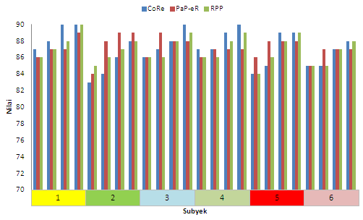
Figure 1. Average result of CoRe, RPP, and PaP-eRs assessment.

Along with the CoRe document and PaP-eRs preparation activities, also held the discussions with each of the research subjects before and after the implementation of the PPL in the classroom. All the teacher’s candidates do not ask for an explanation again on how to prepare CoRe document and PaP-eRs because they have acquired during PPK lecture. Other issues were discussed between researcher and teacher candidates, among others: (1) preparing apperception so that learning activity becomes meaningful; (2) prerequisite materials, (3) the depth of the material, (4) misconceptions that may arise, (5) preparation of RPP based on learning models, and authentic assessment. Here’s an example of linkage description of CoRe document and PaP-eRs with the preparation of RPP that has been written by research subject including CoRe assessment rubric.
Core document questions, number 1: What do you want the students to learn from this idea? This question relates to teacher’s understanding of the material that will be provided associated with the indicator and learning objectives. Some teacher’s candidates using sub topic of the order in the required competencies. As an example for the material of molecular geometry begins with the electron configuration, the stability of the elements, covalent bond, and the shape of molecule. However, there is one teacher’s candidate who wrote the following order: the electron configuration, quantum numbers, and the shape of molecule. After confirmed, the writing sequence based only from one book, regardless of the prerequisite materials and the achievement indicators of competency. The order of the material is associated with the prerequisite materials and also related with the writing apperception in the preliminary activities. In addition, it also deals with the CoRe question number 2. Another finding is that the depth and the broadness of the materials are not in accordance with determined indicators.
Core documents questions, number 2: Why it is important for student to know this? This question relates to the introduction activities which include orientation and apperception. Based on observations of the research team until now, generally both teacher and teacher’s candidates in writing orientation and apperception on the introduction activities only write to motivate students, but how to motivate are not included. Similarly, almost all the lesson plans that written, rarely even almost no one expressed the importance of learning the materials that will be discussed. In general, students have difficulty in making question, digging prerequisite knowledge to develop new knowledge, also trouble in connecting between prior knowledge students’ have and the material to be studied. This condition can be resolved though not optimal, the research subject who wrote CoRe document trying to write questions to explore students’ ideas about the prerequisite knowledge to develop new knowledge, as well as benefit for the student to learn the material. For example, the statement of one of the research subjects as follows: Chemical reaction that have many types and many consequences, like exothermic and endothermic reactions associated with the energy transfer. By knowing the type of reaction was exothermic or endothermic, in the future students are expected to know how to use the chemical reaction.
Core document questions, number 3: The other thing from this material that you know, but not yet known by the students? This question relates to the ability of teachers to make decisions about what needs to be given and what has to be given to the student so that the student's knowledge is not ambiguous. Teacher knowledge in determining the depth and the broadness of the material provided. This problem can be captured through writing material, many teachers and teacher candidates that pay less attention to this problem, for example linking Ar and Mr during Proust’s law material. By writing CoRe are expected to be able to overcome this weakness. Examples of writing CoRe: Students do not know about the stability of the elements, students not yet know about the Lewis structure. Students sometimes still cannot describe the structural formula of a compound and the difficulty of counting the number of bonds that exist in a reaction.
Core documents questions, number 4: Difficulties/limitations related to how to teach this material? Teachers’ knowledge in identifying students’ prior knowledge and difficulty in learning. Generally, teachers and teacher candidates stating that the student did not master the material related to mathematics, or because the material is abstract. In addition, the limitations of the equipment and chemicals, as well as the problem of time. In addition, research subject students also analyze materials that will be given and written in the lesson plan. As an example for thermochemistry material. This material is about the energy flow, and the flow cannot be seen. Students must also be able to distinguish precisely and correctly the difference between the system and the environment. This is important because the system and the environment will be a reference in the determination of a reaction, including an exothermic reaction or whether endothermic. The answers of those CoRe question set out in the lesson plan, for apperception and main activities that begins with assessment questions related material.
Core documents questions, number 5: Knowledge about students’ thinking which influences your teaching of this idea? This question relates to the ability of teachers in analyzing the knowledge that has been owned by the students, and in predicting the ability of students to absorb the material provided by the teacher. This knowledge relates to the writing lesson plans on preliminary activity (apperception), a description of the learning activities, and the writing material. Research subject student are ready preparing well lesson plans based on written CoRe. For example: Students may also be somewhat confuse intra-molecular and inter molecules interactions present in the molecule. So initially emphasized differences of the both. For example: Based on the heat absorbed or released, the reaction was divided into two, the exothermic and endothermic reactions. How do I distinguish between the two? Now we are going to do an experiment so we can distinguish and know the characteristics of exothermic and endothermic reactions.
Core documents questions, number 6: Another factor that affects the way you teach this material? This question is related to the description of the learning that is written in the lesson plan. In general, the conduct of the classroom learning is done both by teachers or teacher candidates begin with explanation step, exercises, then give problems to be one or a homework. Actually, students have enthusiasm and delightful doing experiment activity, but it is rarely done because in addition to laboratory facilities are also due to timing issues. Research subject students have thought about these issues through the writing CoRe before designed in the lesson plans. Here are examples of student statements: problems: students will be difficult to construct materials about intra-molecular and inter molecular interactions that exist in the molecule. . Solution: To overcome this, the learning media can be used in the form of an animated video featuring the two types of bonds in this molecule. Furthermore, teachers can also describe on the board to give further explanations about intra-molecular and inter molecular interactions.
Core documents question, number 7: The procedure of teaching (and the specific reasons for its use)? Consideration of teachers in selecting model / approach / method and strategy and the right media to teach concepts with specific indicators. In addition, also on the teacher's knowledge about the learning styles of each student to understand the learning material. In general, for the implementation in the classroom teachers and teacher’s candidates using conventional procedures, although in the writing lesson plans using a scientific approach. The draft made the research subject, described from one of the following CoRe documents. The method used is an experiment. For an exothermic reaction using quicklime dipped in water experiment. For endothermic reaction using ice melts experiment. Reasons for using this method is that students can see and observe for themselves the difference between exothermic and endothermic reactions. The use of these materials because it is easily obtained and very close to the students’ daily life. Another example: every interaction between molecules happens so that students will better understand and construct the type of interaction of each molecule. For example dipole moment interaction use H₂ gas as example while dipoles used the example of HCl.
Core documents question, number 8: The specific way to ensure students' understanding or confusion regarding this matter? Knowledge of teachers in assessing student’s learning. This question relates to authentic assessment should be prepared for indicators in particular basic competency. Research subject readiness in designing an evaluation tool on the lesson plans appears from the statement in the CoRe document as follows: for the indicator gives a picture subatomic elements along with the notation, the students are asked to come forward and draw protons, electrons, and neutrons based element’s notation. Reason: students can immediately understand and apply the number on the element’s notation by drawing it. Other solutions: through a written test and do the problems on worksheets as a practical guide students, from lab reports that were written.
Core Question number 1 and 3 is concerned with understanding chemistry materials of teacher’s candidates or students in general. Related to the mastery of concepts, Loughran, et al. (2012), said that teachers need to have a rich conceptual understanding of the content of certain subjects they teach. It shows that teachers should have the professional competence as set forth in the Regulation of the Minister of National Education No. 16 of 2007. Generally the difficulty that happens is the in determining the comprehensive ideas in accordance with the curriculum, how to identify the big ideas in the content, importance concept selection, the depth and broadness of a topic, and strategies used in teaching and learning which enables understanding of the events and phenomena that are relevant to students' lives (Harlen, 2010).
PaP-eRs document is a form of teacher reflection after learning activity in narrative form. This document differs from the CoRe document that can be done in group, since PaP-eRs done individually. Based on the results of teacher candidates writing can be described as follows:
- There is no one teacher candidates who wrote problems faced by teachers, all of them write down the problems faced by students. Through discussions with the research team they said that the problems that may occur are already resolved at the time of writing CoRe with the research team.
- In general, the research subject tells the course of the learning process, learning strategies that used, and only 2 research subjects that tells unexpected events.
- At the learning activities stage is not written in detail, because it was written in the lesson plans. The research team suggested the upcoming writing can be written to be used by others.
- Equal with the number 3, is a matter of judgment. All research subjects didn’t write the assessment technique because it considered to be a package with lesson plans.
- Five research subjects outlining the weaknesses of the learning activity, but only two people who wrote the effort to improve.

Some of the factors that hinder the feasibility of activities are: (1) at the beginning of PPL much work to be done, so that the writing of the new CoRe document done about 2 weeks after implementation of PPL, (2) some items of CoRe document is still difficult to be expressed by teacher candidates, and this is primarily related to the weak mastery of concepts owned by teacher candidates, and (3) the teacher candidates are also not accustomed to write, so that the reflection in the PaP-eRs need more exercise. Supporting factor of this study implementation is that the teacher candidate student enthusiast to this additional task because it has benefit directly to the PPL implementation as well to reflect on what has been done. Discussion with the research team either as mentor or not felt the benefits especially to dig the material and learning strategy more deeply, so it is necessary and important to be given through lectures.
One important reason for their difficulties in understanding the chemistry is closely related to multiple levels of representation used in describing and explaining the chemical phenomena (Johnstone, 2000a, 2000b; Tasker & Dalton, 2006; Eilks, et. al., 2007, Chandrasegaran et. al., 2007). These difficulties make students didn’t master the chemistry materials completely (Sirhan, 2007; Haryani, et al, 2012). Mastery of chemical concepts by students should be showed by the ability to transfer and links between the three levels of representation of chemistry that consists of macroscopic, submicroscopic and symbolic level (Johnston, 2000a, 2000b; Treagust & Chandrasegaran 2009; Talanquer 2011; Tuysuza, et. al., 2011). ). Through the writing of this CoRe is expected to improve understanding of chemistry materials of teacher candidates as well as how to teach it, as has been drilled through the CoRe writing numbers 4-7. CoRe has the potential to help the novice teacher or teacher candidates to gain access to the knowledge and experience as expert or experienced teacher (Eames, et. al., 2012).

- Conclusion
Based on the analysis of study result description showed that the implementation of PCK trough the preparation of CoRe document and PaP-eRs can improve the performance of chemistry teacher candidates in preparing lesson plans. Good writing of lesson plans will have an impact on the good implementation of learning process in the classroom. The difficulties faced by teacher candidates mainly concerned with weak mastery of concepts owned, and the teacher candidates are not accustomed to write PaP-eRs as a reflection of what has been done. However, teacher candidates happily writing CoRe document and PaP-eRs as well as need to be debriefed to the teacher candidates because it is very useful in the PPL implementation. The idea of PCK trough preparation of CoRe document and a PaP-eRs is still actual and useful to escort PPL. Therefore it is necessary to design a good instructional materials and implemented trough Chemistry Lesson Planning (PPK) lecture.

References
Akhyani, A. 2008. Model Pembelajaran Kesetimbangan Kimia Berbasis Inkuiri Practicumoratorium untuk Meningkatkan Penguasaan Konsep dan Keterampilan Berpikir Kritis Siswa SMA. Thesis. Bandung: Universitas Pendidikan Indonesia
Chandrasegaran, A.L., Treagust, D.F., & Mocerino, M. 2007. The Development of A Two-Tier Multiple-Choice Diagnostic Instrument for Evaluating Secondary School Students’ Ability to Describe and Explain Chemical Reactions Using Multiple Levels of Representation. Chemistry Education Research and Practice. 8(3), 293-307.
Depdiknas. 2004. Standar Kompetensi Guru Pemula Program Studi Pendidikan Kimia Jenjang S1. Jakarta: Derektur Jenderal Perguruan Tinggi.
Eames, C., William, J. Hume, A and Lockley, J. 2012. CoRe: A way to build pedagogical content knowledge for beginning teachers. Artikel: Teaching & Learning Research Initiative, University of Waikato.
Eilks, I., Moellering, J. & Valanides, N. 2007. Seventh-grade Students' Understanding of Chemical Reactions: Reflections from an Action Research Interview Study. Eurasia Journal of Mathematics, Science & Technology Education, 3(4), 271-286.
Hamidah, D. Rustaman, Nuryani Y & Mariana, M. 2011. Pengembangan Profesional Guru Biologi SMA melalui Penerapan Pedagogical Content Knowledge (PCK) Pada Materi Genetika. Jurnal Pendidikan MIPA, 12 (2). Oktober 2011.
Haryani, S. Prasetya, A.T, Saptorini. Identifikasi Materi Kimia SMA yang Sulit dalam hal Konten, Cara Mengajar, dan Sulit Menurut Siswa. Seminar Nasional Sains & Pendidikan Sains Terpadu Bervisi SETS. Semarang. 20 Oktober 2012
Harlen, W. (Ed). 2010. Principles and big ideas of science education. Hatfield, Heart: Association for Science Education.
Goolamhossen, F. 2013. A Study on Perception of Pre service School Teachers on the Importanceof Effective Communication Skills for Teaching. International Conference on Communication, media,Technology and Design. 02-04 May 2013. Farmagusta – North Cypruss
Johnstone, A.H. 2000a. Teaching of Chemistry - Logical Or Psychological?. Chemistry Education: Research and Practice In Europe. 1(1). 9-15.
Johnstone, A.H. 2000b. Chemical Education Research: Where from Here?. Proceeding University Chemistry Education. 4(1). 34-38.
Loughran, John, Mulhall, Pamela and Berry, Amanda. 2008. Exploring Pedagogical Content Knowledge in Science Teacher Education. International Journal of Science Education.30:10,1301 — 1320
Loughran, J., Berry A., & Mulhall, P. 2012. Understanding and developing science teatchers’ pedagogical content knowledge Clayton: Monash University.
McDermott. 1990. A Perspective on Teacher Preparation in Physics and Other Sciences. American Journal of Physics. 58 (.8)
Ozden, M. 2012. The effect of Content Knowledge on Pedagogical Content Knowledge: The Teaching Phases of Matter. Educational Sciences: Theory & Practice. 8 (2): 633-645 May 2008
Depdiknas. 2007. Peraturan Pemerintah Nomor 16 Tahun 2007 tentang Standar Kualifikasi Akademik dan Kompetensi Guru. Jakarta
Purwaningsih, W. 2011. Pengembangan Program Pembekalan Pedagogical Content Knowledge (PCK) Bioteknologi Melalui Perkuliahan Kapita Selekta Biologi SMA.. Ringkasan Disertasi pada FPS UPI Bandung: Tidak diterbitkan.
Shulman, Lee S. 1987. Knowledge and teaching: Foundations of the new reform. Harvard Educational Review. 57 (1), 1-22.
Sirhan, G.2007. Learning Difficulties in Chemistry: An Overview. Journal of Turkish Science Education. 4(2), 1-20.
Talanquer, V. 2011.Macro, Submicro, and Symbolic: The Many Faces Of The Chemistry “Triplet” . International Journal of Science Education. Taylor & Francis. 33 (2), 179–195.
Tasker, R. & Dalton, R. 2006. Research Into Practice: Visualisation of The Molecular World Using Animations. Chemistry Education Research and Practice. 7(2), 141-159.
Treagust, D.F., & Chandrasegaran, C. 2009. The Efficacy of An Alternative Instructional Programme Designed to Enhance Secondary Students’ Competence in The Triplet Relatioship”. Dalam Gilbert, J.K & D. Treagust (Eds.), Multiple Representation in Chemical Education: Models & Modelling in Science Education. Dordrecht: Springer. 151-164.
Tuysuza, M. 2011. Pre-Service Chemistry Teachers’ Understanding of Phase Changes and Dissolution at Macroscopic, Symbolic, and Microscopic Levels. Procedia Social and Behavioral Sciences Elsevier. 15. 452–455..
Inquiry in the Laboratory to Improve the Multiple Intelligences of Student as Future Chemistry Teacher

Sri Wardani^{1*} and Sri Susilogati S²

¹Department of Chemistry Education, Faculty of Natural and Science, Semarang State University, Semarang, Indonesia
² Department of Chemistry Education, Faculty of Natural and Science, Semarang State University, Semarang, Indonesia

*E-mail: menuksriwardani@gmail.com

ABSTRACT.This study aims to get results of laboratory inquiry activity-based lectures on student as future chemistry teacher. Research data analysis used mixed method with Embedded Experimental model. The model was implemented to 29 students of the experimental class and 35 students of the control class. Multiple Intelligences developed is related to the lectures in the laboratory, they are logical mathematics and intrapersonal intelligence. The process of laboratory inquiry activities undertaken continuously will become habit of mind to develop self-potential to become more optimal. The results showed significant increase between the control class and experimental class for mathematics logical intelligence and intrapersonal intelligence. The highest achievements are in logical analysis indicator (logical mathematics intelligence) and metacognition indicator (intrapersonal intelligence).

- Introduction
Activity in the laboratory in the learning process of science including chemistry, should be done through the exploration stage of self-experience, starting from the analysis of the supporting journal in developing a work design preparatory, up to discovering new knowledge, this stage trains basic skills of inquiry (Cacciatore & Sevian 2009).
Stages of inquiry in the laboratory begins with the search for information from various sources, in this step the intelligence associated with great effort in designing an experiment properly including developing intrapersonal intelligence/ multiple intelligence. During the stage of designing experiments, it needs a discussion with the members of the group to bring together the search results that have been obtained; this process highly develops interpersonal intelligence/ multiple intelligences (Wardani, 2014). After designing the experiment, some stages are carried out such as the stage of preparing experiment, conducting experiment, analyzing the results of the experiment, then at this stage the development of logic and mathematical figures which can develop logical mathematics intelligence is required (Wardani, 2013).
Gardner (2003) stated that everyone has intelligence which is different with all of their potentials, both in children and adults. Furthermore, he stated that everyone has multiple intelligences with different levels of development. However, the multiple intelligences owned by human beings must be balanced with tolerance of any differences such as race, ethnicity, religion, and others (Tilaar, 2008). Gardner in Lazear (2004) identifies eight types of human intelligence. Those eight kinds of human intelligences are linguistic intelligence, logical mathematics intelligence, visual spatial intelligence, musical intelligence, kinesthetic intelligence, interpersonal intelligence, intrapersonal intelligence, and naturalist intelligence.
According to NRC (2005) practicum using a lab manual is still verifiable, so it is not effective for science teaching anymore. This opinion is supported by the results of a field study conducted for the chemistry lab analysis instrument subject which shows the results of pretest understanding of the concept, 80% of students scored below 50 (score 100), while 20% scored between 50-79. This condition is caused by an understanding of the concept of students as future teachers which is still low. The condition related to the meaningless problem of chemistry lab including analytical chemistry, is also expressed by Gianpiera Adanni (2006);, Amarasiriwardena (2007); Kipnis & Hofstein, (2007); and Guy Ashkenazi and Gabriela (2007).
The learning process which is done today generally only transfers information that has been finished and tested. That learning process has been proven to have weaknesses in our learning system, because students finally end up just as the users of information. This learning system also does not foster the creativity of students because it tends to be passive and instant. To foster the creativity of students, it needs a learning model that can develop multiple intelligences of students. The development of multiple intelligences is highly determined by internal and external factors. Internal factors that influence the development of multiple intelligences are the role of genetic, lifestyle, nutrition, and breastfeeding. Meanwhile, the external factors that influence the development of multiple intelligences are environmental influences, motivation, and experience in the learning process, including the stage of inquiry (Gunawan, 2004; Wardani, 2013).
Based on the above explanation, the problem that will be revealed in this paper is whether the model of laboratory inquiry activity-based lecture can improve the multiple intelligence of student as future chemistry teacher.

- Methods
This study was designed by using a mixed method with embedded experimental model. The model is implemented to 29 students of the experimental class and 35 students of the control class. Experimental method with pretest - posttest control group design was used in this study. The experimental class was given a treatment in the form of laboratory inquiry activity-based Instrument Analytical Chemistry learning, while the learning in the control class was in the form of laboratory experiments with standard lab procedure. Measurement data to reveal an increase in the Multiple Intelligence were by means of tests and observation. Increasing of logical mathematics was analyzed from the results of pretest and posttest, by calculating the price (N-gain) of each indicator of logical mathematics between the experimental class and control class. While the increasing of interpersonal and intrapersonal intelligence was seen from the observation that was analyzed descriptively. Learning steps are adapted from Cacciatore & Sevian (2009), the learning begins with a contract of lectures, and then followed by: (1) orienting student on the problem, pretest, (2) organizing student to study, (3) guiding group investigation, (4) presenting the results of research project, (5) analyzing and evaluating the problem-solving process, and (6) students work on the posttest.

- Results and discussion
Multiple Intelligences which are expected to increase through the laboratory inquiry activity is logical mathematics intelligence, intrapersonal and interpersonal. The increase of logical mathematics intelligence is measured after the implementation of the model which includes the analysis of the results of the pretest-posttest for each indicator of logical mathematics. Indicators of logical mathematics intelligence revealed in this study are problem solving (PS), thinking pattern (TP), calculation processes (CP), logical analysis (LA) and mathematical operations (MO). Results of the analysis of the pretest-posttest score of each indicator of logical mathematics intelligence mathematics in the control class and experimental class in % N-gain are shown in Figure 1.

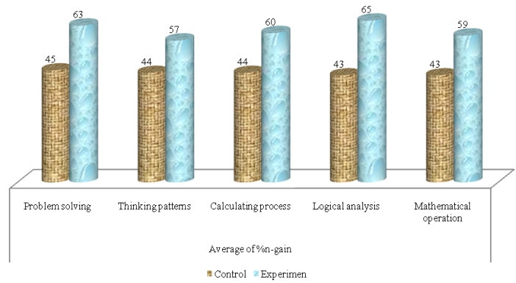

Figure 1. Mean% N-gain of each indicator of logical mathematics intelligence in the control class and experimental class

The increase in the average % N-gain of each indicator of logical mathematics, the highest one is occurred in logical analysis indicator, and then followed with problem solving indicator, calculation processes, and mathematical operations, while the lowest % N-gain is in the thinking pattern indicator. However, all of them belong to the increase level with medium category. The increase of % N-gain in the experimental class is higher than the control class. This happens because the implementation of inquiry activity model in the experimental class can provide a good learning situation for developing logical mathematics intelligence.
The highest increase occurred in the logical analysis indicator, followed by problem solving, calculation processes, and mathematical operations, as well as the lowest for an increase in the thinking pattern indicator. Strengthening towards the increase is obtained through tabulation with t-test, in which it was found that an increase in all of the indicators differed significantly. Other studies that support this result are Herayanti (2009), Iriany (2009), and Nuryati (2010), which indicate that the inquiry approach can improve the mathematical problem solving and logical mathematics reasoning skills / logical analysis.
Each indicator in the logical mathematics intelligence can develop well at the stage of inquiry activity, because in stage which is started with the problem, it is always trained how to plan solving problems, carry out experiments which have been designed, analyze data from the implementation of the experiment so that the increase will be better. Then in each step of inquiry activity, the students always have to calculate and use mathematical stages. Thus the calculation processes and mathematical operations skills are trained. In the implementation of the model, the students always think of observational data processing steps after the experiments, so that the thinking pattern skill is trained.
This model provides an opportunity for students to be actively involved in the process of making the experimental design, conducting the experiment, directly involved in solving the problem and conducting experiments, analyzing the experimental data logically, to reporting the results of the experiment. Thus, students experience a situation that led to the increase in the logical mathematics intelligence. These results are in line with the results of the study conducted by Wildfire (2010), that the inquiry activity can improve the mathematical understanding and logical mathematics reasoning skills in students. The development of logical mathematics intelligence is strengthened again in the presentation step of the experimental design, each student interact with friends in their group and also other groups, in which according to the theory of learning of Vygotsy (Dahar, 1996) will enrich the intellectual development of students.
Carter, (2005) states that if a student is trained to carry out the settlement of the complex problems that this exercise will form the Habits of mind of students. This student's habit is strongly influenced by the attitude of the students towards learning. This habit of thinking is basically preceded by the establishment of a positive attitude of students towards learning. Aklinoglu (2007) stated that the learning innovation gives positive effect on the mastery of concepts and attitudes towards science learning. Habits of mind are also associated with the ability of students in doing the analysis and scientific reasoning. In the study of Anggraeni (2006) and Zulfiani, (2006); it was found that the inquiry-based science learning can improve both of those capabilities. In harmony with this finding, Cacciatore (2009) stated that the laboratory inquiry activity can establish a theory and also build complex thinking.
Intrapersonal intelligence is an ability that allows individuals to properly classify their feelings, for example, distinguish between pain and pleasure, and behave as such distinction. This intelligence allows individuals to construct their mental model accurately, and describe several models to make good decisions in their lives (Lazear, 2004).
The increase of intrapersonal intelligence can be measured with five indicators, they are self-reflection (can connect the facts to be opinion of oneself); emotional processing (show seriousness in solving problem to be a new discovery), metacognition (think about the steps in solving problems), values clarification (can show the ability to assess and connect with the opinion of oneself), and self-identity (can identify concepts and his personal opinion) Lazear 2004.
The increase of intrapersonal intelligence between the control class and experimental class is shown in Figure 2. After the implementation of the inquiry activities in the laboratory were analyzed to measure the improvement of each indicator of intrapersonal intelligence, through the stages of inquiry in analyzing journal, determining the problem, making hypotheses in experimental design and reporting experiments.

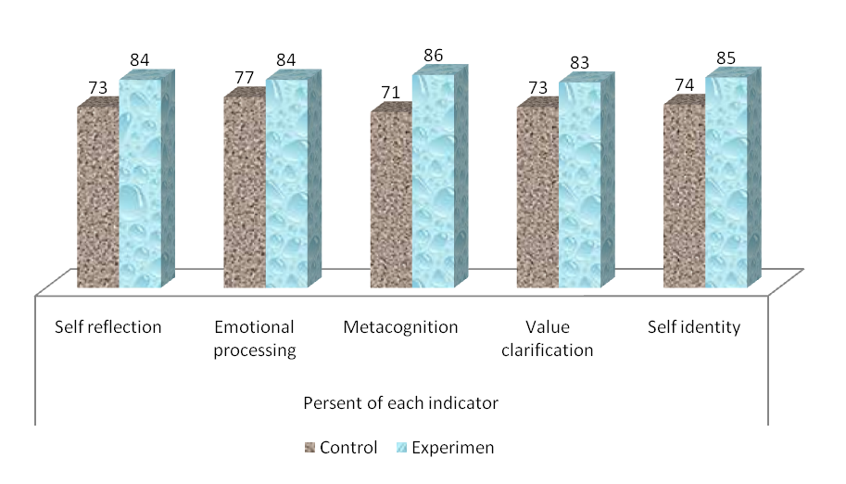

Figure 2. Percentage of each indicator of intrapersonal intelligence in the experimental class and control class

Figure 2 presents the percentage of the observation result of each indicator for the control class and experimental class. The highest increase is in the metacognition indicator. The second highest achievement is on the indicators of self-reflection and self-identity, it is presumably because at this stage of inquiry begins by identifying problems of several journals, to determine the problem. The next increase is in the value clarification indicator, while the lowest increase is in the emotional processing indicator.
This increase possibly happens since starting from designing experiments, students are trained to find the source of information as the theoretical basis and think of such a move is in compliance or not with the problem, besides the student must also be able to adjust with the equipment available in the laboratory.
In addition, during the experiment the students will always think about what steps to take if there are obstacles that occur in implementing the working steps that have been designed well. This metacognition is also potential to develop at the stage of designing the experiment, the data analysis of experimental results, report writing, and presentation of results, because in those stages, the students should always proceed their thinking process.
This result is in accordance with the opinion of Kipnis (2007) and Cacciatore (2009), which state that the inquiry-based lab learning can improve student’s metacognition. A similar study also stated that the problem-based learning can improve student’s metacognition (Haryani, 2011). Also the finding of Anwar (2005) that in solving complex problems, multiple intelligences including using metacognition, which is part of the Habits of Mind are required (Costa, 2000).
Self-identity is one of intrapersonal indicators that the increase belongs to high level. On this indicator the students were able to link the existing facts into their own opinions; students are able to identify the basic concepts with their personal opinions. This increase reasonably occurred because of during inquiry activity, students were trained to find references as a basic concept to solve the problem, and then analyze the observation data and process them into a new understanding. It also develops well because metacognition indicator also develops well and even better. This is similar to the findings of Haryani (2011) that an increase of metacognition in problem-based practicum occurs because metacognition is a reflection on every step in a task.

- Conclusion
The study that has been done results in a conclusion that the laboratory inquiry activity can improve logical mathematics intelligence, with the highest percentage of N-gain is in the logical analysis indicator by 65% and increase the intrapersonal intelligence, in which the highest one is in the metacognition indicator with the percentage of observation result by 86% or it can be said that laboratory inquiry activity can improve Multiple Intelligences.

References
- Alberta Learning Centre. (2004). Focus on Inquiry. [Online]. Available at: http://www.learning.gov.ab.ca/k12/curriculum/bysubject/focusononquiry.pdf. [10 July 2009]
- Avi Hofstein and Rachel Mamlok-Naaman. (2007). The laboratory in science education: the state of the art. Chemistry Education Research and Practice, 2007, 8 (2), 105-107.
- Cacciatore, K. L. & Sevian,H. (2009). Incrementally approaching an inquiry lab.curriculum:can changing a single laboratory experiment improve student performance in general chemistry?.Chemical Education Research. 86 (4).
- Carter, C., Bishop, J. & Kravits, S. L. (2005). Keys to Effective Learning Developing Powerful Habits of Mind. Australia; Pearson Prentice Hall
- Kipnis, M. dan Hofstein, A. (2007). The inquiry laboratory as a source for development of metacognitive skills. International Journal of Science and Mathematics Education
- Rustaman, N.Y. (2007). Basic science inquiry in science education and its assessment. The main paper presented at the plenary session of The First International Seminar of Science Education on “Science Education Facing against the challenge of the 21st century. in Auditorium FPMIPA UPI in Bandung.
- Skoog, D. A., West, D. M., Holler, F. J., & Crouch, S. R. (2004). Fundamental of Analytical Chemistry. 8th. Ed. Canada: Brooks/ Cole-Thomson Learning Academic Resource.
- Wardani,S. (2013). Kecerdasan Logical Mathematics Berbasis Aktivitas Inkuiri Laboratorium. Jurnal Inovasi Pendidikan Kimia. 7(2), Page 1129-1138, http:/kimia.unnes.ac.id.
- Wardani,S. Asep Kadarohman, Buchari, Anna Permanasari (2013). Java Culture Internalization in Elektrometri Learning Based Inquiry Laboratory Activities to Increase Inter-Intrapersonal Intelligence. International Journal of Science and Research (IJSR), 2(5) 417-421, www.ijsr.net
- Wardani,S. (2014). Analisis Kelemahan Eksplanasi Mahasiswa Kaitannya dengan Budaya Kerja dan Pengembangan Kecerdasan Inter-Intrapersonal dalam perkuliahan Elektrometri. Jurnal Inovasi Pendidikan Kimia. 8(1), Page 1219-1229, http:/kimia.unnes.ac.id.

