
JURNAL PUSTAKA ILMIAH

p-ISSN 2477-2070 | e-ISSN 2685-8363


Universitas Sebelas Maret (UNS) Library,
Jl. Ir. Sutami 36 A Kentingan, Jebres, Surakarta 57126
https://jurnal.uns.ac.id/jurnalpustakailmiah

Submitted : 24-05-2024
Accepted : 09-07-2024
Published : 31-12-2024

Diajukan : 24-05-2024
Diterima : 09-07-2024
Diterbitkan : 31-12-2024


Jurnal Pustaka Ilmiah is licensed under a Creative Commons Attribution-NonCommercial-ShareAlike 4.0 International License.

Bibliometric analysis of ICT research in South Africa

Vusumuzi Malele*, Sello Prince Sekwatlakwatla
Unit for Data Science and Computing, Department of Computer Science and Information Systems,
North-West University, South Africa
* Correspondence: vusi.malele@nwu.ac.za

ABSTRACT
Most of the new fixed and wireless communication networks are being provided by local businesses and foreign subsidiaries, indicating the rising popularity of South Africa's ICT sector in the continent's rapidly expanding market. This study analyzes information and communication technology (ICT) research in South Africa and suggests potential development areas in the country's ICT literature. The study focused on publications that published most ICT research articles for 2009–2024. The study conducted bibliometric analysis based on the number of South African publications and citations in ICT research as indexed in the Scopus and Web-of-Science databases. University of South Africa (UNISA) produced 77% of publications between 2009 and 2024. The University of Pretoria (UP) curriculum aligns with worldwide standards. It gives students a thorough grasp of computer science, emphasizing modern software development techniques used in the IT sector. In the same period, the University Of Pretoria (UP) came in second with 49% followed by the University of Cape Town (UCT) at 41%, the University of Johannesburg (UJ) at 29%, The Council for Scientific and Industrial Research (CSIR) at 28%, followed by University of KwaZulu-Natal at 20%, the North-West University (NWU) at 18% followed by University of Western Cape at 15%, University of Fort Hare at 14%, and Tshwane University of Technology, at 13%. Most research areas were education, educational research, information science, library science, environmental sciences, astronomy, astrophysics, multidisciplinary sciences, computer science, and information systems. During this period, South Africa experienced minimal to no publication in ICT research by universities of technology and colleges. The main contribution of this study is to investigate the prevalence of ICT research in South Africa and provide recommendations on how to improve ICT research.

Keywords: ICT research; publications; South Africa; technology; bibliometrics

INTRODUCTION
Globalization and technological advancements drive innovation, affecting organizations, industries, and governments. The widespread use of Information and Communication Technology (ICT) has made it impossible to fathom a future without mobile devices, the Internet, and wireless communications (Awad, 2022). The proliferation of ICT (such as mobile phones and computers) and the use of the internet has encouraged policymakers, researchers, practitioners, and professionals to investigate and implement several approaches to accelerating digital development in underdeveloped countries (Adedoyin, Mavengere & Mutanga, 2022). ICT's effects vary depending on society's human capital, with the development of human capital having the ability to make these technologies more beneficial by enhancing their capacity for economic absorption (Awad, 2022). ICT indirectly influences growth because it generates income, creates new job possibilities, lowers transaction costs, accelerates knowledge establishment, reduces price volatility, promotes market efficiency, and increases investment (Awad & Albaity, 2022). Africa's infrastructure is improving slowly but still lacks all its infrastructural challenges (Krug, Naidoo & Williams, 2024). Due to Africa being poor compared to the developing countries, many large-scale infrastructure expenditures by African nations, such as broadband networks, are dependent on outside funding and assistance. The Africa Coast to Europe (ACE) cable system finally connected South Africa and other African regions to increase South African ICT research. Four fiber optic cables running below the world's oceans recently failed, leaving parts of West and Central Africa and some southern countries without internet services. Many economies remain isolated due to underdeveloped and inefficient ICT and missing power infrastructure (Krug, Naidoo & Williams, 2024). Market structure constraints, particularly in the ICT sector, affect service affordability; however, South Africa has basic infrastructure that can be used to create jobs, develop education, and invest in ICT infrastructure (Liu et al., 2022). This shows that most African countries depend on this technology. These international internet connections can also assist in lowering the cost of data. However, Ardelean & Minnebo (2023) argue that since the existence of the sea cable, the end consumer has not seen any benefit since it only benefits providers and not the users. According to Herselman & Botha (2020), most of the big cities in South Africa have good ICT infrastructure, but rural areas still face challenges with the development of the infrastructure. In this regard, this creates more advantages for the kids growing up in the city and more gaps and disadvantages for the children growing up in rural areas. The study reveals that students and teachers often struggle to apply their theoretical knowledge in teaching practice. The research involved 14 participants from two universities and found that the current teaching practice program is fragmented and ineffective due to a lack of resources. Therefore, ICT research can minimize the challenges faced by the institution (Zondo & Adu, 2024). ICT research and infrastructure do not exist in rural areas. The government must expand the ICT infrastructure in all schools in South Africa. In this regard, the children will know at a young age, and possibly, it will close the gap between the schools in the city and the schools in the rural areas. The use of ICT in managing and promoting natural resources and sustainability has sparked a conversation among policymakers on how to progress technology (Atsu, Adams & Adjei, 2021). On the one hand, ICT adoption has the potential to make a significant contribution to Africa's growth and sustainability. This is because ICT may be utilized to manage and monitor natural resources, encourage sustainable habits, lower energy consumption, and lessen the effects of climate change. Despite the tremendous development in ICT usage in Africa, the study investigates the effect of ICT on malnutrition in children and adults in Africa. In order to address Africa's high rates of malnutrition, it draws attention to the potential advantages of ICT in the agricultural sector and among low-income farm households (Van Greunen & Fosu, 2022). The mediating role of information and communications technologies (ICT) in the relationship between remittances and the ecological footprint in South Africa highlights that technological innovation promotes environmental sustainability. However, the limitation of the study is that it significantly negatively impacts the ecological footprint, suggesting ICTs can act as a channel (Yadou, Ntang & Baida, 2024). Although research in ICT had beneficial benefits in Africa between 1998 and 2023, ICT patents did not significantly affect Africa’s economic development. Kunkel & Matthess (2020), who studied four sub-Saharan African nations and compared them with three East Asian and Pacific countries, found that the impact of ICT varies country by country. South Africa has significantly reduced its technological advancement gap, particularly in internet connectivity, compared to three years: 5.8% in 2000, 24% in 2010, and 56% in 2016 (Baumüller et al., 2023). However, South Africa is one of the most developed African countries regarding ICT infrastructure. Information and communication technologies (ICTs) in South Africa can support supplemental feeding programs for children under six and pregnant and nursing mothers and assist in malnutrition screening. Olaniyi & Ekundayo (2022) investigated integrated care models for the ability to avert fatalities by offering rehabilitation, stabilization, treatment, and care integration; however, they might be hampered by a failure to recognize interdependencies and stakeholder dynamics. Mehdi & Muhammad (2023) argue that ICTs can help break fragmentation. However, in the design and implementation stages, it is essential to comprehend the viewpoints of stakeholders and the contextual dynamics. According to Arnold (2024), technology greatly improves the economic, social, and environmental aspects of a country's development agenda, according to research on the influence of ICTs on sustainable development at the national level. Latif et al. (2023) look at how ICT adoption, financial development, and environmental effects relate to one another in the BRICS economies (Ngepah, Saba & Kajewole, 2024); it gives policymakers information on how to direct ICT advances for a sustainable future. Kunkel & Matthess (2020) expand the analysis on the relationship between infrastructure development and inclusive growth in Africa, considering broad ICT infrastructure and inclusive growth measures despite limited empirical validity. South Africa's ICT sector is leading in the continent; hence, South Africa has become a significant research, development, and innovation hub concerning technology (Adedoyin, Mavengere & Mutanga, 2022). ICT research, development, and innovation (RDI) skills are also important to growth (Evans & Mesagan, 2022). In this regard, ICT RDI forms a strong backbone of the country’s socio-economic growth. It also supports and enables infrastructure for other research and business areas. The ICT RDI is one of the needed and growing skill sets in all business areas in South Africa (Yadou, Ntang & Baida, 2024). Recent reports on ICT and environmental sustainability in Africa highlight their potential to contribute to sustainable development and address environmental challenges. International organizations like the World Bank and ICT offer solutions for climate resilience, such as weather forecasting and early warning systems (Saba et al., 2023 & Ahmad et al., 2023). Innovation is essential for businesses, sectors, and nations because of the increased competition brought about by globalization and technological breakthroughs (Adedoyin, Mavengere & Mutanga, 2022). It promotes competitiveness, long-term economic growth, and enhanced quality of life (Yadou, Ntang & Baida, 2024). In this regard, South Africa continues to enhance the infrastructure to advance technology and increase ICT research. With ICT services and research support, South Africa's manufacturing sector is a key driver of economic expansion and GDP growth of $6.97 trillion in 2023. With nearly 18.9 million employees in South Africa, it continues to expand. However, South Africa lags in recognizing the importance of green skills and ICT research, with only 60.5% of all ICT exports (Alsagr & Ozturk, 2024). Ganda (2024) suggests that ICT can significantly reduce emissions in Sub-Saharan Africa by promoting intelligent land management and agricultural practices. This includes precision agriculture, digital soil mapping, e-commerce platforms, and renewable energy systems. Leveraging ICT and ICT innovation, research can achieve a sustainable green future and reduce environmental impact. Against this background, the objectives of this paper were to determine (i) the distribution of publications per ICT research field, (ii) the collaborative coefficient and collaborative index, and (iii) the annual and exponential growth of literature in ICT RDI in South Africa. Despite this introduction, the rest of this paper comprises the methodology, results, and discussion, then provides a conclusion.
METHODS
To achieve the aim of the research, the following analytical methods were examined (see Figure 1). From 2009 to 2024, Scopus and Web of Science (WOS) data were searched on June 1, 2024.
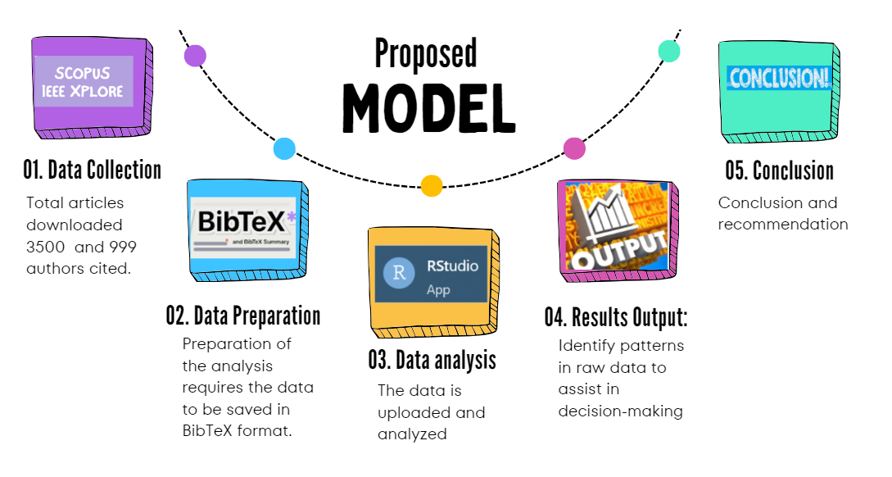
Figure 1: Proposed method
The following analytical methods were used to achieve the research aim: Figure 1 illustrates the five-step research design adopted in this study, where RStudio was used to analyze the bibliographic data. RStudio is a desktop application for R, available in two formats: RStudio Desktop and RStudio Server, which can be accessed via a web browser. This paper used a free version of software available on the internet.
The following steps, from step 1 to step 5, provide the details of each step:
Step 1: Data Collection: Two research databases, Web of Science and Scopus, were consulted and utilized to extract the necessary data for this study. Only papers from 2009 to 2024 were consulted, and text mining was accomplished by searching for the phrase "ICT research in South Africa."

Table 1. Searched Fields
No. | Citation information | Bibliographical information | Abstract & keywords | Funding details | Other information
1 | Author(s) | Affiliations | Abstract | Number | Tradenames & manufacturers
2 | Document title | Serial identifiers (e.g. ISSN) | Author keywords | Acronym | Accession numbers & chemicals
3 | Year | PubMed ID | Indexed keywords | Sponsor | Conference information
4 | Source title | Publisher |  | Funding text | Include references
5 | Volume, issues, pages | Editor(s)
6 | Citation count | Language of original document
7 | Source & document type | Correspondence address
8 | Publication stage | Abbreviated source title
9 | DOI
10 | Open access

Table 1 shows the fields that were searched. Data was obtained by searching for citation information, bibliographic information, abstracts and keywords, funding details, and other information. The search results show 3500 research documents authored by 999 researchers. The search results show 3500 research documents (2000 from the Scopus database and 1500 from the Web of Science). For both databases, a total of 999 were authored by researchers.
Step 2: Data Preparation: The retrieved dataset was prepared for analysis by first removing any duplicates and those articles that were not research articles. This process removed at least 1% of the retrieved articles. The dataset was transformed to be suitable for BibTeX. The bibliographies and references were created, organized, and prepared in this regard.
Step 3: Data analysis: The prepared data was uploaded in RStudio, analyzed, and examined to identify trends and extract pertinent information.
Step 4: Results Output: The analysis provided a transparent, possible decision-making process. In this paper, RStudio software was used for the bibliometric and bibliography to show output results that support the recommendations made in this paper.
Step 5: Conclusion and Recommendation: This step provides recommendations for the study and future studies and highlights the study's limitations.

RESULT AND DISCUSSION
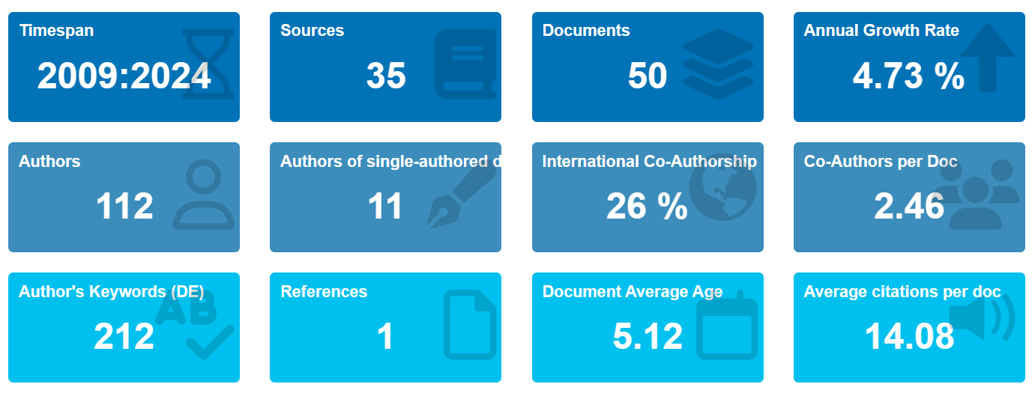
Figure 2: Results summary
Figure 2 provides a summary of the results of the data that was collected from 2009 to 2024. To remain competitive, all economies depend on research and development in the information and communication technology (ICT) industry. South Africa's aspirational growth objectives are designed to enhance the Department of Science and Technology's contribution to national development and support the private sector. There is an annual growth rate of 4.73% in ICT research in South Africa, with an average of 14.08 average citations per document.
Collaboration encourages individuals or organizations to accomplish common goals or reduce losses. As per the literature, South Africa is taking advantage of the internet speed due to the sea cable, and that infrastructure can be expanded to the rural area to close the gap between the city and rural in South Africa and Africa. ICT cooperation uses technology advancement and joint training to create research networks and linkages. As a result of this approach, the digital divide is narrowed in southern African countries through introspection, planning, and coordinated action. The results shown in Figure 2 show that 26% of international co-authorship was highly cited, and the author’s keywords were 212. The average citation per document was 14.08. There is a need for more collaboration with Africa and international research in order to increase ICT research in South Africa.
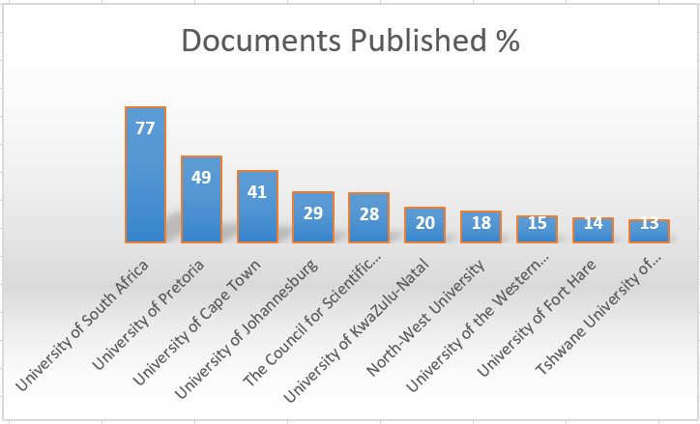
Figure 3: Affiliation
ICT integration is being used by the University of South Africa (Unisa), a fast-expanding open-distance learning provider in South Africa, to establish a mixed, flexible, and technologically advanced learning environment in this regard. Most papers within the ICT RDI area were authored by researchers from UNISA, as illustrated in Figure 3. In this regard, UNISA produced 77% of publications between 2009 and 2024.
The University of Pretoria (UP) curriculum aligns with worldwide standards. It gives students a thorough grasp of computer science, emphasizing modern software development techniques used in the IT sector. In the same period, University of Pretoria (UP) came in second with 49%, followed by University of Cape Town (UCT) at 41%, the University of Johannesburg (UJ) at 29%, The Council for Scientific and Industrial Research (CSIR) at 28%, followed by University of KwaZulu-Natal at 20%, North-West University (NWU) at 18% followed by University of Western Cape at 15%, University of Fort Hare at 14%, and Tshwane University of Technology at 13%.
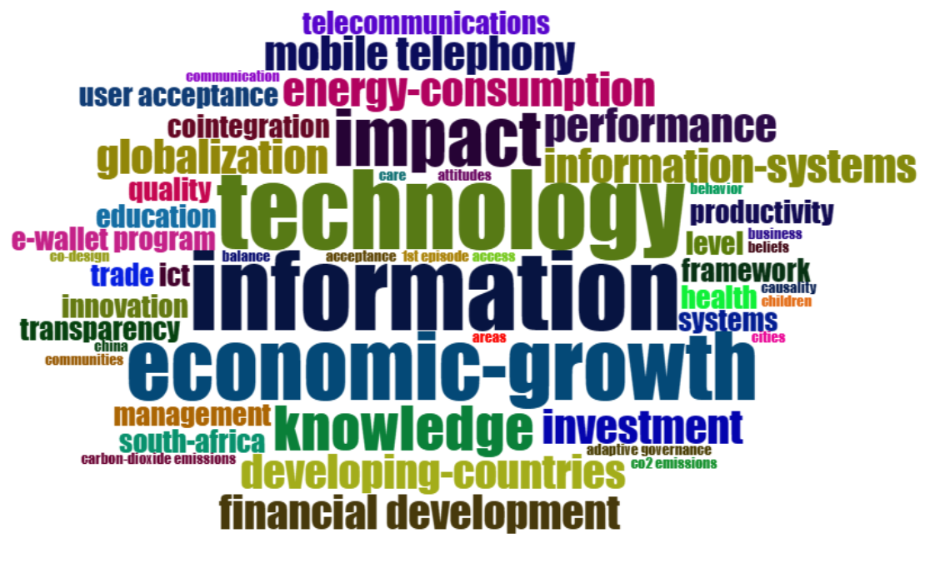
Figure 4: Most frequently searched words
Because using and understanding ICT is essential for getting a job, more students are enrolling in ICT courses, and most school and university curricula disciplines require it. This change reflects ICT's growing significance in the job economy.
Figure 4 illustrates the most searched words in the ICT RDI: economic growth, information, technology, impact, knowledge, information systems, developing countries, financial development, and energy consumption. In this regard, most papers included technology, economic growth, and information as their keywords.
Figure 5 shows a network map illustrating the interconnections and relationships of Figure 4’s keywords. Furthermore, the interconnections and relationships analysis reveals the importance of innovation, user acceptance, knowledge, and investment in ICT RDI. The latter translates to the fact that while researchers are busy with ICT RDI, they also work with innovation, user acceptance, knowledge, and investment.
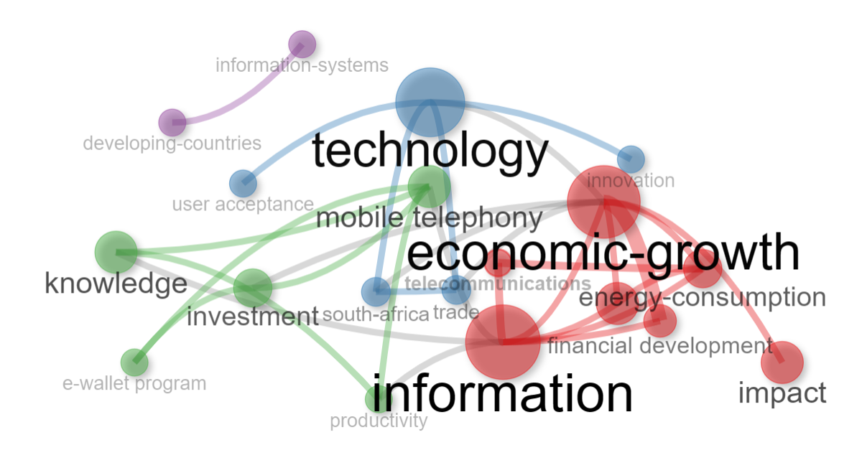
Figure 5: Co-occurrence of ICT research
The publication co-occurrences revealed some challenges that still need to be addressed in ICT research, as the research significantly impacts economic growth, energy consumption, investment, and knowledge transfer (see Figure 5).
Empirical studies show that ICT sector expansion, infrastructure development, and ICT investment are important drivers of economic growth. Advancements in technology, such as e-wallet programs, information systems, telecommunications, and innovation, enhance the growth of each country in the world. The University of South Africa (Unisa) is the institution that created the most impact on economic growth and information, and the author who published the most articles is Kritzinger (2024). There is a clear relationship between technology, economic growth information, investment, and knowledge, as indicated in Figure 5.
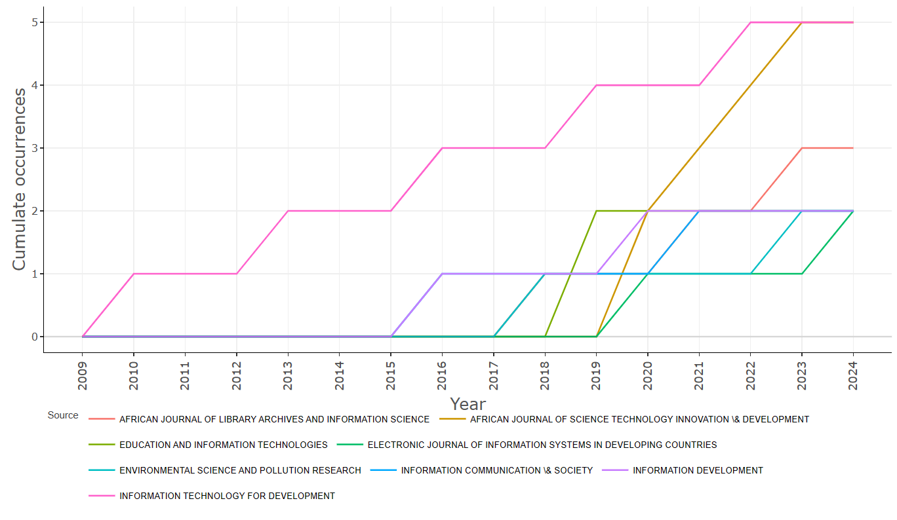
Figure 6: Sources' Production over Time
Between 2019 and 2024, the African Journal of Library Arts and Information Science showed positive growth and a constant increase, followed by information development that indicated improvement from 2015 to 2024, and the electronic journal of information systems in developing countries also showed an increase from 2015 to 2019. Education and information technology also showed a significant increase; in this regard, the cumulative incidence indicates growth in ICT research in South Africa (see Figure 6).

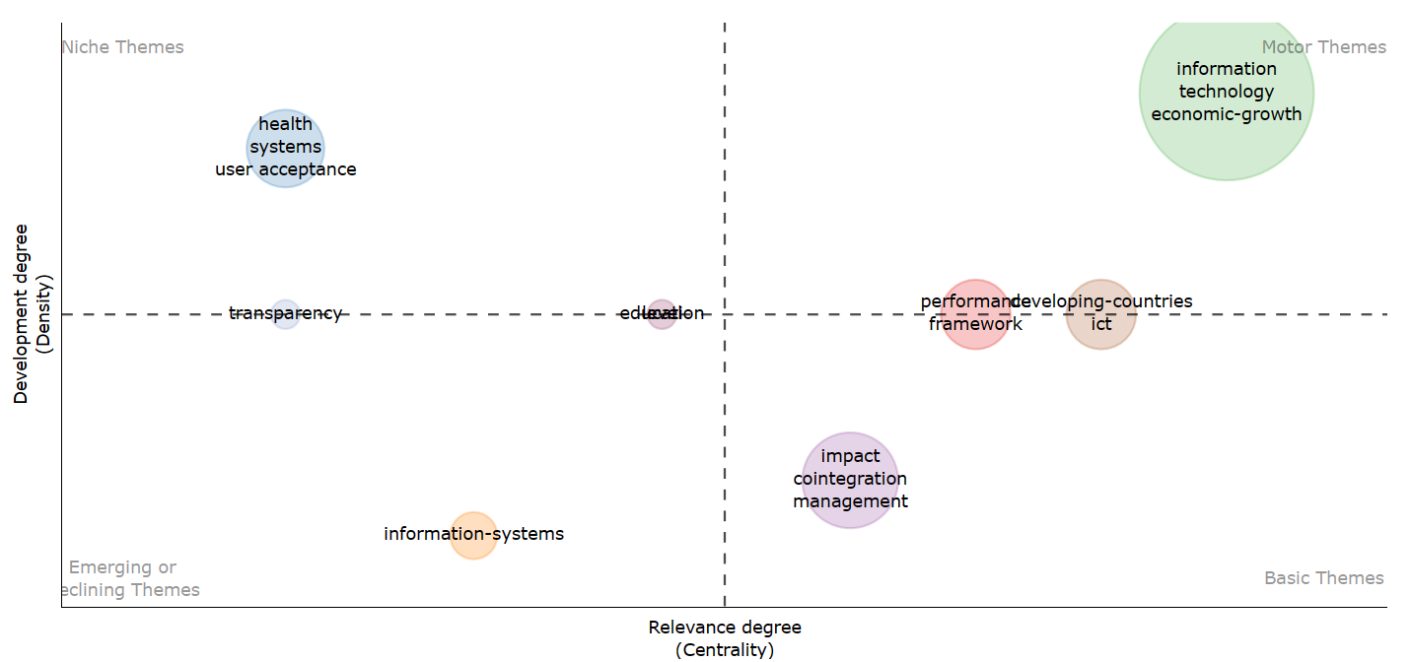
Figure 7: Thematic analysis
A thematic diagram was constructed to illustrate the four quadrants of the research structure relating to ICT research. The motor themes highlighted information technology and economic growth. Performance in developing countries, where the basic themes include ICT, framework, and impact integration management.
Emerging or clinching themes show information systems, education, and transparency in the middle of niche themes, and clinching themes' niche themes only highlight health systems (see Figure 7).
This paper indicates promising results regarding ICT research in South Africa. Universities showed the research is still continuing, and they are contributing to the ICT; however, the publication must be increased in order to align South African research with the developing countries, and collaboration is one of the critical elements that each country must take very seriously in order to grow the research. In this regard, the study demonstrated positive collaboration results with other countries. This study recommends increasing collaboration among universities in Africa and worldwide to increase ICT research.
CONCLUSION AND RECOMMENDATION
The present study analyzes ICT research in South Africa from 2009–2024. With more publications coming out throughout time, the majority of the publications were in the form of articles. The study found that Unisa produced 77% of publications between 2009 and 2024. The University of Pretoria (UP) curriculum aligns with worldwide standards. It gives students a thorough grasp of computer science, emphasizing modern software development techniques used in the IT sector. In the same period, the University Of Pretoria (UP) came in second with 49%, followed by the University of Cape Town (UCT) at 41%, the University of Johannesburg (UJ) at 29%, The Council for Scientific and Industrial Research (CSIR) at 28%, followed by University of KwaZulu-Natal at 20%, North-West University (NWU) at 18%, followed by University of Western Cape at 15%, University of Fort Hare at 14%, and Tshwane University of Technology at 13%. Most of the research areas were education, educational research, information science, library science, environmental sciences, astronomy, astrophysics, multidisciplinary sciences, computer science, and information systems. In order to increase ICT research in South Africa, the study recommends the expansion of ICT infrastructure to all schools in the city and rural areas to close the gap. IT companies must collaborate with institutions of higher learning and provide more training experiences, unlike focusing on theory. There is a need for more collaboration with Africa and international research in order to increase ICT research in South Africa.
During this period, South Africa experienced minimal to no publication in ICT research by universities of technology and colleges. The main contribution of this study is to investigate the prevalence of ICT research in South Africa and provide recommendations on how to improve ICT research.
The scope of this inquiry will be expanded in the future by incorporating more research databases, such as PubMed, ERIC, IEEE Xplore, ScienceDirect, Directory of Open Access Journals (DOAJ), and JSTOR in order to cover most research that was published and provide more solution to South African researchers and the share ideas to implement solution to close the gap for organization and institution of leaning this report solely utilized the Web of Science and Scopus databases. Future researchers will be able to examine the data with bibliometric applications like BibExcel and VOSviewer. The results of a visual assessment and bibliometric study of ICT research in South Africa may not indicate all studies. Future investigations will need a more comprehensive search that includes all articles to look at more studies. Furthermore, future research will expand on the recommendation to further research on the collaboration of ICT companies and higher learning institutions.
ACKNOWLEDGEMENT
I would like to thank North West University for providing assistance for this study, which is a component of my doctoral thesis.
REFERENCES

Adedoyin, F.F., Mavengere, N., Mutanga, A. (2022). A simulation experiment on ICT and patent intensity in South Africa: An application of the novel dynamic ARDL machine learning model. Journal of Technological Forecasting & Social Change, 185. https://doi.org/10.1016/j.techfore.2022.122044
Ahmad, H.A., Green, C.J., Jiang, F., Murinde, V. (2023). Mobile money, ICT, financial inclusion and growth: How different is Africa?. Journal of Economic Modelling, 121. https://doi.org/10.1016/j.econmod.2023.106220
Alsagr, N., Ozturk, I. (2024). How do energy security risk and ICT affect green investment?. Journal of Economic Analysis and Policy, 82. https://doi.org/10.1016/j.eap.2024.04.027
Ardelean, M., Minnebo, P. (2023). The suitability of seas and shores for building submarine
Power interconnections. Journal of Renewable and Sustainable Energy Reviews, 176.
https://doi.org/10.1016/j.rser.2023.113210
Arnold, S. (2024). African agency in ICT infrastructure provider choice: Navigating
Access to foreign finance and technology. Journal of Telecommunications Policy, 48. https://doi.org/10.1016/j.telpol.2024.102713
Atsu, F., Adams, S., Adjei, J. (2021). ICT, energy consumption, financial development, and environmental degradation in South Africa. Journal of Heliyon, 7(7). https://doi.org/10.1016/j.heliyon.2021.e07328
Awad, A. (2022). Is there any impact from ICT on environmental quality in Africa? Evidence from second‐generation panel techniques. Journal of Environmental Challenges, 7. https://doi.org/10.1016/j.envc.2022.100520
Awad, A., Albaity, M. (2022). ICT and economic growth in Sub-Saharan Africa: Transmission channels and effects. Journal of Telecommunications Policy, 46(8).
https://doi.org/10.1016/j.telpol.2022.102381
Baumüller, H., et al. (2023). Building digital bridges in African value chains: Exploring linkages between ICT use and social capital in agricultural marketing. Journal of Rural Studies, 100. https://doi.org/10.1016/j.jrurstud.2023.03.010
Evans, O., Mesagan, E. P. (2022). ICT-trade and pollution in Africa: Do governance and regulation matter? Journal of Policy Modeling, 44(3), 511-531. https://doi.org/10.1016/j.jpolmod.2022.06.003
Ganda, F. (2024). The influence of democracy, corruption, economic growth, and ICT on carbon emissions in Sub-Saharan African countries: Does FDI matter?. Journal of Open Innovation: Technology, Market, and Complexity, 1. https://doi.org/10.1016/j.joitmc.2024.100324
Herselman, M., Botha, A. (2020). Applying Design Science research as a methodology in post graduate studies: A South African perspective. SAICSIT '20: Conference of the South African Institute of Computer Scientists and Information Technologists, 251-258. https://doi.org/10.1145/3410886.3410903
Kritzinger, E. (2024). University of South Africa’s College of Science, Engineering and Technology. https://orcid.org/0000-0002-5141-4348
Krug, M., Naidoo, A., Williams, L. (2024). South Africa’s oceans and coastal and information management system towards improved ocean access, protection, and governance. Journal of Environmental Management. https://doi.org/10.1016/j.jenvman.2024.120255
Kunkel, S., Matthess, M., (2020). Digital transformation and environmental sustainability in the industry: Putting expectations in Asian and African policies into perspective. Journal of Environmental Science & Policy, 112, 318-329.
Latif, N., Refeeq, R., Safdar N., Liaquat M., Younas K., Ahmad S. (2023). Investigating the role of economic integration and financial development: Rebound effect and green ICT in BRICS. Journal of Sustainable Futures, 6. https://doi.org/10.1016/j.sftr.2023.100126
Liu, C., Wang, K., Goay, M., Yoon, S. (2022). Note: Examining the Gender Digital Divide in ICT: A Closer Look at Ghana, South Africa, and India. COMPASS '22: Proceedings of the 5th ACM SIGCAS/SIGCHI Conference on Computing and Sustainable Societies, 623–627. https://doi.org/10.1145/3530190.3534832
Mehdi, N., Muhammad, I.S. (2023). How does ICT trade shape environmental impacts across the north-south regions? Intra-regional and Inter-regional perspective from dynamic CGE model. Journal of Technological Forecasting and Social Change, 186, 122168. https://doi.org/10.1016/j.techfore.2022.122168
Ngepah, N., Saba, C. S., Kajewole, D.O. (2024). The impact of industry 4.0 on South Africa’s manufacturing sector. Journal of Open Innovation: Technology, Market, and Complexity,10. https://doi.org/10.1016/j.joitmc.2024.100226
Olaniyi, E., Ekundayo, P. M. (2022). ICT-trade and pollution in Africa: Do governance and regulation matter?. Journal of Policy Modeling, 3(44), 511-531. https://doi.org/10.1016/j.jpolmod.2022.06.003
Saba, C.S., Djemo, C. R. T., Eita, J.H., Ngepah, N. (2023). Towards environmental sustainability path in Africa: The critical role of ICT, renewable energy sources, agriculturalization, industrialization and institutional quality. Journal of Energy Reports,10. https://doi.org/10.1016/j.egyr.2023.10.039
Van Greunen, D., Fosu, A. (2022). ICT Adoption Challenges: Case of Rural Small-Scale Farmers In The Amathole District Municipality Of South Africa. 2022 IST-Africa Conference (IST-Africa), Ireland, 2022, pp. 1-9, doi: 10.23919/IST-Africa56635.2022.9845556.
Yadou, B. A., Ntang, P. B., Baida, L. A. (2024). Remittances-ecological footprint nexus in Africa: Do ICTs matter?. Journal of Cleaner Production, 434. https://doi.org/10.1016/j.jclepro.2023.139866
Zondo, S.S., Adu, E.O. (2024). Dynamics of Teaching Practice in South Africa: A Nexus between Theory and Practice. Interdisciplinary Journal of Education Research, 6, 2710-2122. https://doi.org/10.38140/ijer-2024.vol6.06

