# LAMPIRAN

**Lampiran 4.1 Perhitungan Persentase Rendemen**

1. **Persentase Rendemen Ekstrak Metanol**

Berat serbuk kering = 15,7399 gram

Berat wadah + ekstrak kering = 15,7121 gram

Berat wadah kosong = 11,2948 gram

Rendemen = 4,4173 gram

% Rendemen = (Rendemen/Berat serbuk kering) x 100%

= (4,4173/15,7399) x 100%

= 28,064%

1. **Persentase Rendemen Fraksi n-Heksana**

Berat ekstrak metanol = 1,044 gram

Berat wadah + ekstrak kering = 100,2750 gram

Berat wadah kosong = 100,1829 gram

Rendemen = 0,0921 gram

% Rendemen = (Rendemen/Berat ekstrak metanol) x 100%

= (0,0921 gram/1,044 gram) x 100%

= 8,82%

1. **Persentase Rendemen Fraksi Diklorometana**

Berat ekstrak metanol = 1,044 gram

Berat wadah + ekstrak kering = 96,3590 gram

Berat wadah kosong = 96,2927 gram

Rendemen = 0,0663 gram

% Rendemen = (Rendemen/Berat ekstrak metanol) x 100%

= (0,0663 gram/1,044 gram) x 100%

= 6,35%

1. **Persentase Rendemen Fraksi Etil Asetat**

Berat ekstrak metanol = 1,044 gram

Berat wadah + ekstrak kering = 100,0926 gram

Berat wadah kosong = 99,7553 gram

Rendemen = 0,3373 gram

% Rendemen = (Rendemen/Berat ekstrak metanol) x 100%

= (0,3373 gram/1,044 gram) x 100%

= 32,31%

1. **Persentase Rendemen Residu**

Berat ekstrak metanol = 1,044 gram

Berat wadah + ekstrak kering = 103,6135 gram

Berat wadah kosong = 103,0663 gram

Rendemen = 0,5472 gram

% Rendemen = (Rendemen/Berat ekstrak metanol) x 100%

= (0,5472 gram/1,044 gram) x 100%

= 52,41%

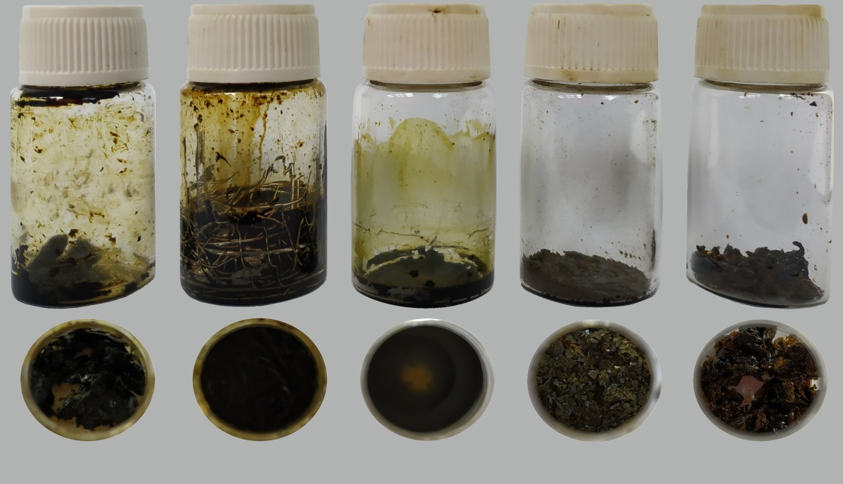

**E**

**D**

**C**

**B**

**A**

Gambar 4.1.1 Sampel uji Senggugu A) ekstrak metanol, B) fraksi n-heksana, C) fraksi diklorometana, D) fraksi etil asetat, E) residu Senggugu

**Lampiran 4.2 Perhitungan Pembuatan Media CAMHB**

1. **Pembuatan dan Penambahan Larutan Induk MgCl2**

Diketahui: BM MgCl2.6H2O = 203,3027 g/mol .............. (a)

BM MgCl2 = 95,211 g/mol .............. (b)

BM Mg2+ = 24,305 g/mol .............. (c)

Dibutuhkan larutan induk MgCl2 dengan konsentrasi 10 mg Mg2+/mL.

MgCl2 yang dibutuhkan = (b/c) x 10 mg/mL

= (95,211/24,305) x 10 mg/mL

= 39,123 mg/mL

MgCl2.6H2O yang dibutuhkan = (a/b) x 39,123 mg/mL

= (203,3027/95,211) x 39,123 mg/mL

= 83,539 mg/mL

Larutan induk MgCl2 dibuat dengan melarutkan 835,39 mg MgCl2.6H2O dalam 10 mL akuades. Konsentrasi ion Mg2+ yang dibutuhkan pada media MHB yaitu 11,25 mg Mg2+/L. Penambahan sejumlah larutan induk MgCl2 konsentrasi 10 mg Mg2+/mL (B) pada 150 mL media MHB agar didapatkan konsentrasi Mg2+ yang diinginkan (A) adalah:

A = (150 mL/1000 mL) x 11,25 mg Mg2+

= 1,69 Mg2+

B = (1,69 mg Mg2+/10 mg Mg2+) x 1 mL = 0,169 mL

Larutan induk MgCl2 konsentrasi 10 mg Mg2+/mL ditambahkan sebanyak 0,169 mL ke dalam media MHB 150 mL.

1. **Pembuatan dan Penambahan Larutan Induk CaCl2**

Diketahui: BM CaCl2.2H2O = 147,01 g/mol .............. (a)

BM CaCl2 = 110,98 g/mol .............. (b)

BM Ca2+ = 40,078 g/mol .............. (c)

Dibutuhkan larutan induk CaCl2 dengan konsentrasi 10 mg Mg2+/mL.

CaCl2 yang dibutuhkan = (b/c) x 10 mg/mL

= (110,98/40,078) x 10 mg/mL

= 27,691 mg/mL

CaCl2.2H2O yang dibutuhkan = (a/b) x 27,691 mg/mL

= (147,01/110,98) x 27,691 mg/mL

= 36,681 mg/mL

Larutan induk CaCl2 dibuat dengan melarutkan 366,81 mg CaCl2.2H2O dalam 10 mL akuades. Konsentrasi ion Ca2+ yang dibutuhkan pada media MHB yaitu 22,5 mg Ca2+/L. Penambahan sejumlah larutan induk CaCl2 konsentrasi 10 mg Ca2+/mL (B) pada 150 mL media MHB agar didapatkan konsentrasi Ca2+ yang diinginkan (A) adalah:

A = (150 mL/1000 mL) x 22,5 mg Mg2+

= 3,38 Mg2+

B = (3,38 mg Ca2+/10 mg Ca2+) x 1 mL = 0,338 mL

Larutan induk CaCl2 konsentrasi 10 mg Ca2+/mL ditambahkan sebanyak 0,338 mL ke dalam media MHB 150 mL.

**Lampiran 4.3 Perhitungan Konsentrasi Kontrol Positif, Kontrol Negatif, dan Larutan Uji**

1. **Perhitungan Pembuatan Induk Gentamisin**

Bahan = Larutan injeksi gentamisin sulfat

Kesetaraan gentamisin = 40 mg/mL

= 40.000 μg/mL

Dibutuhkan larutan induk gentamisin 160 μg/mL:

40.000 μg/mL x volume yang dibutuhkan = 160 μg/mL x 2000 μL

Volume yang dibutuhkan = 8 μL ad 1000 μL (dengan media CAMHB)

1. **Perhitungan Pengenceran Induk Gentamisin**

Seri konsentrasi gentamisin yang dibutuhkan untuk uji aktivitas antibakteri adalah 4μg/mL, 2 μg/mL, 1 μg/mL, dan 0,5 μg/mL.

|  |  |  |  |
| --- | --- | --- | --- |
| Konsentrasi Awal  (µg/mL) | Volume larutan induk yang diambil (µl) | Volume CAMHB yang ditambahkan  (µl) | Konsentrasi Akhir (µg/mL) |
| 160 | 100 | 1900 | 8 |
| 8 | 1000 | 1000 | 4 |
| 4 | 1000 | 1000 | 2 |
| 2 | 1000 | 1000 | 1 |
| 1 | 1000 | 1000 | 0,5 |

1. **Perhitungan Pembuatan Induk Larutan Uji (Ekstrak Metanol, Fraksi Heksana, Fraksi Diklorometana, Fraksi Etil Asetat, dan Residu Senggugu)**

Jumlah penimbangan sampel uji = 20,48 mg

DMSO 100% untuk melarutkan sampel uji = 100 μL

Akuades deionisasi yang ditambahkan = ad 1000 μL

Konsentrasi induk larutan uji = 20,48 mg/1000 μL

= 20480 μg/mL

1. **Perhitungan Pengenceran Induk Larutan Uji (Ekstrak Metanol, Fraksi Heksana, Fraksi Diklorometana, Fraksi Etil Asetat, dan Residu Senggugu)**

Seri konsentrasi yang dibuat adalah 2048 μg/mL, 1024 μg/mL, 512 μg/mL, dan 256 μg/mL, 128 μg/mL, dan 64 μg/mL. Seri konsentrasi uji dibuat dengan langkah (a) dan (b) sebagai berikut:

1. Larutan induk 20480 μg/mL diencerkan secara bertingkat (*two-fold serial dilution*)

|  |  |  |  |  |
| --- | --- | --- | --- | --- |
| Konsentrasi larutan yang diambil (μg/mL) | Volume yang diambil (μL) | + | DMSO 10% (μL) | Konsentrasi yang dihasilkan (μg/mL) |
| 20480 | 200 |  | 200 | 10240 |
| 10240 | 200 |  | 200 | 5120 |
| 5120 | 200 |  | 200 | 2560 |
| 2560 | 200 |  | 200 | 1280 |
| 1280 | 200 |  | 200 | 640 |
| 640 | 200 |  | 200 | 320 |

1. Konsentrasi yang dihasilkan pada (a) diencerkan kembali dengan media CAMHB

|  |  |  |  |  |
| --- | --- | --- | --- | --- |
| Konsentrasi larutan yang diambil (μg/mL) | Volume yang diambil (μL) | + | CAMHB (μL) | Konsentrasi yang dihasilkan (μg/mL) |
| 20480 | 100 |  | 900 | 2048 |
| 10240 | 100 |  | 900 | 1024 |
| 5120 | 100 |  | 900 | 512 |
| 2560 | 100 |  | 900 | 256 |
| 1280 | 100 |  | 900 | 128 |
| 640 | 100 |  | 900 | 64 |

1. **Perhitungan Konsentrasi DMSO**

DMSO 100% untuk melarutkan sampel uji = 100 μL

Jumlah pelarut larutan induk uji = ad 1000 μL

Konsentrasi DMSO dalam larutan induk uji = (100 μL/1000 μL) x 100%

= 10% v/v

Konsentrasi DMSO setelah pengenceran = (100 μL/1000 μL) x 10%

= 1% v/v

**Lampiran 4.4 Tabulasi Hasil Uji dan Penghambatan Kontrol Positif Gentamisin terhadap *P. aeruginosa***

**Absorbansi Kelompok Kontrol DMSO 1% dan Gentamisin**

|  |  |  |  |  |  |  |  |  |  |
| --- | --- | --- | --- | --- | --- | --- | --- | --- | --- |
| Replikasi | Kontrol Negatif (P)  (CAMHB + Bakteri) | | | Kontrol Media (Q)  (Media CAMHB) | | | Rerata | | |
| P | Q | P - Q |
| 1 | 1,097 | 1,095 | 1,102 | 0,159 | 0,155 | 0,152 | 1,098 | 0,155 | 0,943 |
| 2 | 1,114 | 1,112 | 1,119 | 0,159 | 0,155 | 0,159 | 1,115 | 0,158 | 0,957 |
| 3 | 1,134 | 1,135 | 1,137 | 0,161 | 0,163 | 0,163 | 1,135 | 0,162 | 0,973 |

**Absorbansi Kelompok Uji dan Kontrol Uji Gentamisin**

|  |  |  |  |  |  |  |  |  |  |
| --- | --- | --- | --- | --- | --- | --- | --- | --- | --- |
| Konsentrasi | Uji (R)  (Gentamisin + Bakteri) | | | Kontrol Uji (S)  (Gentamisin + Media) | | | R - S | | |
| Replikasi 1 | Replikasi 2 | Replikasi 3 | Replikasi 1 | Replikasi 2 | Replikasi 3 | Replikasi 1 | Replikasi 2 | Replikasi 3 |
| 0,5 | 0,292 | 0,297 | 0,301 | 0,110 | 0,110 | 0,110 | 0,182 | 0,187 | 0,191 |
| 1 | 0,242 | 0,245 | 0,248 | 0,113 | 0,113 | 0,113 | 0,129 | 0,132 | 0,135 |
| 2 | 0,189 | 0,191 | 0,187 | 0,124 | 0,124 | 0,123 | 0,065 | 0,067 | 0,064 |
| 4 | 0,170 | 0,173 | 0,171 | 0,135 | 0,135 | 0,134 | 0,035 | 0,038 | 0,037 |

**Absorbansi Kelompok Uji dan Kontrol Uji DMSO 1%**

|  |  |  |  |  |  |  |  |  |  |
| --- | --- | --- | --- | --- | --- | --- | --- | --- | --- |
| Replikasi | Uji (R)  (DMSO 1% + Bakteri) | | | Rerata R | Kontrol Uji (S)  (DMSO 1% + Media) | | | Rerata S | R-S |
|
| 1 | 1,088 | 1,086 | 1,092 | 1,089 | 0,090 | 0,114 | 0,110 | 0,105 | 0,984 |
| 2 | 1,108 | 1,104 | 1,098 | 1,103 | 0,100 | 0,108 | 0,113 | 0,107 | 0,996 |
| 3 | 1,124 | 1,128 | 1,126 | 1,126 | 0,086 | 0,115 | 0,143 | 0,115 | 1,011 |

Perhitungan persentase aktivitas antibakteri (%penghambatan) dari DMSO 1% dan gentamisin dapat dihitung menggunakan rumus sebagai berikut:

% penghambatan = $\left(1-\frac{(R - S)}{(P - Q)}\right)$ x 100%

**Penghambatan Kontrol Positif Gentamisin**

|  |  |  |  |  |  |  |
| --- | --- | --- | --- | --- | --- | --- |
| Konsentrasi | % Penghambatan | | | Rerata | SD | CV |
| Replikasi 1 | Replikasi 2 | Replikasi 3 |
| 0,5 | 80,693 | 80,467 | 80,370 | 80,510 | 0,166 | 0,206 |
| 1 | 86,315 | 86,212 | 86,125 | 86,218 | 0,095 | 0,110 |
| 2 | 93,105 | 93,001 | 93,422 | 93,176 | 0,219 | 0,235 |
| 4 | 96,287 | 96,031 | 96,197 | 96,172 | 0,130 | 0,135 |

**Penghambatan DMSO 1%**

|  |  |  |  |
| --- | --- | --- | --- |
| Replikasi | %Penghambatan | Rerata | SD |
|
| 1 | -4,385 | -4,133 | 0,228 |
| 2 | -4,074 |
| 3 | -3,940 |

**Lampiran 4.5 Tabulasi Hasil Uji Aktivitas Antibakteri Senggugu terhadap *P. aeruginosa***

**Absorbansi Kelompok Ekstrak Metanol Senggugu**

|  |  |  |  |  |  |  |  |  |  |
| --- | --- | --- | --- | --- | --- | --- | --- | --- | --- |
| Konsentrasi  (μg/mL) | Uji (R)  (Ekstrak + Bakteri) | | | Kontrol Uji (S)  (Ekstrak + Media) | | | R - S | | |
| Replikasi 1 | Replikasi 2 | Replikasi 3 | Replikasi 1 | Replikasi 2 | Replikasi 3 | Replikasi 1 | Replikasi 2 | Replikasi 3 |
| 2048 | 0,272 | 0,268 | 0,277 | 0,226 | 0,227 | 0,225 | 0,046 | 0,041 | 0,052 |
| 1024 | 0,438 | 0,441 | 0,446 | 0,177 | 0,179 | 0,180 | 0,261 | 0,262 | 0,266 |
| 512 | 0,549 | 0,546 | 0,552 | 0,165 | 0,164 | 0,163 | 0,384 | 0,382 | 0,389 |
| 256 | 0,671 | 0,674 | 0,668 | 0,156 | 0,155 | 0,155 | 0,515 | 0,519 | 0,513 |
| 128 | 0,739 | 0,737 | 0,743 | 0,137 | 0,136 | 0,137 | 0,602 | 0,601 | 0,606 |
| 64 | 0,797 | 0,789 | 0,793 | 0,126 | 0,125 | 0,125 | 0,671 | 0,664 | 0,668 |

**Absorbansi Kelompok Fraksi n-Heksana Senggugu**

|  |  |  |  |  |  |  |  |  |  |
| --- | --- | --- | --- | --- | --- | --- | --- | --- | --- |
| Konsentrasi  (μg/mL) | Uji (R)  (Fraksi n-heksana + Bakteri) | | | Kontrol Uji (S)  (Fraksi n-heksana + Media) | | | R - S | | |
| Replikasi 1 | Replikasi 2 | Replikasi 3 | Replikasi 1 | Replikasi 2 | Replikasi 3 | Replikasi 1 | Replikasi 2 | Replikasi 3 |
| 2048 | 0,236 | 0,242 | 0,240 | 0,227 | 0,228 | 0,228 | 0,009 | 0,014 | 0,012 |
| 1024 | 0,269 | 0,276 | 0,273 | 0,200 | 0,199 | 0,198 | 0,069 | 0,077 | 0,075 |
| 512 | 0,325 | 0,329 | 0,331 | 0,174 | 0,175 | 0,175 | 0,151 | 0,154 | 0,156 |
| 256 | 0,549 | 0,558 | 0,554 | 0,167 | 0,166 | 0,166 | 0,382 | 0,392 | 0,388 |
| 128 | 0,657 | 0,664 | 0,660 | 0,155 | 0,154 | 0,153 | 0,502 | 0,510 | 0,507 |
| 64 | 0,725 | 0,728 | 0,732 | 0,127 | 0,128 | 0,128 | 0,598 | 0,600 | 0,604 |

**Absorbansi Kelompok Fraksi Diklorometana Senggugu**

|  |  |  |  |  |  |  |  |  |  |
| --- | --- | --- | --- | --- | --- | --- | --- | --- | --- |
| Konsentrasi  (μg/mL) | Uji (R)  (Fraksi diklorometana + Bakteri) | | | Kontrol Uji (S)  (Fraksi Diklorometana + Media) | | | R - S | | |
| Replikasi 1 | Replikasi 2 | Replikasi 3 | Replikasi 1 | Replikasi 2 | Replikasi 3 | Replikasi 1 | Replikasi 2 | Replikasi 3 |
| 2048 | 0,497 | 0,505 | 0,500 | 0,434 | 0,436 | 0,435 | 0,063 | 0,069 | 0,065 |
| 1024 | 0,568 | 0,564 | 0,559 | 0,339 | 0,340 | 0,337 | 0,229 | 0,224 | 0,222 |
| 512 | 0,618 | 0,621 | 0,625 | 0,258 | 0,257 | 0,256 | 0,360 | 0,364 | 0,369 |
| 256 | 0,688 | 0,684 | 0,688 | 0,199 | 0,200 | 0,198 | 0,479 | 0,474 | 0,471 |
| 128 | 0,763 | 0,769 | 0,772 | 0,149 | 0,152 | 0,150 | 0,574 | 0,577 | 0,577 |
| 64 | 0,791 | 0,795 | 0,799 | 0,113 | 0,115 | 0,114 | 0,655 | 0,656 | 0,660 |

**Absorbansi Kelompok Fraksi Etil Asetat Senggugu**

|  |  |  |  |  |  |  |  |  |  |
| --- | --- | --- | --- | --- | --- | --- | --- | --- | --- |
| Konsentrasi  (μg/mL) | Uji (R)  (Fraksi Etil Asetat + Bakteri) | | | Kontrol Uji (S)  (Fraksi Etil Asetat + Media) | | | R - S | | |
| Replikasi 1 | Replikasi 2 | Replikasi 3 | Replikasi 1 | Replikasi 2 | Replikasi 3 | Replikasi 1 | Replikasi 2 | Replikasi 3 |
| 2048 | 0,351 | 0,355 | 0,362 | 0,254 | 0,252 | 0,253 | 0,115 | 0,125 | 0,120 |
| 1024 | 0,490 | 0,499 | 0,494 | 0,188 | 0,190 | 0,190 | 0,272 | 0,279 | 0,274 |
| 512 | 0,611 | 0,619 | 0,613 | 0,162 | 0,163 | 0,162 | 0,406 | 0,415 | 0,411 |
| 256 | 0,715 | 0,719 | 0,721 | 0,140 | 0,140 | 0,142 | 0,515 | 0,511 | 0,516 |
| 128 | 0,786 | 0,784 | 0,789 | 0,123 | 0,125 | 0,123 | 0,613 | 0,619 | 0,616 |
| 64 | 0,853 | 0,857 | 0,861 | 0,117 | 0,118 | 0,116 | 0,663 | 0,656 | 0,661 |

**Absorbansi Kelompok Residu Senggugu**

|  |  |  |  |  |  |  |  |  |  |
| --- | --- | --- | --- | --- | --- | --- | --- | --- | --- |
| Konsentrasi  (μg/mL) | Uji (R)  (Residu + Bakteri) | | | Kontrol Uji (S)  (Residu + Media) | | | R - S | | |
| Replikasi 1 | Replikasi 2 | Replikasi 3 | Replikasi 1 | Replikasi 2 | Replikasi 3 | Replikasi 1 | Replikasi 2 | Replikasi 3 |
| 2048 | 0,397 | 0,401 | 0,404 | 0,136 | 0,138 | 0,139 | 0,261 | 0,263 | 0,265 |
| 1024 | 0,459 | 0,451 | 0,456 | 0,117 | 0,118 | 0,119 | 0,342 | 0,333 | 0,337 |
| 512 | 0,522 | 0,518 | 0,528 | 0,098 | 0,096 | 0,099 | 0,424 | 0,422 | 0,429 |
| 256 | 0,654 | 0,650 | 0,657 | 0,088 | 0,089 | 0,087 | 0,566 | 0,561 | 0,570 |
| 128 | 0,734 | 0,729 | 0,739 | 0,078 | 0,077 | 0,079 | 0,656 | 0,652 | 0,660 |
| 64 | 0,758 | 0,756 | 0,761 | 0,067 | 0,069 | 0,068 | 0,691 | 0,687 | 0,693 |

**Absorbansi Kelompok Kontrol Senggugu**

|  |  |  |  |  |  |  |  |  |  |
| --- | --- | --- | --- | --- | --- | --- | --- | --- | --- |
| Replikasi | Kontrol Negatif (P)  (DMSO 1% + Bakteri) | | | Kontrol Media (Q)  (DMSO 1% + Media) | | | Rerata | | |
| P | Q | P - Q |
| 1 | 1,038 | 1,056 | 1,112 | 0,090 | 0,114 | 0,110 | 1,069 | 0,105 | 0,964 |
| 2 | 1,108 | 1,154 | 1,098 | 0,100 | 0,108 | 0,113 | 1,120 | 0,107 | 1,013 |
| 3 | 1,134 | 1,138 | 1,124 | 0,086 | 0,115 | 0,143 | 1,132 | 0,115 | 1,017 |

**Lampiran 4.6 Tabulasi Data Aktivitas Antibakteri Ekstrak dan Fraksi Senggugu**

Pada Lampiran 4.5, didapatkan data nilai R S dan P Q untuk ekstrak dan fraksi Senggugu. Perhitungan persentase aktivitas antibakteri (%penghambatan) dari ekstrak metanol dan fraksi Senggugu selanjutnya dapat dihitung menggunakan rumus sebagai berikut:



% penghambatan = $\left(1-\frac{(R - S)}{(P - Q)}\right)$ x 100%

1. **Aktivitas Antibakteri Ekstrak Metanol Senggugu**

|  |  |  |  |  |
| --- | --- | --- | --- | --- |
| Konsentrasi | Log Kons. | % Penghambatan | | |
| Replikasi 1 | Replikasi 2 | Replikasi 3 |
| 2048 | 3,311 | 95,325 | 95,851 | 94,858 |
| 1024 | 3,010 | 73,442 | 73,670 | 73,698 |
| 512 | 2,709 | 58,909 | 59,652 | 60,086 |
| 256 | 2,408 | 47,629 | 47,876 | 49,275 |
| 128 | 2,107 | 38,787 | 39,712 | 40,112 |
| 64 | 1,806 | 31,843 | 33,389 | 33,916 |

Kurva Penghambatan Bakteri oleh Ekstrak Metanol Senggugu

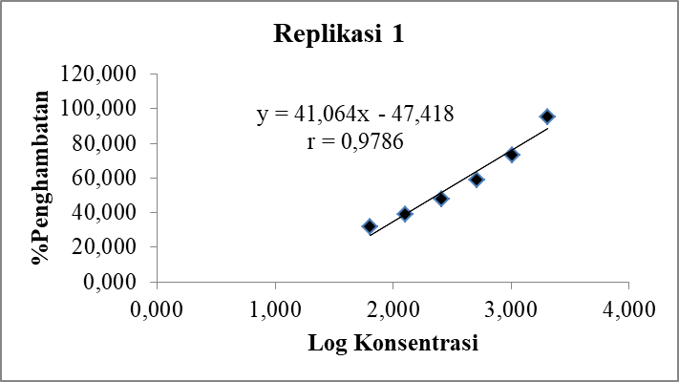

1. Nilai r tabel untuk taraf kepercayaan 95% (p<0,05), n= 6, adalah 0,811.
2. r = 0,9786 > r tabel, artinya terdapat hubungan yang linier antara persen penghambatan bakteri dengan konsentrasi ekstrak metanol Senggugu.

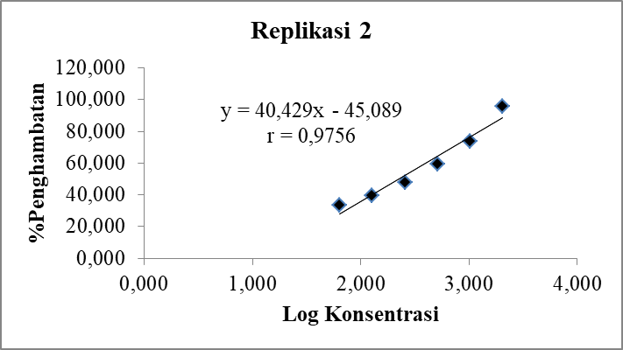

1. Nilai r tabel untuk taraf kepercayaan 95% (p<0,05), n= 6, adalah 0,811.
2. r = 0,9756 > r tabel, artinya terdapat hubungan yang linier antara persen penghambatan bakteri dengan konsentrasi ekstrak metanol Senggugu.

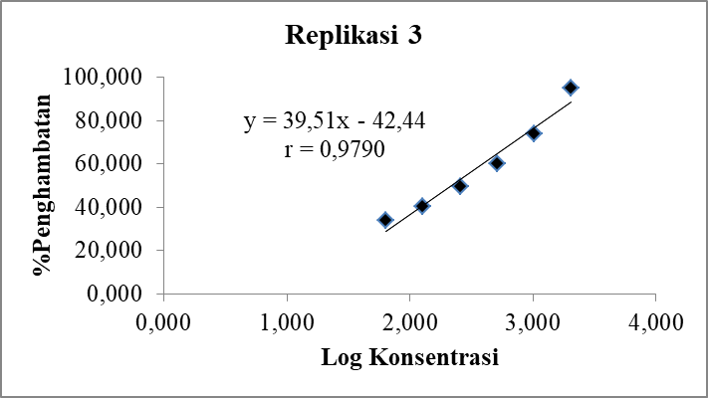

1. Nilai r tabel untuk taraf kepercayaan 95% (p<0,05), n= 6, adalah 0,811.
2. r = 0,9790 > r tabel, artinya terdapat hubungan yang linier antara persen penghambatan bakteri dengan konsentrasi ekstrak metanol Senggugu.
3. **Aktivitas Antibakteri Fraksi n-heksana Senggugu**

|  |  |  |  |  |
| --- | --- | --- | --- | --- |
| Konsentrasi | Log Kons. | % Penghambatan | | |
| Replikasi 1 | Replikasi 2 | Replikasi 3 |
| 2048 | 3,311 | 98,814 | 98,628 | 98,813 |
| 1024 | 3,010 | 92,954 | 92,238 | 92,584 |
| 512 | 2,709 | 84,688 | 84,543 | 84,608 |
| 256 | 2,408 | 57,148 | 57,344 | 57,482 |
| 128 | 2,107 | 45,901 | 46,437 | 46,968 |
| 64 | 1,806 | 39,228 | 39,779 | 40,277 |

Kurva Penghambatan Bakteri oleh Fraksi n-Heksana Senggugu

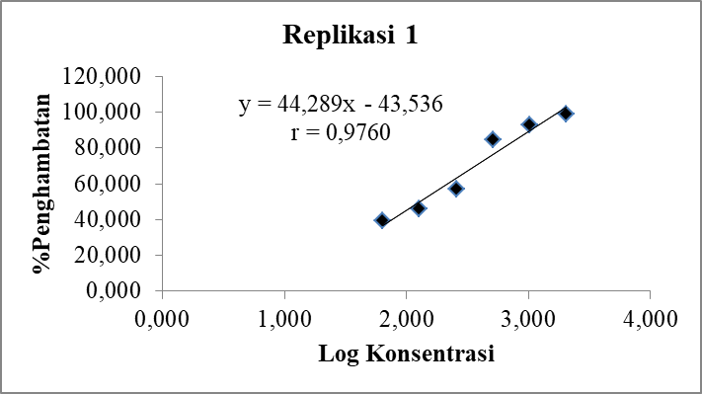

1. Nilai r tabel untuk taraf kepercayaan 95% (p<0,05), n= 6, adalah 0,811.
2. r = 0,9760 > r tabel, artinya terdapat hubungan yang linier antara persen penghambatan bakteri dengan konsentrasi fraksi n-heksana Senggugu.

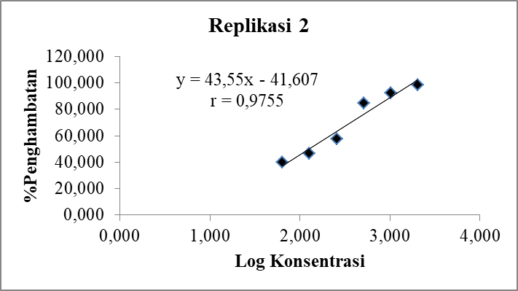

1. Nilai r tabel untuk taraf kepercayaan 95% (p<0,05), n= 6, adalah 0,811.
2. r = 0,9755 > r tabel, artinya terdapat hubungan yang linier antara persen penghambatan bakteri dengan konsentrasi fraksi n-heksana Senggugu.

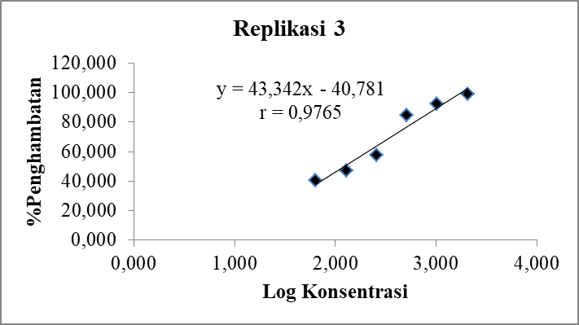

1. Nilai r tabel untuk taraf kepercayaan 95% (p<0,05), n= 6, adalah 0,811.
2. r = 0,9765 > r tabel, artinya terdapat hubungan yang linier antara persen penghambatan bakteri dengan konsentrasi fraksi n-heksana Senggugu.
3. **Aktivitas Antibakteri Fraksi Diklorometana Senggugu**

|  |  |  |  |  |
| --- | --- | --- | --- | --- |
| Konsentrasi | Log Kons. | % Penghambatan | | |
| Replikasi 1 | Replikasi 2 | Replikasi 3 |
| 2048 | 3,311 | 93,598 | 93,075 | 93,573 |
| 1024 | 3,010 | 76,728 | 77,518 | 78,049 |
| 512 | 2,709 | 63,415 | 63,466 | 63,514 |
| 256 | 2,408 | 50,305 | 51,422 | 51,549 |
| 128 | 2,107 | 37,602 | 38,073 | 38,497 |
| 64 | 1,806 | 31,098 | 31,750 | 32,268 |

Kurva Penghambatan Bakteri oleh Fraksi Diklorometana Senggugu

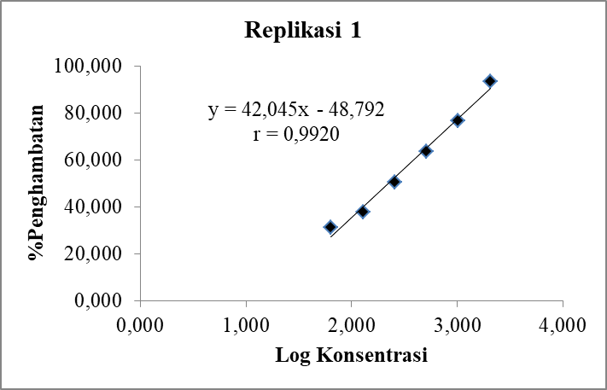

1. Nilai r tabel untuk taraf kepercayaan 95% (p<0,05), n= 6, adalah 0,811.
2. r = 0,9920 > r tabel, artinya terdapat hubungan yang linier antara persen penghambatan bakteri dengan konsentrasi fraksi diklorometana Senggugu.

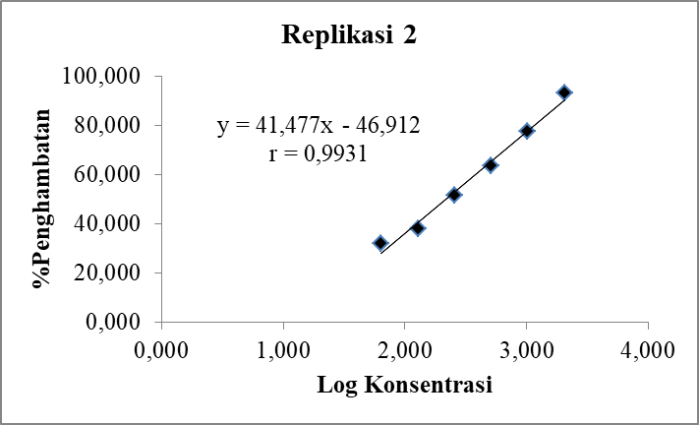

1. Nilai r tabel untuk taraf kepercayaan 95% (p<0,05), n= 6, adalah 0,811.
2. r = 0,9931 > r tabel, artinya terdapat hubungan yang linier antara persen penghambatan bakteri dengan konsentrasi fraksi diklorometana Senggugu.

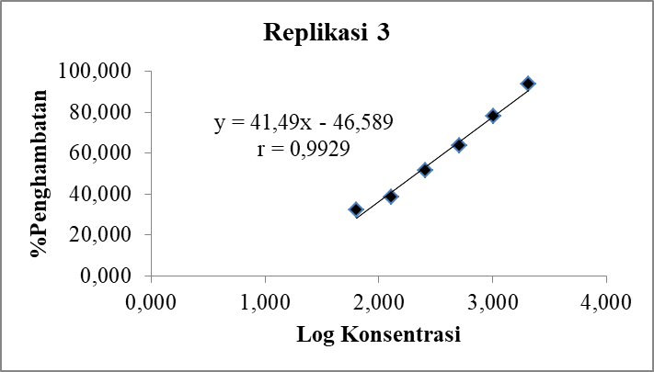

1. Nilai r tabel untuk taraf kepercayaan 95% (p<0,05), n= 6, adalah 0,811.
2. r = 0,9929 > r tabel, artinya terdapat hubungan yang linier antara persen penghambatan bakteri dengan konsentrasi fraksi diklorometana Senggugu.
3. **Aktivitas Antibakteri Fraksi Etil Asetat Senggugu**

|  |  |  |  |  |
| --- | --- | --- | --- | --- |
| Konsentrasi | Log Kons. | % Penghambatan | | |
| Replikasi 1 | Replikasi 2 | Replikasi 3 |
| 2048 | 3,311 | 90,142 | 89,662 | 89,222 |
| 1024 | 3,010 | 69,309 | 68,986 | 69,941 |
| 512 | 2,709 | 54,370 | 54,232 | 55,405 |
| 256 | 2,408 | 41,565 | 41,887 | 42,749 |
| 128 | 2,107 | 32,622 | 33,857 | 34,146 |
| 64 | 1,806 | 25,203 | 25,828 | 26,335 |

Kurva Penghambatan Bakteri oleh Fraksi Etil Asetat Senggugu

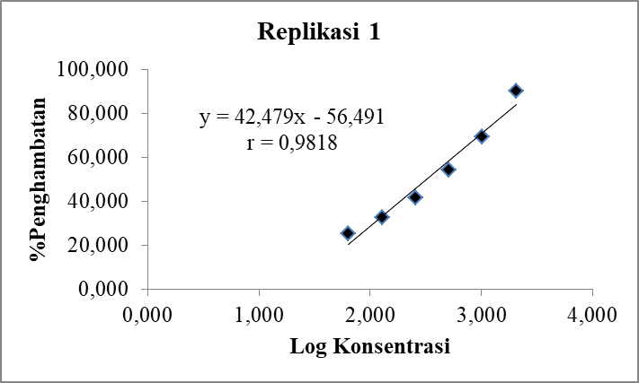

1. Nilai r tabel untuk taraf kepercayaan 95% (p<0,05), n= 6, adalah 0,811.
2. r = 0,9818 > r tabel, artinya terdapat hubungan yang linier antara persen penghambatan bakteri dengan konsentrasi fraksi etil asetat Senggugu.

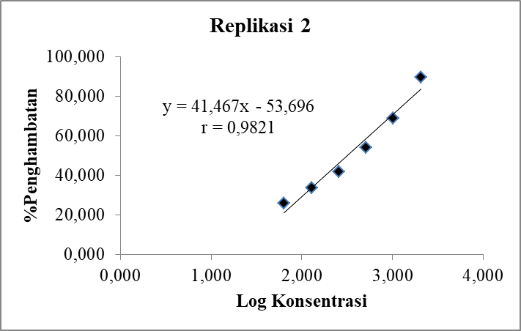

1. Nilai r tabel untuk taraf kepercayaan 95% (p<0,05), n= 6, adalah 0,811.
2. r = 0,9821 > r tabel, artinya terdapat hubungan yang linier antara persen penghambatan bakteri dengan konsentrasi fraksi etil asetat Senggugu.

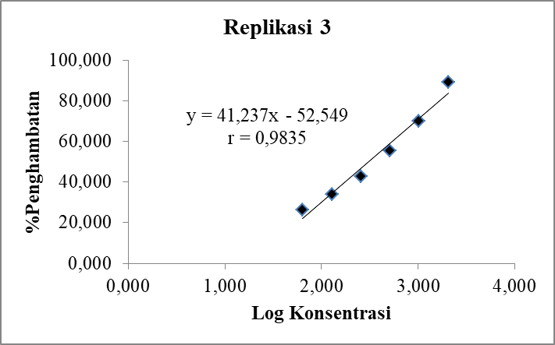

1. Nilai r tabel untuk taraf kepercayaan 95% (p<0,05), n= 6, adalah 0,811.
2. r = 0,9835 > r tabel, artinya terdapat hubungan yang linier antara persen penghambatan bakteri dengan konsentrasi fraksi etil asetat Senggugu.
3. **Aktivitas Antibakteri Residu Senggugu**

|  |  |  |  |  |
| --- | --- | --- | --- | --- |
| Konsentrasi | Log Kons. | % Penghambatan | | |
| Replikasi 1 | Replikasi 2 | Replikasi 3 |
| 2048 | 3,311 | 71,951 | 72,098 | 72,413 |
| 1024 | 3,010 | 53,557 | 54,031 | 54,713 |
| 512 | 2,709 | 43,801 | 44,095 | 44,924 |
| 256 | 2,408 | 39,126 | 39,779 | 40,574 |
| 128 | 2,107 | 31,606 | 32,051 | 33,158 |
| 64 | 1,806 | 21,545 | 22,717 | 23,764 |

Kurva Penghambatan Bakteri oleh Residu Senggugu

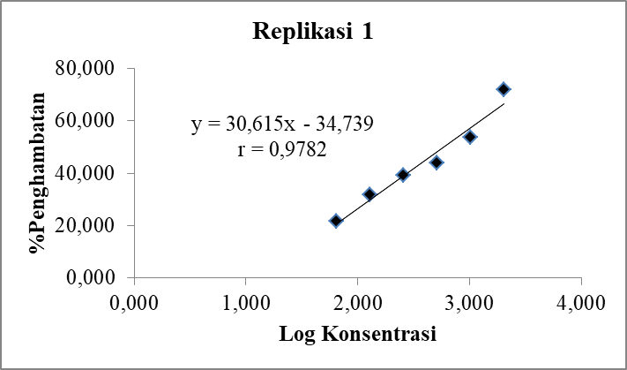

1. Nilai r tabel untuk taraf kepercayaan 95% (p<0,05), n= 6, adalah 0,811.
2. r = 0,9782 > r tabel, artinya terdapat hubungan yang linier antara persen penghambatan bakteri dengan konsentrasi residu Senggugu.

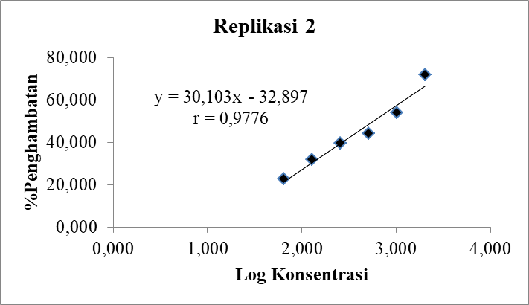

1. Nilai r tabel untuk taraf kepercayaan 95% (p<0,05), n= 6, adalah 0,811.
2. r = 0,9776 > r tabel, artinya terdapat hubungan yang linier antara persen penghambatan bakteri dengan konsentrasi residu Senggugu.

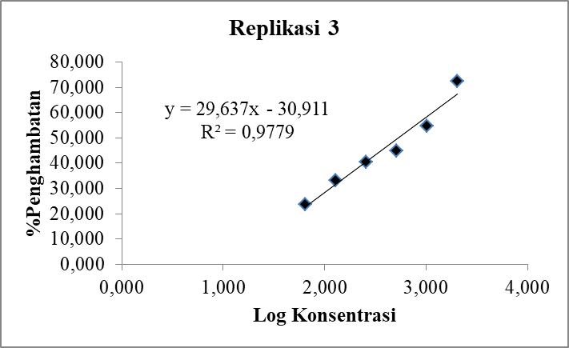

1. Nilai r tabel untuk taraf kepercayaan 95% (p<0,05), n= 6, adalah 0,811.
2. r = 0,9779 > r tabel, artinya terdapat hubungan yang linier antara persen penghambatan bakteri dengan konsentrasi residu Senggugu.

**Lampiran 4.7 Hasil Analisis Probit Aktivitas Antibakteri Ekstrak dan Fraksi Senggugu**

1. **Ekstrak Metanol Senggugu**
2. Replikasi 1

|  |  |  |  |  |
| --- | --- | --- | --- | --- |
| **Confidence Limits** | | | | |
|  | Probability | 95% Confidence Limits for Konsentrasi | | |
|  | Estimate | Lower Bound | Upper Bound |
| PROBIT | ,010 | -1843,732 | -4868,847 | -624,004 |
| ,020 | -1581,890 | -4409,434 | -438,509 |
| ,030 | -1415,760 | -4118,167 | -320,603 |
| ,040 | -1290,787 | -3899,185 | -231,779 |
| ,050 | -1189,131 | -3721,150 | -159,439 |
| ,060 | -1102,605 | -3569,683 | -97,796 |
| ,070 | -1026,740 | -3436,934 | -43,690 |
| ,080 | -958,811 | -3318,121 | 4,803 |
| ,090 | -897,032 | -3210,107 | 48,948 |
| ,100 | -840,165 | -3110,718 | 89,621 |
| ,150 | -604,720 | -2699,653 | 258,451 |
| ,200 | -417,595 | -2373,535 | 393,215 |
| ,250 | -257,059 | -2094,262 | 509,338 |
| ,300 | -112,892 | -1843,947 | 614,101 |
| ,350 | 20,699 | -1612,475 | 711,661 |
| ,400 | 147,465 | -1393,340 | 804,745 |
| ,450 | 270,112 | -1181,882 | 895,363 |
| ,500 | 390,814 | -974,412 | 985,180 |
| ,550 | 511,517 | -767,694 | 1075,749 |
| ,600 | 634,164 | -558,572 | 1168,703 |
| ,650 | 760,929 | -343,623 | 1265,973 |
| ,700 | 894,521 | -118,727 | 1370,109 |
| ,750 | 1038,688 | 121,594 | 1484,866 |
| ,800 | 1199,224 | 385,399 | 1616,457 |
| ,850 | 1386,348 | 685,964 | 1776,774 |
| ,900 | 1621,794 | 1048,667 | 1993,965 |
| ,910 | 1678,661 | 1132,821 | 2049,873 |
| ,920 | 1740,440 | 1222,400 | 2112,453 |
| ,930 | 1808,368 | 1318,473 | 2183,686 |
| ,940 | 1884,234 | 1422,507 | 2266,508 |
| ,950 | 1970,759 | 1536,632 | 2365,492 |
| ,960 | 2072,416 | 1664,222 | 2488,277 |
| ,970 | 2197,389 | 1811,346 | 2648,959 |
| ,980 | 2363,519 | 1991,261 | 2878,218 |
| ,990 | 2625,361 | 2245,189 | 3269,198 |

Nilai IC50 ekstrak metanol Senggugu replikasi 1 adalah 390,814 µg/mL

1. Replikasi 2

|  |  |  |  |  |
| --- | --- | --- | --- | --- |
| **Confidence Limits** | | | | |
|  | Probability | 95% Confidence Limits for Konsentrasi | | |
|  | Estimate | Lower Bound | Upper Bound |
| PROBIT | ,010 | -1854,398 | -5391,771 | -555,395 |
| ,020 | -1593,733 | -4902,399 | -375,453 |
| ,030 | -1428,349 | -4592,105 | -261,088 |
| ,040 | -1303,937 | -4358,801 | -174,939 |
| ,050 | -1202,737 | -4169,108 | -104,781 |
| ,060 | -1116,601 | -4007,713 | -45,002 |
| ,070 | -1041,076 | -3866,253 | 7,465 |
| ,080 | -973,452 | -3739,637 | 54,487 |
| ,090 | -911,951 | -3624,523 | 97,290 |
| ,100 | -855,340 | -3518,595 | 136,724 |
| ,150 | -620,952 | -3080,419 | 300,389 |
| ,200 | -434,668 | -2732,704 | 430,997 |
| ,250 | -274,853 | -2434,857 | 543,509 |
| ,300 | -131,334 | -2167,817 | 644,985 |
| ,350 | 1,658 | -1920,804 | 739,456 |
| ,400 | 127,854 | -1686,875 | 829,562 |
| ,450 | 249,950 | -1461,052 | 917,247 |
| ,500 | 370,110 | -1239,386 | 1004,118 |
| ,550 | 490,270 | -1018,402 | 1091,671 |
| ,600 | 612,366 | -794,699 | 1181,476 |
| ,650 | 738,562 | -564,571 | 1275,383 |
| ,700 | 871,554 | -323,535 | 1375,831 |
| ,750 | 1015,073 | -65,597 | 1486,408 |
| ,800 | 1174,888 | 218,115 | 1613,055 |
| ,850 | 1361,172 | 542,309 | 1767,185 |
| ,900 | 1595,560 | 935,219 | 1976,115 |
| ,910 | 1652,171 | 1026,652 | 2030,045 |
| ,920 | 1713,672 | 1124,064 | 2090,550 |
| ,930 | 1781,296 | 1228,592 | 2159,659 |
| ,940 | 1856,821 | 1341,761 | 2240,417 |
| ,950 | 1942,958 | 1465,716 | 2337,636 |
| ,960 | 2044,157 | 1603,739 | 2459,464 |
| ,970 | 2168,569 | 1761,566 | 2621,092 |
| ,980 | 2333,953 | 1951,630 | 2855,686 |
| ,990 | 2594,618 | 2213,200 | 3263,430 |

Nilai IC50 ekstrak metanol Senggugu replikasi 2 adalah 370,110 µg/mL

1. Replikasi 3

|  |  |  |  |  |
| --- | --- | --- | --- | --- |
| **Confidence Limits** | | | | |
|  | Probability | 95% Confidence Limits for Konsentrasi | | |
|  | Estimate | Lower Bound | Upper Bound |
| PROBIT | ,010 | -1982,052 | -5423,367 | -654,924 |
| ,020 | -1707,956 | -4926,675 | -463,112 |
| ,030 | -1534,051 | -4611,762 | -341,191 |
| ,040 | -1403,228 | -4374,996 | -249,344 |
| ,050 | -1296,814 | -4182,498 | -174,540 |
| ,060 | -1206,240 | -4018,723 | -110,800 |
| ,070 | -1126,823 | -3875,183 | -54,853 |
| ,080 | -1055,715 | -3746,710 | -4,710 |
| ,090 | -991,045 | -3629,912 | 40,936 |
| ,100 | -931,517 | -3522,437 | 82,993 |
| ,150 | -685,052 | -3077,908 | 257,559 |
| ,200 | -489,170 | -2725,207 | 396,896 |
| ,250 | -321,120 | -2423,138 | 516,951 |
| ,300 | -170,206 | -2152,359 | 625,254 |
| ,350 | -30,362 | -1901,933 | 726,102 |
| ,400 | 102,336 | -1664,818 | 822,314 |
| ,450 | 230,723 | -1435,972 | 915,964 |
| ,500 | 357,075 | -1211,395 | 1008,770 |
| ,550 | 483,426 | -987,576 | 1102,334 |
| ,600 | 611,813 | -761,082 | 1198,337 |
| ,650 | 744,512 | -528,182 | 1298,763 |
| ,700 | 884,356 | -284,373 | 1406,229 |
| ,750 | 1035,270 | -23,644 | 1524,581 |
| ,800 | 1203,319 | 262,885 | 1660,177 |
| ,850 | 1399,201 | 589,915 | 1825,184 |
| ,900 | 1645,666 | 985,733 | 2048,463 |
| ,910 | 1705,195 | 1077,798 | 2105,928 |
| ,920 | 1769,865 | 1175,896 | 2170,275 |
| ,930 | 1840,972 | 1281,211 | 2243,576 |
| ,940 | 1920,389 | 1395,351 | 2328,922 |
| ,950 | 2010,964 | 1520,623 | 2431,167 |
| ,960 | 2117,378 | 1660,615 | 2558,476 |
| ,970 | 2248,200 | 1821,672 | 2726,032 |
| ,980 | 2422,105 | 2017,512 | 2967,026 |
| ,990 | 2696,202 | 2290,761 | 3382,281 |

Nilai IC50 ekstrak metanol Senggugu replikasi 3 adalah 357,075 µg/mL

Tabulasi Nilai IC50 Ekstrak Metanol Senggugu

|  |  |  |  |
| --- | --- | --- | --- |
| Uji Aktivitas Antibakteri | IC50 | Rerata ± SD | CV |
| Replikasi 1 | 390,814 | 380,462 ± 17,014 | 4,472 |
| Replikasi 2 | 370,110 |
| Replikasi 3 | 357,075 |

1. **Fraksi n-Heksana**
2. Replikasi 1

|  |  |  |  |  |
| --- | --- | --- | --- | --- |
| **Confidence Limits** | | | | |
|  | Probability | 95% Confidence Limits for Konsentrasi | | |
|  | Estimate | Lower Bound | Upper Bound |
| PROBITa | ,010 | -1335,413 | . | . |
| ,020 | -1157,461 | . | . |
| ,030 | -1044,556 | . | . |
| ,040 | -959,621 | . | . |
| ,050 | -890,534 | . | . |
| ,060 | -831,730 | . | . |
| ,070 | -780,170 | . | . |
| ,080 | -734,004 | . | . |
| ,090 | -692,019 | . | . |
| ,100 | -653,371 | . | . |
| ,150 | -493,358 | . | . |
| ,200 | -366,184 | . | . |
| ,250 | -257,081 | . | . |
| ,300 | -159,103 | . | . |
| ,350 | -68,311 | . | . |
| ,400 | 17,841 | . | . |
| ,450 | 101,194 | . | . |
| ,500 | 183,226 | . | . |
| ,550 | 265,257 | . | . |
| ,600 | 348,611 | . | . |
| ,650 | 434,763 | . | . |
| ,700 | 525,554 | . | . |
| ,750 | 623,532 | . | . |
| ,800 | 732,636 | . | . |
| ,850 | 859,809 | . | . |
| ,900 | 1019,822 | . | . |
| ,910 | 1058,470 | . | . |
| ,920 | 1100,456 | . | . |
| ,930 | 1146,622 | . | . |
| ,940 | 1198,181 | . | . |
| ,950 | 1256,986 | . | . |
| ,960 | 1326,073 | . | . |
| ,970 | 1411,007 | . | . |
| ,980 | 1523,912 | . | . |
| ,990 | 1701,865 | . | . |
| a. A heterogeneity factor is used. | | | | |

Nilai IC50 fraksi n-heksana Senggugu replikasi 1 adalah 183,226 µg/mL

1. Replikasi 2

|  |  |  |  |  |
| --- | --- | --- | --- | --- |
| **Confidence Limits** | | | | |
|  | Probability | 95% Confidence Limits for Konsentrasi | | |
|  | Estimate | Lower Bound | Upper Bound |
| PROBITa | ,010 | -1415,996 | . | . |
| ,020 | -1229,341 | . | . |
| ,030 | -1110,915 | . | . |
| ,040 | -1021,827 | . | . |
| ,050 | -949,361 | . | . |
| ,060 | -887,681 | . | . |
| ,070 | -833,599 | . | . |
| ,080 | -785,176 | . | . |
| ,090 | -741,137 | . | . |
| ,100 | -700,599 | . | . |
| ,150 | -532,761 | . | . |
| ,200 | -399,368 | . | . |
| ,250 | -284,929 | . | . |
| ,300 | -182,159 | . | . |
| ,350 | -86,928 | . | . |
| ,400 | 3,437 | . | . |
| ,450 | 90,867 | . | . |
| ,500 | 176,910 | . | . |
| ,550 | 262,954 | . | . |
| ,600 | 350,383 | . | . |
| ,650 | 440,749 | . | . |
| ,700 | 535,980 | . | . |
| ,750 | 638,750 | . | . |
| ,800 | 753,189 | . | . |
| ,850 | 886,581 | . | . |
| ,900 | 1054,420 | . | . |
| ,910 | 1094,958 | . | . |
| ,920 | 1138,997 | . | . |
| ,930 | 1187,420 | . | . |
| ,940 | 1241,502 | . | . |
| ,950 | 1303,181 | . | . |
| ,960 | 1375,648 | . | . |
| ,970 | 1464,735 | . | . |
| ,980 | 1583,162 | . | . |
| ,990 | 1769,817 | . | . |
| a. A heterogeneity factor is used. | | | | |

Nilai IC50 fraksi n-heksana Senggugu replikasi 2 adalah 176,910 µg/mL

1. Replikasi 3

|  |  |  |  |  |
| --- | --- | --- | --- | --- |
| **Confidence Limits** | | | | |
|  | Probability | 95% Confidence Limits for Konsentrasi | | |
|  | Estimate | Lower Bound | Upper Bound |
| PROBITa | ,010 | -1387,460 | . | . |
| ,020 | -1204,886 | . | . |
| ,030 | -1089,048 | . | . |
| ,040 | -1001,908 | . | . |
| ,050 | -931,027 | . | . |
| ,060 | -870,695 | . | . |
| ,070 | -817,796 | . | . |
| ,080 | -770,432 | . | . |
| ,090 | -727,356 | . | . |
| ,100 | -687,704 | . | . |
| ,150 | -523,535 | . | . |
| ,200 | -393,059 | . | . |
| ,250 | -281,122 | . | . |
| ,300 | -180,599 | . | . |
| ,350 | -87,450 | . | . |
| ,400 | ,940 | . | . |
| ,450 | 86,458 | . | . |
| ,500 | 170,620 | . | . |
| ,550 | 254,782 | . | . |
| ,600 | 340,300 | . | . |
| ,650 | 428,690 | . | . |
| ,700 | 521,839 | . | . |
| ,750 | 622,362 | . | . |
| ,800 | 734,299 | . | . |
| ,850 | 864,775 | . | . |
| ,900 | 1028,944 | . | . |
| ,910 | 1068,596 | . | . |
| ,920 | 1111,672 | . | . |
| ,930 | 1159,036 | . | . |
| ,940 | 1211,935 | . | . |
| ,950 | 1272,267 | . | . |
| ,960 | 1343,148 | . | . |
| ,970 | 1430,288 | . | . |
| ,980 | 1546,126 | . | . |
| ,990 | 1728,700 | . | . |
| a. A heterogeneity factor is used. | | | | |

Nilai IC50 fraksi n-heksana Senggugu replikasi 3 adalah 170,620 µg/mL

Tabulasi Nilai IC50 Fraksi n-Heksana Senggugu

|  |  |  |  |
| --- | --- | --- | --- |
| Uji Aktivitas Antibakteri | IC50 | Rerata ± SD | CV |
| Replikasi 1 | 183,226 | 176,919 ± 6,303 | 3,563 |
| Replikasi 2 | 176,910 |
| Replikasi 3 | 170,620 |

1. **Fraksi Diklorometana**
2. Replikasi 1

|  |  |  |  |  |
| --- | --- | --- | --- | --- |
| **Confidence Limits** | | | | |
|  | Probability | 95% Confidence Limits for Konsentrasi | | |
|  | Estimate | Lower Bound | Upper Bound |
| PROBITa | ,010 | -1942,932 | -18367,743 | -90,808 |
| ,020 | -1673,420 | -16965,918 | 68,018 |
| ,030 | -1502,423 | -16077,292 | 169,576 |
| ,040 | -1373,788 | -15409,284 | 246,444 |
| ,050 | -1269,154 | -14866,245 | 309,306 |
| ,060 | -1180,094 | -14404,294 | 363,070 |
| ,070 | -1102,005 | -13999,467 | 410,425 |
| ,080 | -1032,087 | -13637,176 | 453,008 |
| ,090 | -968,498 | -13307,846 | 491,896 |
| ,100 | -909,965 | -13004,841 | 527,836 |
| ,150 | -667,622 | -11751,982 | 678,299 |
| ,200 | -475,016 | -10758,528 | 800,161 |
| ,250 | -309,776 | -9908,247 | 906,721 |
| ,300 | -161,386 | -9146,608 | 1004,356 |
| ,350 | -23,881 | -8442,821 | 1096,814 |
| ,400 | 106,598 | -7777,128 | 1186,679 |
| ,450 | 232,838 | -7135,446 | 1276,009 |
| ,500 | 357,077 | -6506,711 | 1366,696 |
| ,550 | 481,316 | -5881,335 | 1460,742 |
| ,600 | 607,556 | -5250,136 | 1560,555 |
| ,650 | 738,035 | -4603,397 | 1669,374 |
| ,700 | 875,540 | -3929,817 | 1792,039 |
| ,750 | 1023,930 | -3215,092 | 1936,587 |
| ,800 | 1189,169 | -2439,730 | 2118,067 |
| ,850 | 1381,776 | -1575,805 | 2369,458 |
| ,900 | 1624,119 | -584,177 | 2781,152 |
| ,910 | 1682,652 | -366,666 | 2902,586 |
| ,920 | 1746,240 | -142,137 | 3046,275 |
| ,930 | 1816,159 | 89,509 | 3219,504 |
| ,940 | 1894,248 | 328,314 | 3432,880 |
| ,950 | 1983,308 | 574,464 | 3702,446 |
| ,960 | 2087,942 | 828,906 | 4053,904 |
| ,970 | 2216,576 | 1095,053 | 4532,633 |
| ,980 | 2387,574 | 1383,811 | 5234,058 |
| ,990 | 2657,086 | 1734,983 | 6443,539 |
| a. A heterogeneity factor is used. | | | | |

Nilai IC50 fraksi diklorometana Senggugu replikasi 1 adalah 357,077 µg/mL

1. Replikasi 2

|  |  |  |  |  |
| --- | --- | --- | --- | --- |
| **Confidence Limits** | | | | |
|  | Probability | 95% Confidence Limits for Konsentrasi | | |
|  | Estimate | Lower Bound | Upper Bound |
| PROBITa | ,010 | -2014,877 | -22930,958 | -70,577 |
| ,020 | -1738,738 | -21210,230 | 90,182 |
| ,030 | -1563,537 | -20119,343 | 193,039 |
| ,040 | -1431,740 | -19299,226 | 270,928 |
| ,050 | -1324,533 | -18632,490 | 334,651 |
| ,060 | -1233,284 | -18065,277 | 389,173 |
| ,070 | -1153,276 | -17568,176 | 437,213 |
| ,080 | -1081,638 | -17123,281 | 480,426 |
| ,090 | -1016,486 | -16718,842 | 519,902 |
| ,100 | -956,514 | -16346,713 | 556,397 |
| ,150 | -708,213 | -14807,821 | 709,319 |
| ,200 | -510,871 | -13587,261 | 833,359 |
| ,250 | -341,569 | -12542,342 | 941,987 |
| ,300 | -189,531 | -11606,111 | 1041,677 |
| ,350 | -48,645 | -10740,746 | 1136,246 |
| ,400 | 85,042 | -9921,957 | 1228,342 |
| ,450 | 214,386 | -9132,414 | 1320,091 |
| ,500 | 341,679 | -8358,476 | 1413,472 |
| ,550 | 468,972 | -7588,293 | 1510,607 |
| ,600 | 598,315 | -6810,472 | 1614,078 |
| ,650 | 732,003 | -6012,916 | 1727,406 |
| ,700 | 872,889 | -5181,497 | 1855,922 |
| ,750 | 1024,927 | -4298,252 | 2008,598 |
| ,800 | 1194,228 | -3338,648 | 2202,541 |
| ,850 | 1391,570 | -2267,661 | 2476,154 |
| ,900 | 1639,871 | -1038,201 | 2938,508 |
| ,910 | 1699,843 | -769,386 | 3078,318 |
| ,920 | 1764,995 | -492,777 | 3245,624 |
| ,930 | 1836,633 | -208,819 | 3449,773 |
| ,940 | 1916,641 | 81,701 | 3704,394 |
| ,950 | 2007,891 | 377,832 | 4029,998 |
| ,960 | 2115,097 | 679,170 | 4459,119 |
| ,970 | 2246,894 | 987,836 | 5048,460 |
| ,980 | 2422,096 | 1314,035 | 5916,004 |
| ,990 | 2698,234 | 1698,453 | 7413,073 |
| a. A heterogeneity factor is used. | | | | |

Nilai IC50 fraksi diklorometana Senggugu replikasi 2 adalah 341,679 µg/mL

1. Replikasi 3

|  |  |  |  |  |
| --- | --- | --- | --- | --- |
| **Confidence Limits** | | | | |
|  | Probability | 95% Confidence Limits for Konsentrasi | | |
|  | Estimate | Lower Bound | Upper Bound |
| PROBITa | ,010 | -1984,626 | -18471,920 | -109,472 |
| ,020 | -1713,103 | -17070,489 | 50,671 |
| ,030 | -1540,830 | -16182,114 | 153,065 |
| ,040 | -1411,235 | -15514,296 | 230,564 |
| ,050 | -1305,820 | -14971,411 | 293,937 |
| ,060 | -1216,096 | -14509,591 | 348,138 |
| ,070 | -1137,425 | -14104,878 | 395,874 |
| ,080 | -1066,984 | -13742,689 | 438,799 |
| ,090 | -1002,921 | -13413,452 | 477,997 |
| ,100 | -943,952 | -13110,531 | 514,222 |
| ,150 | -699,800 | -11858,016 | 665,859 |
| ,200 | -505,757 | -10864,824 | 788,641 |
| ,250 | -339,284 | -10014,750 | 895,976 |
| ,300 | -189,787 | -9253,280 | 994,287 |
| ,350 | -51,256 | -8549,627 | 1087,350 |
| ,400 | 80,197 | -7884,032 | 1177,760 |
| ,450 | 207,379 | -7242,407 | 1267,579 |
| ,500 | 332,545 | -6613,679 | 1358,698 |
| ,550 | 457,710 | -5988,242 | 1453,108 |
| ,600 | 584,892 | -5356,881 | 1553,191 |
| ,650 | 716,345 | -4709,825 | 1662,140 |
| ,700 | 854,877 | -4035,673 | 1784,704 |
| ,750 | 1004,374 | -3319,914 | 1928,726 |
| ,800 | 1170,846 | -2542,607 | 2108,827 |
| ,850 | 1364,890 | -1674,680 | 2356,875 |
| ,900 | 1609,041 | -673,596 | 2759,943 |
| ,910 | 1668,011 | -452,829 | 2878,322 |
| ,920 | 1732,074 | -224,313 | 3018,241 |
| ,930 | 1802,514 | 12,214 | 3186,828 |
| ,940 | 1881,185 | 256,963 | 3394,529 |
| ,950 | 1970,910 | 510,259 | 3657,253 |
| ,960 | 2076,325 | 773,120 | 4000,650 |
| ,970 | 2205,919 | 1048,905 | 4470,182 |
| ,980 | 2378,192 | 1348,397 | 5161,459 |
| ,990 | 2649,716 | 1711,586 | 6359,845 |
| a. A heterogeneity factor is used. | | | | |

Nilai IC50 fraksi diklorometana Senggugu replikasi 3 adalah 332,545 µg/mL

Tabulasi Nilai IC50 Fraksi Dikrolometana Senggugu

|  |  |  |  |
| --- | --- | --- | --- |
| Uji Aktivitas Antibakteri | IC50 | Rerata ± SD | CV |
| Replikasi 1 | 357,077 | 343,767 ± 12,399 | 3,607 |
| Replikasi 2 | 341,679 |
| Replikasi 3 | 332,545 |

1. **Fraksi Etil Asetat**
2. Replikasi 1

|  |  |  |  |  |
| --- | --- | --- | --- | --- |
| **Confidence Limits** | | | | |
|  | Probability | 95% Confidence Limits for Konsentrasi | | |
|  | Estimate | Lower Bound | Upper Bound |
| PROBITa | ,010 | -1884,632 | -12022,039 | -143,771 |
| ,020 | -1598,536 | -11011,721 | 30,368 |
| ,030 | -1417,017 | -10371,349 | 141,496 |
| ,040 | -1280,468 | -9890,007 | 225,478 |
| ,050 | -1169,395 | -9498,748 | 294,066 |
| ,060 | -1074,855 | -9165,940 | 352,660 |
| ,070 | -991,962 | -8874,309 | 404,213 |
| ,080 | -917,741 | -8613,340 | 450,524 |
| ,090 | -850,240 | -8376,133 | 492,776 |
| ,100 | -788,105 | -8157,904 | 531,789 |
| ,150 | -530,851 | -7255,774 | 694,710 |
| ,200 | -326,393 | -6540,723 | 826,128 |
| ,250 | -150,986 | -5928,999 | 940,599 |
| ,300 | 6,534 | -5381,333 | 1045,078 |
| ,350 | 152,501 | -4875,576 | 1143,631 |
| ,400 | 291,008 | -4397,545 | 1239,031 |
| ,450 | 425,016 | -3937,174 | 1333,462 |
| ,500 | 556,899 | -3486,606 | 1428,898 |
| ,550 | 688,782 | -3039,104 | 1527,401 |
| ,600 | 822,790 | -2588,317 | 1631,415 |
| ,650 | 961,298 | -2127,673 | 1744,203 |
| ,700 | 1107,264 | -1649,768 | 1870,608 |
| ,750 | 1264,785 | -1145,637 | 2018,622 |
| ,800 | 1440,191 | -603,899 | 2203,079 |
| ,850 | 1644,649 | -10,110 | 2455,759 |
| ,900 | 1901,904 | 651,969 | 2858,732 |
| ,910 | 1964,038 | 793,878 | 2974,065 |
| ,920 | 2031,539 | 939,256 | 3108,145 |
| ,930 | 2105,760 | 1088,390 | 3266,291 |
| ,940 | 2188,653 | 1241,865 | 3456,000 |
| ,950 | 2283,194 | 1400,899 | 3688,368 |
| ,960 | 2394,266 | 1568,042 | 3981,072 |
| ,970 | 2530,816 | 1748,798 | 4365,641 |
| ,980 | 2712,334 | 1956,303 | 4909,635 |
| ,990 | 2998,430 | 2232,043 | 5818,352 |
| a. A heterogeneity factor is used. | | | | |

Nilai IC50 fraksi etil asetat Senggugu replikasi 1 adalah 556,899 µg/mL

1. Replikasi 2

|  |  |  |  |  |
| --- | --- | --- | --- | --- |
| **Confidence Limits** | | | | |
|  | Probability | 95% Confidence Limits for Konsentrasi | | |
|  | Estimate | Lower Bound | Upper Bound |
| PROBITa | ,010 | -1965,087 | -12686,183 | -159,305 |
| ,020 | -1670,247 | -11629,656 | 19,262 |
| ,030 | -1483,182 | -10959,940 | 133,173 |
| ,040 | -1342,459 | -10456,508 | 219,233 |
| ,050 | -1227,992 | -10047,268 | 289,501 |
| ,060 | -1130,563 | -9699,147 | 349,515 |
| ,070 | -1045,137 | -9394,083 | 402,305 |
| ,080 | -968,648 | -9121,079 | 449,718 |
| ,090 | -899,084 | -8872,921 | 492,966 |
| ,100 | -835,050 | -8644,606 | 532,890 |
| ,150 | -569,934 | -7700,657 | 699,525 |
| ,200 | -359,228 | -6952,283 | 833,808 |
| ,250 | -178,461 | -6311,892 | 950,658 |
| ,300 | -16,127 | -5738,404 | 1057,195 |
| ,350 | 134,300 | -5208,637 | 1157,573 |
| ,400 | 277,041 | -4707,734 | 1254,616 |
| ,450 | 415,144 | -4225,130 | 1350,533 |
| ,500 | 551,057 | -3752,562 | 1447,312 |
| ,550 | 686,971 | -3282,911 | 1547,009 |
| ,600 | 825,074 | -2809,431 | 1652,049 |
| ,650 | 967,814 | -2325,087 | 1765,651 |
| ,700 | 1118,241 | -1821,870 | 1892,579 |
| ,750 | 1280,575 | -1289,957 | 2040,692 |
| ,800 | 1461,342 | -716,644 | 2224,619 |
| ,850 | 1672,048 | -85,381 | 2476,013 |
| ,900 | 1937,164 | 622,837 | 2878,378 |
| ,910 | 2001,198 | 775,122 | 2994,333 |
| ,920 | 2070,762 | 931,168 | 3129,693 |
| ,930 | 2147,251 | 1091,154 | 3290,124 |
| ,940 | 2232,677 | 1255,509 | 3483,624 |
| ,950 | 2330,107 | 1425,263 | 3722,004 |
| ,960 | 2444,573 | 1602,782 | 4023,993 |
| ,970 | 2585,296 | 1793,456 | 4422,811 |
| ,980 | 2772,362 | 2010,548 | 4989,346 |
| ,990 | 3067,201 | 2296,441 | 5938,547 |
| a. A heterogeneity factor is used. | | | | |

Nilai IC50 fraksi etil asetat Senggugu replikasi 2 adalah 551,057 µg/mL

1. Replikasi 3

|  |  |  |  |  |
| --- | --- | --- | --- | --- |
| **Confidence Limits** | | | | |
|  | Probability | 95% Confidence Limits for Konsentrasi | | |
|  | Estimate | Lower Bound | Upper Bound |
| PROBITa | ,010 | -2022,846 | -15902,566 | -115,242 |
| ,020 | -1723,260 | -14612,850 | 62,711 |
| ,030 | -1533,183 | -13795,284 | 176,333 |
| ,040 | -1390,195 | -13180,691 | 262,238 |
| ,050 | -1273,885 | -12681,076 | 332,422 |
| ,060 | -1174,887 | -12256,065 | 392,401 |
| ,070 | -1088,085 | -11883,611 | 445,188 |
| ,080 | -1010,365 | -11550,293 | 492,623 |
| ,090 | -939,681 | -11247,304 | 535,912 |
| ,100 | -874,616 | -10968,535 | 575,895 |
| ,150 | -605,232 | -9815,926 | 742,997 |
| ,200 | -391,133 | -8902,035 | 877,972 |
| ,250 | -207,456 | -8119,933 | 995,704 |
| ,300 | -42,508 | -7419,471 | 1103,319 |
| ,350 | 110,341 | -6772,343 | 1204,996 |
| ,400 | 255,379 | -6160,406 | 1303,602 |
| ,450 | 395,706 | -5570,757 | 1401,411 |
| ,500 | 533,808 | -4993,296 | 1500,509 |
| ,550 | 671,909 | -4419,327 | 1603,098 |
| ,600 | 812,236 | -3840,604 | 1711,833 |
| ,650 | 957,274 | -3248,535 | 1830,307 |
| ,700 | 1110,123 | -2633,365 | 1963,942 |
| ,750 | 1275,071 | -1983,201 | 2121,855 |
| ,800 | 1458,749 | -1282,891 | 2321,378 |
| ,850 | 1672,847 | -513,572 | 2600,925 |
| ,900 | 1942,232 | 342,520 | 3064,545 |
| ,910 | 2007,296 | 524,513 | 3201,303 |
| ,920 | 2077,980 | 709,759 | 3362,336 |
| ,930 | 2155,701 | 898,071 | 3554,777 |
| ,940 | 2242,502 | 1089,471 | 3788,618 |
| ,950 | 2341,500 | 1284,590 | 4078,488 |
| ,960 | 2457,810 | 1485,476 | 4447,402 |
| ,970 | 2600,798 | 1697,386 | 4935,989 |
| ,980 | 2790,876 | 1933,757 | 5630,807 |
| ,990 | 3090,462 | 2237,791 | 6794,442 |
| a. A heterogeneity factor is used. | | | | |

Nilai IC50 fraksi etil asetat Senggugu replikasi 3 adalah 533,808 µg/mL

Tabulasi Nilai IC50 Fraksi Etil Asetat Senggugu

|  |  |  |  |
| --- | --- | --- | --- |
| Uji Aktivitas Antibakteri | IC50 | Rerata ± SD | CV |
| Replikasi 1 | 556,899 | 547,225 ± 12,006 | 2,194 |
| Replikasi 2 | 551,057 |
| Replikasi 3 | 533,808 |

1. **Residu**
2. Replikasi 1

|  |  |  |  |  |
| --- | --- | --- | --- | --- |
| **Confidence Limits** | | | | |
|  | Probability | 95% Confidence Limits for Konsentrasi | | |
|  | Estimate | Lower Bound | Upper Bound |
| PROBITa | ,010 | -2998,731 | . | . |
| ,020 | -2536,027 | . | . |
| ,030 | -2242,456 | . | . |
| ,040 | -2021,614 | . | . |
| ,050 | -1841,976 | . | . |
| ,060 | -1689,076 | . | . |
| ,070 | -1555,012 | . | . |
| ,080 | -1434,975 | . | . |
| ,090 | -1325,805 | . | . |
| ,100 | -1225,314 | . | . |
| ,150 | -809,255 | . | . |
| ,200 | -478,585 | . | . |
| ,250 | -194,899 | . | . |
| ,300 | 59,859 | . | . |
| ,350 | 295,931 | . | . |
| ,400 | 519,940 | . | . |
| ,450 | 736,671 | . | . |
| ,500 | 949,967 | . | . |
| ,550 | 1163,262 | . | . |
| ,600 | 1379,993 | . | . |
| ,650 | 1604,002 | . | . |
| ,700 | 1840,074 | . | . |
| ,750 | 2094,832 | . | . |
| ,800 | 2378,518 | . | . |
| ,850 | 2709,188 | . | . |
| ,900 | 3125,247 | . | . |
| ,910 | 3225,738 | . | . |
| ,920 | 3334,908 | . | . |
| ,930 | 3454,945 | . | . |
| ,940 | 3589,009 | . | . |
| ,950 | 3741,909 | . | . |
| ,960 | 3921,547 | . | . |
| ,970 | 4142,389 | . | . |
| ,980 | 4435,960 | . | . |
| ,990 | 4898,664 | . | . |
| a. A heterogeneity factor is used. | | | | |

Nilai IC50 residu Senggugu replikasi 1 adalah 949,967 µg/mL

1. Replikasi 2

|  |  |  |  |  |
| --- | --- | --- | --- | --- |
| **Confidence Limits** | | | | |
|  | Probability | 95% Confidence Limits for Konsentrasi | | |
|  | Estimate | Lower Bound | Upper Bound |
| PROBITa | ,010 | -3079,931 | . | . |
| ,020 | -2610,147 | . | . |
| ,030 | -2312,084 | . | . |
| ,040 | -2087,863 | . | . |
| ,050 | -1905,476 | . | . |
| ,060 | -1750,237 | . | . |
| ,070 | -1614,122 | . | . |
| ,080 | -1492,247 | . | . |
| ,090 | -1381,407 | . | . |
| ,100 | -1279,379 | . | . |
| ,150 | -856,954 | . | . |
| ,200 | -521,224 | . | . |
| ,250 | -233,197 | . | . |
| ,300 | 25,459 | . | . |
| ,350 | 265,143 | . | . |
| ,400 | 492,580 | . | . |
| ,450 | 712,627 | . | . |
| ,500 | 929,186 | . | . |
| ,550 | 1145,745 | . | . |
| ,600 | 1365,793 | . | . |
| ,650 | 1593,229 | . | . |
| ,700 | 1832,913 | . | . |
| ,750 | 2091,570 | . | . |
| ,800 | 2379,596 | . | . |
| ,850 | 2715,326 | . | . |
| ,900 | 3137,751 | . | . |
| ,910 | 3239,780 | . | . |
| ,920 | 3350,620 | . | . |
| ,930 | 3472,494 | . | . |
| ,940 | 3608,609 | . | . |
| ,950 | 3763,849 | . | . |
| ,960 | 3946,236 | . | . |
| ,970 | 4170,457 | . | . |
| ,980 | 4468,520 | . | . |
| ,990 | 4938,304 | . | . |
| a. A heterogeneity factor is used. | | | | |

Nilai IC50 residu Senggugu replikasi 2 adalah 929,186 µg/mL

1. Replikasi 3

|  |  |  |  |  |
| --- | --- | --- | --- | --- |
| **Confidence Limits** | | | | |
|  | Probability | 95% Confidence Limits for Konsentrasi | | |
|  | Estimate | Lower Bound | Upper Bound |
| PROBITa | ,010 | -3181,911 | . | . |
| ,020 | -2704,104 | . | . |
| ,030 | -2400,950 | . | . |
| ,040 | -2172,900 | . | . |
| ,050 | -1987,398 | . | . |
| ,060 | -1829,507 | . | . |
| ,070 | -1691,068 | . | . |
| ,080 | -1567,112 | . | . |
| ,090 | -1454,379 | . | . |
| ,100 | -1350,608 | . | . |
| ,150 | -920,969 | . | . |
| ,200 | -579,505 | . | . |
| ,250 | -286,559 | . | . |
| ,300 | -23,485 | . | . |
| ,350 | 220,292 | . | . |
| ,400 | 451,613 | . | . |
| ,450 | 675,419 | . | . |
| ,500 | 895,676 | . | . |
| ,550 | 1115,933 | . | . |
| ,600 | 1339,739 | . | . |
| ,650 | 1571,060 | . | . |
| ,700 | 1814,837 | . | . |
| ,750 | 2077,911 | . | . |
| ,800 | 2370,857 | . | . |
| ,850 | 2712,321 | . | . |
| ,900 | 3141,960 | . | . |
| ,910 | 3245,731 | . | . |
| ,920 | 3358,464 | . | . |
| ,930 | 3482,420 | . | . |
| ,940 | 3620,860 | . | . |
| ,950 | 3778,750 | . | . |
| ,960 | 3964,252 | . | . |
| ,970 | 4192,302 | . | . |
| ,980 | 4495,456 | . | . |
| ,990 | 4973,263 | . | . |
| a. A heterogeneity factor is used. | | | | |

Nilai IC50 residu Senggugu replikasi 3 adalah 895,676 µg/mL

Tabulasi Nilai IC50 Residu Senggugu

|  |  |  |  |
| --- | --- | --- | --- |
| Uji Aktivitas Antibakteri | IC50 | Rerata ± SD | CV |
| Replikasi 1 | 949,967 | 924,943 ± 27,393 | 2,962 |
| Replikasi 2 | 929,186 |
| Replikasi 3 | 895,676 |

**Lampiran 4.8 Hasil Analisis Statistika Nilai IC50 Ekstrak dan Fraksi Senggugu**

1. **Hasil Uji Normalitas**

|  |  |  |  |  |  |  |  |
| --- | --- | --- | --- | --- | --- | --- | --- |
| **Tests of Normality** | | | | | | | |
|  | KelompokUji | Kolmogorov-Smirnova | | | Shapiro-Wilk | | |
|  | Statistic | df | Sig. | Statistic | df | Sig. |
| IC50 | Ekstrak metanol | ,226 | 3 | . | ,983 | 3 | ,751 |
| Fraksi n-heksana | ,175 | 3 | . | 1,000 | 3 | ,998 |
| Fraksi diklorometana | ,234 | 3 | . | ,979 | 3 | ,720 |
| Fraksi etil asetat | ,291 | 3 | . | ,925 | 3 | ,469 |
| residu | ,228 | 3 | . | ,982 | 3 | ,743 |
| a. Lilliefors Significance Correction | | | | | | | |

1. **Hasil Uji Homogenitas**

|  |  |  |  |
| --- | --- | --- | --- |
| **Test of Homogeneity of Variances** | | | |
| IC50 | | | |
| Levene Statistic | df1 | df2 | Sig. |
| 1,494 | 4 | 10 | ,276 |

1. **Hasil Uji *One Way* ANOVA**

|  |  |  |  |  |  |
| --- | --- | --- | --- | --- | --- |
| **ANOVA** | | | | | |
| IC50 | | | | | |
|  | Sum of Squares | df | Mean Square | F | Sig. |
| Between Groups | 972595,018 | 4 | 243148,754 | 882,601 | ,000 |
| Within Groups | 2754,912 | 10 | 275,491 |  |  |
| Total | 975349,930 | 14 |  |  |  |

1. **Hasil Uji LSD**

|  |  |  |  |  |  |  |
| --- | --- | --- | --- | --- | --- | --- |
| **Multiple Comparisons** | | | | | | |
| Dependent Variable: IC50 | | | | | | |
| (I) Kelompok Uji | (J) KelompokUji | Mean Difference (I-J) | Std. Error | Sig. | 95% Confidence Interval | |
| Lower Bound | Upper Bound |
| Ekstrak metanol | Fraksi n-heksana | 195,747667* | 13,552151 | ,000 | 165,55159 | 225,94374 |
| Fraksi diklorometana | 28,899333 | 13,552151 | ,059 | -1,29674 | 59,09541 |
| Fraksi etil asetat | -174,588333* | 13,552151 | ,000 | -204,78441 | -144,39226 |
| Residu | -552,276667* | 13,552151 | ,000 | -582,47274 | -522,08059 |
| Fraksi n-heksana | Ekstrak metanol | -195,747667* | 13,552151 | ,000 | -225,94374 | -165,55159 |
| Fraksi diklorometana | -166,848333* | 13,552151 | ,000 | -197,04441 | -136,65226 |
| Fraksi etil asetat | -370,336000* | 13,552151 | ,000 | -400,53207 | -340,13993 |
| Residu | -748,024333* | 13,552151 | ,000 | -778,22041 | -717,82826 |
| Fraksi diklorometana | Ekstrak metanol | -28,899333 | 13,552151 | ,059 | -59,09541 | 1,29674 |
| Fraksi n-heksana | 166,848333* | 13,552151 | ,000 | 136,65226 | 197,04441 |
| Fraksi etil asetat | -203,487667* | 13,552151 | ,000 | -233,68374 | -173,29159 |
| Residu | -581,176000* | 13,552151 | ,000 | -611,37207 | -550,97993 |
| Fraksi etil asetat | Ekstrak metanol | 174,588333* | 13,552151 | ,000 | 144,39226 | 204,78441 |
| Fraksi n-heksana | 370,336000* | 13,552151 | ,000 | 340,13993 | 400,53207 |
| Fraksi diklorometana | 203,487667* | 13,552151 | ,000 | 173,29159 | 233,68374 |
| Residu | -377,688333* | 13,552151 | ,000 | -407,88441 | -347,49226 |
| Residu | Ekstrak metanol | 552,276667* | 13,552151 | ,000 | 522,08059 | 582,47274 |
| Fraksi n-heksana | 748,024333* | 13,552151 | ,000 | 717,82826 | 778,22041 |
| Fraksi diklorometana | 581,176000* | 13,552151 | ,000 | 550,97993 | 611,37207 |
| Fraksi etil asetat | 377,688333* | 13,552151 | ,000 | 347,49226 | 407,88441 |
| *. The mean difference is significant at the 0.05 level. | | | | | | |

**Lampiran 4.9 Hasil Skrining Fitokimia Ekstrak dan Fraksi Senggugu**

1. **Uji Alkaloid**

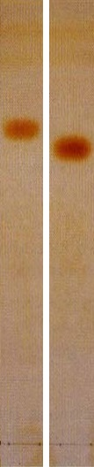 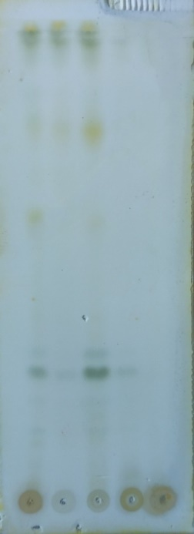

**B**

**A**

Noda jingga

Tidak ada noda jingga

**C**

**G**

**F**

**E**

**D**

Gambar 4.8.1 Skrining fitokimia alkaloid secara KLT pada senyawa referensi A) lobelin dan B) efedrin (Bladt, 2009), serta C) ekstrak metanol, D) fraksi n-heksana, E) fraksi diklorometana, F) fraksi etil asetat, G) residu daun Senggugu.

1. **Uji Terpenoid/Steroid Bebas**

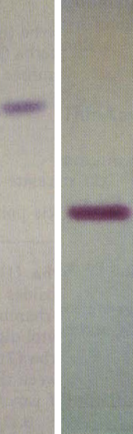 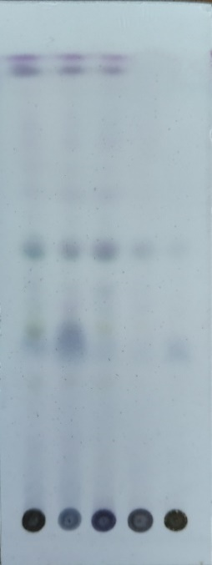

**B**

**A**

**G**

**D**

**E**

**F**

**C**

Noda warna merah ungu dan ungu

Gambar 4.8.2 Skrining fitokimia terpenoid/steroid bebas secara KLT pada senyawa referensi A) asam oleanolat dan B) β-sitosterin (Bladt, 2009), serta C) ekstrak metanol, D) fraksi n-heksana, E) fraksi diklorometana, F) fraksi etil asetat, G) residu daun Senggugu*.*

1. **Uji Polifenol**

Polifenol Timol 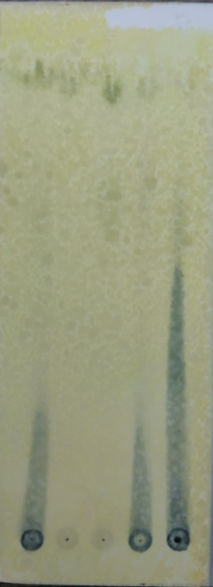

**A**

Noda Hitam

**E**

**F**

**B**

**C**

**D**

Gambar 4.8.3 Skrining fitokimia polifenol secara KLT pada senyawa referensi A) timol (Wagner, 1996), ekstrak metanol, B) fraksi n-heksana, C) fraksi diklorometana, D) fraksi etil asetat, dan E) residu daun Senggugu*.*

1. **Uji Flavonoid**

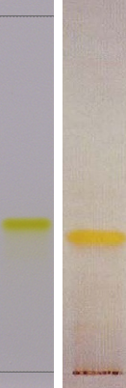 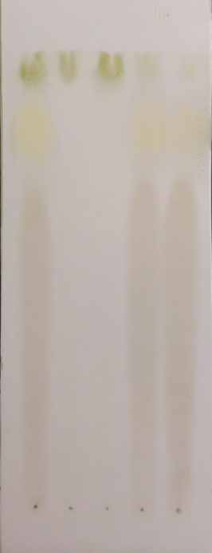

**C**

**E**

**G**

**F**

**D**

**B**

**A**

Noda Kuning

Gambar 4.8.4 Skrining fitokimia flavonoid secara KLT pada senyawa referensi A) aloin dan B) emodin (Wagner, 1996), serta C) ekstrak metanol, B) fraksi n-heksana, C) fraksi diklorometana, D) fraksi etil asetat, E) residu daun Senggugu*.*