Correction of Air Buoyancy on E₀-74 Mass Measurement with Pt-Ir K-112 Standard
Zuhdi Ismail¹, Renanta Hayu Kresiani²
1 PUSRISBANG SDM – Badan Standardisasi Nasional
2 Directorate of SNSU – Badan Standardisasi Nasional
Komplek Puspiptek, Tangerang Selatan
Email: zuhdi@bsn.goid
Abstract: Determination of the mass value of E₀ no 74 by calibrating it using the Pt-Ir standard has high complexity. This is caused by a significant difference in the density of standards. In this study, the E₀ no 74 made of stainless steel has a density of 8,051,130 kg.m⁻³ calibrated by a mass standard of Pt-Ir, which has a density of 21,552,940 kg.m⁻³. By Archimedes' law, the buoyant force generated by the air due to this density difference is huge. Therefore, the correction of air buoyancy is very important. The air buoyancy correction value is obtained by determining the air density using the CIPM-2007 formula. The correction that arises due to air buoyancy while weighing in the air is -0.00115 g and is greater at higher density. The implication of buoyancy correction is identified by analyzing the equivalence of the measurement result using a reference value from the calibration certificate issued by BIPM. The measurement result is equivalent if $-1<E_{n}<1$. The $E_{n}$ value for the corrected mass is -0.078.
Keywords: measurement, mass, density, buoyancy correction, CIPM-2007
- Introduction
Air buoyancy is a parameter that has a significant effect in determining the mass value of the weights. This effect occurs when weighing is carried out in free air. Free air is a fluid that has a density of about 1.2 kg.m⁻³. This effect requires special attention to calibrating the weights with high accuracy and precision, especially if the calibrated weights have very different densities (S Davidson, 2000; Ismail and Hayu, 2016).
This study carried mass value dissemination from weight with platinum and iridium alloy material to a weight with stainless-steel material. With an alloy of 90% platinum and 10% iridium, this mass standard has a density of about 21,000 kg.m⁻³, while the weights with stainless-steel material have a density of about 8,000 kg.m⁻³ (Davis et al., 2016; Jabbour and Yaniv, 2001; OIML-R111, 2004). Due to the very large density difference between the two standards, the buoyancy correction cannot be ignored. Weighing for stainless-steel standard with the platinum-iridium alloy standard will produce a buoyancy correction of more than 1 mg.
  - Mass Dissemination of E₀ Standard
The SNSU-BSN is responsible for disseminating mass measurements in Indonesia (Hayu and Ismail, 2018). In carrying out its duties, the SNSU-BSN manages the highest mass standard in Indonesia, namely weights made of platinum-iridium alloy (referred to as Pt-Ir). However, the mass value of Pt-Ir cannot be disseminated directly, considering that as the highest standard, Pt-Ir must be kept as tight as possible so that changes in mass within a certain period must be kept to a minimum. Therefore, this Pt-Ir mass value must be disseminated first to a working standard owned by SNSU-BSN.
In essence, the dissemination of measurement standard values is carried out by a series of calibration schemes. A simple calibration scheme for a mass standard can be done by comparing weight with another weight with a better accuracy class. Based on OIML R-111, the weight class is divided into several classes with the highest class being E₁ (OIML-R111, 2004).
Furthermore, another accuracy class has better technical specifications than E₁, namely the E₀ class weights. This standard is usually owned by the national metrology institute (NMI). In its production, the best E₁ weights are selected by the manufacturer to get the E₀ weights. Then the weights were calibrated by NMI with an uncertainty of 1/5×MPE class E₁. Class E0 weights are used as the main reference in calibrating other weights in its application. This standard requires strict treatment and careful handling to maintain the stability of its mass value (Mettler Toledo, 2019; Troemner, 2016).

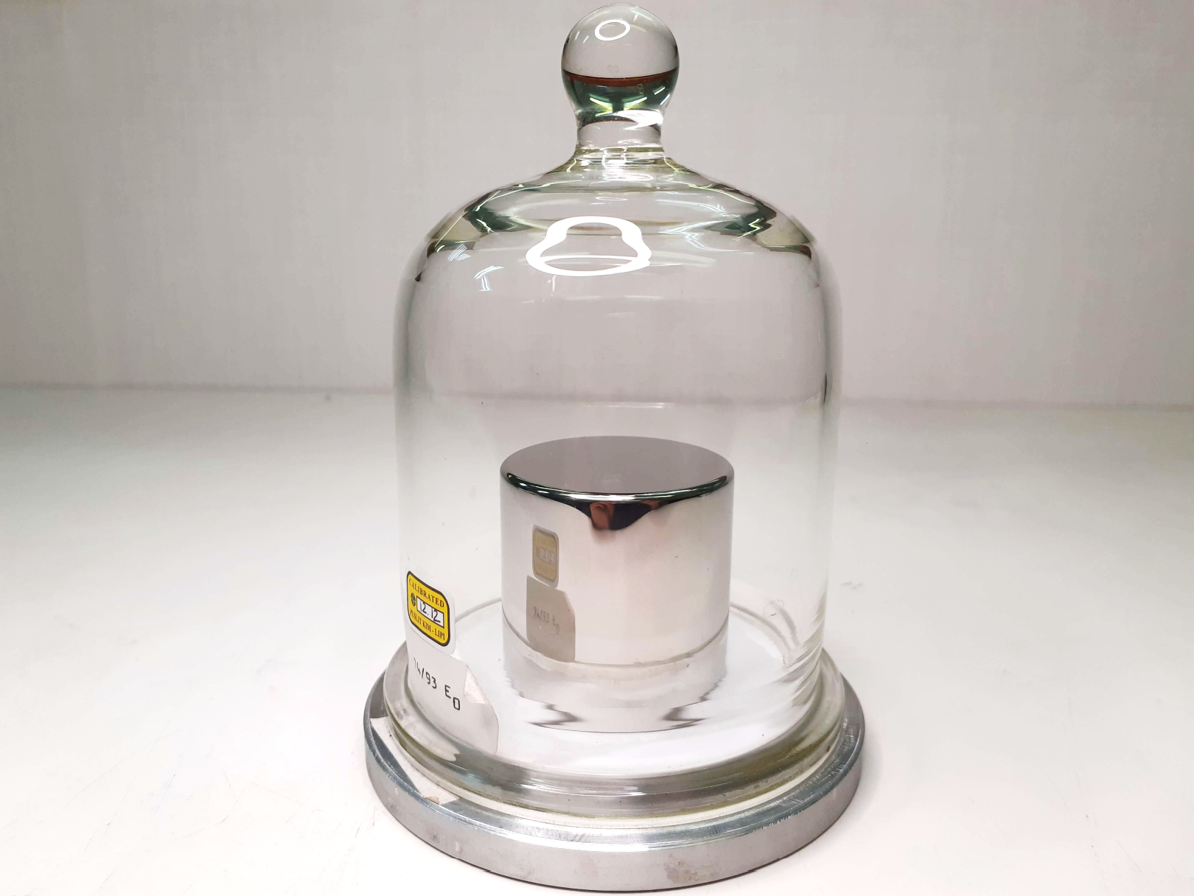
Figure 1. SNSU-BSN stainless-steel working standard, E₀ no. 74.
The SNSU-BSN currently has 5 E₀ weights consisting of one working standard whose value is disseminated to all E₁ weights in Indonesia and four other weights used as checking standards. The working standard owned by SNSU-BSN is known as E₀ no 74 (see Figure 1).
In this study, class E0 no 74 weight was disseminated using a direct comparison method to the Pt-Ir standard no 112. A simple direct comparison scheme is shown in Figure 2.

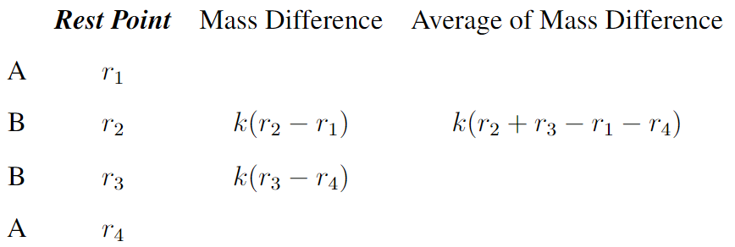

Figure 2. Substitution weighing cycle for direct comparison weighing schemes.
From the above scheme, to calculate the mass of the calibrated weight, $m_{T}$, with the reference weight, $m_{S}$ using Equation (1)

$$m_{T}= m_{S}+ k(X_{T} - X_{S}) + ρ_{a}(V_{T} - V_{S})$$ | (1)

where | $$k$$ | is reciprocal sensitivity,
 | $$X_{T}$$ | is the indication of the scale when the calibrated weight is weighed on the pan,
 | $$X_{S}$$ | is the indication of the scale when the calibrated weight is weighed on the pan,
 | $$ρ_{a}$$ | is the density of the air during calibration,
 | $$V_{T}$$ | is the density of air during calibration,
 | $$V_{S}$$ | is the volume of the reference weight.

Referring to Equation (1) to disseminate the mass value of Pt-Ir to the E₀ weights no 74 then,

$$m_{E_{0}}= m_{Pt-Ir}+ ∆m + m_{b}$$ | (2)

where | $$m_{E_{0}}$$ | is the conventional mass of the weight E₀,
 | $$m_{Pt-Ir}$$ | is the standard conventional mass of Pt-Ir,
 | $$∆m$$ | is the difference in weighing E₀ with Pt-Ir, and
 | $$m_{b}$$ | is the buoyancy correction.

In Equation (2), the buoyancy correction occurs when the measurement is carried out in free air, this effect can be neglected if the weighing is carried out using a vacuum balance.
  - Air Density Measurement on Mass Measurement
In the calibration of the weights carried out in free air, the measurement results will be influenced by the buoyancy of the air, as shown in Equation (2). Therefore, it is necessary to make corrections to these variables. The main component in determining the air buoyancy correction is calculating the air density.
Air density measurements are essential for high-accuracy mass calibration. The CIPM-2007 equation is the latest equation recommended by the Comité International des Poids et Mesures (CIPM). Most inspection bodies and measurement laboratories use this method based on the approximate air density equation presented in Equation (3) (Stuart Davidson, 2010; Picard et al., 2008; Wang et al., 2010).

$$ρ=\frac{pM_{a}}{ZRT}\left[1-x_{v}\left(1-\frac{M_{v}}{M_{a}}\right)\right]$$ | (3)

where | $$ρ$$ | is the density of air, kg.m⁻³,
 | $$p$$ | is air pressure, Pa,
 | $$Z$$ | is the compressibility factor,
 | $$R$$ | is the molar gas constant, 8,314472(15) J.mol⁻¹.K⁻¹,
 | $$T$$ | is the air temperature, K,
 | $$x_{v}$$ | is the mole fraction of water vapour,
 | $$M_{a}$$ | is the molar mass of dry air, 28, 96546×10⁻³ g.mol⁻¹, and
 | $$M_{v}$$ | is the molar mass of water, g mol⁻¹
$M_{v}$ is the molar mass of water (H₂O) whose value is 18.01528(17)×10⁻³ kg.mol⁻¹ (note: the molar mass of oxygen is 15,9994(3)×10⁻³ kg.mol⁻¹ and the molar mass of hydrogen is 1.00794(17)×10⁻³ kg.mol⁻¹) (Wieser, 2006).
Equation (4) is used to determine $x_{v}$ from the relative humidity or dew point temperature of the air:

$$x_{v}=hf\left(p,t\right)∙\frac{p_{sv}\left(t\right)}{p}=f(p,t_{d})∙\frac{p_{sv}\left(t_{d}\right)}{p}$$ | (4)

where | $$h$$ | is relative humidity ($0 ≤ h ≤ 1$), and
 | $$t_{d}$$ | is the dew point temperature

To be able to determine the value of $x_{v}$ based on Equation (3), it is necessary to know the value of $p_{sv}$ and $f$. Both parameters can be searched by Equations (5) and (6).
$$p_{sv}=1Pa×exp⁡\left(AT^{2}+BT+C+D/T\right)$$ | (5)

with | $$A$$ | = 1, 2378847×10⁻⁵ K⁻²,
 | $$B$$ | = −1, 9121316×10⁻² K⁻¹,
 | $$C$$ | = 33, 93711047, and
 | $$D$$ | = −6, 3431645×10³ K

$$f=α+βp+γt^{2}$$ | (6)

with | $$α$$ | = 1, 00062,
 | $$β$$ | = 3, 14×10⁻⁸ Pa⁻¹, and
 | $$γ$$ | = 5, 6×10⁻⁷ Pa⁻²
 | where t is the temperature in units °C.

While the compressibility factor Z is determined by Equation (7)

$$Z=1-\frac{p}{T}\left[a_{0}+a_{1}t+a_{2}t^{2}+\left(b_{0}+b_{1}t\right)x_{v}+\left(c_{0}+c_{1}t\right){x_{v}}^{2}\right]+\frac{p^{2}}{T^{2}}∙\left(d+e{x_{v}}^{2}\right)$$ | (7)

with | $$a_{0}$$ | = 1, 58123 × 10⁻⁶ K.Pa⁻¹,
 | $$a_{1}$$ | = −2, 9331 × 10⁻⁸ Pa⁻¹,
 | $$a_{2}$$ | = 1, 1043 × 10⁻¹⁰ K⁻¹.Pa⁻¹,
 | $$b_{0}$$ | = 5, 707 × 10⁻⁶ K.Pa⁻¹,
 | $$b_{1}$$ | = −2, 051 × 10⁻⁸ Pa⁻¹,
 | $$c_{0}$$ | = 1, 9898 × 10⁻⁴ K.Pa⁻¹,
 | $$c_{1}$$ | = −2, 376 × 10⁻⁶ Pa⁻¹,
 | $$d$$ | = 1, 83 × 10⁻¹¹ K^{2.}Pa⁻², and
 | $$e$$ | = −0, 765 × 10⁻⁸ K².Pa⁻².

By determining the value of air density when weighing is carried out, the correction for the buoyant force of the air is expressed as (Harris, 2018),

$$m_{b}=m_{0}∙\left(ρ_{a}-ρ_{R}\right)∙\left(\frac{1}{ρ_{T}}-\frac{1}{ρ_{S}}\right)$$ | (8)

where | $$m_{0}$$ | is nominal mass,
 | $$ρ_{a}$$ | is the actual air density,
 | $$ρ_{R}$$ | is the reference air density, 1,2 kg.m⁻³,
 | $$ρ_{T}$$ | is the density of the test weight, and
 | $$ρ_{S}$$ | is the density of the reference weight.

- Experimental
The research was conducted at the Mass Laboratory of the SNSU-BSN by involving the working standard of the E₀ class weights no 74 and the Pt-Ir K-112 mass measurement standard. The mass value dissemination process uses a Mettler Toledo AX1006 mass comparator with a resolution or reading power of 0.1 µg (see Figure 3). Environmental conditions are monitored and recorded automatically using the Klimet A30 climate station (see Figure 4).

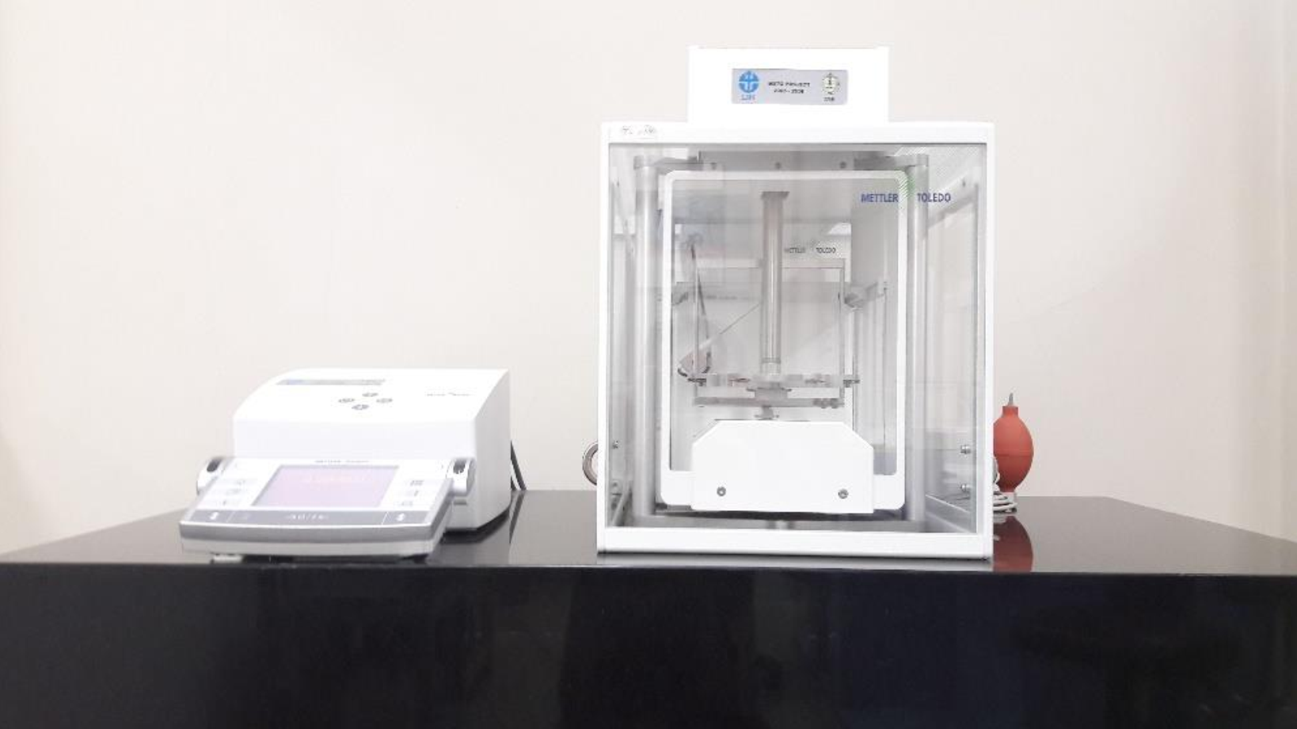
Figure 3. Mettler-Toledo AX1006 mass comparator
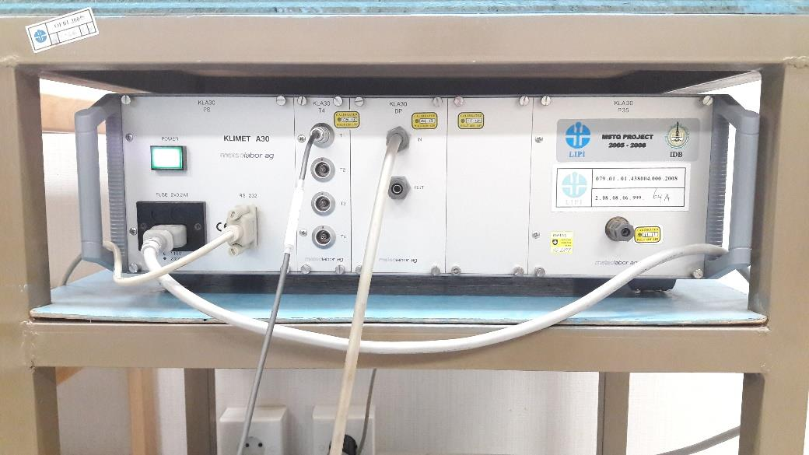
Figure 4. Meteolabor AG - Klimet A30
Parameters of environmental conditions were measured using Meteolabor AG Klimet A30. The parameters measured were temperature, air pressure, and relative humidity. The technical specifications of the thermo-hygrometer are summarized in Table 1. The relative humidity is indicated by dew point temperature. The relative humidity is calculated based on the dew point temperature using Equation (9).

Table 1. Specification of measuring instrument for environmental conditions, Klimet A30 (Ismail and Hayu, 2016; Meteolabor AG, 2004).
 | Resolution | Measuring range | Uncertainty
Air temperature | 0.001 °C | (15 s/d 25) °C | 0.02 °C
Atmospheric Pressure | 0.001 hPa | (600 s/d 1060) hPa | 0.04 hPa
Dew point temperature | 0.001 °C | (0 s/d 17) °C | 0.1 %

$$RH=\frac{100}{\exp\left(\frac{\left(a×T_{a}\right)}{\left(b+T_{a}\right)}-\frac{\left(a×T_{d}\right)}{\left(b+T_{d}\right)}\right)}$$ | (9)

where | $$a$$ | = 17,368,
 | $$b$$ | = 238,83,
 | $$T_{a}$$ | is the air temperature, and
 | $$T_{d}$$ | is the dew point temperature.

The dissemination process in this study uses a direct weighing scheme using the ABBA method. Where A represents the Pt-Ir standard while B is E₀ no 74. This method is a popular method often used in the mass standard calibration process. By knowing the conventional mass of Pt-Ir and the difference between the weighing results, the mass value of E₀ can be determined.
Furthermore, due to the significant difference in density difference between the two measuring standards, the determination of the mass value of E₀ must pay attention to the buoyancy correction. The value is obtained by calculating based on standard load density (Pt-Ir), test load density (E₀), and air density during the data collection process. The density values of the two measuring standards can be obtained from certificates issued by BIPM before.
The measurement equivalence analysis was carried out by calculating the number $E_{n}$, this is to determine the effect of the buoyancy correction. The number $E_{n}$ is determined based on Equation (10) (ISO/IEC 17043, 2010).

$$E_{n}=\frac{\left(X_{1}-X_{2}\right)}{\sqrt{{U_{X_{1}}}^{2}+{U_{X_{2}}}^{2}}}$$ | (10)

where | $$X_{1}$$ | is the reference value,
 | $$X_{2}$$ | is the measured value,
 | $$U_{X_{1}}$$ | is the uncertainty of the reference value, and
 | $$U_{X_{2}}$$ | is the uncertainty of the measurement result.

The number $E_{n}$ describes a measurement equivalence by comparing the measurement results with a reliable reference value. In this study, the reference value chosen is the mass value of the weights E₀ no 74 previously listed on the calibration certificate issued by BIPM in 2017. The measurement results are said to be equivalent if $-1{<E}_{n}<1$.
- Results and Discussion
The air buoyancy correction value correlates with the air density value when weighing ($ρ_{a}$). Meanwhile, air density is a parameter that cannot be separated from environmental conditions. Based on Equation (3), air density can be determined by knowing the parameters of environmental conditions such as air temperature, relative humidity, and air pressure. Because of the importance of this parameter, every weighing process must record environmental conditions. In weighing using the AX1006, the environmental conditions are automatically acquired after every cycle of ABBA.

Table 2. Average of air buoyancy correction of six data collection sets.
No | Date | Air pressure, hPa | Relative humidity, % | Temperature, °C | Air buoyancy correction, g
1. | 12/11/2020 | 1003.842 | 43.75 | 20.858 | −0.00115
2. | 13/11/2020-m | 1002.767 | 43.70 | 20.879 | −0.00125
3. | 13/11/2020-s | 1002.183 | 43.47 | 20.946 | −0.00133
4. | 25/11/2020 | 1002.010 | 45.62 | 20.755 | −0.00130
5. | 26/11/2020 | 1002.026 | 45.35 | 20.857 | −0.00133
6. | 27/11/2020 | 1002.360 | 44.35 | 20.848 | −0.00131

Figure 4. Mass E₀ no 74 disseminated using Pt-Ir as standard.
From the six sets of data collection carried out, the average correction of the air buoyancy can be seen in Table 2. The mass correction due to the buoyancy of the air gives a significant value to the conventional mass of the test weights. The effect of this correction value can be seen in Figure 4. The figure shows that the uncorrected mass value has a more random tendency, and the measured mass is larger than the corrected mass value. By applying the buoyancy correction, it can be seen that the conventional mass is consistent and closer to the nominal mass. This uncorrected mass value has a standard deviation of 1.02 × 10⁻⁴ g. In comparison, the corrected mass value has a better standard deviation of 9.29 × 10⁻⁶ g.

Figure 5. Daily air density fluctuations SNSU-BSN mass laboratory.
Table 3. Conventional mass E₀ no 74 was disseminated from Pt-Ir no 112.
No | Conventional mass, g
No | November 12, 2020 | November 13, 2020 (m) | November 13, 2020(s)
1. | 1000.000 007 | 1000.000 013 | 1000.000 029
2. | 1000.000 014 | 1000.000 013 | 1000.000 046
3. | 1000.000 013 | 1000.000 017 | 1000.000 044
4. | 1000.000 015 | 1000.000 015 | 1000.000 040
5. | 1000.000 020 | 1000.000 016 | 1000.000 036
6. | 1000.000 015 | 1000.000 012 | 1000.000 036
 | November 25, 2020 | November 26, 2020 | November 27, 2020
1. | 1000.000 031 | 1000.000 026 | 1000.000 023
2. | 1000.000 032 | 1000.000 029 | 1000.000 028
3. | 1000.000 035 | 1000.000 029 | 1000.000 029
4. | 1000.000 036 | 1000.000 030 | 1000.000 029
5. | 1000.000 033 | 1000.000 031 | 1000.000 024
6. | 1000.000 034 | 1000.000 027 | 1000.000 026
Mass E₀ no 74 |  | 1000.000 026

The effect of relatively large fluctuations in environmental conditions is shown by weighing on November 13, 2020. On that date, weighing was carried out twice, in the early morning and afternoon. The weighing results in the early morning tend to be more stable when compared to weighing carried out in the afternoon. This phenomenon occurs due to fluctuations in air density during the day, which is relatively higher than at night until the early hours of the morning. This is supported by data from checking daily air density in the mass laboratory. (see Figure 5). The image represents the daily change in air density acquired using Klimet A30 at the beginning and middle of each month from November 2020 to April 2021. It can be seen that in the time range around 08.00 to 20.00, there was a high fluctuation in air density and air density began to stabilize after 08:00. 22.00 to 06.00. In addition to causing a larger buoyancy correction, high air density fluctuations make the data collection process more difficult. Therefore, in SNSU-BSN, the recommended time for collecting data sensitive to changes in environmental conditions is in the early morning hours.
Based on the difference between the weighing results of the two standards ($∆m$) and the correction value for the buoyant air force ($m_{b}$) as shown in Table 2, the conventional mass value of the E₀ weight can be determined. The mass of conventional E₀ no 74 in each series is summarized in Table 3. From all the weighing data, the average mass of unconventional E₀ no 74 uncorrected and corrected is 1000.001312 g and 10000026 g, respectively. The value of the conventional mass of the E₀ weight is then converted to true mass. Conversion from conventional mass to true mass using Equation (11). The results of this conventional mass conversion E₀ resulted in an uncorrected and corrected true mass value of 1000,000359 and 999,999073 g, respectively, with an uncertainty of 0.026 mg.

$$m_{t}=m_{c}\left(1-{ρ_{a}}/{ρ_{c}}\right)\left(1-{ρ_{a}}/{ρ_{t}}\right)$$ | (10)

where | $$m_{t}$$ | is true mass,
 | $$m_{c}$$ | is conventional mass,
 | $$ρ_{a}$$ | is the reference air density, 1,2 kg.m⁻³,
 | $$ρ_{c}$$ | is the density of the reference weight, 8.000 kg.m⁻³, and
 | $$ρ_{t}$$ | is the density of converted weight.

The corrected weighing result has an insignificant true mass difference compared to the calibration certificate issued by BIPM in 2018, which is 999.999071 g with a measurement uncertainty of 0.010 mg. This is very much different when compared to the results of uncorrected weighing. The weighing results are then checked by looking at the $E_{n}$ number with a reference value based on the certificate value. The $E_{n}$ values ​​for uncorrected and corrected weighing are -46,236 and -0.078, respectively. The $E_{n}$ value in the uncorrected weighing result has a very large difference compared to the E_n equality parameter. This shows that there is no equality at all when the buoyancy correction is ignored in this weighing. Furthermore, this can lead to errors and non-recognition of the weighing results. While the $E_{n}$ value of the corrected weighing results is in the range of -1 to 1, so it can be concluded that the weighing results carried out at SNSU-BSN are equivalent to the weighing results by BIPM.
- Conclusion
Buoyancy correction is a parameter that cannot be ignored in weighing with high accuracy, especially if the weights being tested have a much different density from the measuring standard used. This correction arises due to the effect of the air density in which the measurement is made. The weighing results show that the buoyancy correction that occurs in the calibration of the E₀ weight with the Pt-Ir standard can reach 0.00115 g and can be even greater at a denser air density. The magnitude of this correction can have implications for the equality of the measurement results to the reference value. The equivalence parameter in the form of the number $E_{n}$ shows that the uncorrected and corrected mass values ​​have a very significant difference. The calculation of the $E_{n}$ value for the corrected mass is very clearly within the required range, while for the uncorrected mass, the value is very far from that range. Here, the corrected mass is equivalent to the value of the previous calibration certificate, while the uncorrected mass is the opposite.
- Acknowledgement
The author would like to thank Pusrisbang, the Directorate of SNSU-BSN, and all parties providing the facilities and infrastructure to conduct this research.
References
Davidson, S. (2000). Air Density Measurement for Mass Calibration. XVI IMEKO World Congress.
Davidson, Stuart. (2010). Determination of the effect of transfer between vacuum and air on mass standards of platinum-iridium and stainless steel. Metrologia, 47(4), 487–497. https://doi.org/10.1088/0026-1394/47/4/015
Davis, R. S., Barat, P., dan Stock, M. (2016). A brief history of the unit of mass: Continuity of successive definitions of the kilogram. Metrologia, 53(5), A12–A18. https://doi.org/10.1088/0026-1394/53/5/A12
Harris, G. L. (2018). Selected laboratory and measurement practices and procedures to support basic mass calibrations. 47–66. http://nvlpubs.nist.gov/nistpubs/ir/2018/NIST.IR.6969-2018.pdf
Hayu, R., dan Ismail, Z. (2018). Statistical process control to monitor the impacts of extraordinary calibrations result on the mass dissemination. Journal of Physics: Conference Series, 1065(4), 2–6. https://doi.org/10.1088/1742-6596/1065/4/042046
Ismail, Z., dan Hayu, R. (2016). Pengaruh Kondisi Lingkungan Terhadap Perhitungan Massa Konvensional di Lab Massa Puslit Metrologi-LIPI. 11th Annual Meeting on Testing and Quality.
ISO/IEC 17043. (2010). Conformity assessment — General requirements for proficiency testing.
Jabbour, Z. J., dan Yaniv, S. L. (2001). The kilogram and measurements of mass and force. Journal of Research of the National Institute of Standards and Technology, 106(1), 25–46. https://doi.org/10.6028/jres.106.003
Meteolabor AG. (2004). Operating instructions and technical description KLIMET A30. November, 1–17.
Mettler Toledo. (2019). OIML and ASTM Weights - Expertly Manufactured Weights for Reliable Testing Applications.
OIML-R111. (2004). International Recommendation OIML R 111-1 Edition 2004 (E). https://www.oiml.org/en/files/pdf_r/r111-1-e04.pdf
Picard, A., Davis, R. S., Gläser, M., dan Fujii, K. (2008). Revised formula for the density of moist air (CIPM-2007). Metrologia, 45(2), 149–155. https://doi.org/10.1088/0026-1394/45/2/004
Troemner. (2016). Weight Catalog. www.troemner.com
Wang, X. L., Wang, J., Zhong, R. L., Zhang, Y., Cai, C. Q., Yao, H., dan Ding, J. A. (2010). Research on air density measurement for measuring weights. 21st Conference on Measurement of Force, Mass and Torque Together with HARDMEKO 2010 and 2nd Meeting on Vibration Measurement, IMEKO TC3, TC5 and TC22 Conferences, 1, 277–284.
Wieser, M. E. (2006). Atomic weights of the elements 2005 (IUPAC Technical Report). Pure and Applied Chemistry, 78(11), 2051–2066. https://doi.org/10.1351/pac200678112051

