AUTHOR GUIDANCE
Since the manuscript is reviewed and screened anonymously by advisory editors/ expert editors, the information contained: the title of the manuscript, author's name, institution address, contact number and email for correspondence purposes are written in a separate page.

NOTES:
- This template is a guide to be used to prepare manuscripts for submission. The entire manuscript (text, tables, and graphics) may be submitted in one file. Inserting graphics and tables close to the point at which they are discussed in the text of the manuscript can also be a benefit for the reviewer.
- The manuscriptsshould be prepared follow the page formatting that attached in the next page.
- Manuscriptshould be typed inA4 (210 x 297mm) format with 3 cm margins left, right and 2.5 cm margins top and bottom, singled spaced for abstract, references, figure captions and tables,one and a half spaced in Arial 10 for text, using no more than 20 pages for original papers.
- Manuscript file should be saved in the native format of the word-processor used.
- Original resolution of figures, graphics, and tables should be attached in separate pages after original papers.
- There are three page sections in the manuscript file:
- Firstsection page contained the title of the manuscript and the information about author's name, institution address, contact number and email for correspodence purposes.
- Second section pages contained original manuscript including title, Abstract Introduction, Methods, Results and Discussions, Conclusions, Acknowledgements, and References. No information about author's name, institution address, contact number and email for correspodence purposes in the second section pages.
- Third section pagescontained original resolution of figures, graphics, and tables and supplementary data (if available).
- To avoid unnecessary errors, author are strongly advised to use the "spell-check" and "grammar-check" functions of word-processor.
JKPK
JURNAL KIMIA DAN PENDIDIKAN KIMIA
p-ISSN2503-4146 e-ISSN2503-4154

CHITOSAN CROSSLINKING FROM CLAM SHELLS (CERITHIDEA OBTUSA) WITH TRIPOLYPHOSPHATE
FOR CADMIUM (II) ADSORPTION

Soerja Koenarpadi^{1,}* Hajar Anuar² Nanang Tri Widodo³

Budi Hastuti⁴ Saptono Hadi⁵
¹Department of Chemistry, Faculty of Mathematics and Natural Sciences,
Mulawarman University, East Kalimantan, Indonesia
²Department of Petro & Oleo Chemicals, Polytechnic of Samarinda Campus Paser,
East Kalimantan, Indonesia
³Department of Chemistry Education, Faculty of Teacher Training and Education,
Universitas Sebelas Maret,Central Java, Indonesia
³Department of Pharmacy, Faculty of Mathematics and Natural Sciences,
Universitas Sebelas Maret, Central Java, Indonesia

* For correspondence purposes, telp :081347466457, email: soerja.koes@gmail.com
Received: | Accepted: Month xx, 201x | Online Published: Month xx, 201x

CHITOSAN CROSSLINKING FROM CLAM SHELLS (CERITHIDEA OBTUSA) WITH TRIPOLYPHOSPHATE
FOR CADMIUM (II) ADSORPTION

Soerja Koenarpadi^{1,}* Hajar Anuar² Nanang Tri Widodo³

Budi Hastuti⁴ Saptono Hadi⁵
¹Department of Chemistry, Faculty of Mathematics and Natural Sciences,
Mulawarman University, East Kalimantan, Indonesia
²Department of Petro & Oleo Chemicals, Polytechnic of Samarinda Campus Paser,
East Kalimantan, Indonesia
³Department of Chemistry Education, Faculty of Teacher Training and Education,
Universitas Sebelas Maret,Central Java, Indonesia
³Department of Pharmacy, Faculty of Mathematics and Natural Sciences,
Universitas Sebelas Maret, Central Java, Indonesia

* For correspondence purposes, telp :081347466457, email: soerja.koes@gmail.com
ABSTRACT
Chitosan crosslinking from Clam Shells (Cerithidea obtusa) with tripolyphosphate for cadmium adsorption has been researched. The chitosan was prepared by deacetylation of chitin by adding of NaOH 60% and heating at temperature 140ºC for 60 minutes. The chitin was isolated from Clam Shells (Cerithidea obtusa) as abundant waste in East Kalimantan. The crosslinking of chitosan with tripolyphosphate was synthesized by gelation methods using 5 g chitosan were dissolved in acetic acids and added of tripolyphosphate 0.1% as crosslinker. Characterization of chitosan-tripolyphosphate were analyzed using FTIR, XRD and SEM. The result showed that FTIR spectra of a N-H vibration at 1635 cm⁻¹, functional group of NH₃⁺ deformation at 1534 cm⁻¹, streching vibration of a –C-O- at 1072 cm⁻¹ and vibration of P-O at 1026,91 cm⁻¹ was indicated the presence of tripolyphosphate in chitosan. The XRD pattern has a broad at 19,85º and 23.50º, which are thypical fingerprints chitosan-tripolyphosphate indicates amorphous shape. SEM image of chitosan-tripolyphospahte was flat sheet without pores and the surface is tight. The cadmium (II) adsorption on chitosan-tripolyphophate at an optimum pH 4, the kinetics model for cadmium (II) adsorption on chitosan-tripolyphosphate could be described using pseudo second-order equation and was in accordance with the Langmuir isotherm model with maximum adsorption capacity of 27.8 mg/g. Furthermore, using the adsorbent of chitosan crosslinking with tripolyphosphate indicates adsorption effectiveness for cadmium (II) adsorption.

Key word: crosslinking, chitosan, tripolyphospate, heavy metal adsorption, cadmium

INTRODUCTION
Clam shells (Cerithidea obtusa) is clam-spesies from Potamididae familiy and existing is very abundant in beach of Pondong Village, Paser Regency, East Kalimantan. Based on data Ministry of Maritime Affairs and Fisheries, shellfish production in East Kalimantan experienced quite a significant increase from 2020, namely 642.93 tons to 647.57 tons in 2021 [1]. The shells as a waste and unutilized. The utilization of shells waste is processed into chitin and chitosan product. The Chitin is poly (β-(1→4)-N-acetyl-D-glucosamine from the shell of clam, crab and shrimp. Chitin is collected by deproteinization and demineralization of crustaceans’ wastes. The deacetylated form of chitin is chitosan. The result of dyacetilation produces many functional group of amine (-NH2) dan hydroxyl (-OH) [2,3]. Compared with chitin, chitosan have higher solubility, lower crystallinity, degree of deacytilation, particle size, formation of particle and agregation [4].
Application of chitosan exhibits the promising to removing of inorganic heavy metal polutant like research of removal of several heavy metal [5], Pb and Pt [6], Fe(II) and Mn(II) [7]. The removing capacity is due to the presence of functional group that can form to coordination bonds [5]. For removing of organic polutant like dyes [8] or organic solutions [9] The properties of chitosan exhibit biodegradle, non-toxic, biocompatible and can be resized in nano-size.
Synthesis of chitosan have five methods are presently available are ionic gelation method, microemulsion, emulsifcation solvent diffusion, polyelectrolyte complex and reverse micellar method [4]. The most widely used method is ionic gelation method. The ionic gelation method requires simple, easy to find and expensive materials and equipment, so it can be carried out easily, lightly and quickly in an ordinary laboratory This method utilizes the electrostatic interaction between the amine group of chitosan and a negatively charged group of polyanion such as tripolyphosphate [10]. The tripolyphosphate is a type of harmless anionic crosslinker and can interact by inter- and intramolecular with chitosan to provide better spherical morphology, increase the flexibility of the polymer and and produces stable bead structure [11]. According to Dogan’research (2020), the formula of weight ratio between chitosan and triployphosphate of 0.5 : 0.25 will provide a smaller particle size [12]. Modification of crosslinking chitosan with tripolyphosphate as a crosslinker can expands its usefulness as drug delivery [14], organ transplants and restoring organ function [15] and efficient sorption of heavy metal [16].
In this work, isolation of chitin from Clam shells (Cerithidea obtusa,) and deacetylation of hitin by adding of NaOH 60% and heating at temperature 140ºC for 60 minutes. process of chitosan from chitin. The crosslinking chitosan with tripolyphosphate was prepared using gelation method and characterized by functional group using FT-IR spectrometer, crystal structure using X-Ray Difractometer and surface morphology using scanning electron microcscope. The effect of pH, kinetics model and adsorption capacity of cadmium on chitosan-tripoyphosphate was also evaluated.

METHODS
Materials Clam Shells (Cerithidea obtusa) was collected from beach Pondong Beach, Paser Regency, East Kalimantan on Tuesday, March 10, 2020 with sunny weather conditions at the time of sampling. The reagent from analytical grade i.e sodium hidroxide, chloride acid 37%, sodium tripolyphosphate, acetic acid 25%, sodium hypochlorite and 3CdSO₄.8H₂O
Preparation of Chitin from Clam Shells (Cerithidea obtusa) was prepared by a demineralization and deproteination. The initial stage, grinding of Clam shells (Cerithdea obtusa) into a portal pestle until smooth and sieve at 100 mesh. The mineralization stage, 50 g of fine Clam shell was added to 750 mL of 1 N chloride acid solution and heated at temperature 75ºC for 60 minutes. The deproteination stage, 30.3 g of extract was added to 300 mL of 3.5% sodium hydroxide solution and heated at temperature 85ºC for 30 minutes. After that it is cooled to room temperature.. The product of chitin was transformed into chitosan by deacetylation process.
The chitosan was prepared by deacetylation of 18 g of chitin by adding of 360 mL of 60% sodium hydroxide solution and heating at temperature 140ºC for 60 minutes. The resulting of chitosan was separated, washed with distilled water to neutral pH.
Crosslinking of chitosan with tripolyphosphate. Five grams of chitosan were dissolved into 25 mL 1% acetic acids solutions and then 5 mL croslinker of 0.1% sodium tripolyphosphate solution was added into chitosan solution. The mixture was shaked by magnetic stirer for 60 minutes to homogeneous. The product of chitosan-tripolyphosphate was washed by deionized water to neutral.
Characterization of chitosan-tripolyphosphate. The functional group of chitosan-tripolyphosphate was analyzed by Shimadzu 8201 PC Fourier transform spectrometer (FTIR). The crystal structure were characterized by Shimadzu X-ray diffraction (XRD) using CuKα radiation (λ = 1.5406 Å) operated at 40 kV and 30 mA). The surface morphology surface was examined by JEOL SSM-6510 LA Scanning electron microscopy (SEM)
The adsorption of cadmium on chitosan-tripolyphosphate was carried out by a batch method. A series of 50 mg.L⁻¹ of cadmium (II) solution were adjusted to pH 2; 3; 4; 5; 6; 7; 8; 9; 10; 11 by adding HCl or NaOH solutions. Interaction of cadmium (II) solution on 20 mg of chitosan-tripolyphosphate by shaking for 120 minutes. After adsorbent was separated, concentration of cadmium (II) was analyzed using Perkin Elmer Atomic Absorption Spectrometer. The adsorption kinetics was measured at an initial cadmium (II) concentration of 70 mg.L⁻¹ was added 20 mg of chitosan-tripolyphosphate with interaction time of 1; 2; 5; 10; 15; 30; 50; 100; 150; 200; 250; 300 minutes. The kinetics models of Lagergren’s pseudo first-order and Ho’s pseudo second-order were used to analyze the adsorption kinetic model. The adsorption capacity was also measured using the batch method in the inital cadmium (II) concentrations of 1, 2, 5, 10, 20, 30, 40, 50, 60, 70, 80, 90 and 100 mg.L⁻¹ was added 20 mg of chitosan-tripolyphosphate The isotherm models of Langmuir and Freundlich were used to analyze the adsorption capacity..

RESULTS AND DISCUSSION
Clam shells (Cerithidea obtusa) were obtained from beach of Pondong, Paser Regency, East Kalimantan. The size of Clam shell taken was around 5 cm, blackish brown color and existing is very abundant and unutilized. The initial stage, Clam shells were ground until smooth and sieved with a 100 mesh. The demineralization The mineralization stage, fine Clam shell was added chloride acid solution and heated at temperature 75ºC for 60 minutues and deproteination stage, extract was added sodium hydroxide solution and heated at temperature 85ºC for 30 minutes. The form of Calm shells and chitin are shown in Fig.1.
Figure 1. The form of a) Calm shells and b) chitin
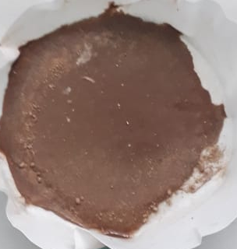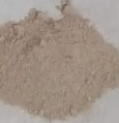
(a)
(b)
The deacetylation process of chitin by adding of sodium hydroxide and heating at temperature 140ºC for 60 minutes The chitosan-tripolyphospate was synthisized by gelation method that is the complexation of chitosan with tripolyphospate as a crosslinker by weight ratio between chitosan and triployphosphate of 2 : 1. The form physical of chitosan and chitosan-tripolyphospate are shown in Fig.2.
Figure 2. The form physical of a) chitosan and b) chitosan-tripolyphosphate

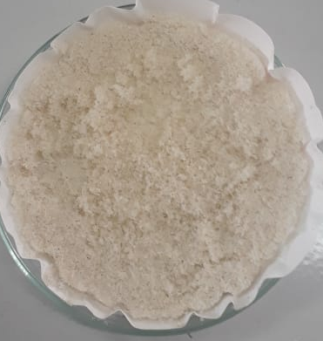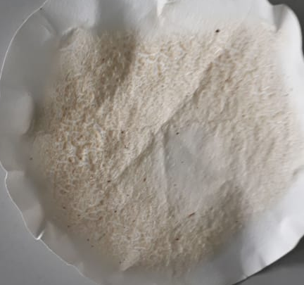
(a)
(b)
The adsorbent of chitosan tripolyphosphate was successfully syntesized which was indicated change in the characteristics of the FTIR, XRD and SEM analysis. The FT-IR spectra of chitin, chitosan and chitosan-tripolyphosphate are shown in Fig.3
Figure 3. FTIR Spectra of chitin, chitosan and chitosan-tripolyphosphate
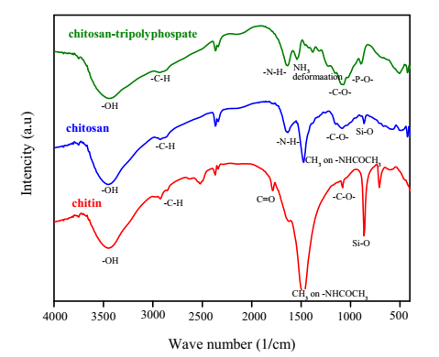
The functional group of chitin has a wavenumber at 3425 cm⁻¹ due to the -OH groups. The -CH₂ group was showing at 2924 cm⁻¹ as attributed to the symmetrical stretching, the band at 1473 cm⁻¹ was -CH₃ group on amide (-NHCOCH₃), wave number at 1798 cm⁻¹ due to the C=O group on amide (-NHCO) and then at 1080 cm⁻¹ the stretching vibration of C-O-C in glucose circle. The impurities spectra of silica mineral on chitin at wavenumber 864,11cm⁻¹ and 709,80 cm⁻¹. [16]. The FTIR spectra of chitosan has similar to a chitin, this has a wavenumber at 3448 cm⁻¹ due tothe -OH groups, -CH₂ group at 2931 cm⁻¹, stretching vibration of C-O-C at 1087 cm⁻¹, CH₃ group on amide (-NHCOCH₃) at 1473 cm⁻¹,wave number at 1798 cm⁻¹ due to the C=O group on amide (-NHCO). [16] and then presence of silica mineral at wave number 864 cm⁻¹. The difference FTIR spectra of chitin and chitosan was loss of C=O group of amida (-NHCO-) [16]. The success of crosslinking chitosan with tripolyphosphate was indicated by the FTIR spectra has peak at 1534 cm⁻¹ was assigned to deformation of -NH,the band at 1651 cm⁻¹ was bending vibration of N-H group from amine (-NH₂) and vibration of P-O on tripolyphosphat at 1026 cm⁻¹. The loss FTIR spectra of chitosan-tripolyphosphate were C=O group, CH₃ group on amide (-NHCOCH₃) and impurities of silica mineral. [16].
The difractogram of Clam Shell has crystalline structure because there are still many minerals. XRD pattern of chitosan has two characteristic peaks at 10,15º and 19,94º but still has impurities in peaks at 32º and 38º. This diffractogram result that the structure of chitosan is crystalline. XRD pattern of Clam shells, chitosan and chitosan-tripolyphosphate are shown in Fig.4.
Figure 4. XRD pattern of Clam shells, chitosan and chitosan-tripolyphosphate
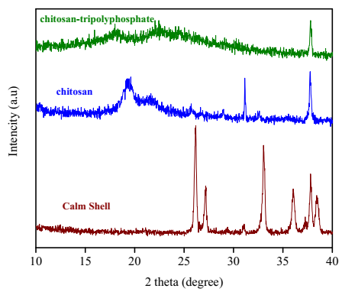
The characteristic XRD pattern of chitosan-tripolyphosphate has a broad at 19,85º and 23.50º [10]. Crosslinking of chitosan with tripolyphosphate shows the appearance of two peaks which indicate an amorphous form. The change in the structure of chitosan from crystalline to amorphous is due to crosslinking with tripolyphoaphate. The decrease in crystallinity can be caused by the formation of a dense network structure of tripoliphosphate counterions that penetrate each other, where the polymer chains are cross-linked to each other by TPP.
SEM image of chitosan and chitosan-tripolyphosphate are shown in Figure 5. The morphological surface of chitosan has flat-shape without pores with a dense surface and then SEM image of chitosan-tripolyphosphate showed threads-shaped on surface dense. The change in surface morphology of chitosan-tripolyphsphate compared to chitosan is caused by the addition of crosslinker which functions to strengthen and stabilize of chitosan.
Figure 5. SEM image of a) chitosan and b) chitosan-tripolyphosphate
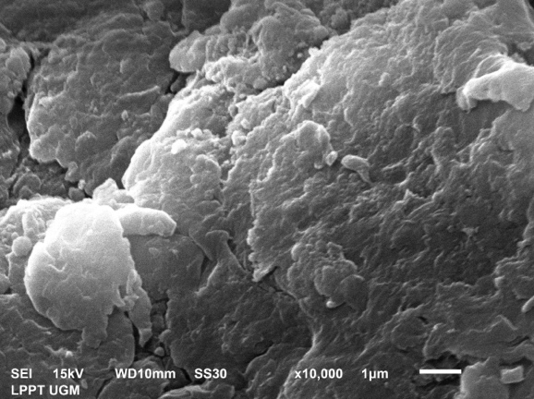
(a)
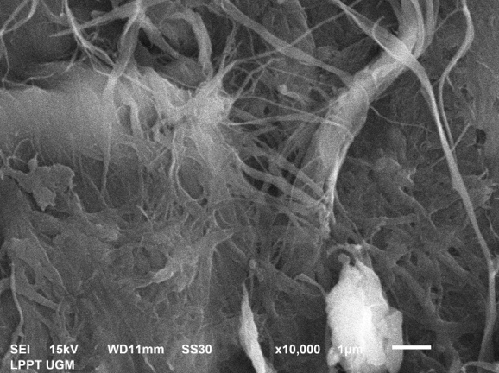
(b)

Table 1 The functional group of chitin,chitosan and chitosan-tripolyphosphate
Functional group | Wave number (cm⁻¹)
Functional group | chitin | Chitosan | chitosan-tripolyphosphate
O-H streching | 3425 | 3448 | 3448
C-H Stretching | 2924, 2854 | 2931 | 2924
N-H amide | 1473 | - | -
C=O | 1798 | - | -
N-H bending | - | 1635 | -
Deformation NH₃⁺ | - | - | 1534
C-O | 1080 | 1087 | 1072
P-O | - | - | 1026
Si-O | 864 | 864 | -

The effect of pH adsorption of cadmium (II) on chitosan-tripolyphosphate are shown in Fig.6. Based in Figure 6, pH range experiment was varied from 1.0-9.0. At low pH, ion H⁺ has high concentration and compete with cadmium (II) ion for sorption. Hovewer, if pH solutions was increased, the sorption of cadmium (II) was increased because concentration of ion H⁺ due to decreased. Optimum pH for sorption of cadmium (II) ion on chitosan-tripolyphosphate at pH 4.0. Increasing the pH futher was resulted in a decreased for sorption until at pH 7. At pH 8 -9, the sorption of cadmium ion was increased because Cadmium (II) ion has was started to precipitate. Chitosan has a pKa of 6.5 and is protonated at a pH below 6.5, resulting in increased cation adsorption. If the pH is very low, it was produces more H⁺, which competes with cadmium (II) cations. In contrast, at pH values above 4, the weakening of chitosan protonation exceeds the decrease in competitive adsorption of hydrogen ions.
The kinetics models adsorption of cadmium (II) on chitosan-tripolyphosphate using the Lagergreen’s pseudo first-order and Ho’s pseudo second-order. The value of the correlation coefficient (R²) for the Ho’s pseudo second-order is greater, namely 0.996, with the Ho’s pseudo second-order rate constant value being 0.01 g. mg⁻¹ min⁻¹. This shows that the dominant interaction between adsorbent and adsorbate occurs due to chemisorption interactions.
Figure 6. The effect of pH adsorption of cadmium (II) on chitosan-tripolyphosphate
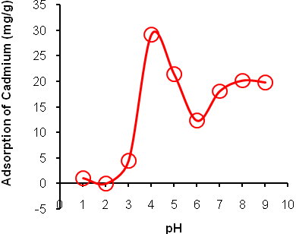

Table 2 Kinetic parameters of the Lagergreen’s pseudo first-order and Ho’s pseudo second-order model for adsorption of cadmium (II) on chitosan-tripolyphosphate
Adsorbent | Lagergreen’s pseudo first-order |  |  | Ho’s pseudo second-order
Adsorbent | q _{m} (mg/g) | K₁ (min⁻¹) | R² | q _{m} (mg/g) | K₂ (g/mg.min) | R²
chitosan-tripolyphosphate | 5,79 | 0,002 | 0,162 | 30,3 | 0,010 | 0,996
Table 3 Adsorption isotherm parameters of adsorption of cadmium (II) on chitosan-tripolyphosphate by Langmuir and Freundlich
Adsorbent | Lagergreen’s pseudo first-order |  |  | Ho’s pseudo second-order
Adsorbent | q _{m} (mg/g) | K₁ (min⁻¹) | R² | q _{m} (mg/g) | K₂ (g/mg.min) | R²
chitosan-tripolyphosphate | 5,79 | 0,002 | 0,162 | 30,3 | 0,010 | 0,996

The kinetics models adsorption of cadmium (II) on chitosan-tripolyphosphate are shown in Figure 7. The adsorption capacity of chitosan-tripolyphosphate to adsorb cadmium (II) in various of initial cadmium (II) concentration was determined as shown in Fig. 7.
Figure 7 Plot of kinetics model for adsorption of cadmium (II) on chitosan-tripolyphosphate (a) Lagergren’s pseudo first-order, (b) Ho’s pseudo second-order
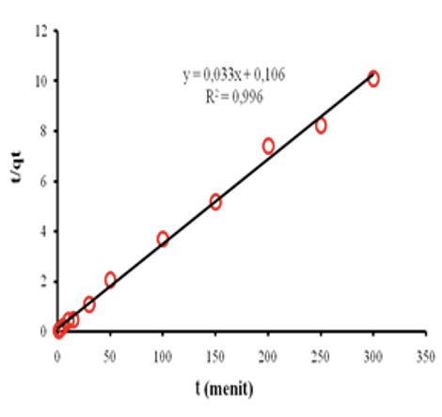
(a)
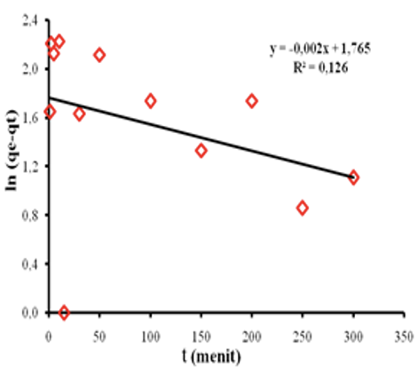
(b)
Based on the calculation results of the Langmuir and Freundlich isotherm parameters for adsorption of cadmium (II) on chitosan-tripolyphosphate, it was obtained that the correlation coefficient R² was greater using the Langmuir isotherm equation model than the Freundlich isotherm.

Figure 8. Plot of isotherm models for adsorption of cadmium (II) on chitosan-tripolyphosphate
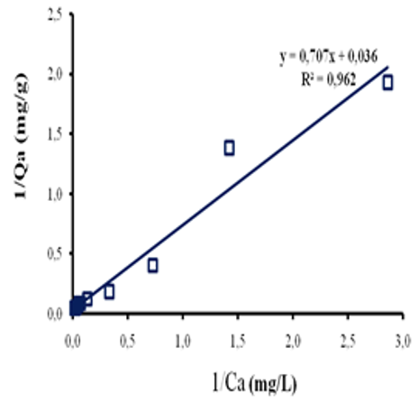
(a)
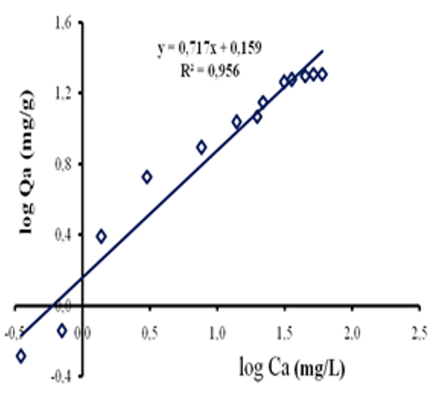
(b)
Therefore, experimental data on the adsorption of cadmium (II) tends to be suitable for using the Langmuir isotherm equation model, this menas that adsorption occurs homogeneously, adsorption occurs through the same mechanism and occurs in a single layer and there is no interaction between the adsorbate molecules.

CONCLUSION
The succesfull isolation of chitin from Clam Shells (Cerithidea obtusa) and synthesis of chitosan-tripolyphosphate from chitin, indicated by functional group vibration of N-H, -C-O, -P-O. The XRD pattern has a broad which are thypical fingerprints indicates amorphous shape. SEM image of chitosan-tripolyphospahte was flat sheet without pores and the surface is tight. The adsorption of cadmium on chitosan-tripolyphosphate was optimum pH at pH 4. the kinetics model for cadmium (II) adsorption on chitosan-tripolyphosphate could be described using pseudo second-order equation and was in accordance with the Langmuir isotherm model with maximum adsorption capacity of 27.8 mg/g. Furthermore, using the adsorbent of chitosan crosslinking with tripolyphosphate indicates adsorption effectiveness for cadmium (II) adsorption

Acknowledgement
We would like to express our thanks to the Indonesian Ministry of Education and Culture, Research, Technology and Higher Education for the PKPTDN 2023 grant ( No. 1280.1/UN27.22/PT.01.03/2023 ) and to the Faculty of Mathematics and Natural Sciences, Mulawarman University for the research facilities.

REFERENCES

[1] Statistik-KKP,
https://statistik.kkp.go.id/home.php?m=total&i=2#panel-footer, March, Saturday, 2024
[2] E. Susilowati, S.R.D Ariani,
L. Mahardiani and L. Izzati, Synthesis and Characterization Chitosan Film with Silver Nanoparticle Addition as a Multiresistant Antibacterial Material, JKPK (Jurnal Kimia Dan Pendidikan Kimia), Vol. 6, No. 3, p.371-383, 2021
[3] P.K. Dutta, J. Dutta, and V.S. Tripathi, V.S., Chitin and Chitosan: Chemistry, Properties and Applications”, J.Sci.Ind.Res., Vol 63, p.20-31, 2004
[4] W. Tiyaaboonchai, Chitosan Nano particles As Promisisng System for Drug Delivery, Nareusan University Journal, p.51-66, 2003

[5] Y.Zhang, M.Zhao, Q.Cheng, C.Wang, L,Ho.,X.Han, H.Fan,G.Su, D.Pan, Z.
Li, Research progress of adsorption and removal of heavy metals by chitosan and its derivatives: A review”, Chemosphere, Vol.279, 2021
[6] K. Kondo, R. Eto, M. Matsumoto, Adsorption of Pd and Pt on Chemically Modified Chitosan, Bull. Soc. Sea Water Sci., Jpn., 69, p.197-204, 2015

[7] M.E.A. Ali, M.M.S. Abdoelfadl, A. Seliem, H.F. Khalil and G.M. Elkady, Chitosan nanoparticles extracted from shrimp shells, application for removal of Fe(II) and Mn(II) from aqueous phases, Separation Science and Technology, Vol.53, No.9, 2018
[8] D. Ariyani, D.R. Mujiyanti, U.T. Santoso, U. Irawati, R. Maulana, R.E. Rohmah, Effect Of Chitosan Concentration On Macroporous Chitosan-TPP Beads Toward Turbidity, Dye Content, and COD of Sasirangan Wastewater, JKPK (Jurnal Kimia Dan Pendidikan Kimia), Vol. 6, No. 3, 2021
[9] D. Sikorski, K.G. Jagieła, and Z. Draczyński, The Kinetics of Chitosan Degradation in Organic Acid Solutions, Marine. Drugs, Vol 19, No.236, p.1-16, 2021
[10] D.R. Bhumkar and D.P. Pokharkar, Studies on Effect of pH on Crosslinking of Chitosan with Natium-Tripolyphosphat : A Technical Note”, AAPS, PharmaSecTech, Vol 7, No.2, p.138-143, 2021
[11] D. Koiparambil and J. Shanavas, Chitosan nanoparticles preparation and applications Environmental Chemistry Letters, Vol 16, p101–112, 2017

[12] M. Dogan, Preparation of chitosan nanoparticles and characterization studies, Cumhuriyet Tıp Dergisi (Cumhuriyet Medical Journal), Vol 42, No. 3, p.344-350, 2020
[13] D. Kavaz, O. Sedat, G. Eylem, D. Murat, B. Emir, Bleomycin Loaded Magnetic Chitosan Nanoparticles as Multifunctional Nanocarriers, Journal of Bioactive and Compatible Polymers Vol 25, p.305-318, 2010
[14] S. Kumar and J. Koh, Physiochemical and optical study of chitosan–terephthaldehyde derivative for biomedical applications, Int J Biol Macromol, Vol 51, No. 5, p.1167–1172, 2021
[15] A.M. Holban, V. Grumezescu, A. Ficai, A.M. Grumezescu, M.C. Chifiricus, F. Iordache, E. Andronescu, Highly Biocompatible Magnetite Nanoparticles Functionalized With Chitosan For Improving The Efficiency Of Antibiotics, U.P.B. Sci. Bull., Series B, Vol. 78, No.3, 2016.
[16] R.M. Silverstein, B.C Basser and T.C Morril, Spectrometric Identification of Organic Compounds, New York, Joh Wiley and Sons Inc, 1981

