Supporting Data
- Mud Volcano Sample
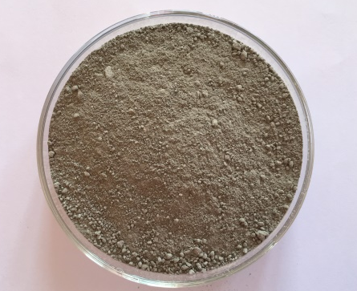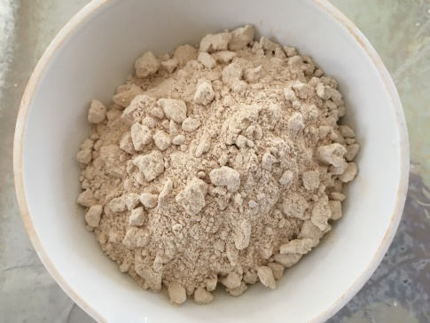
a
b
Figure 1. Mud volcano ash (a) Without preparation (b) Preparation result
XRF and XRD Data Analysis of Mud Volcano samples
Before preparation
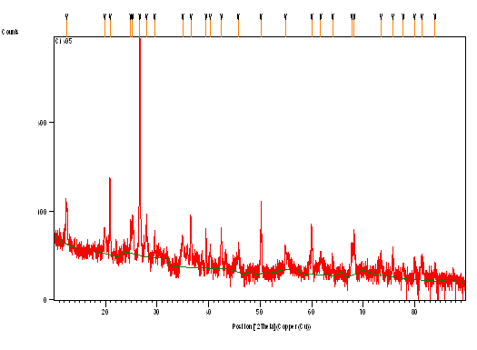
Peak List

Pos.[°2Th.] Height[cts] FWHM[°2Th.] d-spacing[Å] Rel.Int.[%]
12.4309 78.32 0.1574 7.12069 9.11
19.8431 31.67 0.3149 4.47439 3.68
20.8818 157.76 0.1181 4.25412 18.35
24.8886 49.09 0.1574 3.57759 5.71
25.2342 56.28 0.2362 3.52937 6.55
26.6704 859.72 0.1574 3.34248 100.00
27.9540 68.13 0.1574 3.19185 7.92
29.5043 33.08 0.1181 3.02758 3.85
34.9569 30.27 0.4723 2.56682 3.52
36.5755 68.94 0.1968 2.45686 8.02
39.4983 41.51 0.1574 2.28154 4.83
40.3158 24.29 0.2362 2.23714 2.83
42.4699 43.74 0.1574 2.12853 5.09
45.7467 18.41 0.4723 1.98340 2.14
50.1621 114.52 0.0720 1.81717 13.32
54.9058 25.25 0.2362 1.67224 2.94
59.9740 60.96 0.1574 1.54248 7.09
61.7868 11.90 0.9446 1.50151 1.38
64.0845 10.07 0.2362 1.45310 1.17
67.7601 34.92 0.1181 1.38296 4.06
68.2393 32.60 0.3936 1.37441 3.79
73.4660 19.37 0.1181 1.28901 2.25
75.7376 13.24 0.2362 1.25589 1.54
77.8119 7.09 0.4723 1.22752 0.82
79.9778 9.52 0.3936 1.19964 1.11
81.4064 13.73 0.6298 1.18216 1.60
83.9379 8.46 0.5760 1.15189 0.98
After preparation
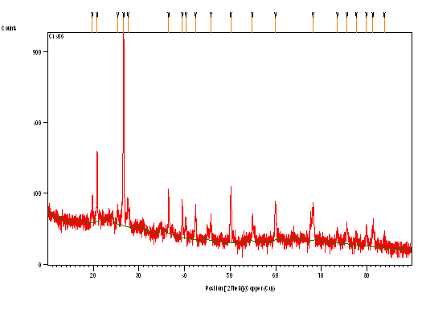
Peak List

Pos.[°2Th.] Height[cts] FWHM[°2Th.] d-spacing[Å] Rel.Int.[%]
19.7555 54.83 0.1968 4.49405 5.40
20.8478 213.87 0.1181 4.26099 21.07
25.3460 30.40 0.2362 3.51407 2.99
26.6482 1014.98 0.1771 3.34523 100.00
27.5992 46.64 0.2362 3.23207 4.60
36.5419 79.39 0.1181 2.45904 7.82
39.4876 70.70 0.1378 2.28213 6.97
40.2906 20.94 0.2362 2.23848 2.06
42.4495 50.21 0.1574 2.12950 4.95
45.7883 28.38 0.2755 1.98169 2.80
50.1545 104.39 0.0984 1.81893 10.28
54.8679 34.11 0.1181 1.67331 3.36
59.9376 64.07 0.1968 1.54333 6.31
68.1958 50.58 0.3149 1.37518 4.98
73.5046 9.88 0.4723 1.28842 0.97
75.6282 20.18 0.3149 1.25744 1.99
77.6925 9.08 0.4723 1.22911 0.89
79.8996 19.14 0.3149 1.20062 1.89
81.3013 19.58 0.3149 1.18343 1.93
83.8172 7.75 0.5760 1.15324 0.76

- Calcined Silica
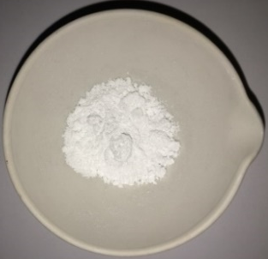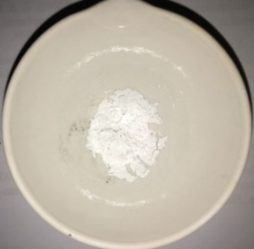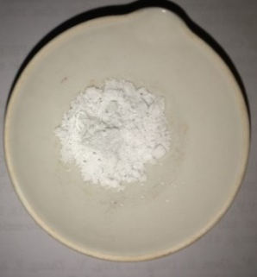
a
c
b
Figure 2. Calcined silica at temperature (a) 600ºC; (b) 800ºC; and (c) 1000ºC
XRD Data analysis of Silica
Silica extracted
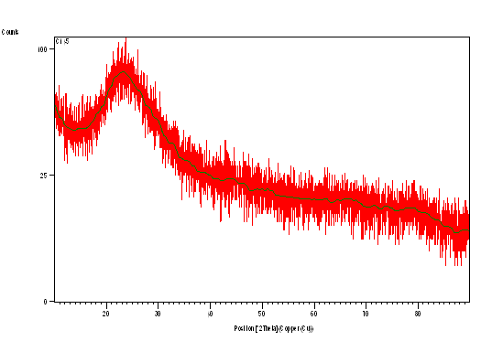

Calcined Silica at 600ºC
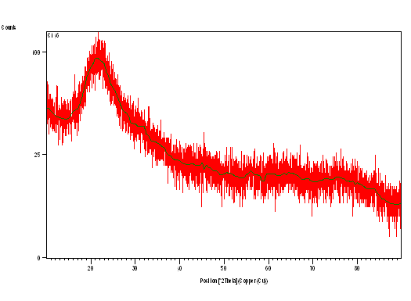
Calcined silica at 800ºC
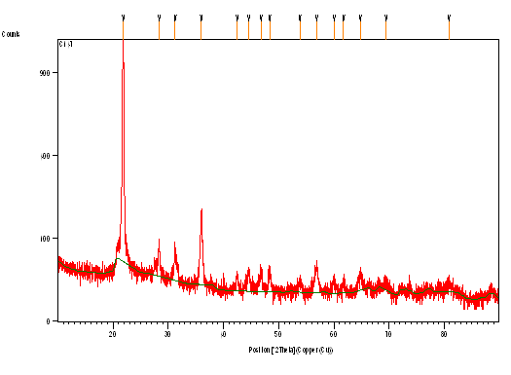

Peak List

Pos.[°2Th.] Height[cts] FWHM[°2Th.] d-spacing[Å] Rel.Int.[%]
21.8292 1085.67 0.1574 4.07159 100.00
28.3421 52.91 0.1968 3.14903 4.87
31.2716 55.51 0.2362 2.86039 5.11
36.0021 148.16 0.3149 2.49467 13.65
42.4541 16.90 0.4723 2.12928 1.56
44.5792 21.67 0.3936 2.03259 2.00
46.8049 21.81 0.3936 1.94099 2.01
48.3657 26.61 0.3936 1.88194 2.45
53.8477 10.93 0.6298 1.70258 1.01
56.8856 28.61 0.5510 1.61866 2.64
60.0627 11.24 0.7872 1.54041 1.04
61.7924 10.60 0.4723 1.50138 0.98
64.8251 17.86 0.7872 1.43828 1.65
69.4773 5.67 0.9446 1.35291 0.52
80.8627 7.01 1.1520 1.18775 0.65

Calcined silica at 1000ºC
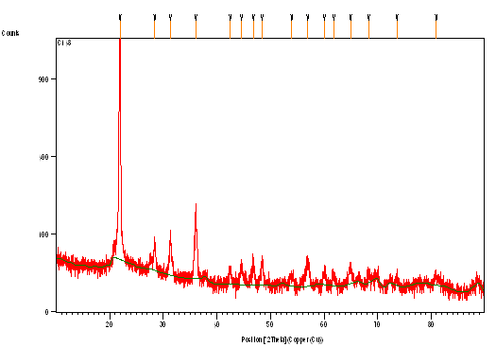
Peak List

Pos.[°2Th.] Height[cts] FWHM[°2Th.] d-spacing[Å] Rel.Int.[%]
21.8941 1155.00 0.2362 4.05966 100.00
28.3809 53.45 0.2362 3.14481 4.63
31.3161 78.83 0.2362 2.85643 6.83
36.0499 158.48 0.2362 2.49146 13.72
42.5113 16.22 0.3936 2.12655 1.40
44.5905 25.79 0.3149 2.03210 2.23
46.8056 30.53 0.3149 1.94097 2.64
48.4496 32.07 0.3149 1.87888 2.78
53.9671 10.24 0.7872 1.69909 0.89
56.9644 30.79 0.5510 1.61661 2.67
60.0676 13.03 0.6298 1.54030 1.13
61.8150 10.72 0.4723 1.50089 0.93
64.9356 17.15 0.7872 1.43610 1.48
68.3300 9.03 0.4723 1.37281 0.78
73.5804 6.74 0.4723 1.28728 0.58
80.9515 8.69 1.1520 1.18667 0.75

