Plasma Characteristics of Under-water Arc Discharge in Nanoparticle Fabrication

Abstract— Synthetic nanoparticles is the process of making particles with a size of less than 100 nm and changing the properties of the material so that it can be improved to improve the usability of new products. One method that can be used is the arc discharge method in water, which is a synthetic method of nanoparticles, which is very simple because it does not require complicated equipment. This study uses graphene as an electrode, which is then immersed in water and mounted horizontally. Current and voltage monitoring is carried out during the arc discharge process using a Hall-based current sensor and the voltage is measured directly between the two electrodes. Variations in input current of 10A, 40A, 70A, and 100A affect the arc formed, current and voltage, and ionization energy. Monitoring with OES is also carried out to determine the shape of the plasma, and the wavelength when the arc occurs. The results obtained that the current of has more effective and optimal results in synthesizing nanoparticles.
Keywords—Plasma Arc Discharge, Nanoparticle, Current-voltage Monitoring, Ionization.

Introduction (Heading 1)
Nowadays technological developments in the material field are leading to the nanoparticle revolution and there is an acceleration in the application of nanoscience and nanotechnology in the industrial world. This is because nanotechnology is very influential on the development of the times and the survival of life in the future. Some of the applications of nanotechnology are in the fields of material development, environmental science, electronics, optics, magnetism, energy storage, and electrochemistry [1].
The use of nano-based carbon materials is also very widely applied in the industrial field. The advantages of graphene in terms of optical properties, electrical properties, and mechanical properties make graphene interesting to study and develop further. Graphene can also be used as a good transistor because it has high mobility [2].
Synthetic nanoparticles is a process of making particles with a size of less than 100 nm and changing the properties of a material so that it can be improved to improve the usability of new products. Synthesis of nanoparticles can be carried out in vapor media (vapor/aerosol), liquid media (liquid) and solid media (solid).
The method of synthesizing nanoparticles with arc discharge in water has the advantage of producing nanoparticles that crystallize by themselves due to the high temperature caused by joules heating [3]. The arc discharge method in water is a very simple synthetic method of nanoparticles because it does not require complicated equipment, so knowing and controlling the process of making nanoparticles is expected to increase the quantity and quality of production economically.
In 2016, Bin Qin [4] used a graphene layer with an arc discharge synthetic method and gas media in the form of helium, helium oxygen, and hydrogen helium. The arc discharge synthesis was carried out at pressures of 73 kPa and 169 kPa respectively with currents at 120 A and a voltage of 25-30 V. Then research was carried out by S. Yatom [5] who used a synthetic method with a laser with two graphite electrode cylinders. The electrodes are positioned vertically, with the cathode on top and the chamber filled with 500 Torr of helium gas. Further research on the synthetic method of gas in the form of argon and an argon/hydrogen mixture used as plasma gas by Fengmei Su [6]. And Isya Fitri [7] who conducted research using liquid media in the form of ethanol where ethanol can produce CNP quickly and more than distilled water liquid media.
In this research, liquid media was used in the form of distilled water. Variations of input current are also given, namely 10A, 40A, 70A, and 100A. The electrode used is graphene with a medium in the form of water. The current and voltage monitoring system is carried out simultaneously using the WCS1500 current sensor and the voltage is measured in parallel using 1:10 differential probes. The method used in this study is to vary the effect of different current variations so that it will affect the arc formed, current and voltage, wavelength, and the resulting nanoparticles.
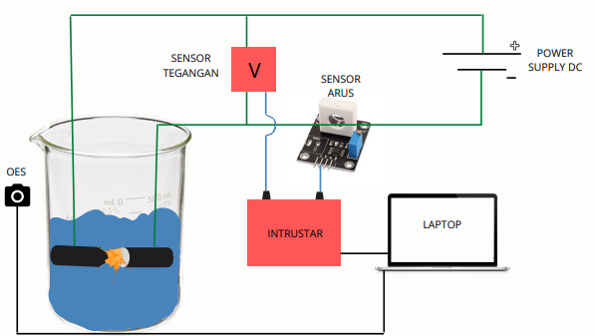
FIGURE 1. Scematic and Configuration of Arc Discharge Under-water system

Experimental setup and method

Device Configuration
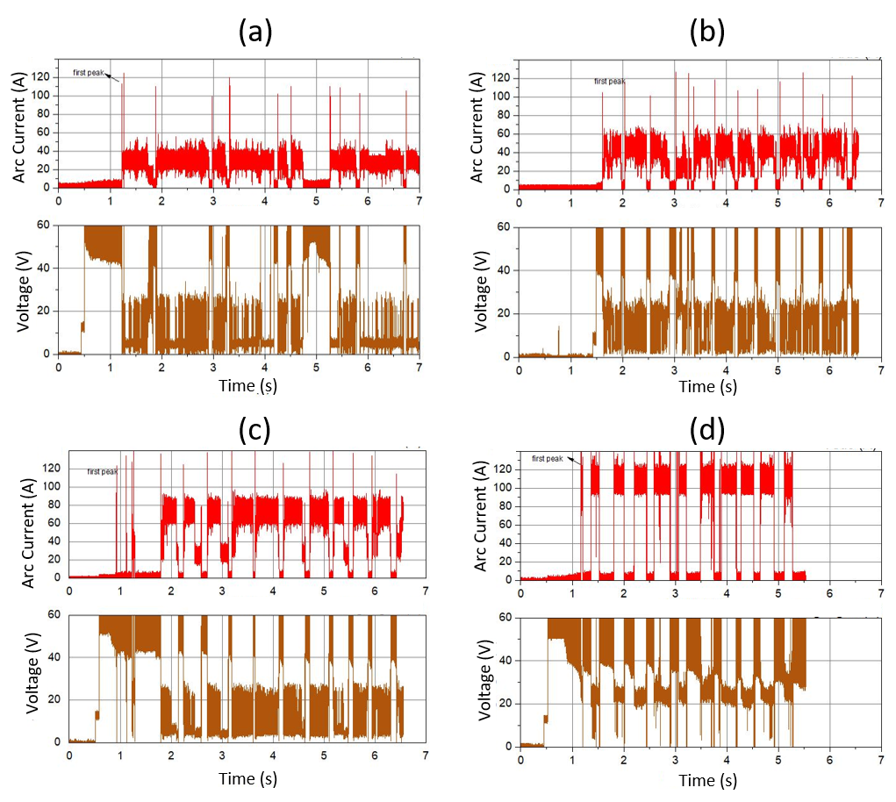
The design of the tool that will be made is the design of a tool for a plasma arc discharge system in water as shown in Figure 1. The electrode is made of 99.9% pure graphite which has the shape of a cylindrical rod with a diameter of 10 mm. The anode and cathode are immersed in a beaker containing a liquid medium. The anode and cathode are mounted horizontally on the welding clamp. The anode is made tapered so that electrons move from the anode to the cathode. The anode is moved manually via a lever. The electrodes are connected to an external DC power source.
FIGURE 2. Current vs. voltage characteristics of arc discharge
Current is applied to the electrodes and the distance between the anode and cathode is adjusted to approximately 1 mm until a spark appears. The arc current is recorded by a digital oscilloscope which will then be processed using the Multi Analyzer Software and Origin Software. The soot produced by the arc discharge method causes the initially clear liquid medium to become cloudy and black. This soot is collected by separating the solid CNP from the liquid medium. The CNP was then poured into a petri dish and dried in a desiccator.
During the arc process, OES (Optical Emission Spectroscopy) is brought close to the measuring cup at the moment so that it can record and capture wavelengths and can determine the shape of the plasma that occurs. Then the data will be recorded with Ocean View Software.

Data Processing Method
The data obtained is then processed using the origin software. Energy at the time of arc discharge is used to erode the anode. The energy produced by the arc discharge per unit time is as follows:

P = V x I (1)
where:
P = Power (Watts)
V = Arc discharge voltage (V)
I = Arc discharge cuurent (A)

W = ∆𝑃. ∆𝑡 (2)
where:
W = Energy (Joule)
P = Power (W)
T = Time (s)

N = 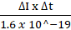 (3)

Eionization = (4)
where:
N = Number of charges
Eionization = Ionization Energy (Joule)

Results and Discussion
Analysis was focused on power consumption and energy ionization when the current is stable for each variation of applied current. Figure 2 shows voltage and current characteristics during arc discharge event. Initially before arc occurs, current and voltage values are 0 A and ~50 V respectively. The characteristics of the arc discharge are the current up and the voltage down. For an input current of 10 A, the current experiences several first peaks and the voltage drops to 29V.

Figure 2 shows that before the arc discharge occurred, the electrodes had no glow because the two electrodes had not been brought close to a distance of approximately 1 mm. After the arc occurs, the incandescence begins to appear and at the first peak, the current will increase and the voltage will decrease this is due to the condition of the maximum charge on the electrode then when the electrodes touch there will be a short circuit which causes the current to rise and then constant and the voltage drops to near zero. Then when the arc discharge takes place, the longer the glow will be very bright which lasts for a few seconds, this area is called the arc column.
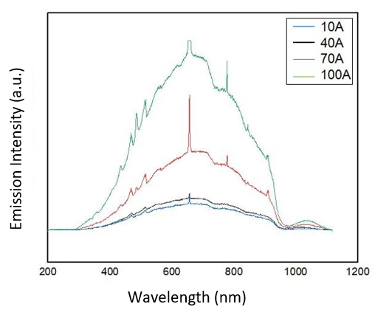
FIGURE 3. OES Spectra of arc discharge

The emission of light is caused by the absorption of light by the atom so that the atom is excited, that is, it returns to its original state by releasing energy in the form of light. From the graph above (Figure 3), there are three peaks with O_{II}, C_{II}, and H_{I} ions. This means that these ions participate in the reaction in the form of H and O from distilled water, and C from graphite carbon electrodes. In the graph above, it can be seen that the graph for the arc discharge of water media has the highest peak when the input current is 100 A, this is because more light is produced when there is an arc.

Ionization is a process in the formation of arc discharge where electrons move from the cathode to the anode and the electrons will collide with each other, resulting in a large electric field. During its journey, the electrons will accumulate molecules or gas atoms between the electrodes so that an ionization process occurs, where the electrons will be released from their shells due to the addition of energy. This collision process occurs continuously and will produce electronic avalanches and result in chain ionization. The amount of energy produced for the ionization process to occur is called ionization energy.
Figure 4 shows that at the peaks the ionization energy has the same value as the peaks in the OES method. However, there are several peaks in the ionization energy that are not present in the OES peak. If the value of ionization energy <2 x 10-19 J is in the infrared region, 2-7 x 10-19 J is in the visible light region, and >7 x 10-19 J is in the ultraviolet light region.
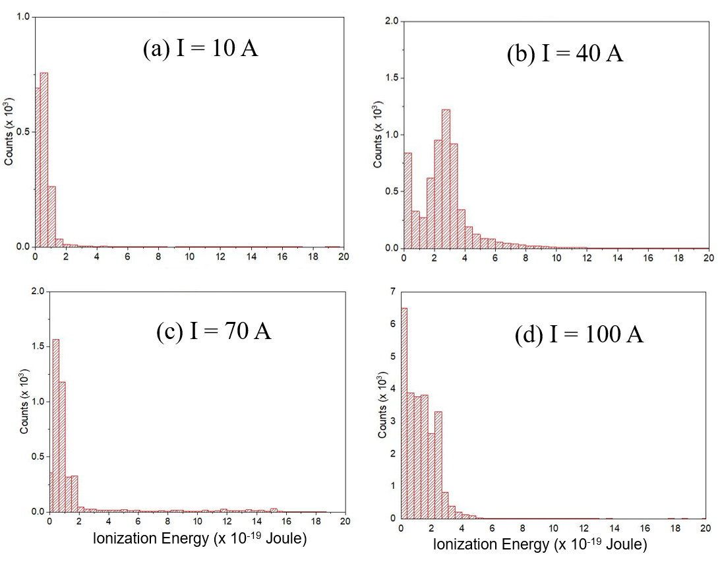
FIGURE 4. Ionization energy derived from current and voltage vs. time data for different current variation

Conclusion
We have successfully designed a plasma arc discharge system in water for the manufacture of nanoparticles. The electrode used is graphene with a medium in the form of water. The current and voltage monitoring system is carried out simultaneously using the WCS1500 current sensor and the voltage is measured in parallel using 1:10 differential probes. The effect of current variations on the arc formed, current and voltage, as well as ionization energy is that the greater the input current, the brighter the arc formed, the greater the current and the lower the voltage. And the distribution of ionization energy values ​​will be more evenly distributed. The shape of the plasma and the wavelength produced during the arc discharge process are recorded through OES, that the larger the input current, the longer the wavelength will have a peak that varies.

Acknowledgment
This work was partially supported by Grants-in-Aid for International Collaboration (No: 452/UN27.21/
PN/2020), (No: 260/UN27.22/HK.07.00/2021), and Grants-in-Aid for Fundamental Research (No: 254/UN27.22/PT.01.03/2022) from Sebelas Maret University.

References
- I. Safarik and M. Safarikova. "Magnetic nano- and microparticles in biotechnology". Chemical Papers, Voulume 63, Issue 5, pp. 497–505, 25 August 2009. DOI: 10.2478/s11696-009-0054-2
- L. Kedzierski, J. M. Curtis, P. C. Doherty, E. Handman, and K. Kedzierska. "Decreased IL-10 and IL-13 production and increased CD44hi T cell recruitment contribute to Leishmania major immunity induced by non-persistent parasites". European Journal of Immunology, Volume 38, Issue 11, pp. 3090-3100, 7 November 2008. DOI: 10.1002/eji.200838423
- X. Gang, J. S.-li, and S. Z.-qian, "The production of carbon nano-materials by arc discharge under water or liquid nitrogen". New Carbon Materials, Volume 22, Issue 4, pp. 337–341, December 2007. DOI: 10.1016/S1872-5805(08)60005-0.
- B. Qin, T. Zhang, H. Chen, and Y. Ma. "The growth mechanism of few-layer graphene in the arc discharge process". Carbon, Volume 102, pp. 494-498, 2016. DOI: 10.1016/j.carbon.2016.02.074
- S. Yatom, J. Bak, A. Khrabryi, and Y. Raitses. "Detection of nanoparticles in carbon arc discharge with laser-induced incandescence". Carbon, Volume 117, pp. 154-162, 2017. DOI: 10.1016/j.carbon.2017.02.055
- F. Su, X. Qiu, F. Liang, M. Tanaka, T. Qu, Y. Yao, W. Ma, B. Yang, Y. Dai, K. Hayashi, and T. Watanabe. "Preparation of Nickel Nanoparticles by Direct Current Arc Discharge Method and Their Catalytic Application in Hybrid Na-Air Battery". Nanomaterials, Volume 8, Issue 9, September 2018. DOI: 10.3390/nano8090684.
- F. Andhika, S. Hastuti, and T. E. Saraswati. "The surface characteristics of carbon nanoparticles produced via submerged arc discharge in ethanol/water". AIP Conference Proceedings, Volume 2296, pp. 020069-1-020069-6, 16 November 2020. DOI: 10.1063/5.0031109

