AERODYNAMIC CHARACTERISTIC AND AirPLANE STABILITY at THE PLERIMENARY DESIGN STAGE

1st Meiyanto Eko Sulistyo
Dept. of Electrical Engineering
Sebelas Maret University
Surakarta, Indonesia
mekosulistyo@staff.uns.ac.id
2nd Muhammad Ikyu Arqie Ramadhan
Dept. of Electrical Engineering
Sebelas Maret University
Surakarta, Indonesia
ikyu@student.uns.ac.id
3rd Ardya Paradipta Sylvano Inderawan
Division of Technology Center
PT. Dirgantara Indonesia
Bandung, Indonesia
ardyapsi@indonesia-aerospace.com

Abstract— Preliminary Design is the second stage in aircraft design after knowing the needs and specifications at the Conceptual Design stage. This Preliminary Design includes the conceptual design evaluation of aircraft performance in several fields, such as aerodynamics, engine power, and aircraft structure. This Job Training Report illustrates how is taken to conduct aerodynamic and aircraft stability analysis at the plerimenary design stage using NASA's open source software, Open Vehicle Simulation Program (OpenVsp). The aircraft model is simulated until aerodynamic and stability data are obtained which later can be processed for aircraft control design.
Keywords— Aerodynamics, Stability, Preliminary Design, OpenVsp

Introduction
The development of aircraft models that will take on certain missions requires many aspects to be reviewed so that the aircraft can carry out its mission. Starting from the type of mission that must be carried out, such as: fighter aircraft, reconnaissance aircraft, passenger aircraft and so on. Besides the type and weight of the load, the shape and structure of the aircraft and so on. In aircraft manufacturing, the design process is carried out in stages, starting from Market Research, Determination of Design Requirements and Objectives, Conceptual Design, Pre-Design Design, Detailed Design, and finally manufacturing.
The benefits obtained from the analysis of aerodynamics and airplane stability at the plerimenary design stage OpenVSP software are as follows: understanding how the process of developing an aircraft model from market research to the manufacturing process; know the steps to doing aerodynamic analysis and the stability of an aircraft model; and the results of aerodynamic and stability analysis are processed for the basis of aircraft design considerations and aircraft control.

BASIC THEORY

Airplane
An airplane is a device that is made and in its use using air media. Understanding airplanes can also be interpreted as objects that can fly, whether the object is lighter than air or heavier than air. About how these objects can fly of course there is a characteristic of these objects, so they can be flown. Usually these properties can arise as a result of the presence of air, or can be interpreted as aircraft can fly in the air due to air. [1]

Aerodynamics
Aerodynamics comes from Greece where aero is defined as air and dynamics is defined as strength or power. So aerodynamics can also be interpreted as science to find out the effects caused by the air or other gases that move. In essence, aerodynamics aims to break the speed or air resistance at high speeds. Air resistance that works on a vehicle (car, truck, bus or motorcycle) is mainly determined by the body shape of an object. In aerodynamics it is known that some forces work on an object, for example, more specifically on a car, as stated by Djoeli Satrijo. [2]
There are several kinds of forces acting on objects that fly in the air. These aerodynamic forces include lift, thrust, weight, and air drag. These forces affect the flying profile of all objects in the air, ranging from birds that can fly naturally smoothly to even the largest aircraft. So the same forces work on this mini-sized model airplane. [2]
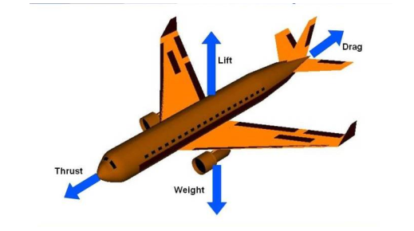
Figure 1 Illustration of Styles that Work on a Airplane [3]
Air drag is the force caused by molecules and particles in the air. This force is experienced by objects moving in the air. In a stationary object the zero air drag force. When the object starts to move, this air resistance begins to appear in the opposite direction to the direction of motion, which is inhibiting movement (that's why this force is called air drag). The faster the object moves the greater the air drag. So that objects can continue to move forward when flying, we need a force that can overcome the air resistance, namely the thrust produced by the engine. So that we do not need to produce thrust that is too large (so it is not economical) we must find ways to reduce drag. One way is to use a streamlined design. [4]

Airfoil
Airfoil or aerofoil is a form of geometry that when placed in a fluid flow will produce a lift force greater than the drag force. [5].

Inhibition coefficient and lift coefficient
Inhibition coefficient is a function of the dimensionless parameters used to measure the resistance or resistance of an object in a fluid environment such as air and water. [5] In its use the smaller the object drag coefficient, the smaller the drag force on an object and the more aerodynamic efficiency the drag coefficient can be known using the following equation:
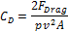
Where:
F_{Drag} = Inhibitory Force (Newton)
p = Fluid Density (kg/m²)
A = Surface Area of Objects (m²)
V = Fluid Speed (m/s)
Lift coefficient is a function of dimensionless parameters that indicate the amount of lift force acting on an object flowed by fluid [5]. The lift coefficient is strongly influenced by the shape of the object. Lift coefficient can be known by using the following equation:
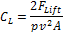
Where:
F_{Lift} = Lift Force (Newton)
p = Fluid Density (kg/m²)
A = Surface Area of Objects (m²)
V = Fluid Speed (m/s)
The maximum lift coefficient is the highest price produced by the wing at the maximum attack angle. If the maximum angle of attack is passed, there will be a loss of lift coefficient called stall. [5]

Stall Angle
In general, the slightest increase in stall angle results in an increase in the ability of the airfoil, but when it reaches a certain angle the airfoil will lose its lifting ability, this angle is called stall angle on the airfoil. [6]
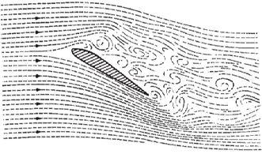
Figure 2 Illustrations of Force that Works on an Airplane [6]
Stall angle is the size of the angle of attack where the lift force produced reaches a maximum, above that angle the lift force will drop while the drag will enlarge rapidly. This can happen because the turbulent flow increases. Compare the air flow around the wing at a small attack angle, which can occur when flying straight and horizontally and at a large attack angle. When the attack angle is enlarged, the lift force generated by the airfoil will be even greater until a certain attack angle. This limit is called a stall angle. If the aircraft's attack angle is made greater than the critical angle of attack, the lift force is greater while the drag will also increase rapidly. This can happen because the air flow on the upper surface of the wing experiences turbulansi which causes the aircraft stall (the aircraft loses lift). [6]

Stability and Control
The stability of an airplane is related to how the ability of an airplane to maintain the position and condition of the aircraft in all circumstances. Whereas airplane control is related to the ability of an airplane to change the position and state of the airplane. [7].

RESULTS AND DISCUSSION

Aerodynamic Pressure Simulation Results
Speed and pressure are aerodynamic parameters used in this study. From the simulation results it can be seen that the speed and pressure distribution contours of Perlan II are as follows:
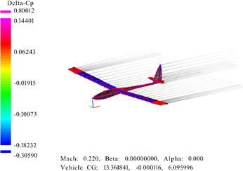
Figure 3 Results of Pressure Simulation on Perlan II
From the above data, we can find the Lift Coefficient and Inhibitance Coefficients which are the coefficients that greatly affect the performance of the model plane.

Simulation Results of Relationship of Lift Coefficient (Cl) with Attack Angle (α)
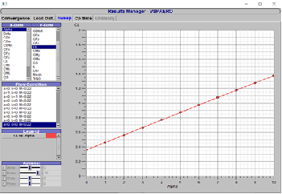
Figure 4 Simulation Results of Relationship CI with α
As shown in the diagram above, the smallest airfoil lift coefficient value is when the airfoil is at an angle of attack of 0 ° and the largest Lift coefficient value at the angle of attack of 10 ° and not yet stalled.

Simulation Results of Relationship of Inhibition Coefficient (Cd) with Attack Angle (α)
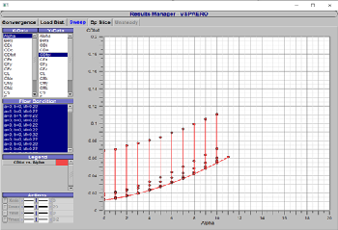
Figure 5 Simulation Results of Relationship Cd with α
Seen in the graph above, the smallest drag coefficient occurs when the angle of attack is 0 °. And the biggest drag coefficient is on the airfoil with the angle of attack condition of 10 °.

Simulation results of The Longitudinal Degree Of Stability of the relationship of CMy with attack angle
The stability in an airplane is a very important parameter in making an aircraft. From the simulation results it can be seen in the comparison between the Lift Coefficient (CMy) and attack angle (α) the following results are obtained:
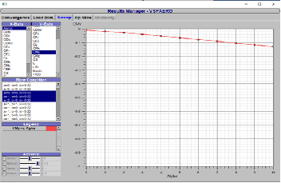
Figure 6 Simulation results of The Longitudinal Degree Of Stability of the relationship of CMy with attack angle
From the results of the comparison of CMy with α, the positive Cm value refers to the moment of pitching nose-up, or the nose of the plane going up, the data obtained has a negative slope so that it is found that the aircraft type Perlan II has Static Characteristics, so that the aircraft type Perlan II it's easy to get back to the original position when interference occurs.

CONCLUSION
Airplane development is an iterative process. Design at the conceptual design stage can never be launched, must go through a preliminary process to detail. In aircraft development, aircraft aerodynamics and stability is one of the theoretical foundations that can fly, with the study of aerodynamics and airplane stability concepts, it will be used for the development of flying equipment such as control units and others. OpenVSP can be used to conduct aerodynamic and stability analysis on airplanes in a short time and with a free application. The results of the data obtained can be used to buy the system approved on the airplane.

Acknowledgment
The authors are grateful to the Technology Center Division of PT Dirgantara Indonesia for conducting this research.

References

- Loftin Jr, Laurence K.: Quest for Performance: The Evolution of Modern Aircraft, NASA, Washington DC, 1985.
- Lutfi, Nasrul, Analisa Aerodinamis Pada Bodi Mobil Kategori Urban Concept Menggunakan Cfd (Computational Fluid Dynamics). Undergraduate (S1) Thesis, University Of Muhammadiyah Malang, 2018.
- NASA, Four Forces on an Airplane, https://www.grc.nasa.gov/www/k-12/airplane/Images/forces.jpg, Accessed February 25, 2020.
- Anderson, John D., Jr : Fundamentals of aerodinamics, McGraw-Hill Book Company, Boston, 2001.
- Peube, J.L. : Fundamentals of fluid Mechanics and Transport Phenomena, British Library, 2008.
- Kermode, A. C.: Mechanic Of Flight 11th Edition, Pitman Books Ltd, England, 2006.
- Dimitriadis, Introduction to Aircraft Design, Universite de Liege, 2017

