TO WHOM IT MAY CONCERN

Following the VALIDATION request of scientific paper translation entitled "Impacts of the COVID-19 Pandemic on the Eleocharis dulcis Crafter Communities in Ogan Komering Ilir District, South Sumatra Province, Indonesia" (authors: Ulfa Sevia Azni, Alfitri Alfitri) from the original version of Indonesian to English, I, the translator, hereby verify that after comparing and examining both papers (Indonesian and English versions), and by providing some input, state that the translation has a similar meaning and is in accordance with the original version, so it can be used.

Thus, this certificate is made for proper use.

Palembang, 12 April 2021
The Translator,

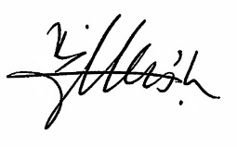
Bambang A. Loeneto, M.A., Ph.D.

