THE EFFECT OF VARIATION OF TYPES OF MICROBIAL STARTERS ON THE PHYSICAL CHARACTERISTICS OF MODIFIED CASSAVA FLOUR (MOCAF) RICH BETA-CAROTENE
ABSTRACT
The development of beta-carotene-rich MOCAF flour as a functional food aims to increase its nutritional content and functional properties as an antioxidant for health. The development of beta-carotene-rich MOCAF flour can be optimized through good fermentation methods, especially with the use of starter. This study aims to further analyze the effect of using a type of starter on the MOCAF characteristics of cassava species rich in beta-carotene through a comparison of several types of starter. In this study, three types of starter were used, namely the Bimo-CF starter, the Berhasil starter and the BRIN starter. The results showed that the use of starter during fermentation affected the physicochemical properties of mocaf flour in the form of differences in solubility, increased viscosity and decreased syneresis. Microstructural analysis (Scanning Electron Microscope) SEM of mocaf flour using starter during fermentation resulted in a more massive reshuffling of starch granules. This is characterized by changes in the morphology and structure of the starch granules which are more separated from one another, hollow, and have an increasingly irregular shape. NIR (Near infrared) and proximate analysis of the content of mocaf flour, showed that the use of starter during fermentation affected the decrease in water content, protein content, ash content, fiber content, phosphorus, and increased fat and dry matter content.
Keywords: beta carotene, type of microbial starter, NIR (Near infrared), proximate, SEM (Scanning Electron Microscope), MOCAF flour
INTRODUCTION
Cassava is one of the root crops from the food crop sub-sector, which generally grows in the tropics, including Indonesia. Cassava is an energy source that contains many carbohydrates and is one of Indonesia's most widely grown food crops because of its ease of cultivation. Cassava has broad adaptability and a fairly good ability to grow in various soil conditions, which makes the cultivation opportunities quite good (Sudarmonowati et al., 2020). Based on data from the Directorate General of Food Crops, in 2020, the production capacity of cassava cultivation in Indonesia will reach 18.48 million tons, an increase of 5.06 million tons or 37.72% from the previous year. With this large production capacity, cassava is important in maintaining food security.
Cassava is an alternative food ingredient that stores food reserves in the roots that can be consumed and diversified into various processed food products. Efforts to utilize cassava to support food diversification, among others, can be developed into food products as a source of carbohydrates through the development of technology for making MOCAF flour (Modified Cassava Flour) as a substitute for wheat flour which has great potential in the manufacture of various processed food products, such as cookies, bread and noodles (Hadistio and Fitri, 2019). Processing cassava into MOCAF flour aims to modify the characteristics of the flour produced through fermentation (Seveline et al., 2020). During the fermentation process, cassava's starch content will undergo physical, chemical and microbiological changes (Asmoro, 2021). One of the weaknesses of MOCAF flour is its low antioxidant content, which antioxidants are very important for body health because of its activity in protecting cells from damage caused by free radicals (Rahman et al., 2020; Arina et al., 2021). The development of MOCAF flour in foodstuffs can be carried out through functional food innovations that are applied as MOCAF flour rich in beta-carotene. Beta-carotene is included in the carotenoid group, acting as provitamin A and as an antioxidant (Purwanti et al., 2019). Several studies on the beta-carotene content in cassava have described types of cassava containing beta-carotene, one of which is yellow cassava. Yellow cassava is indicated as a source of vegetable provitamin A in the form of beta-carotene which can act as an antioxidant (Rahman et al., 2020).
The development of beta-carotene-rich MOCAF flour can be optimized by selecting a good type of starter. Starter is an additional ingredient used in the early stages of the fermentation process. The starter can be a microbial culture grown on a substrate or media. Starter performance is influenced by several environmental factors that affect microbial growth, such as substrate, temperature and pH (Kusumaningati et al., 2013). In the MOCAF fermentation process, a starter is used to ferment cassava in the form of chips with a faster fermentation time (Hadistio and Fitri, 2019). Enzyme and microbial activity in the starter produce lactic acid and organic acids, which ultimately affect the characteristics of MOCAF in terms of structure, physicochemical properties and scent of flour after fermentation (Astuti and Setyawati, 2016).
Many studies have used cassava as a raw material for MOCAF flour. (Novitasari and Arief, 2018) reported that using a starter in MOCAF fermentation made from cassava varieties casessart resulted in a water content value of 8.10%, ash 1.44% wb, protein 1.11%, fat 0.73%, crude fibre 0.90%, and carbohydrates 87.69%. Meanwhile, (Hersoelistyorini et al., 2015) reported that using a starter in fermentation using cassava of the Indu variety from the Sumowono area, Semarang Regency produced swelling power and solubility values of 13.05 (g/g) and 1.43 respectively %. (Hartati et al., 2017) reported that using a 10-gram BIMO-CF starter to ferment 10 kg of yellow cassava with 60 grams of sodium metabisulfite before drying in the sun produced a beta-carotene value of 2.65 mg/Kg containing protein reached 1.33%. Meanwhile, (Fathoni et al., 2016) reported that in MOCAF flour made from yellow cassava in the same variety with the addition of 0.3% sodium bisulphite at a drying temperature of 40°C -50°C, the beta-carotene content was 9.85 micrograms/gram body and 9.44 micrograms/ gram with the resulting protein content reaching 2.02% and 2.41%. In addition to cassava varieties, fermented types of treatment especially using a starter, can produce different characteristics of MOCAF flour. This study aims to further analyze the effect of using a type of starter on the characteristics of the MOCAF of cassava species rich in beta-carotene to obtain optimal MOCAF fermentation results by comparing several types of starter.
METHODOLOGY
Materials
This study used samples of cassava genotype Bokor aged 8-12 months from Boyolali, Central Java. Three types of starter were used for the fermentation process: the Bimo-CF starter, the Berhasil starter and the BRIN starter. Then, as an ingredient for post-fermentation soaking, 0.3% sodium metabisulfite was used to protect the beta-carotene content of the sample before entering the drying process. The equipment used is a scale, knife, slicer, fermentation tub, thermometer, pH meter, spinner, hammer mill, low-density polyethylene (LDPE) aluminium packaging and equipment for analysis. This research was conducted at PT. Solution Mocaf Flour, Surakarta, Central Java. Meanwhile, analysis of the physicochemical properties of MOCAF flour at the UMS Chemical Engineering Laboratory and flour quality at the Research Center for Food Process and Technology BRIN Gunungkidul, Yogyakarta and the Research Center for Applied Microbiology (PRMT) BRIN Bogor, West Java.
Methods
Production of MOCAF flour rich in beta-carotene
The sorted cassava of the Bokor genotype at the age of 8-12 months was separated from the skin by peeling and washing thoroughly using water and then thinly sliced using a slicer to form chips. To carry out the fermentation process, the chips are soaked in water for 24 hours with the addition of a starter according to a predetermined design (Table 1). Next, the chips were immersed in water containing 0.3% sodium metabisulfite solution for 30 minutes. The chips are drained and then put into a spinner to reduce the water content before the drying process is carried out. In the drying process, the chips are naturally dried using sunlight. After that, the chips were ground using a hammer mill and then sieved using a 100-mesh sieve. After the flouring process, MOCAF flour is packaged in aluminium (LDPE) packaging.
(Table 1.)
Viscosity Analysis
In the viscosity test, 5 grams of the sample was dissolved in 500 mL of distilled water and then heated for 20 minutes while stirring. After that, the solution was cooled to 50°C, and the viscosity was measured using a Viscotester Rion VT-03F with spindle number 4. The viscosity value is expressed in millipascal seconds (mPa.s).
Solubility Analysis
Solubility testing was carried out using the Kainuma et al., (1967) in (Hersoelistyorini et al., 2015). 1 gram of sample was dissolved in 10 mL of distilled water and then heated in a water bath at 60°C for 30 minutes. After that, the suspension was cooled, and then the supernatant was separated from the paste formed using a centrifuge at 3000 rpm for 20 minutes. 5 mL of the supernatant was taken and then dried in an oven at 100°C until the weight was constant and the dry residue was recorded. The solubility value is calculated using the formula:
$$\% Solubility=\frac{weight of dry sediment}{supernatant volume}$$
Syneresis Analysis
Syneresis testing was carried out using the freeze-thaw method. A sample of 5 grams was dissolved in 100 mL of distilled water and then heated at 100°C for 20 minutes. After that, the sample was cooled to room temperature until the same. Furthermore, the samples were stored in the freezer, frozen for 24 hours, and thawed at room temperature. The paste and water that came out were separated using a centrifuge at 3500 rpm for 15 minutes. The water that comes out is weighed, and the sample is frozen under the same conditions for up to five times freezing. The syneresis value is calculated using the formula:
$$Syneresis (g/g)=\frac{weight of the water comes out}{wight of initial pasta}$$
Near Infrared (NIR) Analysis
The MicroNIR 2200 spectrometer (JDSU, Santa Rosa, California, USA) which covers the spectral range of 1150-2150 nm was used in this work. The NIR spectrometer is an ultra-compact handheld spectrometer, with physical dimensional size of 45 - 42 mm and a weight of under 60 g. The miniaturised spectrometer mainly consists of a linear variable filter (LVF) as the dispersing element, a 128-pixel uncooled InGaAs photodiode array, a pair of integrated vacuum tungsten lamps and a mini USB 2.0 as the interface. The MicroNIR spectrometer owes its small size mainly to the novel LVF used as the dispersive element, which is a dielectric thin-film Fabry-Perot bandpass filter deposited using energetic processes (O’Brien et al., 2012). The filter coating in the LVF is intentionally wedged in one direction. Since the centre wavelength of the bandpass filter is a function of the coating thickness, the peak transmitted wavelength varies continuously along the direction of the wedge. The detailed working principle of the spectrometer used can be referenced to O’Brien et al. (2012). The spectrometer can record data every 8.1 nm with a spectral resolution of about 1.25% of centre wavelength.
Prior to collecting spectra from samples, the white and dark reference spectra were collected to correct the environmental and the instrumental influences. The white reference spectrum was obtained by collecting from a 99% diffuse reflectance panel and the dark reference spectrum (~0% reflectance) was acquired by covering the sapphire window completely using its opaque cap. In this study, the white and dark reference spectra were collected once for every 6 samples. When collecting spectra from samples, the Polyvinyl chloride film was first used to cover the testing sample to avoid the possible contamination to the sampling window. Then, the handheld MicroNIR spectrometer was placed directly upon the film for spectral collection. The spectra were collected in absorbance mode for all samples, and the integration time of 10 ms was set for all spectral collections. As some noise was observed from the original spectra, the spectral pre-processing method of 5-point SavitzkyeGolay (SG) smoothing was applied via the control software to smooth the original spectra. Three different positions were selected from each Petri dish sample for acquiring the spectra and the mean spectrum of the three positions was used to represent each sample for following data analysis.
Scanning Electron Microscope Analysis
The sputter coater (Hitachi E102 Ion Sputter; Tokyo, Japan) was used to cover the mocaf flour samples. An acceleration voltage of 20.0 kV was used to analyze all samples mocaf flour. The Hitachi S 2400 scanning electron microscope (SEM) (Hitachi, Tokyo, Japan) was used to record and analyze the mocaf flour. Mocaf flour images were captured at 10.000 × magnification (Ying et al. 2013). The particle size of mocaf flour was analyzed using Image-J free software for processing digital images according to Java program created by researchers at the Research Services Branch, National Institute of Mental Health, Bethesda (Maryland, USA) (Collins, 2007).
RESULTS AND DISCUSSION
Solubility Mocaf Flour
Solubility is a parameter that indicates the ability of a substance to dissolve in water. In this case, the solubility in water indicates the amount of MOCAF flour in grams dissolved in one millilitre of solvent (water) (Hidayat et al., 2009). Based on the analysis, the solubility value of MOCAF flour with a starter ranged from 1,214% -1,391%, while the control solubility value was 1,308% (Figure 1). The highest solubility level was found using the BRIN starter type, with a solubility level reaching 1,391%. The lowest solubility level was found using the Berhasil starter type, with a solubility level of 1,214%. Compared with the control data, the results obtained from using the BRIN type of starter resulted in a higher solubility than the control (without a starter). Diniyah et al. (2018) reported that modification increases starch solubility.
(Figure 1.)
However, this theory does not apply to the solubility value of MOCAF flour from cassava genotype bokor fermented with Berhasil starter and BIMO-CF types because the solubility value obtained is still lower than the control solubility value. This also occurs in the results of research conducted by Hersoelistyorini et al. (2015), which reported that the solubility value of mocaf flour by fermentation using the BIMO-CF starter resulted in a lower solubility of 1.43% compared to the solubility value of mocaf flour by natural fermentation. Without a starter, which can reach 1.91%. Differences influence this difference in solubility level in the number of starch structures (amylose and amylopectin) broken up by each starter's activity during fermentation. The starter with the highest solubility is indicated to have the greatest starch decomposition activity, as indicated by the high solubility value obtained. Cell reshuffling during fermentation will cut the bonds in starch into a simpler structure. Some of it will also change into its basic structure, namely glucose, so it becomes water-soluble (Diniyah et al., 2018).
Viscosity Mocaf Flour
Viscosity is a parameter that determines the thickness of a fluid and expresses the size of the friction in the fluid. The results of measuring the viscosity of MOCAF flour using a starter ranged from 1,967 mPa.s to 2,200 mPa.s. The highest viscosity value was found in using the Bimo CF starter type, which reached 2,200 mPa.s, and the lowest viscosity value was found in using the BRIN starter type, which was 1,967 mPa.s. In comparison, using the starter type produced a viscosity value of 2,033 mPa.s (Figure 2). Compared with the control viscosity of 1,933 mPa.s, using the starter type in the fermentation process has resulted in a higher viscosity than the viscosity results in the control fermentation process (without a starter).
(Figure 2.)
This difference in viscosity is thought to be influenced by microbial activity during fermentation which causes changes in the characteristics of the flour. The number of pectinolytic and cellulolytic enzymes produced by microbes during fermentation increased the number of starch granules released. The activity of pectinolytic and cellulolytic enzymes, which began to intensify in degrading cellulose cell walls, resulted in damage to the cell wall (Subagio et al, 2008). Finally, the starch granules would begin to liberate. Due to the activity of extracellular amylolytic enzymes, the liberated granules will experience hydrolysis on their surface, resulting in holes in the starch granules. The holes strengthen the bond between the grains so that the material is not easily broken and is sticky so that it can change the characteristics of the resulting flour in the form of increased viscosity (Subagio, 2007; Kartikasari et al., 2016; Assalam et al., 2019).
Syneresis Mocaf Flour
Syneresis is the release of water or seepage of liquid from inside the food where the components in the material do not tightly bind to the water. Freeze-thaw syneresis testing is important because it can be used as an indicator to evaluate flour quality related to the resistance of the physical properties of starch gel to unwanted changes during freezing and thawing, thus affecting the shelf life of flour (Charoerein et al., 2008; Putri et al., 2018).
(Figure 3.)
The results of measuring the syneresis of MOCAF flour (Figure 3) show that the amount of water released decreases as the storage time increases. This is to the results of a study conducted by (Putri et al., 2018), which stated that the syneresis value decreased as the storage process took longer because the quantity of water that came out of the starch paste decreased. Using a starter in fermentation gives a lower syneresis value than the control results (without a starter). This shows that using a starter in the fermentation process can reduce the syneresis value of MOCAF flour. The best syneresis value was obtained by using the BRIN starter because it has the lowest syneresis value. A low or decreasing syneresis value indicates that the flour is of good quality because a high syneresis value indicates that the gel is physically unstable, which can reduce the product's quality (Kuncari et al., 2014; Dewi et al., 2022). The higher the syneresis value indicates, the greater the chance of starch retrogradation which can affect the shelf life of food products (Putri et al., 2018).
Near Infrared (NIR) Mocaf Flour
NIR analysis is a spectroscopic analysis method that measures the sample spectrum with a relatively fast measurement time and does not damage the sample (Mechram et al., 2021). NIR spectroscopy has been widely used in agriculture and the food industry to identify compounds in food products (Lengkey et al., 2013). From the NIR analysis, it can be seen the value of water content, fat content, protein content and fibre content contained in mocaf flour (Table 2).
The results of the NIR analysis of the moisture content of mocaf flour in fermentation using a starter ranged from 12.76% -13.01% (Table 2). This result is lower than the control water content of 13.39%. From this, it can be seen that using a starter during fermentation reduces the water content in mocaf flour. This decrease in water content is possible due to starch degradation during fermentation, which causes the formation of simple sugars to the release of components, including bound water, which has an impact on changing the texture of the material to become soft and porous so that it can increase water evaporation during drying (Gaol et al., 2023). The lower the water content, the better the quality of the flour because, in these conditions, microbial growth can be minimized to extend the shelf life of the flour.
The results of the NIR analysis for the fat content of mocaf flour in fermentation using a starter ranged from 1.63% -1.70% (Table 2). Using the BIMO-CF starter type resulted in a decrease in levels of 0.06% of the control data. However, the BRIN and Berhasil starter types increased fat content by 0.01% from the control fat content of 1.69%. From this, it can be seen that using a starter during fermentation tends to increase the fat content of mocaf flour, although not significantly. According to (Aisah et al., 2021), the increase or decrease in fat content is basically due to the overhaul of fatty acids in cassava due to the secretory activity of the microbes themselves. The increase in fat content is caused by microorganisms being able to produce microbial oil during the fermentation process; in this case, the oil obtained is called single-cell oil (SCO), which is a euphemism similar to single-cell protein, which is commonly used to denote proteins derived from single cell microorganisms (Kurniati et al., 2012; Wulandari et al., 2017). The longer the fermentation process, the more oil accumulates due to the number of microbes producing oil. Meanwhile, according to (Khasanah et al., 2021), the decrease in fat content is considered part of the fat component used for microbial metabolism in fermentation because fat is a nutrient usually used as a carbon source besides carbohydrates and protein. In addition, a decrease in fat content is also possible because, during fermentation, the fat component is converted into fatty acids and glycerol by the lipase enzyme produced by the microbes contained in the starter (Behera and Ray, 2017 in Khasanah et al., 2021).
(Table 2.)
The results of NIR analysis of mocaf protein content in fermentation using a starter ranged from 3.80% -4.10% (Table 2). Using the Berhasil starter type gave the same results as the control protein content data, which was 4.10%. However, the use of BIMO-CF and BRIN starter types resulted in a decrease in levels of 0.07% and 0.3% of the control data. From this, it can be seen that using a starter during fermentation tends to reduce the protein content of mocaf flour. The decrease in protein levels is due to the activity of lactic acid bacteria in hydrolyzing proteins through proteolytic enzymes, which can convert protein complexes into shorter peptide fractions and several types of amino acids (Diniyah et al., 2018; Astuti and Setyawati, 2016). Then the results of the protein breakdown will be partly utilized by microbes to multiply. Others will continue to be degraded to produce an amino acid that quickly oxidizes to produce ammonia (NH3) or NH2, which is volatile, causing a decrease in the fermented protein (Shintawati et al., 2022; Muthmainna et al., 2016).
The protein reshuffling during this fermentation was proven by identifying amino acid contents such as alanine, glycine, glutamic acid and melatonin from the NIR test results of mocaf flour (Table 2). Analysis of the alanine content of mocaf flour in fermentation using a starter ranged from 0.05% -0.10%, with an alanine content of 0.07% as a control. Analysis of the glycine content gave different results for each starter, whereby using the Starter Berhasil and BIMO-CF, the glycine content could be identified as 0.12% and 0.11%, respectively. Meanwhile, using the BRIN starter and control glycine content was not identified. This also happened in the analysis of methionine content, which was only identified using the Berhasil starter and BRIN, which produced the same value of 0.14%, which was still lower than the control data, which was 0.16%.
Meanwhile, methionine content was not identified when using the BIMO-CF starter. Analysis of the glutamic acid content of mocaf flour in fermentation using a starter ranged from 0.49% -0.52%. This result was higher than the control glutamic acid content, which was 0.32%, indicating that using a starter could increase protein breakdown because a high glutamic acid content resulted in lower protein content. This is proven when compared with the identified protein content; the glutamic acid content negatively correlates with the protein content of mocaf flour. The higher the glutamic acid content, the lower the protein content in mocaf flour because many proteins have been hydrolyzed to glutamic acid by proteolytic enzymes during fermentation. Generally, it can be observed that using a starter during fermentation gives different results in protein breakdown. This is thought to be related to the difference in the ability of each bacteria in the starter to overhaul the protein complex. In this case, the decrease in the quantity of protein in mocaf flour can also be understood that a decrease in protein content does not mean a total loss of protein content. However, the protein has been transformed into a simple fraction that is still beneficial for the body.
Proximate Analysis of Mocaf Flour
One of the assessments of food quality can be done through proximate analysis. Proximate analysis is a method of chemical analysis based on the chemical composition contained in the material. The proximate analysis shows the value of the dry matter, moisture content, ash content, crude protein and crude fat contained in mocaf flour. The results of the proximate analysis of dry matter mocaf flour in fermentation using a starter ranged from 88.91% -89.96% (Table 3). Using the Berhasil starter type, there was a decrease in the quantity of dry matter by 0.22%. However, when using BIMO-CF and BRIN starter types, there was an increase in dry matter quantity of 0.68% and 0.83% from the control data. From this, it can be seen that using a starter during fermentation tends to increase the quantity of mocaf flour dry matter. According to (Balo et al., 2022), the results of a high dry matter content indicate that the mechanism for decomposing nutrients can be minimized during the fermentation process to prevent material damage. This can happen because, basically, during fermentation, microbial respiration will break down the nutrient content so that it will reduce the dry matter, while cell liberation activity followed by the release of bound water components in the material will increase the water content, which causes a lot of nutrients to decompose so that it has an impact on decreasing the quantity of the dry material (Kuncoro et al., 2015; Seran et al., 2020).
The results of the proximate analysis of the moisture content of mocaf flour in fermentation using a starter ranged from 10.04% -11.09% (Table 3). When compared with control data, the use of starter Berhasil can increase the water content by 0.22% from the control data. However, the use of BIMO-CF and BRIN starter types resulted in a decrease in water content of 0.68% and 0.83% of the control data. From this, it can be seen that using a starter during fermentation tends to reduce the moisture content of mocaf flour. This was also proven by the results of the NIR analysis (Table 2), where there was a decrease in the water content of 0.38% until 0.63% when using a starter during fermentation. This decrease in water content is probably caused by changes in the structure of starch granules due to starch degradation during fermentation, which in turn causes the granule structure to become more porous/perforated, thereby increasing water evaporation during drying (Gaol et al., 2023).
(Table 3.)
The results of the proximate analysis of mocaf flour ash content in fermentation using a starter ranged from 0.40% -0.65% (Table 3). The BIMO-CF starter type gives the same results as the control ash content data, which is 0.65%. However, the use of the Berhasil and BRIN starter type resulted in a decrease in levels of 0.14% and 0.25%. From this, it can be seen that adding a starter tends to decrease the ash content of mocaf flour. According to (Dewi et al., 2022), the decrease in ash content is caused by an increase in organic matter during fermentation due to the process of degradation of the material (substrate) by microbes which will affect the ratio of organic matter in the flour. The less organic matter can be decomposed, the lower the ash content obtained. Conversely, the more organic matter that can be decomposed, the higher the ash content proportionally.
The results of the proximate analysis of the crude protein content of mocaf flour in fermentation using a starter ranged from 0.79% -0.88% (Table 3). This result is lower than the crude control protein content of 0.94%. From this, it can be seen that using a starter during fermentation reduces the crude protein content in mocaf flour. This was also proven by the results of the NIR analysis (Table 2), where there was a decrease in protein content of 0.07% and 0.3% in the use of a starter during fermentation. This decrease in protein content is possible due to the activity of proteolytic bacteria, which produce extracellular protease enzymes which can then hydrolyze proteins into their simpler parts, namely shorter peptide fractions and amino acids. Then, some of the decomposition results will be used for microbial respiration and the rest will continue to be broken down into volatiles compounds such as NH₃ or NH₂ wich can be lost through evaporation (Shintawati et al., 2022; Muthmainna et al., 2016; Diniyah et al., 2018).
The results of the proximate analysis of the crude fat content of mocaf flour in fermentation using a starter ranged from 0.77% -0.88% (Table 3). This result is higher than the control crude fat content of 0.72%. From this, it can be seen that using a starter during fermentation increases the crude fat content in mocaf flour. This is also proven by the results of the NIR analysis (Table 2), where using a starter during fermentation tends to increase the fat content by 0.01%. However, this increase is not so significant. The increase in fat content is thought to be caused by the ability of microorganisms to produce microbial oil during the fermentation process, which is called single-cell oil (SCO), which will then increase with the length of fermentation time due to an increase in the number of microbes in producing oil (Kurniati et al., 2012).
Scanning Electron Microscope (SEM) Mocaf Flour
SEM is a sensing instrument used to obtain microstructural images of a sample through the principle of electron reflection. In this case, SEM analysis was used to further observe changes in the shape of cassava starch granules after the fermentation process. The results of SEM analysis of mocaf flour showed that the largest starch granule size ranged from 16.5 µm-18.5 µm, while the smallest starch granule ranged from 4.07 µm-5.47 µm (Figure 4). Starch granules generally form in the fermentation method using a starter, which begins to separate. Some parts of the granules begin to have holes with an irregular round granule structure. In more detail, this change can be seen in the use of Berhasil starter (A), where the starch granule forms separate from each other, and the sizes are increasingly non-uniform or inhomogeneous. This also happened in using the BIMO-CF (B) starter, where it was found that the size of starch granules had a non-uniform size with smaller granule sizes and found starch granules with many holes so that their shape looked irregularly round. When using the BRIN (C) starter, the shape of the starch granule changes began to appear more significant. This can be seen from the shape of many starch granules, which were already irregular and began to separate.
(Figure 4.)
Compared with the control (K), the starch granules in control appear to be bound to each other and are still clustered on the cassava cell walls with a granular shape that looks more irregularly rounded than in the sample using the starter. From this, it can be seen that using a starter during fermentation gives a more massive overhaul of starch granules characterized by significant changes in the morphology and structure of starch granules. This can happen because, during the fermentation process, microbial activity in the starter will produce pectinolytic and cellulolytic enzymes, which will degrade the cell wall cellulose and result in the liberation of starch granules, which practically will also make the starch granules separate from each other (Subagio et al., 2008; Kartikasari et al., 2016). Furthermore, in the presence of extracellular amylolytic enzyme activity, the free starch granules will hydrolyze on some of their surfaces, resulting in perforated starch granules (Meutia et al., 2021). As a result, this can also trigger the liberation of starch from the granules so that it can cause changes in the chemical properties, viscosity, and morphology of the resulting starch.
CONCLUSION
The results showed that using a starter during fermentation affected the physicochemical properties of mocaf flour, namely differences in solubility, increase in viscosity and decrease in syneresis. The results of NIR and proximate analysis of mocaf flour content showed that using a starter during fermentation affected the decrease in water content, protein content, ash content, fibre content, phosphorus, and an increase in fat content and dry matter. The results of the microstructural analysis of mocaf flour on the use of starter during fermentation gave a more massive overhaul of the starch granules, characterized by changes in the morphology and structure of the starch granules, which were more separated from each other, hollow, and had an increasingly irregular shape.

REFERENCES
Aisah, A., Harini, N. and Damat, D. (2021). Pengaruh Waktu dan Suhu Pengeringan Menggunakan Pengering Kabinet dalam Pembuatan MOCAF (Modified Cassava Flour) dengan Fermentasi Ragi Tape. Food Technology and Halal Science Journal 4(2): 172-91.
Arina, I. G. A. A. P., Ina, P. T. and Ekawati, I. G. A. (2021). Pengaruh Perbandingan Modified Cassava Flour (Mocaf) Dan Puree Labu Kuning (Cucurbita Moschata) Terhadap Karakteristik Brownies Kukus. Jurnal Ilmu dan Teknologi Pangan (ITEPA) 10(2): 246-255.
Asmoro, N. W. (2021). Karakteristik Dan Sifat Tepung Singkong Termodifikasi (Mocaf) Dan Manfaatnya Pada Produk Pangan. Journal of Food and Agricultural Product 1(1): 34-43.
Assalam, S., Asmoro, N. W., Tari, I. N. and Hartati, S. (2019). Pengaruh Ketebalan Irisan Chips Singkong Dan Lama Fermentasi Terhadap Sifat Fisiko Kimia Tepung Mocaf (Modified Cassava Flour). AGRISAINTIFIKA: Jurnal Ilmu-Ilmu Pertanian 3(1): 31-39.
Astuti, S. and Setyawati, H. (2016). Peningkatan Nilai Gizi Umbi Talas Melalui Proses Fermentasi Menggunakan Starter Bimo CF Dan Pegagan (Centella Asiatica Linn Urban). Seminar Nasional Inovasi Dan Aplikasi Teknologi di Industri (SENIATI): 58-62.
Balo, E. F. S., Pendong, A. F., Tuturoong, R. A. V., Waani, M. R. and Malalantang, S. S. (2022). Pengaruh lama ensilase terhadap kandungan bahan kering (BK), bahan organik (BO), protein kasar (PK) sorgum varietas pahat ratun ke-1 sebagai pakan ruminansia. ZOOTEC 42(1): 74-80.
Behera, S. S., & Ray, R. C. (2017). Microbial linamarase In Cassava Fermentation. In Microbial Enzyme Technology In Food Applications, 1st Edition hal 333-346. Boca Raton: CRC Press.
Charoenrein, S., Tatirat, O. and Muadklay, J. (2008). Use of Centrifugation-Filtration for Determination of Syneresis in Freeze-Thaw Starch Gels. Carbohydrate Polymers 73(1): 143-147.
Collins, T. J. (2007). ImageJ for microscopy. Biotechniques 43(S1): S25-S30.
Dewi, K. L., Aulina, D. E., Wulandari, F. and Maharani, S. (2022a). Modifikasi Pati Dengan Fermentasi (S. Cerevisiae) Pada Tepung Pisang, Tepung Ubi Ungu, Dan Tepung Ketan Hitam. Edufortech 7(2): 166-183.
Dewi, E. R. S., Nugroho, A. S. and Maria, U. (2022b). Variations in Microbial Community on the Nutrient Content of Fermented Fish Feed Pellets with Tofu Waste. Jurnal Biologi Tropis 22(2): 390-397.
Diniyah, N., Subagio, A., Sari, R. N. L. and Yuwana, N. (2018a). Sifat Fisikokimia Dan Fungsional Pati Dari Mocaf (Modified Cassava Flour) Varietas Kaspro Dan Cimanggu. Jurnal Penelitian Pascapanen Pertanian 15(2): 80-90.
Diniyah, N., Yuwana, N., Maryanto, B. H. P., Purnomo, B. H. and Subagio, A. (2018b). Karakterisasi Sera Mocaf (Modified Cassava Flour) dari Ubikayu Varietas Manis dan Pahit. Jurnal Penelitian Pascapanen Pertanian 15(3): 131-139.
Direktorat Jenderal Tanaman Pangan (2021). Laporan Tahunan 2021. https://tanamanpangan.pertanian.go.id/assets/front/uploads/document/LAPORAN%20TAHUNAN%20DJTP-2021.pdf. [March 3, 2023]
Fathoni, A., Hartati, N. S. and Mayasti, N. K. I. (2016). Minimalisasi Penurunan Kadar Beta-Karoten Dan Protein Dalam Proses Produksi Tepung Ubi Kayu. PANGAN 25(2): 113–24.
Gaol, M. P. L. and Daulay, A. S. (2023). Uji Kadar Protein Pada Optimasi Pembuatan Tepung Mocaf Dari Ubi Kayu Dengan Fermentasi Lactobacillus Casei. Jurnal Farmasi, Sains dan Kesehatan (FARMASAINKES) 2(2): 121-131.
Hadistio, A. and Fitri, S. (2019). Tepung Mocaf (Modified Cassava Flour) untuk Ketahanan Pangan Indonesia. Jurnal Pangan Halal 1(1): 13-17.
Hartati, Fathoni, A., Kurniawati, S., Hartati, N. S. and Sudarmonowati, E. (2017). Technological Innovation in the Protection of Beta Carotene on MOCAF Production Which Is Rich in Beta Carotene. Nusantara Bioscience 9(1): 6–11.
Hersoelistyorini, W., Dewi, S. S. and Kumoro, A. C. (2015). Sifat Fisikokimia Dan Organoleptik Tepung Mocaf (Modified Cassava Flour) Dengan Fermentasi Menggunakan Ekstrak Kubis. The 2nd University Research Coloquium: 10-17.
Hidayat, B., Kalsum, N. and Surfiana. (2009). Karakterisasi Tepung Ubi Kayu Modifikasi yang Diproses Menggunakan Metode Pragelatinisasi Parsial (Characterization of Modified Cassava Flour Processed Through Partial Pregelatinisation Method). Jurnal Teknologi Industri dan Hasil Pertanian 14(2): 151-154.
Kainuma, K., Odat, T., Cuzuki S. (1967). Study of starch phosphatesmonoesters. Journal of Technology Society Starch 14: 24-28.
Kartikasari, S. N., Sari, P. and Subagio, A. (2016). Karakterisasi Sifat Kimia, Profil Amilografi (RVA) Dan Morfologi Granula (SEM) Pati Singkong Termodifikasi Secara Biologi. Jurnal Agroteknologi 10(1): 12-24.
Khasanah, Y., Nurhayati, R., Mustikasari, A. and Astuti, I. W. (2021). Karakteristik Fisikokimia Dan Mikrobiologi Modified Cassava Flour (Mocaf) Yang Difermentasi Menggunakan Starter Kering The Physicochemical And Microbiological Characteristics Of Fermented Modified Cassava Flour (Mocaf) By Using The Dry Starter. Jurnal Riset Teknologi Industri 15(2): 168-178.
Kuncari, E. S., Iskandarsyah and Praptiwi. (2014). Evaluasi, Uji Stabilitas Fisik Dan Sineresis Sediaan Gel Yang Mengandung Minoksidil, Apigenin Dan Perasan Herba Seledri (Apium Graveolens L.). Buletin Penelitian Kesehatan 42(4): 213–22.
Kuncoro, D. C., Muhtarudin and Fathul, F. (2015). Pengaruh Penambahan Berbagai Starter pada Silase Ransum Berbasis Limbah Pertanian terhadap Protein Kasar, Bahan Kering, Bahan Organik, dan Kadar Abu. Jurnal Ilmiah Peternakan Terpadu 3(4): 234-238.
Kurniati, L. I., Aida, N., Gunawan, S. and Widjaja, T. (2012). Pembuatan mocaf (modified cassava flour) dengan proses fermentasi menggunakan Lactobacillus plantarum, Saccharomyces cereviseae, dan Rhizopus oryzae. Jurnal teknik pomits 1(1): 1-6.
Kusumaningati, M. A., Nurhatika, S. and Muhibuddin, A. (2013). Pengaruh Konsentrasi Inokulum Bakteri Zymomonas Mobilis Dan Lama Fermentasi Pada Produksi Etanol Dari Sampah Sayur Dan Buah Pasar Wonokromo Surabaya. Jurnal Sains dan Seni Pomits 2(2): E218-E223.
Lengkey, L. C. E. CH., Budiastra, I. W., Seminar, K. B. and Purwoko, B. S. (2013). Prediction Model of Moisture , Fat, and Free Fatty Acid Content of Physic Nut (Jatropha Curcas L.) Seed Using Near Infrared (NIR) Spectroscopy and Partial Least Square (PLS) Method. Jurnal Littri 19(4): 203-11.
Mechram, S., Rahadi, B., Kusuma, Z. and Soemarno. (2021). Nirs technology (Near infrared reflectance spectroscopy) for detecting soil fertility case study in Aceh Province: Review. Sains dan Teknologi Pertanian Modern. NST Proceedings 2021: 71-75.
Meuthia, Y. R. M., Siregar, N. C. and Hasanah, F. Helmi. (2021) Pengaruh Waktu Fermentasi dan Pengadukan pada Fermentor Tank Lini Proses Mokaf 4.0 Terhadap Karakteristik Reologi Mokaf yang Dihasilkan. Warta IHP 38(2): 169-176.
Muthmainna, M., Sabang, S. M. and Supriadi, S. (2016). Pengaruh Waktu Fermentasi Terhadap Kadar Protein Dari Tempe Biji Buah Lamtoro Gung (Leucaena leucocephala). Jurnal Akademika Kimia 5(1): 50-54.
Novitasari, E. and Arief, R. W. (2018). Analysis of Chemical Characteristic of Casava Flour from Klenteng and Casessart (UJ5) Varieties. Jurnal Penelitian Pertanian Terapan 18(1): 52-58.
O'Brien, N. A., Hulse, C. A., Friedrich, D. M., Van Milligen, F. J., von Gunten, M. K., Pfeifer, F., and Siesler, H. W. (2012). Miniature near-infrared (NIR) spectrometer engine for handheld applications. In Next-generation spectroscopic technologies V (8374): 31-38. SPIE.
Permata, D. A., Kasim, A., Asben, A. and Yusniwati, Y. (2021). Pengaruh Lama Fermentasi Spontan Terhadap Karakteristik Tandan Kosong Kelapa Sawit Fraksi Serat Campuran. Jurnal Teknologi Pertanian Andalas 25(1): 96-103.
Purwanti, A., Putri, M. E. V. E. and Alviyati, N. (2019). Optimasi Ekstrak β-karoten Ubi Jalar Kuning (Ipomoea Batatas .L) Sebagai Sumber Potensial Pigmen Alami. Prosiding Nasional Rekayasa Teknologi Industri dan Informasi XIV Tahun 2019 (ReTII): 414-419.
Putri, N. A., Herlina, H. and Subagio, A. (2018). Karakteristik Mocaf (Modified Cassava Flour) Berdasarkan Metode Penggilingan Dan Lama Fermentasi. Jurnal Agroteknologi 12(01): 79-89.
Rahman, N., Supatmi, Fitriani, H. and Hartati, N. S. (2020). Variasi Morfologi Dan Kandungan Beta Karoten Pada Beberapa Klon Ubi Kayu Genotip Ubi Kuning Hasil Radiasi Tunas In Vitro. Jurnal ILMU DASAR 21(2): 73-80.
Seveline, Heldyana, R. and Kurniawati, S. (2020). The Use of Three Species of Lactic Acid Bacteria in the Mocaf (Modified Cassava Flour) Production. Industria: Jurnal Teknologi dan Manajemen Agroindustri 9(3): 163-72.
Subagio, A. (2007). Industrialisasi Modified Cassava Flour (mocaf) sebagai Bahan Baku Industri Pangan untuk menunjang Diversivikasi Pangan Pokok Nasional. Jember : Fakultas Teknologi Pertanian, Universitas Jember.
Subagio, A., Siti W, W., Witono, Y. and Fahmi, F. (2008). Prosedur Operasi Standar (POS) Produksi Mocal Berbasis Klaster. Bogor: Southeast Asian Food and Agricultural Science and Technology (SEAFAST) Center, Institut Pertanian Bogor.
Sudarmonowati, E., Hartati, N. S., Wahyuni, Hartati, Kurniawati, S., Fathoni, A. and Harmoko, R. (2020). Pangan fungsional berbasis ubi kayu kaya beta karoten . Jakarta: LIPI Press.
Seran, S. O. T., Oematan, G. and Maranatha, G. (2020). Pengaruh lama proses fermentasi tepung tongkol jagung menggunakan EM4 terhadap kandungan bahan kering, Bahan organik dan protein kasar. Jurnal Peternakan Lahan Kering 2(3): 1015-1021.
Shintawati, S., Afifah, D. A. and Amisah, A. (2022). Rekayasa Proses Fermentasi Limbah Industri Gula Pg. Bunga Mayang Sebagai Alternatif Pakan Ternak Sapi. Jurnal Cakrawala Ilmiah 2(2): 569-582.
Siletty, L., Polnaya, F. J. and Moniharapon, E. (2022). Karakteristik Kimia Tepung Umbi Talas (Colocasia esculenta) Kultivar Tanimbar dengan Lama Fermentasi. AGRITEKNO: Jurnal Teknologi Pertanian 11(1): 48-53.
Wulandari C.A., Hersoelistyorini W. and Nurhidajah. (2017). Pembuatan Tepung Gadung (Dioscorea hispida Dennst) Melalui Proses Perendaman Menggunakan Ekstrak Kubis Fermentasi. Prosiding Seminar Nasional Publikasi Hasil-Hasil Penelitian dan Pengabdian Masyarakat Universitas Muhammadiyah Semarang 1(1): 423-430.
Ying, D., Schwander, S., Weerakkody, R., Sanguansri, L., Gantenbein-Demarchi, C. and Augustin, M. A. (2013). Microencapsulated Lactobacillus rhamnosus GG in whey protein and resistant starch matrices: Probiotic survival in fruit juice. Journal of functional foods, 5(1), 98-105.

TABLE :

Table 1. Design of fermentation starter treatment for mocaf flour production
Treatment | Inoculum starter | Fermentation time | Drying methods
1 | Berhasil | 24 hour | Solar thermal
2 | Bimo CF | 24 hour | Solar thermal
3 | BRIN | 24 hour | Solar thermal
Control | - | 24 hour | Solar thermal

Table 2. Results of NIR Analysis of MOCAF Flour
Parameter | Treatment
 | Starter Berhasil | Starter BIMO-CF | Starter BRIN | Control
Moisture content (%) | 12.92 | 13.01 | 12.76 | 13.39
Fat (%) | 1.70 | 1.63 | 1.70 | 1.69
Protein (%) | 4.10 | 4.03 | 3.80 | 4.10
Alanin (%) | 0.10 | 0.06 | 0.05 | 0.07
Glisin (%) | 0.12 | 0.11 | - | -
Glutamic acid (%) | 0.49 | 0.51 | 0.52 | 0.32
Methionine (%) | 0.14 | - | 0.14 | 0.16
Fibre (%) | 2.23 | 2.21 | 2.15 | 2.46
Phosphor (%) | 0.16 | 0.21 | - | -

Table 3. Proximate Analysis of MOCAF Flour
Treatment | Starter | Parameter
 |  | Raw materials (%) | Moisture content (%) | Ash (%) | Raw Protein (%) | Raw Fat (%)
1 | Berhasil | 88.91 | 11.09 | 0.51 | 0.88 | 0.88
2 | BIMO-CF | 89.81 | 10.19 | 0.65 | 0.87 | 0.79
3 | BRIN | 89.96 | 10.04 | 0.40 | 0.79 | 0.77
Control | - | 89.13 | 10.87 | 0.65 | 0.94 | 0.72

FIGURE :
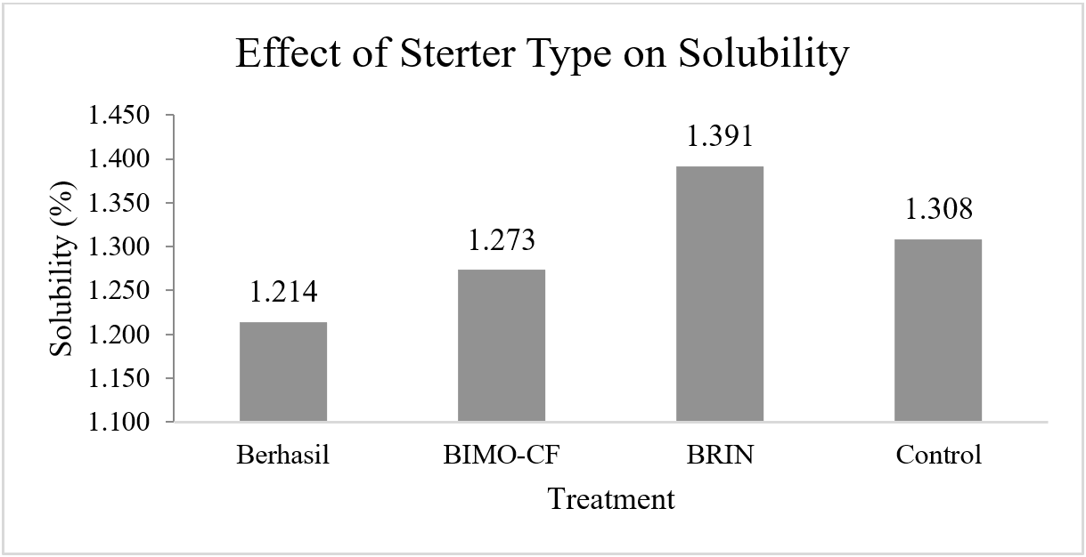
Figure 1. The effect of using lactic acid bacteria starter on the solubility of mocaf flour

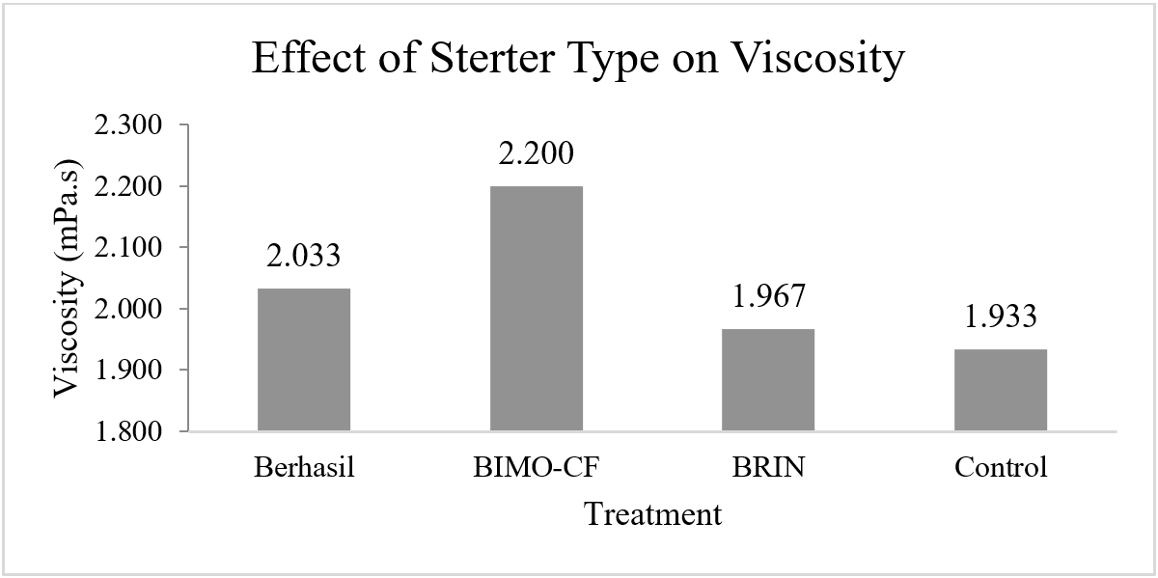
Figure 2. The effect of using a starter on the viscosity of mocaf flour

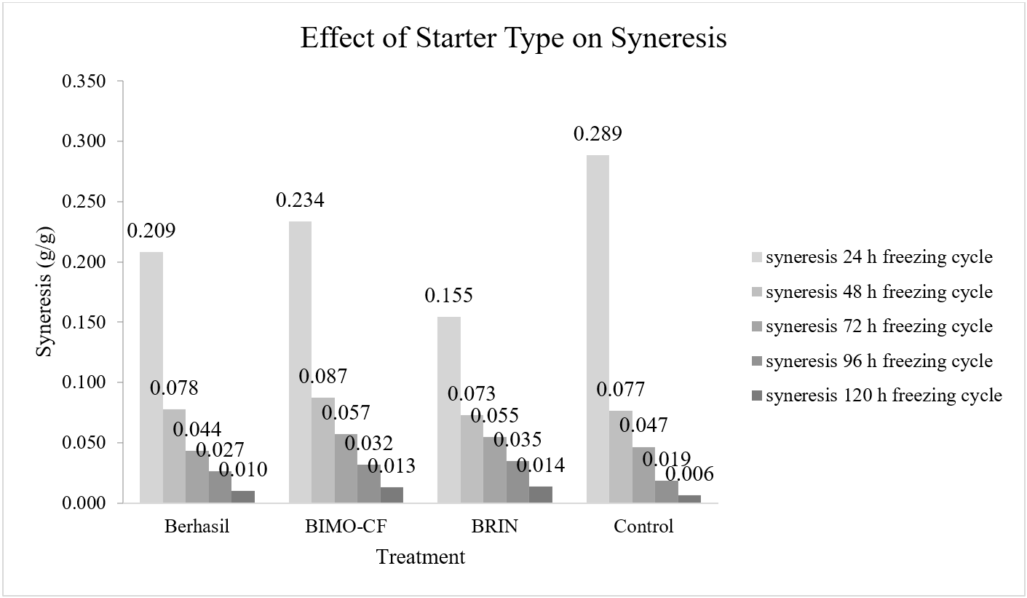
Figure 3. The effect of using a starter on the syneresis of mocaf flour

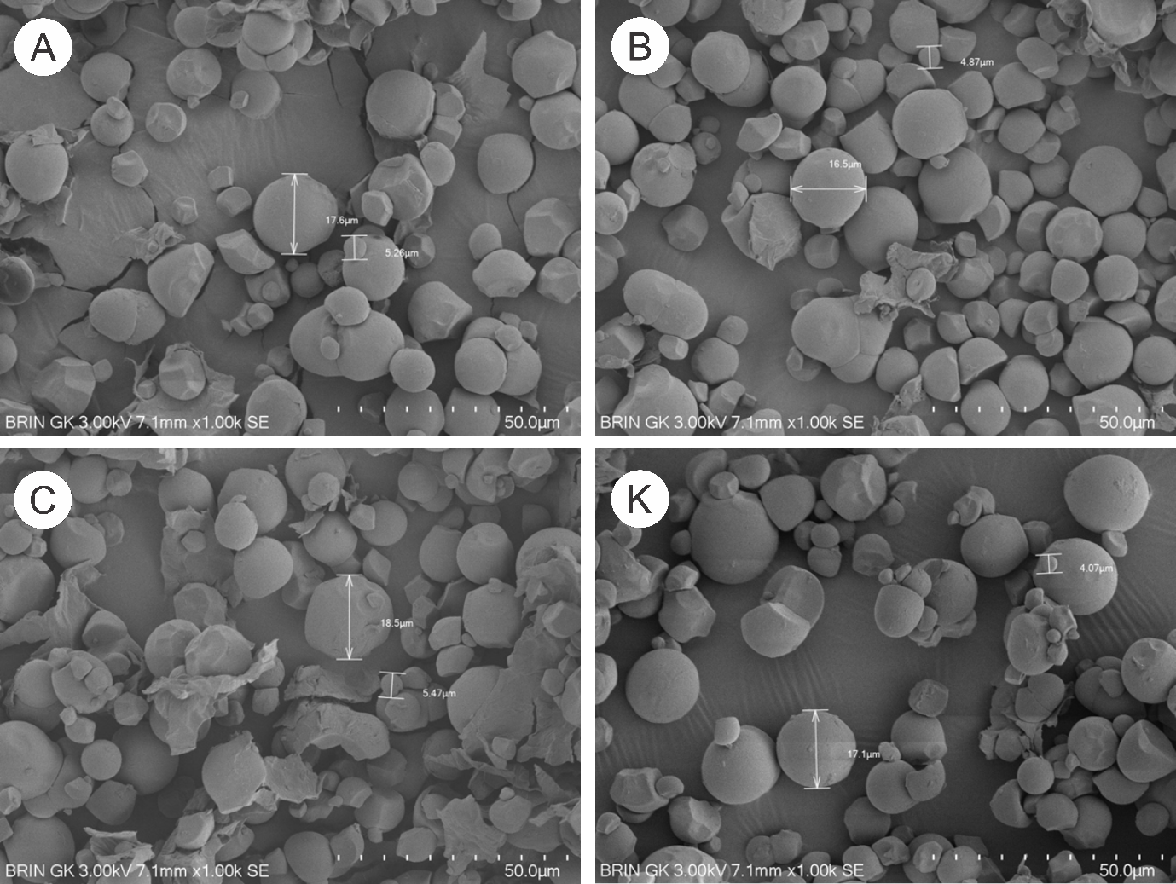
Figure 4. Results of SEM analysis of MOCAF flour with starter type (A) Berhasil, (B) BIMO-CF, (C) BRIN and (K) Control

