Implementation of *Virtual Laboratory* as Media in Elementary School Teacher Education Universitas Pasundan

Devi Rahmiati

Elementary School Teachers Education Universitas Pasundan

[devirahmiati@unpas.ac.id](mailto:devirahmiati@unpas.ac.id)

**Abstract:** The aim this research to get an overview are the using of Virtual Laboratory as media learning students of Elementary School Teacher Education at Universitas Pasundan. The use of media in learning is very important to make solution for lecturers to applied basic concept of science in elementary school. This research in the fourth semester of the Academic Year 2019/2020 in Class A amounting to 40 people. The research method is quasi-experimental with analysis data used a paired t test with SPSS version 21.0 for windows. Based on data analysis, the results is thitung = 2,830 > t*tabel* = 1,686, then H0 rejected and H1 accepted. It can be concluded that there are significant the used virtual laboratory media in basic concept of science subject in Elementary School Teacher Education at Universitas Pasundan. Its means there are different knowledge and abilities of students at the pre test and post test result if learning used virtual laboratory as media learning in basic concept of science subject at elementary school. The use of virtual laboratory as a media in the learning process will be able to improve and provide a better meaning of learning outcomes characterized students.

**Keyword :** *virtual laboratory* media, Elementary School Teacher Education at Unpas, and basic concept of science subject.

1. Introduction

In the era of Industrial Revolution 4.0, the government developed a program to improve the quality of learning through Student Centered Learning based on the use of Information and Communication Technology (ICT). Its implementation in the field requires lecturers to carry out a learning process that encourages renewal efforts in the utilization of information and communication technology through a collaborative learning activity system. Through these collaborative activities, the development of learning by lecturers can build students' knowledge by utilizing ICT-based learning media so that learning can take place in a sustainable, communicative, and innovative way.

Learning media is one of the important components in the education system that cannot be ignored. During the learning process, learning media has an important role to help lecturers in conveying scientific material concepts that must be understood by students, making it easier for students to understand and apply the concepts presented. The use of media in the learning process is inseparable from the functions and benefits that are felt in order to generate interest, motivation, and stimulation and even bring psychological influence to students in the learning process.

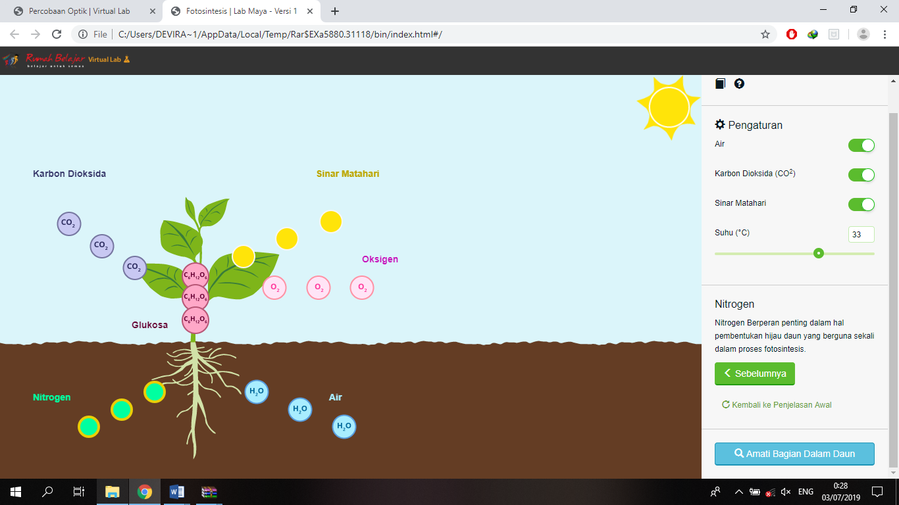Therefore, a lecturer must be skilled in choosing learning media to help students understand concepts in an optimal, practical, efficient, and can arouse student learning motivation. But actually as a lecturer not only can you use learning media, but also can find, modify, and even make a variety of learning media that are effective, fun, efficient, and in accordance with the characteristics of students to have an impact on improving student learning outcomes. Here is figure virtual lab are used in basic concept of science subject in elementary school:

**Figure 1.** Virtual Laboratory about photosynthesis process

Good learning media are learning media that can involve the five senses of students to be active in learning activities. While the characteristics of the lecture material Basic Concepts of Science in Elementary School still dominate in the form of a set of concepts, material, and law which presentation of material is often presented in the form of text that is less interesting through power point so that students only listen to the lecturer when delivering the material. This makes students less interested in learning materials, so the learning outcomes become less optimal. Therefore, one way to overcome this problem is to use learning media Virtual laboratory. Virtual laboratory (virtual lab) is one of the superior products as a result of advances in information technology and laboratories in the learning process. Virtual lab based learning is an alternative learning as a substitute for limited facilities and infrastructure owned by an educational institution, namely a laboratory. Virtual laboratories or also called virtual labs are a series of tools, materials, and laboratories in the form of computer software that is operated by a computer or device so that it can carry out continuous simulations in a laboratory.

Virtual laboratory (virtual labs) can develop science process skills. Learning science with simulation allows interaction between students and simulation programs. Where students can modify and manipulate parameters to produce certain consequences shown by the simulation program. So simulations can develop student science process skills, namely skills to manipulate, test, explore, predict, formulate questions, build hypotheses, collect data and observe, analyse, and give meaning to the physical symptoms that occur. The science process can also develop student skills in using scientific methods to better understand patterns of science and nature. Its sample 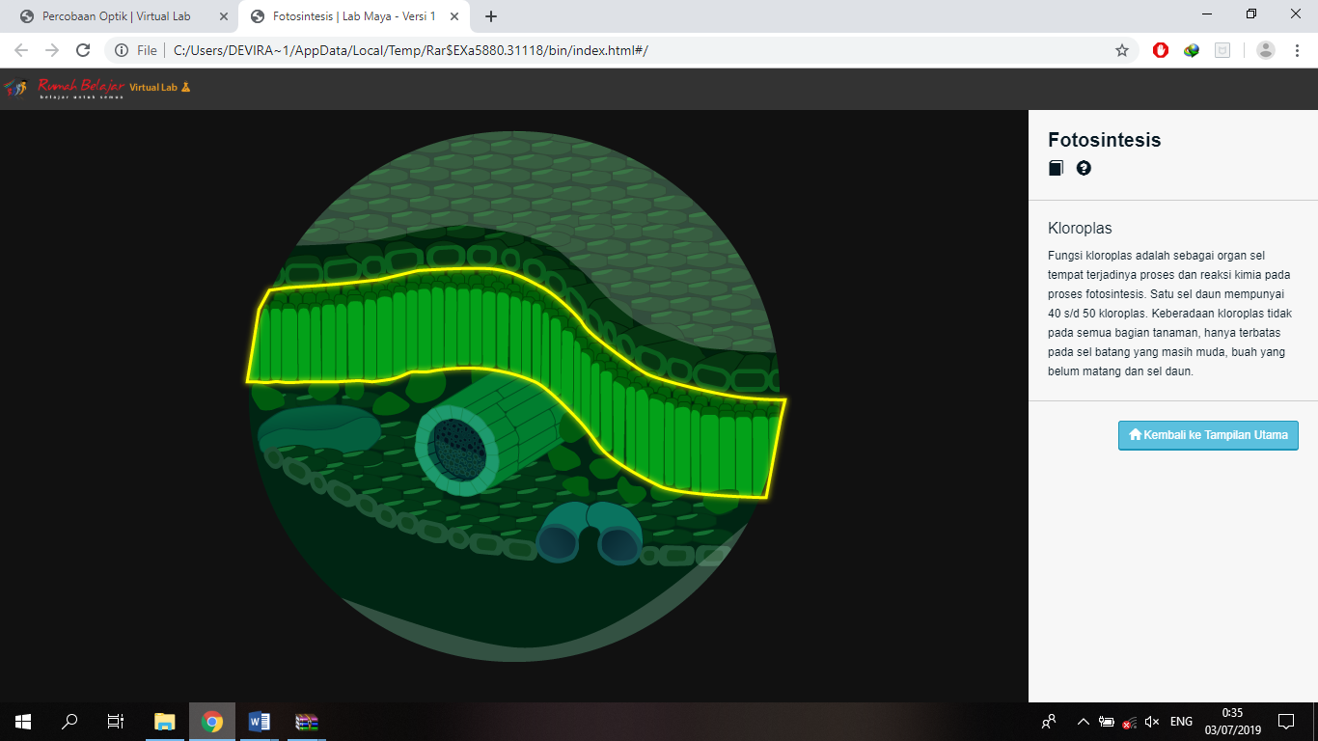anatomy leaf with microscope:

**Figure 2.** anatomy leaf

In a virtual lab (simulation), students can collect data quickly in any situation, and it is also possible to conduct experiments that are not normally done in the laboratory in general. With a virtual lab, students can see changes that occur in a natural phenomenon that may be difficult to see or even have a dangerous risk if done with ordinary observation. The virtual lab learning media (simulation) can increase students' motivation and interest, because problems can be quickly known to them so that they can also quickly get feedback to see the truth of the conclusions. Basically, media in learning activities are used to help study difficult objects presented in the classroom. The use of media in the learning process will be able to provide a better meaning of teaching materials.

1. Methods

This research method is a quasi-experimental with design research is a pretest and posttest design group. The population in this study were students PGSD FKIP Unpas at fourth Semester Academic Year 2019/2020 were taking courses in basic concept of science subject in elementary school. Samples were taken using a convenience sampling technique, which means that the subject is determined by the researchers based on the convenience of researchers in conducting research that students PGSD Semester IV Class A is an amounting to 40 people.

Data collection techniques by a test of mastery concepts, observation, and documentation. Mechanical testing data was analyzed by using paired t test with SPSS version 21.0 for windows. This test aims to see improve in the value of pretest and posttest of students in class A at basic concept of science subject in elementary school.

1. Results and Discussion
   1. Result

In this reserach, data processing in the form of quantitative data to test the hypothesis by using paired t test. Pretest and posttest results data is processed using SPSS version 21.0 for windows. The next test is the mean similarity test with t test in count SPSS version 21.0 for windows. The hypothesis formulated in the form of statistical hypothesis (one side test), as follows:

H0: μ1 = μ2

H1: μ1 ≠ μ2

Information:

|  |  |  |
| --- | --- | --- |
| H0 | : | No different significant knowledge and abilities of students at the pre test and post test result in basic concept of science subject at elementary school |
| H1 | : | There are different significant knowledge and abilities of students at the pre test and post test result in basic concept of science subject at elementary school |

The t-test results shown in Table 1.

**Table 1**

**Output Test-t**

***Paired Samples Test***

|  | | Levene's Test for Equality of Variances | | t-test for Equality of Means | | | | | | |
| --- | --- | --- | --- | --- | --- | --- | --- | --- | --- | --- |
| F | Sig. | T | Df | Sig. (2-tailed) | Mean Difference | Std. Error Difference | 95% Confidence Interval of the Difference | |
| Lower | Upper |
| Pair 1 | Pretest - Posttest | ,977 | ,329 | 2,830 | 38 | ,007 | ,13900 | ,04912 | ,23843 | ,03957 |

Based on the calculations, then thitung is 2,830. While at the 5% significance level (0.05), (n1+n2-2) yaitu t*tabel* (38) = 1,686. By looking at the results thitung and t*tabel* it is seen that thitung = 2,830 > t*tabel* = 1,686, then rejected and H1 accepted. Thus it can be concluded that there are significant the used virtual laboratory learning media in basic concept of science subject at elementary school.

* 1. Discussion

Some things that will be discussed include learning outcomes in the form of mastery concepts, the influence of used virtual laboratory as learning media, and basic concept of science subject in elementary school.

* + 1. Learning outcomes

Based on the analysis, it can be concluded that this research declared successful seen have a significant the used virtual laboratory learning media in basic concept of science subject at elementary school. This is consistent with previous research that the application virtual laboratory as a media to improve learning outcomes characterized in class A. Results of study here is closely connected with the mastery concept which is measured through an evaluation of the pretest and posttest.

The mastery of concepts derived from the learning process, while learning is a cognitive process that involves three processes are almost same time acquire new information, and transformation of information, and to test the relevance of knowledge. Someone said to master of concept if the person understood the concepts learned based on the characteristics possessed by the object so as to explain using their own words according to their knowledge. [1]

From the above explanation can be concluded that virtual laboratory learning media used in this research can affect student learning outcomes significantly visible from the correlation test, particularly on the matter in the basic concept of science subject in elementary school.

* + 1. Virtual Laboratory as media learning

Clark, et.al. in Margaret describes a simulation with a broader definition, where simulations are computational modeling of natural phenomena, or real (real) situations and event hypotheses, which allow users to explore in manipulating or modifying parameters in it. This definition explains the interaction between simulation programs and students or users of simulation programs. Where the interaction in question is the opportunity for students to manipulate or modify the parameters or simulations in a little to see the effects or consequences of changing these parameters or variables on other variables and the overall simulation phenomenon. Plass, Homer, and Hayward in Margaret reveal that simulation media is different from static images such as graphs or diagrams in books, because simulations are dynamic but simulations differ from ordinary dynamic images such as animation because in simulations it allows users to be able to interact. Simulation allows users to observe and interact by modeling a process that might be abstract. This makes the simulation profitable to understand and predict a phenomenon, such as electricity. [2]

Based on some of the definitions above, it can be concluded that simulation media is a representation or modeling of objects, systems and real phenomena or imagination, and users can interact with these models. Learning by modeling using computer simulation is one of the solutions or alternatives offered to support science learning. Virtual media is a learning media in which the material used for learning activities is a complete set of computers with software specifically designed for practical activities. This software contains animations of material tools and design of learning activities. So that students just run a simulation of learning activities in accordance with the material variables provided and vary them to see the dependent variable that will appear or occur.

1. Conclusion

Based on the results of data analysis and hypothesis research, it can be concluded that there are significant learning used virtual laboratory media in through a learning process that involves at basic concept of science subject at elementary school in society.

Acknowledgements

This work was supported by Faculty of Teacher Training and Education Universitas Pasundan.

References

1. Pradina, R.A. (2010). Penguasaan Konsep Sistem Reproduksi dengan Pembelajaran Aktif Menggunakan Kartu Sortir. Bandung: Skripsi UPI: Tidak diterbitkan. Hlm 11.
2. Margaret, A.H., & Margaret, H. (2011). *Learning Science Through Computer Games and Simulations*. Tersedia di <http://www.nap.edu/catalog/13078.html>. Diakses pada 7 Februari 2014. p. 1-3.

============================================================================================================================