A Formatted Technical Work for an IJIE Journal
(Center, Bold, 18pt)
First Author(10pt)
Informatics and Computer Education Program, Faculty of Teacher Training and Education,
Sebelas Maret University, Surakarta
email:
Second Author  Informatics and Computer Education Program, Faculty of Teacher Training and Education,  Sebelas Maret University, Surakarta  email: |  | Third Author*  Informatics and Computer Education Program, Faculty of Teacher Training and Education,  Sebelas Maret University, Surakarta  email:

Abstract:
A well-prepared abstract enables the reader to identify the basic content of a document quickly and accurately, to determine its relevance to their interests, and thus to decide whether to read the document in its entirety. The Abstract should be informative and completely self-explanatory, provide a clear statement of the problem, the proposed approach or solution, and point out major findings and conclusions. The Abstract should be 100 to 200 words in length. The abstract should be written in the past tense. Standard nomenclature should be used and abbreviations should be avoided. No literature should be cited. The keyword list provides the opportunity to add keywords, used by the indexing and abstracting services, in addition to those already present in the title. Judicious use of keywords may increase the ease with which interested parties can locate our article (9 pt).

Keywords: First keyword, second keyword, Third keyword

DOI :

This work is licensed under a Creative Commons Atribution-ShareAlike 4.0 Internasional License.

- Introduction (14pt)
This document is a template for the Word (doc) version. If you can use this version of the document as a reference to write your manuscript. The introduction describes the background of the completed problem, the issues related to the problem solved, the research review previously conducted by other researchers relevant to the research undertaken.
The main text format consists of a flat left-right column on A4 paper. Text margin from left and top is 2.5 cm, right and bottom is 2 cm. The manuscript is written in Microsoft Word, single space, Arial 10pt and maximum 12 pages. The title of the article should be the fewest words that accurately describe the contents of the paper. Indexing and depreciation services depend on the accuracy of the title, extracting it from useful keywords in cross-reference and computer search.
A paper with an undue title will never reach an audience that is meant to be, so be specific. The introduction should provide a clear background, a clear statement of the problem, relevant literature on the matter, proposed approach or solution, and a new value of innovative research. This must be understood by colleagues from various disciplines. Organizations and bibliographic citations are made in the style of APA 6th (.....,20xx) and so on. The term in a foreign language is written metallically. The section title / sub-section should be typed on a separate line, for example, 1. Introduction. Authors are advised to present their articles in the structure of sections: Introduction - Comprehensive Theoretical Base and Proposed Method / Framework / Approach - Research Methods - Results and Discussions - Conclusions. To review papers and case reports, Introduction - Case Report / Critical Review - Discussion - Conclusion.
- Research Method (14pt)
The paper should contain a post containing 1. Introduction, 2. Research Method (may include analysis, architecture, methods used for problem-solving, implementation), 3. Results and Discussion, 4. Conclusions and 5. Future works are containing further research in the future. Each paragraph can consist of several subparagraphs written with Arab numbering as shown in the following section. The number of pages minimum ten pages and maximum 12 pages A4 size.
Table 1. The Performance of ...
Variable | Speed (rpm) | Power (kW)
x | 10 | 8.6
y | 15 | 12.4
z | 20 | 15.3

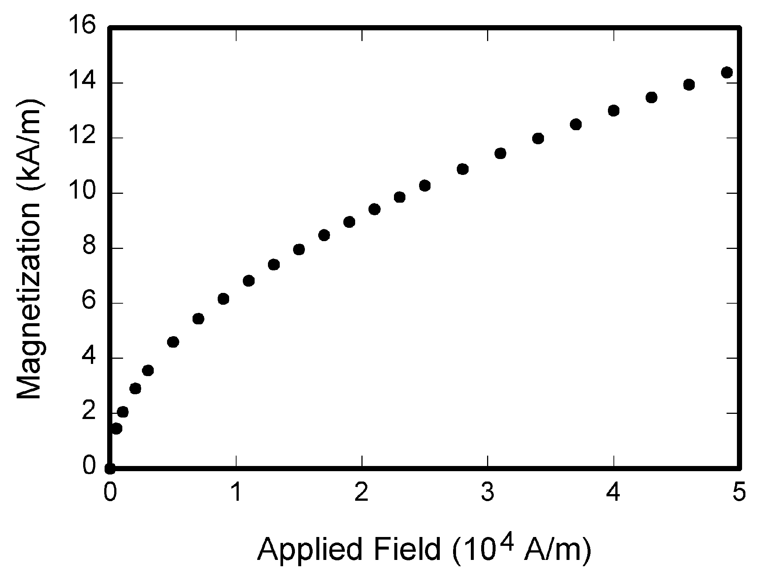
Figure 1. Effects of selecting different switching under dynamic condition
Number equations consecutively with equation numbers in parentheses flush with the right margin, as in (1). Be sure that the symbols in your equation have been defined before the equation appears or immediately following.
where IF is the fault current.
Use “(1),” not “Eq. (1)” or “equation (1),” except at the beginning of a sentence: “Equation (1) is .…”
- Result and Discussion(14pt)
Discussion of the results of research and testing obtained presented in the form of theoretical descriptions, both qualitatively and quantitatively. The results of the experiment should be displayed in either a graph or table. For charts can follow the format for diagrams and drawings..
      - Result
        - Media Requirements Analysis
xxx
        - Design Interfaces Media
xxx
        - Feasibility Test of Media
xxx

- Discussion
xxx

- Conclusion (14pt)
Please include a brief summary of the possible clinical implications of your work in the conclusion section. Although a conclusion may review the main points of the paper, do not replicate the abstract as the conclusion. Consider elaborating on the translational importance of the work or suggest applications and extensions
References
References are important to the reader; therefore, each citation must be complete and correct. There is no editorial check on references; therefore, an incomplete or wrong reference will be published unless caught by a reviewer or discusser and will detract from the authority and value of the paper. References should be readily available publications. “Using APA 6th Style”

List only one reference per reference number. If a reference is available from two sources, each should be listed as a separate reference. Give all authors' names; do not use et al.
Samples of the correct formats for various types of references are given below

Chang, R. C, & Yang, C. Y. (2016). Developing a Mobile App for Game-based Learning in Middle School Mathematics Course. 2016 International Conference on Applied System Innovation (ICASI).
Daryanto. (2010). Media Pembelajaran. Bandung: PT Sarana Tutorial Nurani Sejahtera.
Husni, E. & Budianingsih. (2013). Mobile Applications BIUTIS: Let’s Study Vocabulary Learning as a Media for Children with Autism. Procedia Technology, 11. 1147-1155
Cheng, C. H., & Su, C. H.. (2012). A Game-based learning system for improving student’s learning effectiveness in system analysis course. Procedia - Social and Behavioral Science, 31. 669-675.
Kularbphettong, K. Putglan, R. Tachpetpaiboon, N. Tongsiri, C. & Roonrakwit, P. (2015). Developing of mLearning for Discrete Mathematics based on Android Platform. Procedia - Social and Behavioral Science, 197. 793-796.
Pressman, R. S. (2001). Software Engineering: A Practitioner's Approach, Fifth Edition. New York: McGraw-Hil.
Pressman, R. S. (2010). Software Engineering: A Practitioner’s Approach, Seventh Edition. New York: The McGraw-Hill Companies, Inc.
Stubbé, H., Badri, A., Telford, R., vander Huist, A., & van Joolingen, W. (2016). E-Learning Sudan, Formal Learning for Out-of-School Children. The Electronic Journal of e-Learning, 14. 136-149.
Sugiyono. (2014). Metode Penelitian Pendidikan: Pendekatan Kuantitatif, Kualitatif dan R&D. Bandung: Alfabeta.
Sujadi. (2003). Metodologi Penelitian Pendidikan. Jakarta: Rineka Cipta.
Wagner, S. (2013). Software Product Quality Control. Berlin: Springer.

