IDENTIFICATION OF TEMPLE ROCK (ANDESITE) SUBSURFACE AROUND BADUT TEMPLE WITH GEOELECTRICAL RESISTIVITY METHOD

Ahmad Luthfin^{1,a}, Husni cahyadi ^{2,b}, and Jufri ^{3,c}

¹ Department of Physics, Faculty of SAINTEK, UIN Malang
² Department of Physics education, Faculty of Tarbiyah & Ilmu Keguruan, IAIN Tulungagung
³ Department of science, Faculty of Keguruan & Ilmu Pendidikan, Universitas Darussalam Ambon

e-mail: ª ahmadluthfin@fis.uin-malang.ac.id, ^{b} huznie.kurniawan@gmail.com, and ^{c} jufridarussalam@gmail.com

Abstract
Badut temple site based upon its physical form of the upper part, the structure is incomplete, so it is possible that there are still remnants of rocks that complete the intact function of the temple still buried. Although in the history of renovations have been carried out excavation but it is possible that are certain parts of the temple have not been found. Thus, based on these assumptions the experimental or research activities identify subsurface structures around the foundation of the Badut Temple it is very important to know whether or not the temple rocks are still buried. The purpose of this study is to determine the possibility of temple rock (andesite) buried in the area around the temple. The measurement results at line 1, at a depth of 0.5m -7.91m have a resistivity value of 9.88 Ωm - 36.7 Ωm is a layer of silt and sandy soil. The measurement results at line II, at a depth of 0.5m -7.91m have a resistivity value of 12,3 Ωm – 66,8 Ωm is a layer of silt and sandy soil. The measurement results at line III, at a depth of 0.5m -7.91m have a resistivity value of 7,35 Ωm – 31,4 Ωm is a layer of silt and sandy soil. The measurement results at line IV, at a depth of 0.5m -7.91m have a resistivity value of 9,24 Ωm – 36,3 Ωm is a layer of silt and sandy soil. For Badut temples composed of andesite rocks, andesite rocks have a resistivity of more than 200 Ωm. So the results of this study show that based on 4 research trajectories that have been carried out at a depth of 0.5m-7.91m, they did not find temple rocks (andesite) which are considered as part of the buried temple rock of the Badut. Based on the overall results of the interpolation of 1,2,3 and 4 line by the Wenner configuration resistivity geoelectric method, it can be seen that the subsurface rocks surrounding the Badut Temple building at a depth of 0.5 m to 7.91 m, consisting of silt, sandy soils and not found temple rock (andesite) buried in the ground.
Keywords: temple rock; geoelectric resistivity

IDENTIFIKASI BATUAN CANDI (ANDESIT) DI BAWAH PERMUKAAN SEKITAR CANDI BADUT DENGAN METODE GEOLISTRIK RESISTIVITAS

Abstrak
Situs Candi Badut berdasarkan bentuk fisik bagian atas, susunannya kurang lengkap, sehingga dimungkinkan masih terdapat sisa – sisa batuan yang memenuhi fungsi utuh dari candi tersebut masih terkubur. Walaupun dalam sejarah renovasinya pernah dilakukan penggalian tapi kemungkinan ada bagian – bagian tertentu belum dapat ditemukan.Dengan demikian, berdasarkan asumsi tersebut kegiatan eksperimen atau penelitian mengindentifikasi sturuktur bawah permukaan disekitar pondasi Candi Badut itu sangat penting dilakukan untuk mengetahui ada tidaknya batuan candi yang masih terkubur. Tujuan dari penelitian kali ini untuk menentukan kemungkinan adanya batuan candi (andesit) yang terkubur didalamnya. Hasil pengukuran lintasan 1 yaitu pada kedalaman 0.5m -7,91m memiliki nilai resistivitas batuan 9,88 Ωm – 36,7 Ωm merupakan lapisan tanah lanau dan pasiran. Hasil pengukuran lintasan II yaitu pada kedalaman 0.5m -7,91m memiliki nilai resistivitas batuan 12,3 Ωm – 66,8 Ωm merupakan lapisan tanah lanau dan pasiran. Hasil pengukuran lintasan III yaitu pada kedalaman 0.5m -7,91m memiliki nilai resistivitas batuan 7,35 Ωm – 31,4 Ωm merupakan lapisan tanah lanau dan pasiran. Hasil pengukuran lintasan IV yaitu pada kedalaman 0.5m -7,91m memiliki nilai resistivitas batuan 9,24 Ωm – 36,3 Ωm merupakan lapisan tanah lanau dan pasiran. Untuk candi badut tersusun dari batuan andesit, batuan andesit memiliki resistivitas lebih dari 200 Ωm. Berdasarkan hasil keseluruhan interpolasi lintasan 1,2,3 dan 4 dengan metode geolistrik resistivitas konfigurasi wenner dapat diketahui bahwa batuan penyusun lapisan bawah permukaan disekitar bangunan Candi Badut pada kedalaman 0,5 m-7,91 m, terdiri dari tanah lanau dan pasiran dan tidak ditemukan batuan candi (andesit) yang terkubur didalam tanah.
.
Kata Kunci: batuan candi; geolistrik resistivitas.

- INTRODUCTION
Badut Temple is one of the many cultural heritage sites found in East Java Province, precisely in Karangbesuki Village, Sukun District, Malang. Badut temple is a Hindu patterned temple composed of andesite rocks. The site of the Badut Temple when it was first founded in 1921 AD by Maureen Brecher, a Dutch VOC employee who worked in Malang, was still a rocky hill mound, in 1923-1925 AD, it was under observation B. De Haan from the archaeological hindia dutch the first time the rebuild was carried out. Furthermore, in 1990-1993 AD, further restoration was carried out by the Regional Office of the Decree of the East Java Asylum and Archeology, through the Preservation/Utilization of East Java Archaeological and Heritage projects, which were carried out in stages[1].
The site of the Badut Temple is based on the physical form of the upper part, the structure was incomplete. There are some statues of gods that are gone. so it is possible that there are still remnants of rock that complete the intact function of the temple which is still buried. Although from the renovations history have been do excavation but the possibility that there are certain parts can not be found. Thus, based on these assumptions, the research activity to identify subsurface structures around the foundation of Badut Temple which is very important to know if there are any buried temple rocks
2. Resistivity method
Resistivity method is one of the geophysical methods that studies the nature of electric currents beneath the surface of the earth and detects it on the surface of the earth based on the nature of the resistivity type of rock layers making up the earth's crust [2]. This method can be used in determining the structure of building foundations, estimating the potential for subsurface water, geothermal exploration, mineral exploration to estimating sea water intrusion and waste. Data obtained from the results of measurements in the field are data on the accumulation of subsurface conditions. Geoelectric resistivity method is very often used to conduct subsurface investigations, because the geoelectrical resistivity method in the earth can determine the type and structure of rocks [3]. Geophysical method is a method that can provide subsurface information without having to dig up [4].The purpose of the geoelectric method is to determine the distribution of subsurface resistivity [5].
The basic principle of the physical law used in the resistivity geoelectric method is the ohm's law in which a current is flowed below the surface through an electrode. The working principle of this method is by injecting a current electrode (AB) into the earth. Then the potential electrode will measure the potential difference from the current that passes beneath the surface of the earth and then the apparent rock resistivity calculation is calculated using Ohm's law [6]
The ohm's equation for the current flowing continuously in the medium is shown as follows [7]:
$$J=σE$$
$$E=-∇V$$
$$J=-σ∇V$$
$$∇.J=0$$
$∇.(σ∇V)=0$ (1)
Where J is the current density (A / m2), E is the electric field (V / m), $σ$is conductivity, V is the electric potential (V). As for applying the laplace terms, the following equation is obtained:
$$∇.\left(∇.V\right)=∇.∇V+∇^{2}V$$
$$0=∇.∇V+∇^{2}V$$
$$∇xE=∇V=0$$
$∇^{2}V=0$ (2)
By entering the coordinates of the ball obtained:
$∇^{2}V=\frac{1}{r^{2}}\frac{∂}{∂r}\left(r^{2}\frac{∂V}{∂r}\right)+\frac{1}{r^{2}\sin{θ}}\frac{∂}{∂θ}\left(\sin{θ}\frac{∂V}{∂θ}\right)+\frac{1}{r^{2}{Sin}^{2}θ}\frac{∂^{2}V}{{∂∅}^{2}}=0$ (3)
For the first term in equation (3) we get the following equation
$$\frac{1}{r^{2}}\frac{∂}{∂r}\left(r^{2}\frac{∂V}{∂r}\right)=0$$
$\frac{∂}{∂r}\left(r^{2}\frac{∂V}{∂r}\right)=0$ (4)
So the constants for equation (4) above are
$$r^{2}\frac{∂V}{∂r}=A$$
$$V=-\frac{A}{r}$$
$A=-\frac{Iρ}{2π}$ (5)
Where r is the radius (m), V is the electric potential (v), I is the electric current (A), $ρ$is the resistivity value of the rock in Ωm, the potential P1 by C1 and C2 is
$$V_{1}+V_{2}=\frac{Iρ}{2π}\left(\frac{1}{r_{1}}-\frac{1}{r_{2}}\right)$$
Potential difference between P1 and P2
$∇V=\frac{Iρ}{2π}\left\{\left(\frac{1}{r_{1}}-\frac{1}{r_{2}}\right)-\left(\frac{1}{r_{3}}-\frac{1}{r_{4}}\right)\right\}$ (6)Based on equation (6) above, we get the following geometric factors k:
$$k=\frac{2π}{\left(\frac{1}{r_{1}}-\frac{1}{r_{2}}\right)-\left(\frac{1}{r_{3}}-\frac{1}{r_{4}}\right)}$$
So we get the resistivity equation as follows:
$$∇V=\frac{Iρ}{k}$$
$$ρ=\frac{∇V}{I}k=Rk$$
Where R is the resistance Ω, based on the results of previous studies, the resistivity value of andesite rocks is 212 - 300 Ωm [8].
The resistivity method has a variety of electrode configurations. The existence of various electrode configurations causes an effect on the resistivity magnitude, this is because each configuration has a different factor K based on the arrangement of the electrodes [9]. The structure of the electrode configuration is divided into 2 (two) types, namely sounding type (1 dimensional) and mapping (2 dimensional). Sounding type (1 dimension) is usually used to identify vertical contrast sensitivity, for example: Wenner sounding and Schlumberger configurations. Whereas the type of mapping (2 dimensions) is used to identify density contrast vertically and horizontally, including configuration of Wenner mapping, dipole-dipole, pole-pole.
Wenner konfiguration
Wenner configuration resistivity method is a configuration that requires a very large place. This configuration consists of 2 (two) current electrodes and 2 potential electrodes. Potential electrodes are placed on the inside and current electrodes on the outside (Figure 1) with the distance between the electrodes A [10]. Measurements were made by moving all the electrodes simultaneously with the distance na always the same (AM = MN = AB). This configuration is used laterally in data collection or mapping. The geometric factor for this configuration is 2πa, so the apparent resistivity is
The advantage of this Wenner configuration is that the accuracy of the voltage reading at the MN electrode is better than a relatively large number because the MN electrode is relatively close to the AB electrode. While the disadvantage is that it cannot detect the homogeneity of rocks near the surface which can affect the calculation results. Data obtained from the Wenner configuration is very difficult to eliminate the rock non-homogeneity factor, so the calculation results are less accurate.
Figure 1. Schematic of Wenner Configuration Electrodes [10]

- METHOD
- The Wenner Configuration Resistivity Geoelectric Method
The initial procedure before conducting data acquisition of Wenner's geoelectric resistivity method is to make a survey design. As explained in the previous chapter, the form of the resistivity method survey design is a line of a certain length. The lines intersect each other so that in the interpretation phase, the data per line will be easily correlated from one line to another. This resistivity method uses several survey equipment, among others
1. OYYO MCOHM-EL Resistivitimeter MODEL-2119D
2. Electrodes 2 (two) pairs.
3. Cable
4. ACCU Battery
5. Multimeter
6. Roll-meter
7. Data table
8. Stationery
The transfer arrangement for the Wenner configuration follows Figure 2.1 where the distance between the potential-potential or potential-current electrodes must be the same. For the record, the distance of the datum point need not be the same as the distance of the electrode.
Simplification is done by shifting continuously with the spacing of a potential electrode to the end of the datum that has been determined. If the pair of potential electrodes has reached the end of the measurement line, the current electrode is shifted as far as a from the outer current electrode. Each time the distance between the electrode currents is a. While the space between the current electrode and the inner potential is na.
- Processing of Wenner Resistivity Data
Wenner configuration is a resistivity mapping method that works horizontally and vertically together. So it can be as determained the measurements results in the form of a vertical lateral section in 2 (two) dimensions. Data processing of these two configurations uses RES2dinv software, where the data will be plotted according to the datum position at the time of acquisition.
- Qualitative and Quantitative Interpretation
The next process is to interpret the results of data processing by correlating them with local geological maps or qualitative well data. Before correlating with the supporting data, the results of the processing are synchronized with the quantitative resistivity reference data.
Wenner Configuration Geoelectric Method Measurement by the Wenner method is carried out in the temple garden area by making four tracks as listed in the following figure.

Figure 2. Measurement Location

The measurement results are then analyzed using Res2Dinv software. The resistivity data is first multiplied by the Wenner configuration geometry factor to get the subsurface resistivity (ρ) value in the Badut Temple area. From the processing results, it is obtained the distribution of resistivity (ρ) values below the ground surface in the form of color images. The color image. contained in the contours of each line is defined based on the resistivity value (ρ), as in the following table

Table 1 Resistant Value (ρ) for Geological Material^{[11]}
No | Material Type | Resistivity (Ωm)
1 | Clay | - 3
2 | Silt | 3 – 15
3 | Silt, Sandy soils | 15 – 150
4 | Blooming bedrock filled with moist soil | 150 – 300
5 | Gravel has a layer of silt | ± 300
6 | The bedrock is filled with dry soil | 300 – 2400
7 | The bedrock is not weathered | > 2400

- RESULTS AND DISCUSSION
- Line 1
Data acquisition on line 1 which has a length of 48 meters with a spacing of 2 meters starting point is at coordinates 7 ° 57'27.70 "LS and 112 ° 35'55.71" BT until the end point 7 ° 57'27.16 "LS and 112 ° 35 ' 54.22 "East with varying distances between the electrodes respectively 2 m, 4 m, 6 m, 8 m to 48 m.
The results of measurements on line 1 are processed data by using Res2dinv, then the cross section of resistivity (ρ) is obtained as shown in Figure 3. as follows:

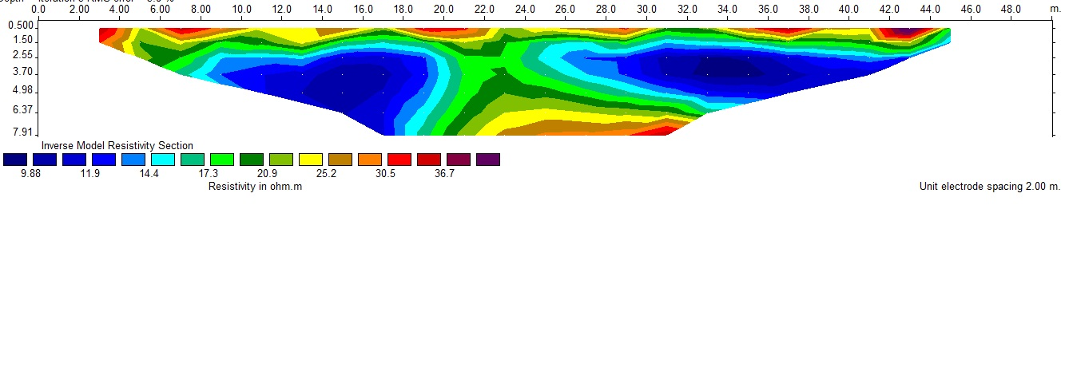
Figure 3 Resistivity contours(ρ) on Line 1

Based on Figure 3. Resistivity contour (ρ) track 1 above at a depth of 0.5m -7.91m has a rock resistivity value of 9.88 --m - 36.7 Ωm is a layer of silt and sandy soils.

- Line 2
Line 2 has a length of 48 m, the measurement process is carried out the same as the treatment on line 1. The starting point of line 2 lies at coordinates 7057'28.44 "latitude and 112035'56.38" east longitude, the end point is located at coordinates 7057'47.69 "LS and 112035'53.05" BT.
The results of measurements on line 2 are processed data by using Res2dinv, then the cross section of resistivity (ρ) is obtained as in Figure 4. as follows:
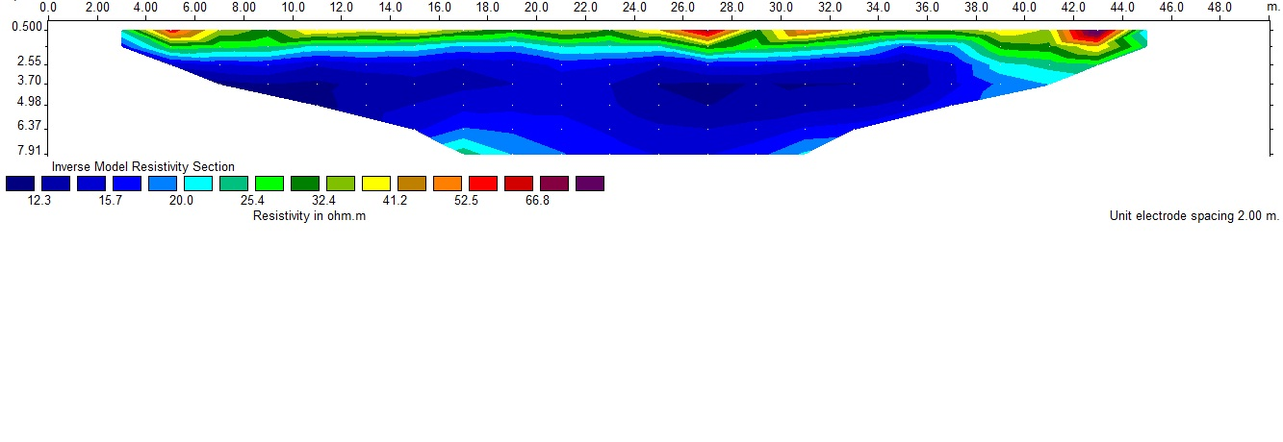

Figure 4 Resistivity contours (ρ) on Line 2
Based on Figure 4. Resistivity contour (ρ) line 2 above at a depth of 0.5m -7.91m has a rock resistivity value of 12.3 Ωm - 66.8 Ωm is a layer of silt and sandy soils.

- Line 3
Line 3 has a length of 48 m, the measurement process is carried out the same as the treatment on the previous track. The starting point of this line is located at coordinates 7 ° 57'28.70 "LS and 112035 '54.25" East, the end point is located at coordinates 7 ° 57'28.27 "South and 112035 '55.67" East.
The results of measurements on line 3 are processed data by using Res2dinv, then the cross section of resistivity (ρ) is obtained as in Figure 5. as follows:

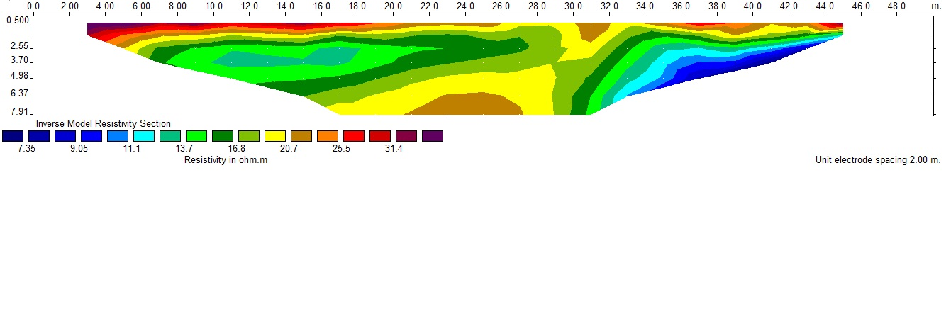
Figure 5 Resistivity contours(ρ) on Line 3
Based on Figure 5. Resistivity contour (ρ) line 3 above at a depth of 0.5m -7.91m has a rock resistivity value of 7.35 Ωm - 31.4 Ωm is a layer of silt and sandy soils.
- Line 4
Line 4 has a length of 48 m, the measurement process is carried out the same as the treatment on the previous track. The starting point of this line is located at coordinates 7 ° 57'28.48 "latitude and 112 ° 35'53.93" east longitude, end points are located at coordinates 7 ° 57'26.77 "latitude and 112 ° 35'54.63" east longitude.
The results of measurements on line 3 are processed data by using Res2dinv, then the cross section of resistivity (ρ) is obtained as in Figure 6. as follows:
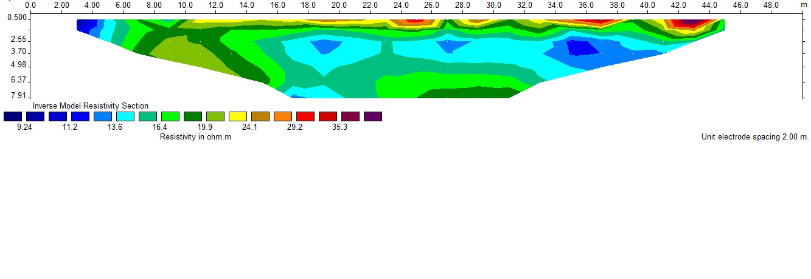
Figure 6 Resistivity contours (ρ) on Line 4
Based on Figure 6. Resistivity contour (ρ) of track 4 above at a depth of 0.5m -7.91m has a resistivity value of rock 9.24 Ωm - 36.3 Ωm is a layer of silt and sandy soils.

CONCLUSION
Based on the overall results of the interpolation of 1,2,3 and 4 trajectory by the Wenner configuration resistivity geoelectric method, it can be seen that the subsurface rocks surrounding the Badut Temple building at a depth of 0.5 m to 7.91 m, consisting of silt and sandy soils and not found temple rocks (andesite) buried in the ground.

ACKNOWLEDGMENT (OPTIONAL)
Thank you to the head of the East Java Cultural Heritage Preservation Hall in Mojokerto, who has given permission to do this research in the Malang Badut Temple..

REFERENCES

- Candi badut, Destinasi Wisata situs sejarah. (2015). Retrieved (maret 16, 2018) from candi badut, destinasi Wisata situs sejarah: https://www.cendananews.com/2015/03/candi-badut-destinasi-wisata-situs-sejarah.html
- Widodo Sumartono, Yudha Arman, Yoga Putra.,2013, Identifikasi Sebaran Kandungan Bijih Besi Di Kabupaten Bengkayang Menggunakan Metode Geolistrik Resistivitas. Prisma Fisika, Vol.1 No.1, 14-21
http://jurnal.untan.ac.id/index.php/jpfu/article/view/1417
- Ojo, J.S., Olorunfemi, M.O., Akintorinwa1, O.J., Bayode1, S., Omosuyi, G.O. and Akinluyi, F.O. (2015), “Subsoil competence characterization of the Akure metropolis, southwest Nigeria”, Journal of Geography, Environment and Earth Science International, Vol. 3 No. 1, pp. 1-14, Article no.JGEESI.15851
http://www.sciencedomain.org/index.php?/review-history/9766
- Susilo Adi, Sunaryo, Fitriah fina and Sarjiyana, 2018. Fault Analysis In Pohgajih Village, Blitar, Indonesia Using Resistivity Method For Hazard Risk Reduction International Journal of GEOMATE, Jan., 2018 Vol.14, Issue 41, pp.111-118 Geotec., Const. Mat. & Env., DOI: https://doi.org/10.21660/2018.41.87552 ISSN: 2186-2982 (Print), 2186-2990 (Online), Japan)
- Nur Islami, 2011. Geoelectrical Resistivity Method For Salt/Brackish Water Mapping. Journal of Coastal Development Volume 14, Number 2, February 2011: 104-114, ISSN : 1410-5217 Accredited : 83/Dikti/Kep/2009
https://media.neliti.com/media/publications/92090-EN-geoelectrical-resistivity-method-for-sal.pdf
- Telford, W.M., L.P. Geldart, R.E. Sheriff. 1990. Applied Geophysics, 2nd Edition, Cambridge University.
https://kobita1234.files.wordpress.com/2016/12/telford-geldart-sheriff-applied-geophysics.pdf
- Loke, M.H. 2007. Rapid 2-D Resistivity & IP inversion using the least-squares
method, Geoelectrical Imaging 2D and 3D, GEOTOMO SOFTWARE, Malaysia
https://www.academia.edu/39226833/Rapid_2-D_Resistivity_and_IP_inversion_using_the_least-squares_method
- Munaji*, Imam sayiful, Lutfianur ismi, 2013. Penentuan Tahanan Jenis Batuan Andesit Menggunakan Metode Geolistrik Konfigurasi Schlumberger (Studi Kasus Desa Polosiri). Jurnal Fisika Vol. 3 No. 2, Nopember 2013. https://journal.unnes.ac.id/nju/index.php/jf/article/view/3820
- Hendrajaya, L., dan Arif, I., 1990, Geolistrik Tahanan Jenis, Laboratorium Fisika Bumi, Jurusan FMIPA, ITB. Bandung.
https://www.coursehero.com/file/p4ehn3m/Hendrajaya-L-dan-Arif-I-1990-Geolistrik-Tahanan-Jenis-Monografi-Metoda/
- Kurniati, Asih dkk. 2008. Buku Panduan : Workshop Geofisika. Laboratorium Geofisika, Jurusan Fisika, Fakultas MIPA, Universitas Brawijaya. Malang.
- Roy, E. 2005. Geotechnical Engineering Investigation Hand Book second edition. Taylor & Francis Group. New York
https://epdf.pub/geotechnical-engineering-investigation-handbook-second-edition.html

