**Status and Recent Developments of Pantoea *stewartii* subsp. *Stewartia* Causes of Wilt Disease in Corn Plants.**

**Detection and Identification of Bacteria Pantoea *stewartii* subsp. *stewartii.***

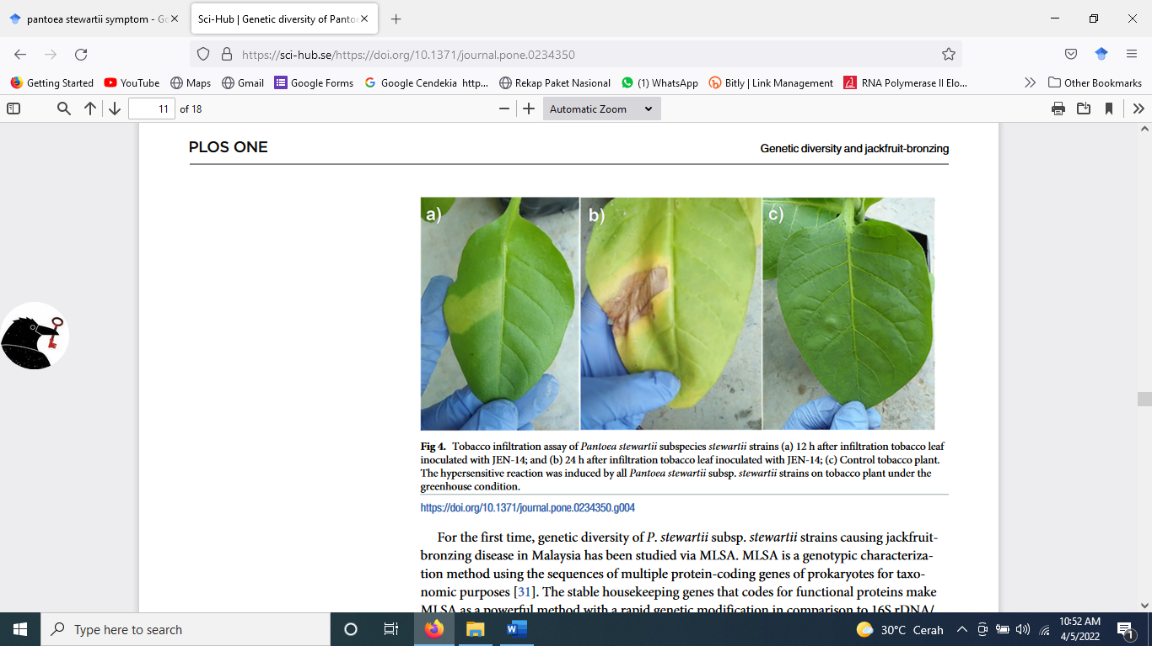

Figure 3. Bacterial Colony Morphology on King'B (left side) and Hypersensitivity Reactions Tobacco Plants 12 and 24 hours after infiltration (right side) (Abidin et al*.*, 2020).