Status and Recent Developments of Pantoea stewartii subsp. Stewartia Causes of Wilt Disease in Corn Plants.

Host Range, Symptoms and Mechanisms of P. stewartii subsp. stewartii Infection in Host Plants.
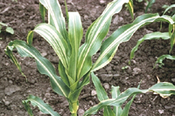
B
A

C

Figure 2. Symptoms and Signs of P. stewartii subsp. stewartii Infection on the host; a. Maize- Leaf Blight (EPPO, 2021), b. Jackfruit-Bronzing (Abidin et al., 2020), C. Necrosis- Dracaena sanderiana (Choi and Kim, 2013).

