Status and Recent Developments of Pantoea stewartii subsp. Stewartia Causes of Wilt Disease in Corn Plants.

Status and Impact of Geographical Distribution of P. stewartii subsp. stewartii.
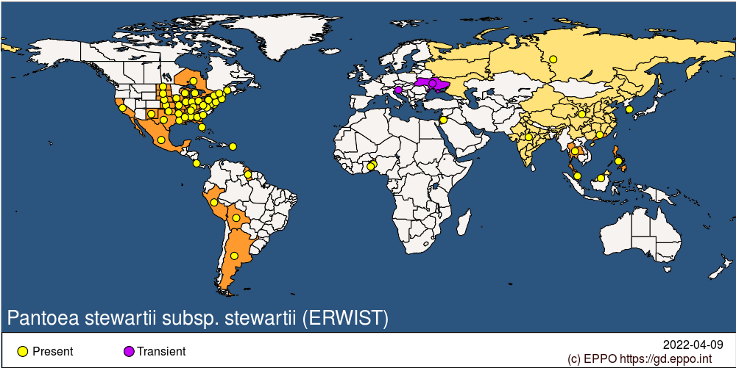
Figure 1. Current distribution of Stewart wilt caused by P. stewartii subsp. stewartii (EPPO, 2022)

