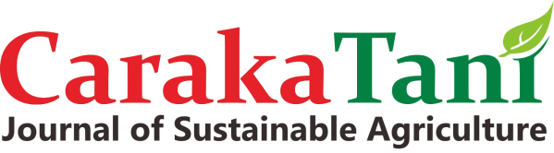
AUTHOR DECLARATION
ISSN
2613
-
9456 (
Print
)

2599
-
2570

(
Online
)

Faculty of Agriculture, Universitas Sebelas Maret

URL:
http://jurnal.uns.ac.id/carakatani
/

Email:
carakatani@mail.uns.ac.id

DOI Prefix:

10.20961
/carakatan
i

Caraka Tani: Journal of Sustainable Agriculture

Full Name* : Dr. David Nwazuo Enyiukwu
Affiliation* : Department of Plant Health Management,
Michael Okpara University of Agriculture, Umudike,
PMB 7267 Umuahia Abia State, Nigeria
Address*: As Above
E-mail*: enyidave2003@gmail.com
Title of the Manuscript:

In Vivo Evaluation of Goat Weed (Ageratum conyzoides), Lemon Grass (Cymbopogon nardus), Clay and Permethrin for Control of Sitophilus zeamais Mot. on Stored Maize Grains

Author(s) Name : 1. K. C. Emeasor
2. V. N. Nwakanma
3. D. N. Enyiukwu
4.
5.
As the Corresponding Author, hereby declare that:

- This manuscript is original, has NOT been published before and is currently considered for publication elsewhere, and during peer review process by this journal will not be withdrawn and sent to other journals to be assessed.

- I/We would like to improve the manuscript that has been assessed and not withdrawn unilaterally without informing the editors, especially if the manuscript is in the peer review process.

- I/We affirm that the manuscript does not violate the intellectual property rights of any third party. I/We agree to indemnify and hold harmless the Caraka Tani in respect of any claim on account of violation of intellectual property rights.

- I/We hereby confirm the transfer of all copyrights in and relating to the above-named manuscript, in all forms and media, now or hereafter known, to Caraka Tani effective from the date stated below. I/We acknowledge that the Caraka Tani are relying on this agreement in publishing the above-named manuscript. However, this agreement will be null and void if the manuscript is not published in the Caraka Tani.

- I/We have no known competing financial interests or personal relationships that could have appeared to influence the work reported in this manuscript.

- I/We hereby confirm that all the authors have made a significant contribution to the manuscript.

I made this statement to be used properly.

Dr. David Nwazuo Enyiukwu _(August 6, 2021)

(*Author) (*) Filled with the Corresponding Author data
This statement must be upload for supplementary files while submitting your manuscript.
The Corresponding Author is the sole contact for the Editorial process and is responsible for communicating with the other authors about progress, submissions of revisions and final approval of proofs.

