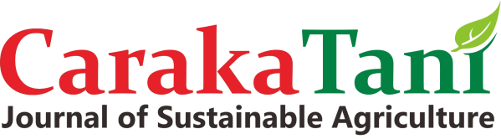ISSN 2613-9456 (Print) 2599-2570 (Online)



Faculty of Agriculture, Universitas Sebelas Maret URL: <http://jurnal.uns.ac.id/carakatani/>

Email: [carakatani@mail.uns.ac.id](mailto:carakatani@mail.uns.ac.id) DOI Prefix: [10.20961/carakatani](https://search.crossref.org/?q=caraka%2Btani%3A%2Bjournal%2Bof%2Bsustainable%2Bagriculture&page=1)

AUTHOR DECLARATION

**Caraka Tani: Journal of Sustainable Agriculture**

Full Name* : Wa Ode Al Zarliani

Affiliation* : Universitas Muhammadiyah Buton

Address* : Jalan Betoambari No 36 93712 Sulawesi Tenggara, Indonesia.

E-mail* : alzarlianiwaode@gmail.com

Title of the Manuscript : THE BEHAVIOR AND PERFORMANCE OF CASHEW MARKET IN SOUTH BUTON REGENCY

Author(s) Name :

1. Wa Ode Al Zarliani

2. Wardana

3. Achmad Amiruddin

As the Corresponding Author, hereby declare that:

1. This manuscript is original, has NOT been published before and is currently considered for publication elsewhere, and during peer review process by this journal will not be withdrawn and sent to other journals to be assessed.
2. I/We would like to improve the manuscript that has been assessed and not withdrawn unilaterally without informing the editors, especially if the manuscript is in the peer review process.
3. I/We affirm that the manuscript does not violate the intellectual property rights of any third party. I/We agree to indemnify and hold harmless the Caraka Tani in respect of any claim on account of violation of intellectual property rights.
4. I/We hereby confirm the transfer of all copyrights in and relating to the above-named manuscript, in all forms and media, now or hereafter known, to Caraka Tani effective from the date stated below. I/We acknowledge that the Caraka Tani are relying on this agreement in publishing the above-named manuscript. However, this agreement will be null and void if the manuscript is not published in the Caraka Tani.
5. I/We have no known competing financial interests or personal relationships that could have appeared to influence the work reported in this manuscript.
6. I/We hereby confirm that all the authors have made a significant contribution to the manuscript.

I made this statement to be used properly.



Buton, September 2020

(Wa Ode Al Zarliani)

*) *Filled with the* ***Corresponding Author*** *data*

*This statement must be upload for* ***supplementary files*** *while submitting your manuscript.*

*The Corresponding Author is the sole contact for the Editorial process and is responsible for communicating with the other authors about progress, submissions of revisions and final approval of proofs.*