 | Faculty of Agriculture, Universitas Sebelas Maret
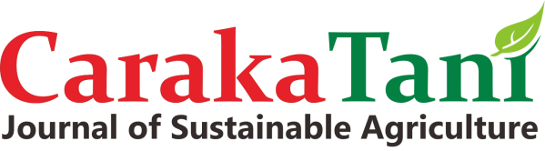 | URL: http://jurnal.uns.ac.id/carakatani/
 | Email: carakatani@mail.uns.ac.id
ISSN 2613-9456 (Print) 2599-2570 (Online) | DOI Prefix: 10.20961/carakatani

AUTHOR DECLARATION
Caraka Tani: Journal of Sustainable Agriculture
Full Name |  | : | Eka Tarwaca Susila Putra
Affiliation |  | : | Department of Agronomy, Faculty of Agriculture, Universitas Gadjah Mada
Address |  | : | Jl. Flora No. 1, Bulaksumur, Sleman, Yogyakarta 55281, Indonesia
E-mail |  | : | eka.tarwaca.s@ugm.ac.id
Title of the Manuscript |  | : | Effects of Spent and Deoiled Bleaching Earth Filler-Based NPK Fertilization on the Soil Nutrient Status and Growth of Soybean (Glycine max L. Merrill)
Author(s) Name |  | : | 1. | Muhammad Parikesit Wisnubroto
 |  |  | 2. | Eka Tarwaca Susila Putra
 |  |  | 3. | Budiastuti Kurniasih
As the Corresponding Author, hereby declare that:
1. | This manuscript is original, has NOT been published before and is currently considered for publication elsewhere, and during peer review process by this journal will not be withdrawn and sent to other journals to be assessed.
2. | I/We would like to improve the manuscript that has been assessed and not withdrawn unilaterally without informing the editors, especially if the manuscript is in the peer review process.
3. | I/We affirm that the manuscript does not violate the intellectual property rights of any third party. I/We agree to indemnify and hold harmless the Caraka Tani in respect of any claim on account of violation of intellectual property rights.
4. | I/We hereby confirm the transfer of all copyrights in and relating to the above-named manuscript, in all forms and media, now or hereafter known, to Caraka Tani effective from the date stated below. I/We acknowledge that the Caraka Tani are relying on this agreement in publishing the above-named manuscript. However, this agreement will be null and void if the manuscript is not published in the Caraka Tani.
5. | I/We have no known competing financial interests or personal relationships that could have appeared to influence the work reported in this manuscript.
6. | I/We hereby confirm that all the authors have made a significant contribution to the manuscript.
I made this statement to be used properly.
 |  |  |  |  | Yogyakarta, 18 – August – 2020
 |  |  |  |  | 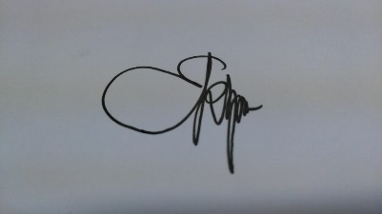
 |  |  |  |  | (Eka Tarwaca Susila Putra)

