THE INFLUENCE OF CUTTING AND EQUIPMENT SLICING MODELS ON THE GROWTH OF CASSAVA PLANT LOCAL TOBELO VARIETIES

Tri Mulya Hartati^{1*}, Chumidach Roini², Indah Rodianawati³
¹Department of Soil Science, Faculty of Agriculture, Khairun University, Ternate, Indonesia
²Department of Biology Education, Faculty of Teacher and Training Education, Khairun University, Ternate, Indonesia
³Department of Agricultural Product Technology, Faculty of Agriculture, Khairun University, Ternate, Indonesia
*Corresponding author: trimulyahartati@gmail.com

Abstract
The increase in cassava production in the long run is aimed at increasing yields that remain high according to needs and demands. The growth and development of cassava plants can be identified through the formation of a number of roots and shoots. This study aims to examine the relationship of source and depth to the growth of Tobelo local varieties of through setting the number of branches and cuttings model. This research uses factorial randomized block design (RBD), as the first factor is to manipulate the source by regulating the number of crop shoots, consisting of 3 levels: one shoot (S1), two shoots (S2) and three shoots (S3). The second factor is manipulating the bottom by applying the cuttings model, which consists of 3 levels, namely: flat slice (L1), one-sided sliced ​​(L2) and two-sided sliced ​​(L3). Observation parameters included: plant height, number of leaves, stem diameter, and leaf area. The results showed that the treatment of cuttings sliced ​​model had no significant effect on all growth parameters, but from the average yield of L3 treatment gave the highest yield on the growth of cassava plants. The treatment of the number of shoots gives a significantly different effect to very real to all growth parameters, except that the leaf area parameter is not significantly different. The S1 treatment gave the highest yield of all growth parameters, whereas in the leaf area parameter the S3 treatment gave the highest average leaf area.

Keywords: Source-Sink, Manipulation, Cassava Growth, Tobelo Local Varieties
INTRODUCTION
Cassava has a strategic and very prospective role as food, feed and industry (Radjit and Prasetiawati, 2011), chemical content and vegetable energy sources (Sundari, 2012). In Indonesia, cassava is the third staple food after rice and corn (Nurdjanah, et al., 2007). The opportunities for developing cassava business are quite wide open, because the need for products made from cassava is very large, such as tapioca, cassava, pellets, flour, syrup, textiles, paper and the livestock industry (Ariani, et al., 2013). At present the demand for cassava for food, feed, and industry has reached around 24.8 million tons. These needs are not yet included as bioethanol raw materials (Saleh et al., 2012).
Cassava is one of the sources of local food potential that is widely spread in Indonesia, this plant grows and produces from the lowlands to the highlands. For North Maluku, the existence of cassava which is quite famous comes from Tobelo, North Halmahera. This area is a fairly high supplier of cassava for Ternate and surrounding areas, because it is known for its good taste, but its potential has not been fully utilized.
The improvement of cassava productivity is inseparable from the application of its cultivation method, including the use of superior varieties and selection of appropriate plant material. New cassava varieties have long been used by both large-scale and small-scale farmers, but their tubers have not been able to increase cassava productivity. Therefore a crop improvement program is needed. Ceballos et al. (2010) mentioned that one of the cassava plant improvement programs is aimed at developing high-yielding varieties.
The growth and development of cassava plants can be identified through the formation of a number of roots and shoots. Shoots is a network that supplies assimilates or referred to as sources. According to Taiz and Zeiger (2006), the source is an organ that produces and exports assimilates in plants. Gardner et al. 2008 added that this tissue is an active photosynthetic organ, green in color and containing chlorophyll, such as leaves. While the roots or tubers in cassava are called sink. Sink is a network that accommodates or receives assimilation, but is not actively photosynthesizing, for example fruits, seeds, tubers, and old leaves (Gardner et al., 2008; Taiz and Zeiger, 2006). Efforts to improve cassava yields need a good understanding of the relationship between the source and the root (leaves and tubers). There is a relationship between leaf and tuber growth in cassava, there is a suspicion that the larger the tuber size, the production of branches and leaves will gradually stop and the leaves will experience aging which has implications for the total leaf area also decreases.
In connection with the above efforts to improve yields of cassava plants need to be done. Scientific information about the sink-source relationship in cassava is still small and is an unresolved problem. Thus it is necessary to carry out special studies aimed at increasing cassava yields. This study aims to examine the relationship of source and depth to the growth of Tobelo local varieties of Tobelo through setting the number of branches and cuttings slice models. It is expected that this research can eliminate the use of high fertilizer, modern technology that is difficult to apply in the field and can use marginal land whose productivity is always low.

MATERIAL AND METHODS
This research was carried out in farmers' land in the Kalumata sub-district of South Ternate -Ternate district, the Soil Science Laboratory of the Faculty of Agriculture, Khairun University, Ternate, and the Soil Science Laboratory of the Faculty of Agriculture, Tanjungpura University, West Kalimantan. The time of implementation starts in April - November 2019.
The materials used in this study were local cassava varieties from Tobelo, chicken manure, Urea, SP36, KNO3, pesticides, and aquades. While the tools used are hoes, machetes, fansticks, digital scales, cutting saws, buckets, measuring cups, raffia ropes, gauges, rulers, millimeter paper blocks, sample rings, measuring cups, pycnometers, thermometers, ovens, and stationery write.
This study uses a factorial design in a Randomized Block Design (RBD) pattern. As the first factor is manipulation at the source that is the regulation of the number of planting buds (S) consisting of 3 levels, namely: S1 = 1 bud, S2 = 2 buds and S3 = 3 buds. As the second factor is manipulation at the bottom, namely the cuttings model at the bottom of the cuttings (L) consisting of 3 levels, namely: L1 = flat cuttings, L2 = sliced ​​cuttings of one side, and L3 = sliced ​​cuttings of two sides. Each treatment combination was repeated 3 times.
Soil processing is done by plowing the soil, penggaruan followed by piling. The soil is treated as deep as ± 50 cm. Cassava planting material in the form of main stem cuttings with 10 buds sliced ​​with slices according to the treatment namely; flat, tilted one side and tilted two sides. Cassava cuttings are planted in an upright position with a spacing of 100x100 cm, then planted as deep as 5-10 cm or approximately one third of the cuttings buried in the soil.
Watering is done every morning and evening by looking at the conditions on the ground. In the first 1-3 days of planting cuttings doused with enough water to avoid dryness of cuttings. The growth of shoots regulated according to treatment is done one week after the growth of shoots reaches the number of each treatment. Manure is given as a base fertilizer at a dose of 1 kg / m2, given 2 times (half the dose at 2 weeks before the plant and half the dose given at planting) by spreading to the soil surface and inorganic fertilizer in the form of 200 kg urea + 100 kg SP36 + 100 KCl / ha (Sundari, 2010) given in two stages, namely half dose at 1 month of age and half dose at 3 months of age as continued fertilizer. Fertilizers are spread evenly over the surface. Weeding is done manually at the age of 4-5 weeks and age 1-2 months after planting. Soil is carried out 3 times at the age of 2, 3 and 4 months to loosen the soil, improve soil aeration and make room for roots to grow and develop and form sweet potatoes. Adjustment of the number of shoots is done by removing the shoots that grow beyond the treatment. Eradication of pests and diseases carried out when an attack occurs. Harvesting is done when the cassava plant is 6 months old.
Observation parameters include:
- Plant height, plant height is measured starting from the base of the stem which borders the soil surface to the point of growth, observations are carried out every 2 weeks.
- Stem diameter, stem diameter measurements are taken together with measurements of plant height.
- Number of leaves, calculated based on the number of leaves growing, the calculations are carried out together with measurements of plant height and stem diameter
- Leaf area. Leaf area was measured using the gravimetric method, ie the leaves were traced using paper, then the tracing was cut and weighed. The results are compared with the weight and area of ​​the whole paper. The whole paper was previously weighed and calculated the area beforehand (Sitompul and Guritno, 1995). Leaf area is calculated based on the weight of the leaf replica with the total paper weight, with the following formula:
LA = (W_{r}/W_{t})x At
Note: LA = Leaf Area
Wr = Net weight of leaf replicas
Wt = Total paper weight
At = Total paper area
Observation data were analyzed by analysis of variance (ANOVA). The treatments that have significant effect will be further tested using the Least Significant Difference (LSD) at a 5% significance level (Gomez and Gomez, 1984)

RESULTS AND DISCUSSION
- Characteristics of Soil, Manure, and Artificial Fertilizers Used in Research.
- Characteristics of Soil
The results of the analysis of the characteristics of soil properties at the study site (Table 1.), showed that the composition of the soil compilation fraction was graded by sand fraction (59%), followed by dust fraction (23%) and clay fraction (18%), so that the texture of this soil was included into the sandy loam class. The high sand fraction influences the bulk density (BD) and particle density (PD) of the soil. From the results of the analysis it appears that the study site has a BD value of 1.17 g cm⁻³, this indicates that the study site still has a low level of soil density. Brady (1989) said that soil BD can represent soil density, the higher the soil BD, the higher the proportion of solids or the more solid and conversely the lower the soil BD, the lower the proportion of solids. Warrick (2002) adds that the BD value of the soil depends on the arrangement of soil particles forming a collection (lump). Likewise with the PD soil value, the study site has a soil PD value of 2.11 g cm⁻³. The use of the study site land as a mixed garden makes the soil texture a little smoother, due to the tillage, this causes the range of porosity values ​​to be quite high (45%), because the porosity of the sandy soil is generally around 35-40%.
Table 1. Characteristics of Soil Properties Research Location at 0-20 cm Depth in Kalumata, South Ternate District, Ternate Regency

Soil Properties | Value | Unit | Class/Class Texture
Clay | 18 | % | -
Silt | 23 | % | -
Sand | 59 | % | -
Texture | - | - | Sandy Loam
Bulk Density (BD) | 1,17 | g cm⁻³ | -
Particle Density (PD) | 2,11 | g cm⁻³ | -
Total Porosity (n) | 45 | % | -
Total N | 0,91 | % | Very high
P available | 7,63 | mg g⁻¹ | Moderate
K available | 0,16 | cmol(+) kg⁻¹ | Very low
C Organic | 4,24 | % | High
C/N Ratio | 4,66 |  | Very low
CEC | 12,91 | cmol(+) kg⁻¹ | Low
pH (H₂O) | 5,55 |  | Acid
Base Saturation | 16,61 | % | Very low
Source: Analysis of the Soil Science Laboratory Faculty Agriculture UNKHAIR (2019) and the Laboratory of Chemistry and Soil Fertility Faculty Agriculture, UNTAN (2019). Awards according to the Soil Research Institute (2009).

The nutrient content it contains, where total N is very high (0.91%), P is available moderately (7.63 mg g⁻¹), except K is very low (0.16 cmol (+) kg⁻¹). Judging from the value of the CEC, the land used in this study has a low CEC value of 12.91 cmol (+) kg⁻¹. CEC is the chemical nature of the soil which is very closely related to soil fertility. Hardjowigeno (2003) said that soils with high CEC were able to absorb and provide nutrients better than soils with low CEC. Cassava plants are able to live in the pH range of 4.5-8.0, while the soil of the study site has a pH of 5.55 (acid), thus still allowing the cassava plants to adapt and live optimally at this pH. The soil of the research location has a very low base saturation (16.61%). Generally the base saturation value is influenced by soil pH, soils that have a low pH value, have a low base saturation value (Hartati, 2018).
- Characteristic Manure and Artificial Fertilizers
Manure used in this study is chicken manure obtained from chicken farmers in Gambesi, South Ternate District. The composition of nutrient content of manure from the analysis results as shown in Table 2.
Table 2. Composition of Chicken Manure Nutrient Content Used in the Research
Properties | Value | Unit | Class
C Organic | 54,53 | % | Very high
Total N | 1,91 | % | Moderate
Total P | 0,62 | mg g⁻¹ | Very high
Total K | 0,78 | cmol(+) kg⁻¹ | Very low
C/N Ratio | 28,55 |  | Very high
pH | 7,13 |  | Base
Source: Analysis of the Laboratory of Chemistry and Soil Fertility Faculty Agriculture, UNTAN (2019). Awards according to the Soil Research Institute (2009).

Artificial fertilizers used in this study were Urea, SP36 and KNO3 fertilizers, obtained from local fertilizer sellers and agricultural materials. KNO3 fertilizer is used as a substitute for KCl fertilizer, because at the time of this research the KCl fertilizer was not obtained. This KNO3 fertilizer is NPK compound fertilizer, with the composition N: P: K = 13: 0: 45. All artificial fertilizers used are basic fertilizers.
- The Effect of Cuttings Cut Model, Number of Buds and Their Interaction on the Growth of Cassava Plants

The results of the analysis of the variance of the effect of the cuttings slice model treatment, the number of shoots and their interactions on the growth of cassava plants showed that the effect of the cuttings model did not significantly affect all growth parameters. The treatment of the number of shoots and their interactions have a significant to very significant effect on the parameters of plant height, stem diameter and number of leaves, while the treatment area has no significant effect. The different test of the average effect of the cuttings cuttings model, the number of shoots and their interactions on plant growth parameters are listed in Table 3.

Table 3. Effect of Cut Slash Model, Number of Buds and Interaction on Growth of Cassava Plants

Cut Slash Model | Number of Buds |  |  | Average
 | S1 | S2 | S3
Plant height (cm)
L1 | 244,83 ^{cd} | 248,17 ^{cd} | 176,42 ª | 223,14
L2 | 218,33 ^{b} | 228,00 ^{bc} | 263,83 ^{d} | 236,72
L3 | 225,67 ^{bc} | 239,42 ^{bc} | 219,51 ^{b} | 228,20
Average | 229,61 ^{b} | 238,53 ^{b} | 219,92 ª | 229,35
Stem diameter (cm)
L1 | 5,76 ^{g} | 5,11 ^{d} | 4,33 ª | 5,07
L2 | 5,60 ^{fg} | 4,88 ^{cd} | 4,92^{cd} | 5,13
L3 | 5,70 ^{fg} | 5,46 ^{ef} | 4,79 ^{bc} | 5,31
Average | 5,69 ^{c} | 5,15 ^{b} | 4,68 ª | 5,17
Number of leaves (sheet)
L1 | 252 ^{e} | 231 ^{de} | 152 ^{ab} | 212
L2 | 224 ^{e} | 180 ^{ab} | 189 ^{bc} | 198
L3 | 170 ^{ab} | 213 ^{cd} | 251 ^{e} | 211
Average | 215 ^{b} | 208 ^{ab} | 197 ª | 207
Note : The numbers followed by the same letters in the same column show no significant difference in BNT Test α = 0.05

In Table 3. it appears that the treatment interaction gives the highest value on the combination of the model cuttings with a single cuttings (L1S1) for the stem diameter and number of leaves parameters, except for the plant height parameter. In plant height parameters, the combination of the one-sided sliced ​​cuttings with three shoots (L2S3) model was the highest combination of plant height, this combination was not significantly different from (L1S1) and the treatment of the flat cuttings with two shoots (L1S2).
The independent effect of the treatment of cuttings (L) slices model, it appears that the sliced ​​cuttings model tends to provide the highest average value of all observed parameters. While the independent effect of the treatment of the number of shoots (S), the results of the average difference test showed that all treatments were significantly different from each other, it appears that the more the number of shoots the average value of plant height, stem diameter, and number of leaves tended to decrease. This condition is in line with the results of Amarullah's study (2018) and the research of Ikeh et al. (2012) that the growth of plant height and stem diameter of cassava plants due to manipulation of sources with the arrangement of plant branches and cuttings model, resulted in significant differences in plant height, stem diameter, number of leaves and leaf area.
The leaf area parameters, although not significantly different, it can be seen in Figure 1. that the combination of treatments gives an average value of leaf area that varies. The highest leaf area was found in the L3S3 treatment and the lowest was in the L3S1 treatment.

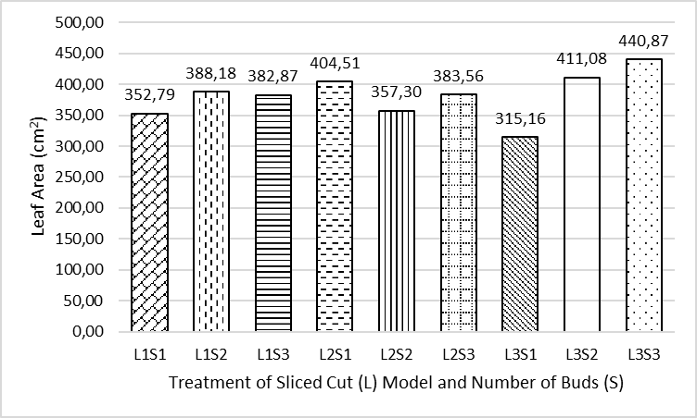

Figure 1. Graph of Combination of Cutted Cuttings and Number of Buds Treatment on Leaves Area of ​​Cassava Plants

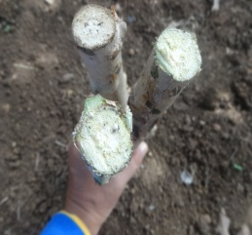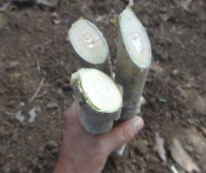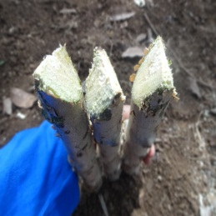
- 1 side slanted cuttings (S2)
- 2 side slanted cuttings (S3)
- Flat cutings (S1)

Figure 2. Differential Treatment of Sliced ​​Cut Model

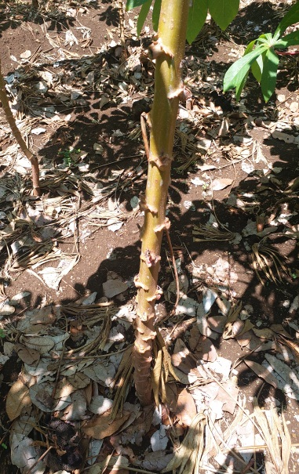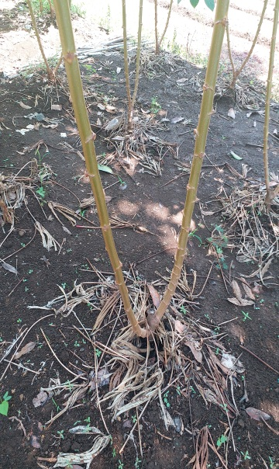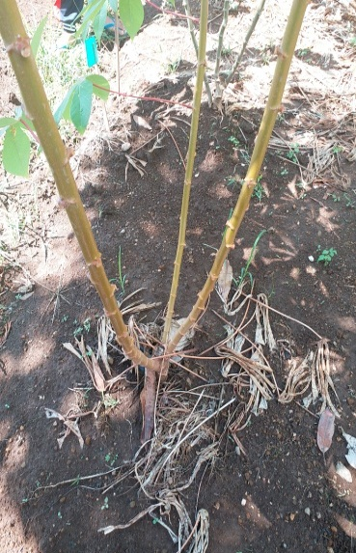
a. 1 Shoot (L1) b. 2 Shoot (L2) c. 3 Shoot (S3)
Figure 2. Treatment of Difference in Number of Buds

Plant growth is often defined as an increase in size, weight and / or number of plant size cells (Lakitan, 1996). Furthermore Darmawan and Justika (2010) explained that plant growth can be defined as an increase in plant size followed by an increase in dry weight. The process of plant growth consists of cell division, followed by cell enlargement and finally cell differentiation. Growth only occurs in certain locations, namely on the meristem network. During the growth and development of plants will form a variety of organs. In general, plant organs consist of vegetative organs and generative organs. Roots, stems and leaves are classified as vegetative organs and flowers, fruits and seeds are classified as generative organs. The phase in which plants only form vegetative organs is called the vegetative growth phase. Vegetative growth is characterized by various plant growth and development activities related to leaf formation and enlargement, formation of apical or lateral meristems and their growth into branches and expansion of plant root systems. Generative growth or reproductive growth begins with the formation of flowers. Flowers then develop into fruit. Seeds are formed along with fruit development (Lakitan, 1996).
Cassava is cultivated vegetatively through stem cuttings of varying lengths, then at the time after the cuttings are planted calluses will form at the base of the cuttings. At the base of cassava cuttings, the callus formed will differentiate into a large number of roots or tubers. In line with Sundari's statement (2010) which states that in a vertical and sloping planting position with the base of cuttings in the soil, callus will immediately form at the base and a few days later roots will form. From the results of this study it appears that the treatment of the two-sided cuttings (L3) slices model gives the highest average value of all growth parameters. This condition reflects that in the two-sided cuttings slice model will form a number of callus on each side, as a result the roots or tubers are also formed a lot. Many roots or bulbs will be able to absorb water and nutrients present in the soil to be allocated to all parts of the plant, so that in turn the growth of upper plants in this case plant height, stem diameter, number of leaves and leaf area also increases.
In the treatment of number of shoots, it appears that the number of one shoot (S1) gives the best results on the growth component of cassava plants. However, if the number of shoots increases, the component of plant growth decreases. This condition is possible because the more the number of shoots the distribution of nutrient uptake and water from the soil will also be divided on each number of shoots, consequently plant growth will be lower. Conversely, the number of buds decreases, taking the results of absorption of water and nutrients in plants is only focused on one bud. In line with the results of the study of Enyi (1972), the more shoots, the growth rates and yields of cassava plants decreased. However, the leaf area parameters occur otherwise, the more the number of buds, the higher the leaf area. So it appears that the highest leaf area there is the S3 treatment, this condition shows that in this treatment even though the number of leaves is small, but has a broad leaf shape, consequently the leaf area becomes higher

CONCLUSION
Conclusions from the results of this study:
- Interaction of cuttings cuttings treatment model with the number of shoots for the diameter parameters of stems and number of leaves gives the highest value in the combination of the cuttings cuttings with one shoot (L1S1) model, the plant height parameters are in the treatment combination (L2S3), but this combination is not significantly different from the treatment of L1S1 and the treatment of a model of flat cuttings with two buds (L1S2).
- In the treatment of cuttings sliced ​​model, independently the sliced ​​cuttings model tends to provide the highest average value of all observed parameters
- In the treatment of number of shoots, independently the more number of shoots the average value of the observed parameters tends to decrease, except in the leaf area parameter the more the number of shoots the leaf area increases

ACKNOWLEDGEMENTS
The author is grateful to the Chancellor of the Khairun University of Ternate for helping to carry out this research with the help of funding sources from the University of Khairun in accordance with the Letter of Agreement for Higher Education Competitive Research Program, Number: 039 / PEN-PKUPT / PL / 2019 May 2 2019

REFERENCE
Amarullah. (2016). Manipulasi Sumber dan Lubuk Dengan Pengaturan Jumlah Cabang Pertanaman dan Model Irisan Stek Untuk Meningkatkan Hasil Ubikayu. Penelitian Disertasi Doktor. Universitas Borneo Tarakan.
Ariani, M., Hermanto, G.S., Hardono, Sugiarto., & Wahyudi, T.S. (2013). Kajian Strategi Pengembangan Diversifikasi Pangan Lokal. Pusat Sosial Ekonomi dan Kebijakan Pertanian. Badan Penelitian dan Pengembangan Pertanian.
Brady, N.C. (1989). The Nature and Properties of Soil (9th edition). The Macmillan Publishing Company-New York. Collier Macmillan Publishers-London.750 pp
Ceballos, H., Okogbenin, E., Pe’rez, J.C., Beccera, L.A., Debouck, D. (2010). Cassava. In: Bradshaw J, ed. Root and Tuber Crops. New York: Springer, 53-96.
Darmawan, J., & Justika, S.B. (2010). Dasar-Dasar Fisiologi Tanaman. Penerbit SITC. Jakarta. 1-85 Hal.
Enyi, B.A.C. (1972). Growth Rate of Three Cassava (Manihot esculenta Crantz) Varietties Under Varying Population Densities. J. Agric. Sci. UK, 81: 15-28
Gardner, F.P., Pearce, R.B., & Roger, L.M. (1991). Fisiologi Budidaya Tumbuhan. Terjemahan Herawati Susilo. Universitas Indonesia Press. Hal 247 – 275
Goldsworthy, P.R., & Fisher, N.N. (1994). Fisiologi Tanaman Budidaya Tropika. Gadjah Mada University Press. Yogyakarta. Indonesia. 874p.
Gomez, K.A., & Gomez, A.A. (1984). Statistical Procedures for Agricultural Research. 2nd ed., A Wiley Interscience Publication.
Hardjowigeno, S. (2003). Ilmu Tanah. Akedemika Pressindo. Jakarta
Hartati, T.M. (2018). Evaluasi Kesesuaian Lahan, Kesuburan Tanah Beberapa Tanaman Perkebunan dan Perbaikan Sifat Tanah Untuk Peningkatan Produksi Pala Di Galela, Halmahera Utara. (Disertasi). Program Pascasarjana Fakultas Pertanian Universitas Gadjah Mada. Yogyakarta.
Ikeh, A.O., Udaeyo, N.U., Udoh, E.I., Iboko, K.O., & Udounang, P.I. (2012). Growth and Yield of Cassava (Manihot esculenta Crants) as influenced by The Number of Shoot Retained Per Stand on as Ultisol. Nature and Science. 2012: 10(8.)
Lakitan, B. (1996). Fisiologi. Pertumbuhan dan Perkembangan Tanaman. PT. Raja Grafindo Persada Jakarta. 1 – 218 Hal.
Nurdjanah, S., Susilawati, & Sabatini, M.R. (2007). Prediksi Kadar Pati Ubikayu (Manihot esculenta) Pada Berbagai Umur Panen. Jurnal Teknologi dan Industri Hasil Pertanian Vol. 12 No.2.pp. 65-73
Radjit. B.S., & Prasetiaswati, N. (2011). Hasil Umbi dan Kadar Pati Pada Beberapa Varietas Ubi Kayu Dengan Sistem Sambung (Mukibat). J. Agrivigor 10(2): 185 – 195.
Saleh, N., Rahayuningsih, S.A., & Adie, M.M. (2012). Peningkatan Produksi dan Kualitas Umbi – umbian. Balai Penelitian Kacang – kacangan dan Umbi – umbian (Balitkabi). Malang. Indonesia.
Sudarmadji, S., Haryono, B., & Suhardi. (2007). Prosedur Analisis Untuk Bahan Makanan dan Pertanian. Edisi keempat Penerbit Liberty, Yogyakarta.
Sundari, T. (2012). Produksi Stek dan Ubi Klon–klon Harapan Ubi Kayu Pada Beberapa Posisi Tanam. Prosiding: Seminar nasional tanaman pangan. P3TP. Balai Penelitian dan Pengembangan Pertanian. 3: 704 – 713.
Taiz, L., & Zeiger, E. (2006). Plant Physiology 4th ed. Sinuer Associates, Sunderland, MA.
Warrick, A.W. (2002). Soil Physics. Companion. CRC Press LLC, 2000. N.W. Corporate Blvd., Boca Roton, Florida. P ix+389

