**OPTIMIZATION COMPOSITION SURFACTANT, COSURFACTANT AND OIL SNEDDS (Self-Nanoemulsifying Drug Delivery System) of SECANG WOOD METHANOL EXTRACT (*Caesalpinia sappan* L.)**

**Anif Nur Artanti1, Dian Eka Ermawati2, Nugraha Mas’ud3, Fea Prihapsara4**

1,2Pharmacy Diphloma Programme, Faculty of Matematics and Natural Science

Universitas Sebelas Maret, Surakarata, Indonesia

3,4Pharmacy, Faculty of Matematics and Natural Science

Universitas Sebelas Maret, Surakarata, Indonesia

*Corresponding author : anif.apt@staff.uns.ac.id

**Abstract**

Indonesia has the potential biodiversity especially the source of natural medicinal substances as traditional medicinal. One of the plants that used as a traditional medicine is secang wood (*Caesalpinia sappan* L,). Secang wood has biological activity such as antibacteria, *anti-*inflamation, hypoglycemic, vasorelaxant, *anti*-allergic, *anti*-acne and antioxidant. Develope formulation technologies to increase the effectiveness of drug delivery system can be formulated using techniques SNEDDS (Self-Nanoemulsifying Drug Delivery System).

This study aims to determine the proportion of optimum composition of candlenut oil, surfactant, and cosurfactant of secang wood SNEDDS with *Simplex Lattice Design* method using Design Expert software. The SNEDDS formula was prepared using tween 80 and croduret 50 ss as a surfactant, propylene glycol as co-surfactant, and candlenut oil based on physical stability parameters : percent transmittance, separation phase and emulsification time. The optimum formula of SNEDDS was compared with *SLD* prediction using student's t-test [p> 0,05], then loading dose extract, accelerated stability test, Particle Size Analysis and Zeta Potencial.

The optimum composition of tween 80-croduret, propylene glycol, and candlenut oil SNEDDS secang wood based on SLD are 62,43%: 22,57%:15,0%. Results of transmittance percent response of 94,32%; emulsification time 74,67 sec; and 0,89 separation phase. The predicted SLD value for transmittance percent of 94,98%; emulsification time 78,97 sec; and phase separation 0,84. The result of statistical analysis of one sample t-test showed no significant difference between observation result and SLD prediction. The SNEDDS system is capable of loading 25,0 mg of secang wood methanol extract each system with 23,2 nm particle size, 0,142 index polidispersion and zeta potential +20,8 mV.

**Keywords : SNEDDS, secang wood methanol extract, SLD**

**INTRODUCTION**

Traditional medicine are consumed by Indonesian people increased from 15.04% in 1999 become 30.67% in 2003 (Jauhari *et al*., 2008). According to the data of WHO mentioned the 65% of people in developed countries have used traditional medicine. Traditional medicine has become the world's attention either developed countries or developing countries in the last ten years (Depkes, 2007).

Secang wood (*Caesalpinia sappan* L.) is a medicinal plant that has great potential to develope as traditional medicine. *Caesalpinia sappan* plant comes from South-East Asia and is easily found in Indonesia (BPOM RI, 2008). Based on existing studies, secang wood has biology activity such as antibacterial, *anti*-inflamation, hypoglycemic, vasorelaxant, *ant*i-allergic, *anti*-acne and antioxidants (Nirmal *et al*., 2015). The current formulation technology development has been growing rapidly which focuses on increasing the effectiveness of drug delivery system, one of the application technology is nanoparticles that the latest trend (Martien *et al*., 2012).

Formulation of nanoparticles can be formulated using techniques SNEDDS (Self-Nanoemulsifying Drug Delivery System). SNEDDS is an isotropic system composed of natural or synthetic oils, surfactants and surfactants. This system will be emulsified with the spontaneous forming phase oil in the water while in the gastrointestinal fluid nanometer-sized droplets (Mahmoud *et al*., 2013). SNEDDS system components in this study is the candlenut oil as a phase of oil (*Aleurites moluccana*), is a long-chain fatty acids C-14, many contain linoleic acid and fatty acids do not saturate (Ako *et al*., 2005), tween 80 – croduret 50ss as surfactants and propyleneglycol as *co*-surfactants.

Optimization of composition of formula is done by *Simplex Lattice Design* methodusing *software Design Expert* version *Stat Ease Dx 9 Trial*. Based on the research of Saryanti (2016) have been doing optimization of comotition surfactant, cosurfactant and candlenut oil with *Simplex Lattice Design*. The upper limit of each component that is 1:4:1 as well as 1:3:1 lower limit when analyzed using the assistance *software Design Expert*. This system can produce oil droplet size 15.5 nm, zeta potential-38.9 mV, transmittance 92%, emulsification time 40 seconds, and capable of accommodating up to extract 120 mg/g system. The purpose of this research is to get the optimum of composition surfactant, surfactant, and candle nut oil by adopting the formula of Saryanti (2016) so that it is able to produce SNEDDS’s methanol extracts of secang wood with physical testing parameters : percentage of transmittance, emulsification time, accelerated stability, particle size analyzer, zeta potential and the ability to load methanol extracts of secang wood.

**MATERIALS AND METHODS**

**MATERIALS**

Stopwatch, rotary evaporator (Stuart), waterbath (Grant), vortex (Maxi Mix II Thermolyne), sonicator (Branson 1510), hotplates magnetic stirrer (IKA ® C-MAG HS 7), yellow and blue tip tip (Thermo), refrigerator (Porkka), moisture balance Analyzer (OHAUS), UV/Vis spectrophotometer (Genesys ™), micropipet (Gilson), analytical balance (Metler Teledo), sentrifugator (Mini Spin plus), pH meter (Eutech Instruments), pH-indicator strips (Merck), UV-Vis light 254nm-366nm, flakon and tools (glass Pyrex).

Secang wood powder obtained from CV Herbadream (Grobogan, Central Java), secang wood fraction (laboratory of Biology UNS), silica gel TLC plates GF-254 (Merck), ethyl acetate pro analysis (Merck), n-hexane pro analysis (Merck), methanol technical (Brataco), oil phase: candle nut oil (Agung Jaya), co- surfactants: propylene glycol (Agung Jaya), surfactants: Croduret® 50ss (Croda) and Tween 80 (Agung Jaya). The ingredients of making artificial gastric fluid (AGF) is consist of aquadest (Agung Jaya), 37% HCl and NaCl (e. Merck).

**METHODS**

**1. Preparation of Methanol extracts of Secang Wood (*Caesalpinia sappan* L.)**

Extraction process of secang wood powder by maceration method with methanol solvent with the ratio 1:10 for 24 hours. After the maceration process, the macerate can be take by filtered the macerate. Remaceration with the ratio 3:2 for 24 hours and then the remacerate can be take by filtered the remacerate. Macerate evaporated using rotary evaporator at 550C until vicous extract. The randemen of extract was calculated (Hangoluan, 2011).

**2. Characterization of Test Extract**

Organoletics characteristic of secang wood extract observation include : color, odour, and consistency. The water content of the extract was carried out by weighing 1.0 grams of extract placed over the aluminum plate in to the Moisture Ballance instrument then operated at 105ºC until extract dry and the percentage of water content in the extract was obtained.

**3. Detection of active compound of extract by TLC method**

Analysis of active compound of methanolic secang wood extract with Thin Layer Chromatography method. The stationary phase that used was Silica Gel 60 F254 and mobile phase : ethyl acetate-n hexane (6:4). Observations were also performed under UV 254 and UV 366 light (Warinhomhaun et al., 2016).

**4. Optimization of formula SNEDDS with SLD method**

Optimization of optimum composition of SNEDDS uses three component : Tween 80-Croduret, propylene glycol and candle nut oil with analysis by software Design Expert. The determination of the percentage of each component that is 1:3:1 [upper limit] and 1:5:1 [lower limit]. The composition of surfactants (Tween80-Croduret 50SS) combined with the ratio 85%:15%. Software Design Expert would generate 14 formula with repetition on a four-point [table-1]. The physical test of SNEDDS : transmittance (%), emulsification time (seconds), and stability (F = 1), The SNEDDS system maked in 4.0 grams.

**5. Loading Dose of Secang wood Extract in SNEDDS system**

Methanol extracts of secang wood can be loaded in the system with the weights series 25.0 mg; 50.0 mg; and 100.0 mg each SNEDDS system. Secang woods are homogenize with magnetic stirrer for 15 minutes, sonicator for 15 minutes, then incubation in waterbath at 40° C for 15 minutes. Observations of the solubility of the extract is done visually, then conducted centrifugation test at 6000 rpm for 10 minutes. Observations were made to the solubility, precipitation and separation.

**6. Optimization SNEDDS of secang wood methanolic extract**

Software Design Expert releases 14 formulas with variation candle nut oil, surfactant and co-surfactant component. The mixture of component mixed according to proportion percentage [Table-1]. The mixture homogenized with a vortex for 60 seconds, sonicate for 5 minutes and incubation at 45° C for 15 minutes. The 100.0 µl stable mixture placed into a flask and added until 5.0 mL aquadest and vortex for 30 seconds. The homogenous and clear appearance mixture to be first sign of succesfull SNEDDS formula.

**7. Observations of physical stability of SNEDDS**

SNEDDS formula of 14 that has been tested with parameter values clarity test/percentage transmittance (%). Amount of 100.0 µl SNEDDS added until 5.0 mL aquadest in a flask and homogenize with vortex for 60 minutes. After that, the percentage transmittance can be measured by UV-VIS spectrophotometry on a wavelength of 650 nm, blanko as akuades (Patel et al., 2011).

Emulsification time can be observed in artificial gastric fluid (AGF). Amount of 1.0 mL each SNEDDS formula into 250.0 mL artificial gastric fluid without pepsin. Every 1.0 liter media contains 2.0 grams of NaCl AGF and 7.0 mL HCl 37% with a pH value of 1.2. Artificial gastric fluid media without pepsin conditioned at 37° C above the hotplate magnetic stirer with the speed of 100 rpm. Observations were made to the time needed by SNEDDS to form o/w emulsion until the SNEDDS’s formula emulsified in media perfectly.

Observation of the stability of SNEDDS system by freeze thawing which refers to research (Avachat and Patel, 2015; Yuliani et al., 2016). System SNEDDS taken each 1.5 mL into effendrof, then stored at a temperature of 4° C and 30° C for 24 hours at each temperature for storage for six cycles. After that, centrifuged at a speed of 6000 rpm for 10 minutes.

The observation data of physical stability incorporated into software Design Expert with the awarding criteria in range [surfactant, cosurfactant, and candle nut oil]; the maximum for the percent transmitan; as well as the minimum for the emulsification time. Optimum formula obtained with the desirability value approaching one, and then compared with the prediction formula SLD with statistical analysis [students’s t-test].

**8. Measurement of the particle Size and Zeta Potential Analysis Optimum Formula**

SNEDDS of 100.0 µl added 5.0 mL of aquadest, then flipped through carefully. After that, a number of 3.0 mL mixture put into cuvvete to be analyzed using 100 SZ-HORIBA instruments. The output of measurement such as particle size, particle size distribution, zeta potential and deviation of mean.

**DATA ANALYSIS**

The optimum composition of the SNEDDS formula is obtained by Simplex Lattice Design [Mixture Design] method using software Design Expert. The result of observation and prediction data of SLD was done by statistical analysis : One Sample T-Test using SPSS software.

**RESULT AND DICUSSION**

**1. Characteristic of secang wood methanol extract**

Determination of the plant was done in the laboratory of Biology, Faculty of Mathematic and Natural Sciences, UNS showed that the plant was used in this research is *Caesalpinia sappan* L. with the extract randement is 6.8%. Maceration method was chosen because it is simple and easy to be applied. The methanol solvent is polar solvent can be put polar or non polar compound of secang woods (Hangoluan, 2011).

Methanol extracts of secang wood obtained has a red color, the smell of secang wood and has the thick consistency. The value of the moisture balance is 1.2% according to the requirements that the moisture content of the extract preferably less than 10% to avoid contamination by microorganism (Depkes, 2009).

**2. Analysis of the active compound of secang wood methanol extract**

Thin layer chromatography assay [figure-1] results that fractions on visual observation, there is a pink, brown and yellow indicated compounds anthocyanin, phenolic acids and flavonoids (Divya et al., 2013). The results of the TLC Rf value shows on secang wood methanol extract are 0.0625; 0.1375; 0.225; 0.3125; 0.4; 0.5125; 0.6875; 0.9. From the results of secang wood methanol extracts, TLC on Rf value of 0.4 it is possible of protosappanin A compound (Warinhomhaun et al., 2016).

**3. Optimization methods with SLD SNEDDS Formula**

Upper limit lower limit 1:3:1 and 1:5:1 which includes the oil-surfactant-co surfactants, that incorporated into software Design Expert. Simplex Lattice Design obtained 14 formula which subsequently conducted physical stability analysis ( Table-1). The combination of the surfactant Tween 80-Croduret 50ss use the ratio 85%: 15% can be less than 20 nm (Saryanti. 2016). Results of secang wood methanol extracts can load of 25.0 mg/g, on the system of SNEDDS shows the optimum stability as well as percent suitable emulsion transmitan and time required. Propylene glycol is a safety co-surfactant used orally, the use of co-surfactant can reduce the flexibility of the surface tension (Senapati et al., 2016.).

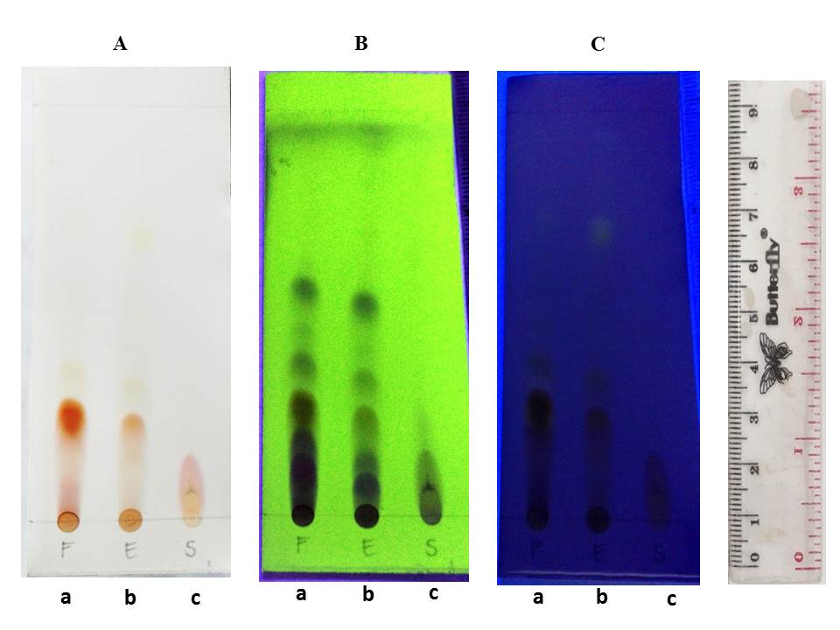

**Figure 1. TLC analysis with mobile phase ethyl acetate: n-hexane (6: 4) with Silica Gel 60 GF 254 stationary phase. Observations on visible light [A], UV 254 light [B], and UV 366 light [c]. Fraction of secang wood extract [a], secang wood methanol extract [b], optimum formula of SNEDDS secang wood methanol extract [c]**

**Table-1. Analysis result of 14 Formulas with SLD method using DX software and parameters of physical stability responses of SNEDDS secang wood methanol extract**

|  |  |  |  |  |  |  |  |
| --- | --- | --- | --- | --- | --- | --- | --- |
| Run | Percentage of oil [A], surfactant [B] dan co-surfactant [C] based on *SLD* | | | | Physical stability of SNEDDS secang wood methanol extract | | |
| Oil (%) | Surfactant (%) | Co-surfactant (%) | Extract (gram) | Transmittance (%) | Emulsification time (detik) | Phase separation (F value=1) |
| 1 | 15,0 | 60,0 | 25,0 | 0,1 | 76,3 | 49 | 0,88 |
| 2 | 16,7 | 61,7 | 21,7 | 0,1 | 95,2 | 133 | 0,87 |
| 3 | 16,7 | 66,7 | 16,7 | 0,1 | 98,4 | 129 | 1,00 |
| 4 | 15,0 | 65,0 | 20,0 | 0,1 | 98,9 | 82 | 0,86 |
| 5 | 20,0 | 65,0 | 15,0 | 0,1 | 100,2 | 147 | 0,92 |
| 6 | 15,0 | 70,0 | 15,0 | 0,1 | 98,5 | 165 | 1,00 |
| 7 | 25,0 | 60,0 | 15,0 | 0,1 | 81,5 | 94 | 0,57 |
| 8 | 25,0 | 60,0 | 15,0 | 0,1 | 88,6 | 58 | 0,50 |
| 9 | 20,0 | 60,0 | 20,0 | 0,1 | 70,6 | 69 | 0,64 |
| 10 | 21,7 | 61,7 | 16,7 | 0,1 | 88,9 | 113 | 0,67 |
| 11 | 20,0 | 65,0 | 15,0 | 0,1 | 94,9 | 90 | 0,64 |
| 12 | 18,3 | 63,3 | 18,3 | 0,1 | 96,2 | 83 | 0,69 |
| 13 | 15,0 | 70,0 | 15,0 | 0,1 | 98,3 | 96 | 1,00 |
| 14 | 15,0 | 60,0 | 25,0 | 0,1 | 85,6 | 44 | 0,67 |

**\*SNEDDS systems made of 4 grams.**

Physical analize parameters include percentage transmittance, the high value of percentage transmittance show that the small particle size when it dispersed in the water and then the solution looks clear on visual observation and oil droplets on very small size (Ahmad et al. 2014). Emulsification time described the duration SNEDDS formula from early drop until emulsified and form a homogeneous mixture on medium with mild agitation (Puspita et al., 2016; Prihapsara et al., 2017). According to Sakthi et al. (2013) there are the type of nanoemulsi emulsification such as less than 30 seconds (A), less than 1 minute (B), less than 2 minutes (C) and between 4-5 minutes (D). The aim of centrifugation test to observe the oil phase separation with destroying emulgator/surfactants layer are absorbed around each grain. The freeze and thaw to discover physical stability SNEDDS formula on different temperature treatment period is relatively short (Ermawati et al., 2017; Yuliani et al., 2016). Formulas that have not experienced deposition or stable value for phase separation (F) = 1.

**4. Optimum formula of SNEDDS secang wood methanol extract**

Experimental design is often used in the design of research because it provides maximum information, but require only a little amount of experimentation. Simplex Lattice Design was a method used to optimize the proportions of formula components. The amount of oil the nuts (A), the surfactant Tween 80:-Croduret 50ss (B), and co-surfactants: propylene glycol (C) was chosen as an independent factor. The profile properties of the mixture is determined by Simplex Lattice Design based on the equation: Y = Bolton (A) α1 + α2 (B) + (C) + α3 α12 (A) (B) + α13 (A) (C) + Α23 (B) (C) + α 123 (A) (B) (C). Where Y is the response, ABC is the proportion of components, and α is the coefficient.

**Table-2. Analysis of Software Design Expert about physical stability parameters of SNEDDS of secang wood methanol extract based on mathematical model and statistical analysis [ANOVA]**

|  |  |  |  |  |
| --- | --- | --- | --- | --- |
| Phisical respon of SNEDDS formula | | Matematic equations | Matematic Model | *p-value* [ANOVA] p>0,005 |
| Transmitan (%) | Y = -5,97 (A)-4,12 (B)- 19,91 (C)+ 0,29 (A)(B)- 0,310 (A)(C)+ 0,51 (B)(C) | *quadratic* | 0,0059 |
| Waktu emulsi (detik) | Y = -1,66 A + 3,28 B + 4,46 C | *linier* | 0,038 |
| Fase Pemisahan (harga F) | Y = -0,03 (A) + 0,02 (B)- 2,52 (C) | *linier* | 0,0004 |

Anova statistical analysis explained that the response model with quadratic transmitan percent, when the emulsion and the stability of a linear model with SNEDDS. The model shows the influence of the use of the composition of oils, surfactants, and co-surfactants of each formula should have a meaningful difference. Lack of fit explains the closeness of observations with predictions of the software. The value of the lack of fit there should no difference between the results of observational research with the predictions of the SLD (Bolton. 2002). Table-2 shows that there was no significant effects on the mixture of oils, surfactants, and ko-surfactant against the parameters of the response time and stability of emulsion SNEDDS. Parameter respons of transmitan suggests that components of surfactants and cosurfactant in mixture provides the greatest influence, namely can increase the percent value of the coefficient transmitan + 0.51.

The numbers in the triangle indicates the composition of the oils, surfactants, and ko-surfactants in modeling. The highest response is shown in the red area, the lower the response shown in the yellow area and lower again in the Green and blue areas (Figure-2). The solution chosen is the most great desirability value and approaching of 0.663 in diagram super impose which means the formula will produce the most optimal formula according to the characteristics of the desired target. The proportion of the optimum composition of candlenut oil, surfactants, and co-surfactant are respectively 15%: 62.43%: 22.57%.

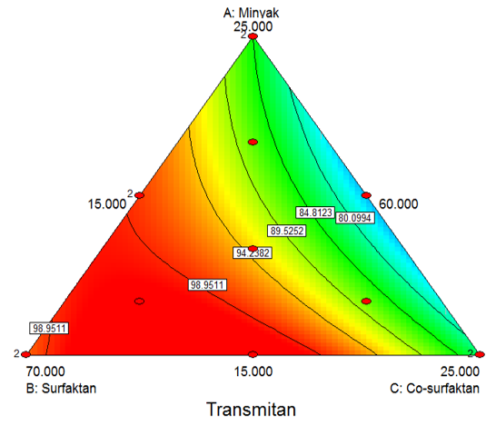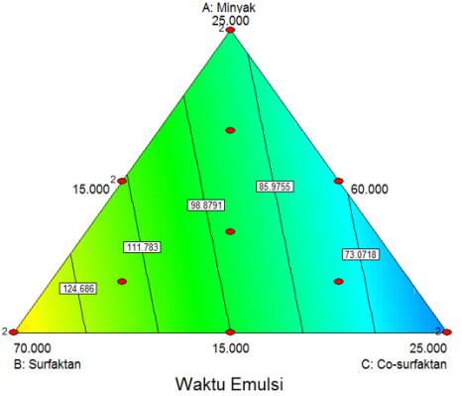

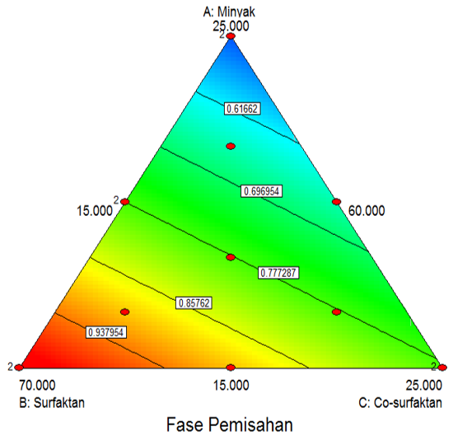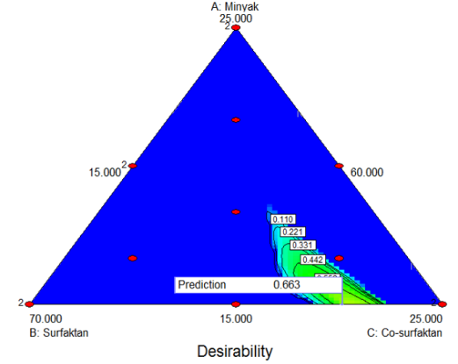

**Figure-3. The counter plot diagram of the SMEDDS stability response parameter : transmitant [1], emulsification time [2], and phase of separation [3]. The super impose diagram showed that the optimum area of the candlenut oil component : surfactant : co-surfactant [4]**.

The predictions value are obtained by Simplex Lattice Design methode shows the prediction value of software against the value of observation results given by the optimal formula. Based on test results as presented in table-3, the response percentage transmittance (clarity), emulsification time and phase separation (stability) of the observations of the optimal formula have no significantly different compare with the prediction of software Design Expert [p-value 0.05 >].

**Table-3. Results of verification of SLD prediction values compare with Observation of Optimum Formula SNEDDS secang wood methanol extract**

|  |  |  |  |
| --- | --- | --- | --- |
| Response of physical stability | Prediction *SLD* | Observation | *Sig-value* [p>0.05] |
| Transmittance (%) | 94,980 | 94,32±SE 0,924 | 0,559 |
| Emulsification time (second) | 78,970 | 74,67±SE 0,882 | 0,096 |
| Phase separation (F) | 0,840 | 0,89±SE 0,019 | 0,107 |

1. **Measurement of PSA and the Optimum Formula SNEDDS Zeta potential**

The results of droplets size of SNEDDS of secang wood methanol extracts is 23.2 nm, polidispersibilty index 0.142. Low polidispersibility index shows a narrow particle size distribution of mean particle size in the uniform SNEDDS (Avachat and Patel. 2014). Uniformity of particle size can improve the bioavailabilitas because the drug will absorb faster with relatively the same speed (Balakumar et al., 2013). The value of zeta potential is obtained from SNEDDS of secang wood methanol extract was + 20.8 mV. Zeta potential value will produce material that is relatively stable. The value of a positive zeta potential indicates that the system has a positive charge of SNEDDS and enough to counter the repulsive so that it will produce a stable formulas (Dash et al., 2015).

**CONCLUSION**

The optimum composition of tween 80-croduret 50ss, propylene glycol, and candle nut oil based on the physical stability by SLD are respectively 62.43%: 22.57%: 15.0%. The results of the response of transmittance percentage is 94.32%; emulsification time 74.67 seconds; and separation phase 0.89. The prediction value of the SLD in transmittance percentage is 94.98%, emulsification time 79 seconds; and separation phase 0.84. The results of the statistical analysis of one sample t-test shows there is no significantly different between the observation and prediction system of SLD. SNEDDS capable to load 25.0 mg secang wood methanol extracts each SNEDDS system, with particle size 23.2 nm, polidispersibility index 0.142 and zeta potential + 20.8 mV.

**REFERENCES**

Ahmad, J., Mir, S.R., Kohli, K., and Amin, S., 2014. Effect of oil and cosurfactant on the formation of Solutol HS 15 based colloidal drug carrier by Box–Behnken statistical design. *Colloids and Surfaces A:* *Physicochemical and Engineering Aspects*, **453**: 68–77.

Ako, H., Kong, N., and Brown, A., 2005. Fatty acid profiles of kukui nut oils over time and from different sources. *Industrial Crops and Products*, **22**: 169–174.

Avachat, A.M. dan Patel, V.G., 2014. Self nanoemulsifying drug delivery system of stabilized ellagic acid–phospholipid complex with improved dissolution and permeability. *Saudi Pharmaceutical Journal*,

Avachat, A.M. dan V.G. Patel. 2015. Self Nanoemulsifying Drug Delivery Systems of Stabilized Ellagic Acid-Phospolipid Complex with Improved Dissolution and Permeability. *Saudi Pharm. Journal*, 23(3), 276-289.

Balakumar, K., Raghavan, C.V., selvan, N.T., prasad, R.H., dan Abdu, S., 2013. Self nanoemulsifying drug delivery system (SNEDDS) of Rosuvastatin calcium: Design, formulation, bioavailability and pharmacokinetic evaluation. *Colloids and Surfaces B: Biointerfaces*, **112**: 337–343.

Bolton, S. 2002. *Pharmaceutical Statistics: Practical and Clinical Application,* *3rd Edition*. Marcell Dekker Inc, New York.

BPOM RI. 2008. *Direktorat Obat Asli Indonesia*. Jakarta: Badan Pengawas Obat dan Makanan.

Dash, R.N., Mohammed, H., Humaira, T., dan Ramesh, D., 2015. Design, optimization and evaluation of glipizide solid self-nanoemulsifying drug delivery for enhanced solubility and dissolution. *Saudi Pharmaceutical* *Journal*, **23**: 528 540.

Departemen Kesehatan, RI., 2009. *Materia Medika Indonesia*, I. Departemen Kesehatan, Republik Indonesia : Jakarta.

Divya T., M.R. Nandini, R. Pooja, Dr.A. Manickam, V.B. Rekha. 2013. Extraction of Natural Dyes from Forest Trees and Their Application in Textiles. *International Journal for Scientific Research & Development*, 1, 589-593.

Ermawati, D.E., Martodihardjo S.,T.N.Saifullah Sulaiman. 2017. Optimasi Komposisi Emulgator Formula Emulsi Air dalam Minyak Jus Buah Stroberi (*Fragaria vesca* L.) dengan Metode *Simplex Lattice Design*. *Journal of Pharmaceutical and Clinical Research*, 2, 78-89.

Hangoluan, B.Y.M. 2011. Pengembangan Metode Isolasi Brazilin Dari Kayu Secang (*Caesalpinia Sappan*). *Skripsi*. Departemen Kimia FMIPA Institut Pertanian Bogor.

Jauhari, A.H., Muhana, S.U., Retna, S.P. 2008. Motivasi dan Kepercayaan Pasien Untuk Berobat ke Sinshe. *Berita Kedokteran Rakyat*, 24(1), 1-7.

Mahmoud, H., Al-Suwayeh, S., S, Elkadi. 2013. Design and optimization of self nanoemulsifying drug delivery systems of simvastatin aiming dissolution enhancement. *African Journal of Pharmacy and Pharmacology*, 7(22), 1482-1500.

Martien, R., Adhyatmika, Iramie D.K., Irianto, Verda F., Dian P.S. 2012. Perkembangan Teknologi Nanopartikel sebagai Sistem Penghantaran Obat. *Majalah Farmaseutik*, 8(1), 133-144.

Nirmal, N.P., Rajput, M.S., Rangabathla, G.S.V.P, Mehraj, A. 2015. Brazilin from *Caesalpinia sappan* heartwood and its pharmacological activities : A review. *Asia Pacific Journal of Tropical Medicine*, 8(6),421-430.

Patel, J., Kevin, G., Patel, A., Raval, M., dan Sheth, N., 2011. Design and development of a self-nanoemulsifying drug delivery system for telmisartan for oral drug delivery. *International journal of pharmaceutical* *investigation*, **1**: 112.

Prihapsara, F., M. Harini, T. Widiyani, A.N. Artanti, I.L.Ani. 2017. Antidiabetic Activity of Self Nanoemulsifying Drug Delivery System From Bay Leaves (*Eugenia polyantha* Wight) Ethyl Acetate Fraction. *IOP Conf. Ser: Mater.Sci.Eng*, 176, 1-7.

Puspita, O.E., Suwaldi, A.K., Nugroho. 2016. Optimization of Self- nanoemulsifying Drug Delivery System for Pterostilbene. *Journal of Food and Pharmaceutical Sciences*, 4,18-24.

Sakhti, M.U., Lobo, F.J.R., Kiran, B.U. 2013. Self Nano Emulsifying Drug Delivery Systems for Oral Delivery of Hydrophobic Drugs. *Biomedical* *& Pharmacology Journal*, 6(2), 355-362.

Saryanti, D., Martodihardjo, S., Martien, R., 2016. Optimasi SNEDDS Ekstrak Purwoceng Gunung (*Artemisia lactiflora* wall ex. DC) dan Uji Absorbi secara In Vitro. *Tesis*. Fakultas Farmasi : Universitas Gadjah Mada. Yogyakarta.

Senapati, P.C., Sahoo, S.K., dan Sahu, A.N., 2016. Mixed surfactant based (SNEDDS) self-nanoemulsifying drug delivery system presenting efavirenz for enhancement of oral bioavailability. *Biomedicine &* *Pharmacotherapy*, **80**: 42–51.

Warinhomhaun, S., Sritularak, B., Panapisal, V., Charnvanich, D. 2016. Comparative study of semi-purification methods of *Caesalpinia sappan* L. extract : Thin layer chromatography and free radical scavenging activity. *Thai Journal of Pharmaceutical Sciences (TJPS)*, 40, 76-79.

Yuliani, S.H., Hartini, M., Stephanie, Bety, P. Enade, P.I. 2016. Perbandingan Stabilitas Fisis Sediaan Nanoemulsi Minyak Biji Delima dengan Fase Minyak *Long-Chain Tryglyceride* dan *Medium-Chain Tryglyceride*. *Traditional Medicine Journal*, 21(2),93-98.