Agrosains : Jurnal Penelitian Agronomi
Department of Agrotechnology
Faculty of Agriculture Universitas Sebelas Maret
Jl. Ir. Sutami No. 36A Kotak Pos 4 Slouns 57126 Surakarta

DOI Prefix: doi.org/10/20961/agsjpa
Telp. (0271) 663961
https://jurnal.uns.ac.id/agrosains/index ; email: agrosains@mail.uns.ac.id

STATEMENT LETTER

To
Chief Editor Jurnal Agrosains : Jurnal Penelitian Agronomi

I declare that scientific article:
Title:
Survei Penyakit Busuk Pangkal Batang Kelapa Sawit di Kebun Cikasungka, PT Perkebunan Nusantara VIII, Bogor

Author:
Amelia Salsabila¹⁾, Evan Purnama Ramdan^{1) *}, Paranita Asnur¹⁾, Hendi Hidayat²⁾

Address:
¹⁾Program Studi Agroteknologi, Fakultas Teknologi Industri, Universitas Gunadarma, Jl. Margonda Raya 100,Pondok Cina, Beji, Depok,Jawa Barat, Indonesia. Tel./Fax. +62-271-663375,
²⁾PT. Perkebunan Nusantara VIII Kebun Cikasungka, Jl. Raya Cigudeg No.18, Cigudeg, Kec. Cigudeg, Bogor, Jawa Barat, Indonesia.

*corresponding author: evan_ramdan@staff.gunadarma.ac.id

Updates and Novelty:
Pada penelitian ini merupakan penelitian pendahuluan berupa survey tingkat insidensi dan keparahan penyakit busuk pangkal batang. Survey dilakukan di 3 blok berbeda yang masing-masing terdiri dari 5 plot sampling, sehingga data yang didapat bisa mencakup/menginterprestasikan kondisi blok penelitian. Selain survei, dilakukan juga wawancara mengenai upaya pengendalian yang telah dilakukan. Sehingga dari data yang diperoleh dapat menjadi masukan mengenai penelitian berikutnya.
Statement:
Stating that my article has never been and will not be published in other journals. The
author guarantees that the article is original, written by the listed author and there are
no works or opinions that have been written and published by other people / institutions,
except those cited in writing and mentioned in the bibliography. This article also does not
contain elements of plagiarism. I do hereby declare that all the information given above
is true to the best of my knowledge and belief

List of candidate reviewers submitted
- Ali Wafa, ali.wafa@unej.ac.id/ 0852-3667-5625
- Eka Bobby Febrianto, eka_bobby@stipap.ac.id /0852-62603036

Place and Date
Depok, 22 Oktober 2021
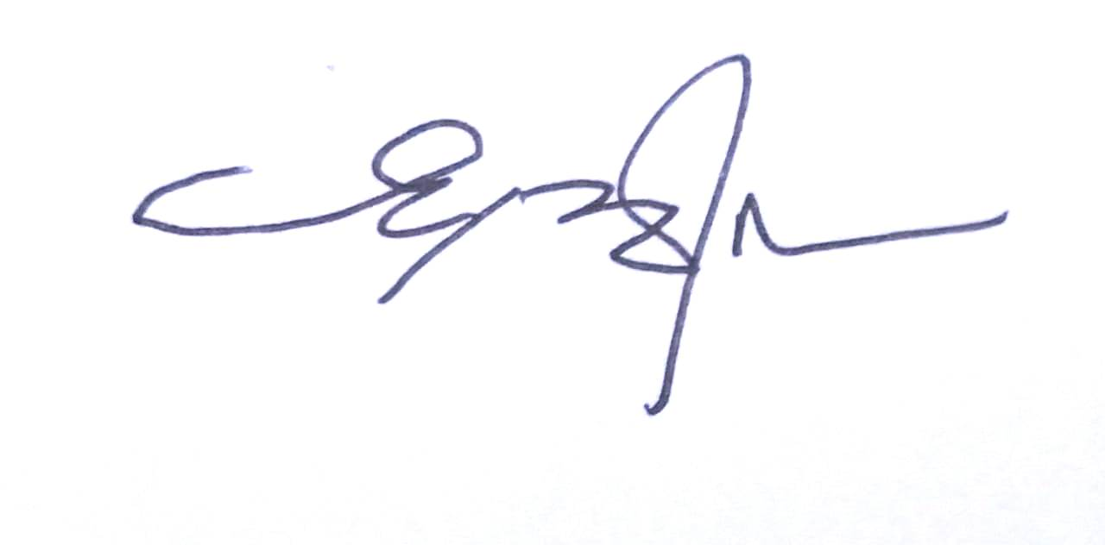
Signatures and names
Evan Purnama Ramdan

