Supp 1. Forest plot for dSI showing the individual study sensitivity of (A) in-hospital mortality, (B) massive transfusion
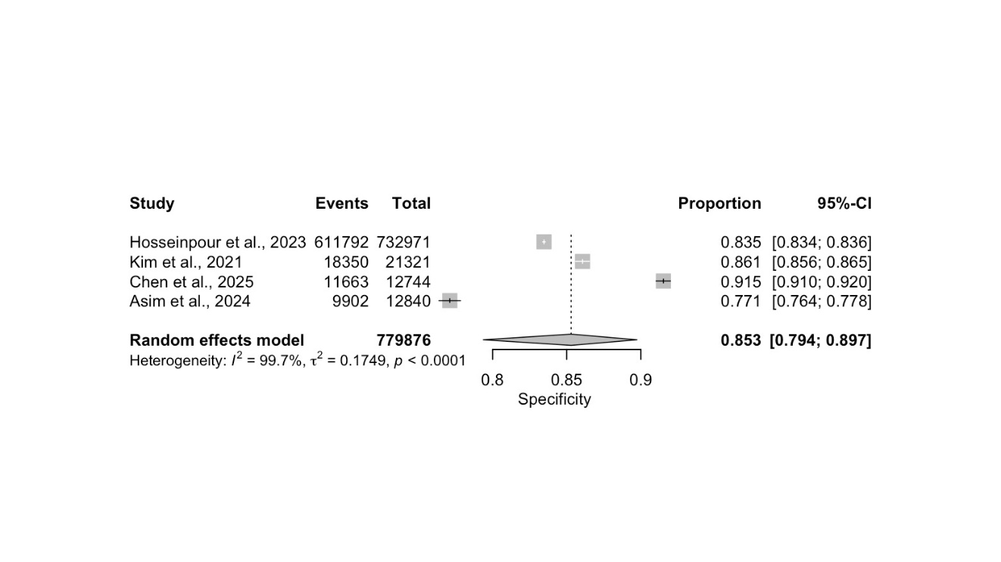
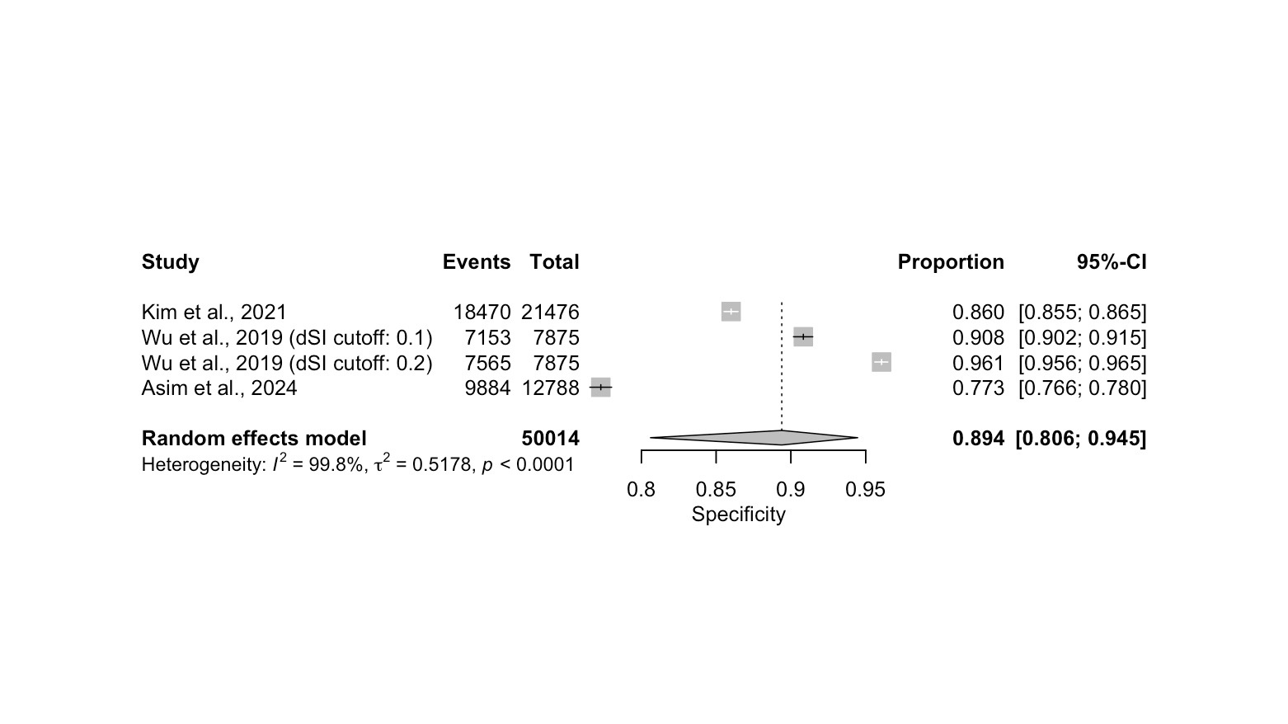
B)
A)

Supp 2. Forest plot for dSI showing the individual study specificity of (A) in-hospital mortality, (B) massive transfusion

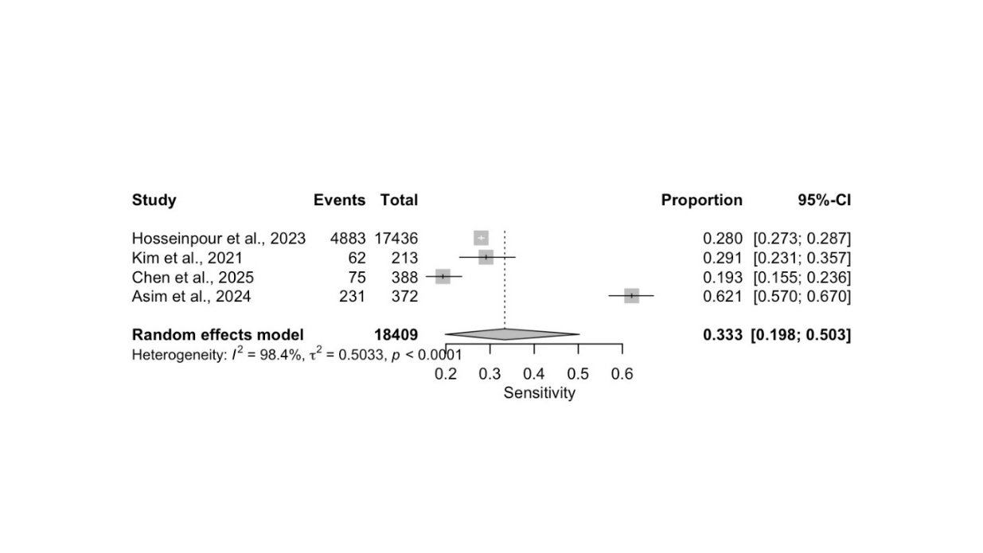
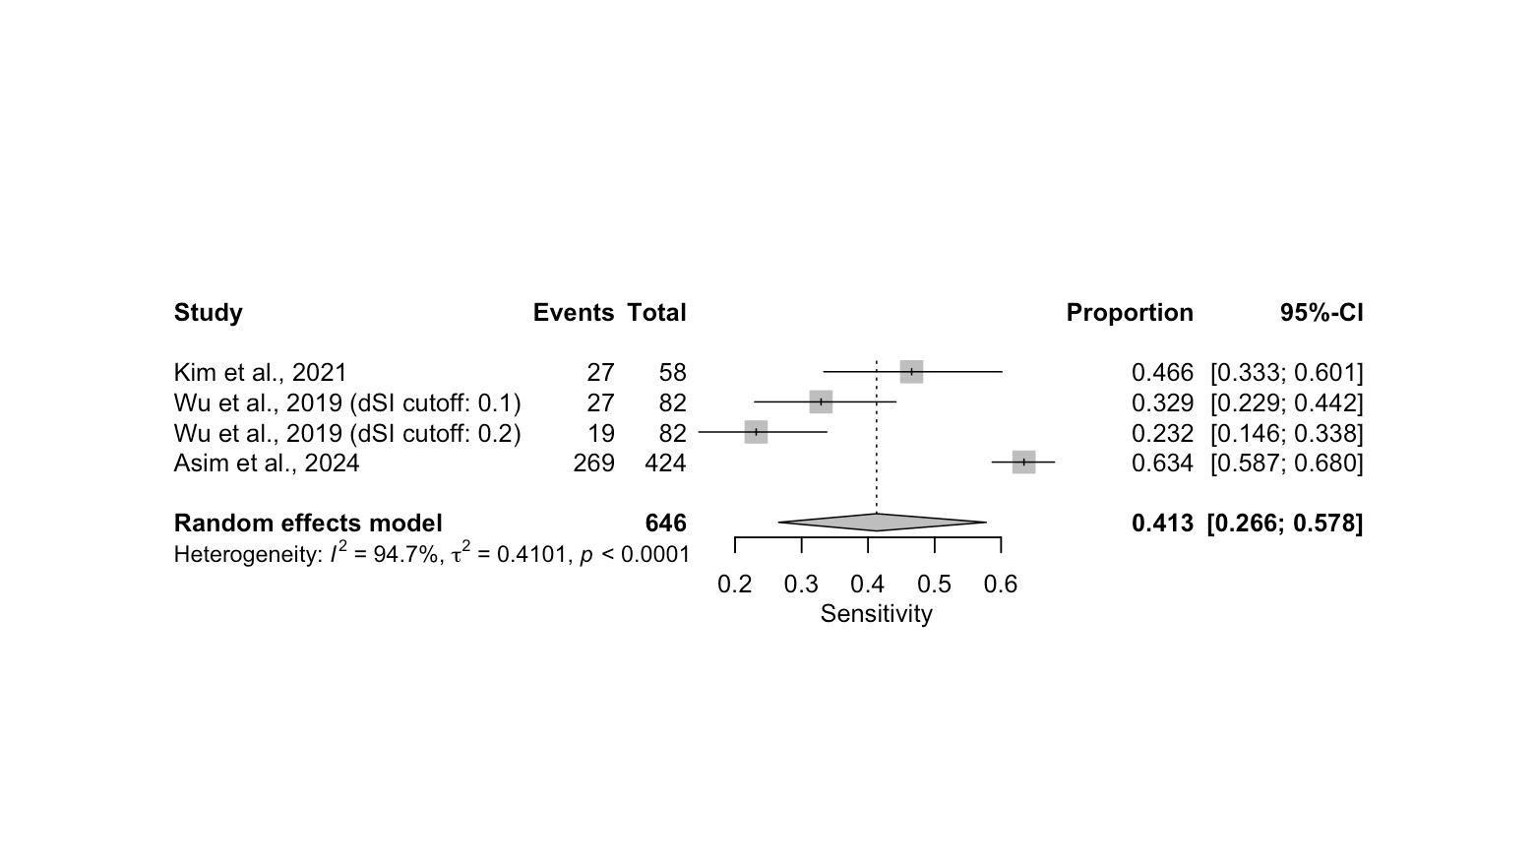
B)
A)

Supp 3. SROC curve for subgroup analysis of in-hospital mortality
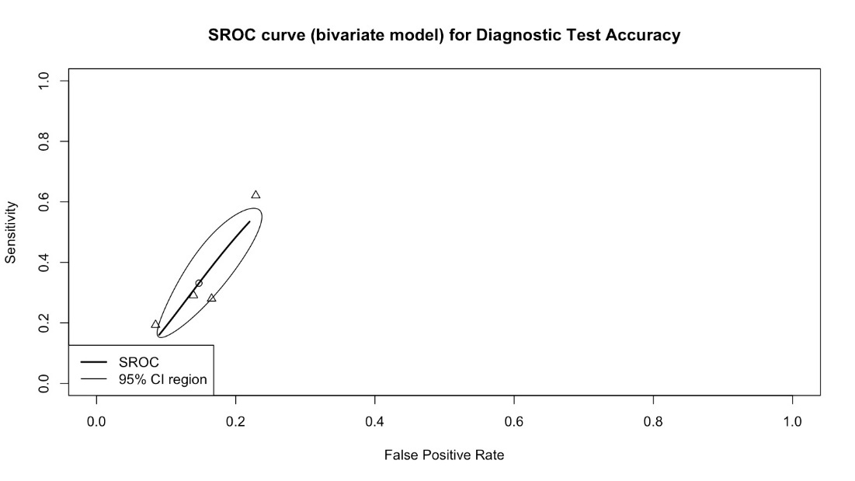
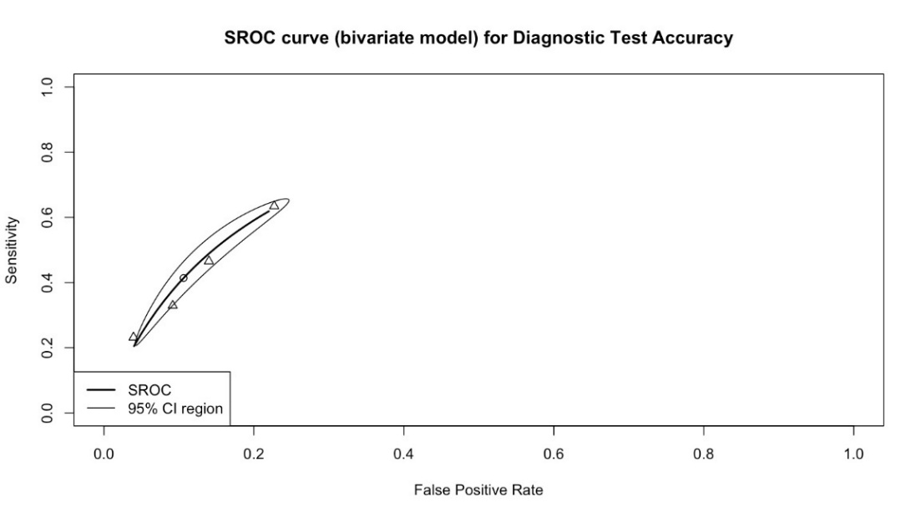
Supp 4. SROC curve for subgroup analysis of massive transfusion

