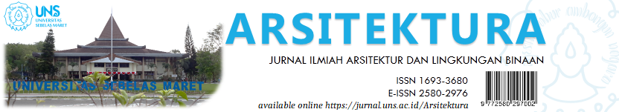

Volume 18 Issue 2 October 2020, pages:

Identifikasi Ruang Manuver Menuju Resiliensi Komunitas di Masa Pandemi Covid-19

Identifying Room for Maneuver towards Community Resilience during the COVID-19 Pandemic

Muhammad Nelza Mulki Iqbal¹*, Bayu Teguh Ujianto²
Architecture Department, Faculty of Engineering and Civil Planning, Institut Teknologi Nasional Malang ^{1,2}
nelzamiqbal@lecturer.itn.ac.id

DOI:
Received: Revised Accepted: Available online:

Abstract
Since firstly announced as an infectious case in Indonesia in early 2020, the COVID-19 pandemic has significantly impacted to the economy, society, culture, education, and the environment. Although the government has moved with various stimuli, policies and continues to improve vaccination programs, there are still many things that ultimately force people, communities, and individuals to move independently as a form of resilience to this pandemic situation. Community Architects (ARKOM) and informal communities within this group network have worked for a long time in realizing inclusive, disaster-responsive, and participatory settlements. Through a participatory and bottom-up approach that places the community as the main subject of development, ARKOM has succeeded in making a significant contribution to the growth of community resilience to disasters. However, the COVID-19 pandemic presents different challenges than previous disasters. As a new model of disaster, the COVID-19 presents a different challenge where the recovery process and the prevention of its impacts should go hand in hand. Therefore, seeing disaster as both a challenge and an opportunity to develop, this study aims to document the resilience process shown by informal communities during the crisis moment of the COVID-19 pandemic.This research takes the lens of room of maneuver that was initiated by Safier consisting of strategic, technical, organizational, and social dimensions based on the movement in the field generated by ARKOM and the communities within. The research method is based on data collection and analysis using snowball techniques through in-depth interviews with respondents involving the community and facilitators in the field.

Keywords: Community Resilience, Community Architecture, Informal Communities, Participatory, Room for Maneuver

1. INTRODUCTION
The COVID-19 pandemic shows the world's unpreparedness to face another disaster category that is often ignored, those related to non-physical disasters. So, it is pretty visible how chaotic this pandemic is due to the readiness of many countries that usually only fit to the post-disaster recovery process, as happens in handling physical disasters. The COVID-19 pandemic presents a different challenge because no one can concretely predict when this pandemic will end. However, the impact of this disaster has penetrated various sectors, mainly the economy. We are still working on the recovery process, and it can be seen from the government's multiple policies, even though it is founded to be inconsistencies in the field (Agustino, 2020). Thus, the parallel handling of impacts and prevention is forced to go hand in hand. One of the most critical challenges is the cultural shock, which requires us to face social distancing in our togetherness culture which has long been an answer key when facing a significant challenge like a disaster.

Therefore, it is a bit complicated when we return to the togetherness aspect that usually acted as our main tool to solve many problems. The togetherness is built from the tradition of cooperation attached to our daily lives (Bhan et al., 2020; Iqbal, 2018). It is interesting to do in-depth observations and research regarding the transformation of togetherness or collaboration during the COVID-19 pandemic. It potentially provides a new challenge for community resilience which has often been an interesting discussion and topic when discussing disaster-related matters in the Indonesian context. Is there a possibility of transformation running in a habit that has long been embedded in our society? How can we assess community resilience when dealing with the COVID-19 pandemic? What can we learn from community-based resilience, and what are the maneuvering spaces so that the concept of community resilience remains relevant during a pandemic?

The things above need to be investigated because discussions and research related to com-munity resilience are still focused on physical disasters, not non-physical disasters such as the COVID-19 pandemic. It includes the need to reorient the urgency of community-based development. According to the researcher's hypothesis, community-based disaster resilience will be more effective when applied to a society with a strong background of culture and traditions, such as Indonesia with its gotong-royong philosophy. Moreover, informal groups and communities have a stronger tendency toward togetherness to take more insights towards non-physical disaster handling in the future.

2. METHODS
This research was conducted qualitatively with a descriptive analysis to produce an in-depth research study. The investigation is carried out by tabulating data based on the research focus to be processed and analyzed; thus, it will provide an overview of the existing problems (Sugiyono, 2017). Tabulation technique of data collection is done through literature study from various sources such as books, journals, news both online and offline. The data collection is then interpreted with a specific case study on community resilience and its maneuvers during the COVID-19 pandemic.

In addition to the analysis description, the data processing is also accompanied by Room For Maneuver (Safier, 2002) as its entry point to produce an in-depth identification of existing practices. According to Safier, Room for Maneuver makes up the “driver of change,” employing four dimensions: technical, organizational, social, and strategic action. Furthermore, descriptive in-formation and empirical studies are used to provide validity to the qualitative research.

The research is divided into two stages: data collection and data analysis. Primary data col-lection employs a snowball method to select relevant respondents to extract data. Then in-depth interviews using semi-structured questions with the community and facilitators were used to dig into the actual conditions. The immersion technique is also used to capture real phenomena in the field by observing respondent’s views. The community involved in this research is the Kalijawi Community (Community of Residents in the Outskirts of Gajah Wong and Winongo). This community has long collaborated with ARKOM (Community Architecture) as a community facilitator.
3. RESULTS AND DISCUSSION
3.1 Challenging Community Resilience through Room for Maneuver
Resilience is the ability to respond and recover from disasters (Cutter et al., 2008). In urban areas, studies on resilience are also well developed, and it is divided into three main characteristics: the ability to persist, adapt, and transform (Folke, C., S. R. Carpenter, B. Walker, M. Scheffer, T. Chapin, 2010). This concept then sharpened again with the idea of community as a form of resilience as community resilience. The concept of community resilience is widely applied to re-search related to post-disaster management, such as what happened in cases of physical disasters like the eruption of Mount Merapi in Yogyakarta Gunung Merapi di Yogyakarta (Akbar, 2019; Jana et al., 2016; Rahman et al., 2016). However, there are still few studies related to resilience and its relation to non-physical disasters such as the COVID-19 pandemic. Even though residents and communities in the field have carried out many independent initiatives, it needs to be re-viewed to be claimed as a resilience effort. Most of these initiations are carried out by community groups in the informal category (French et al., 2020). Informal here is not only related to land and residential status so that it can be categorized as a vulnerable community, but it is also related to their livelihoods. Data shows that around 80% (BPS, 2019) of the economic contribution in Yogyakarta is supported by the informal sector, which is also the sector most affected by the COVID-19 pandemic.
Room for Maneuver (RfM) is a conception of inter-dimensional analysis consisting of four models of space for action to encourage drivers of change (Safier, 2002). These four dimensions are technical, organizational, social, and strategic actions. The technical dimension involves individual and groups ethic in advancing local knowledge. Next, the organizational dimension develops the existing institution's goals, priorities, resources, and procedures. Third, the social dimension refers to social interaction, mobilization, participation, and collaboration. Lastly, the strategic dimension connects with contextual circumstances to identify and exploit situations strategically related to time and space. Such a general formulation, Room for Maneuver, needs to be explained by experience and can only be implied here using specific case references from the com-munity and city levels. Safier's four dimensions are used to group the types of actions that respond to the pandemic challenge by focusing on the work of ARKOM and Kalijawi.
3.2 Identifying and Expanding Room for Maneuver
Technical Dimensions
Since 2009, Arsitek Komunitas (ARKOM) has assisted vulnerable communities in Yogyakarta and other Indonesian cities (Arkom Indonesia, 2020a). They acted as a technical organization and NGO that works on the issue of just cities, local wisdom, participatory approach, co-production knowledge, and disaster management. Their main initial action mostly started with a community mapping exercise. Through community mapping, the community could identify their needs, problems and put them on a map for different possible solutions and actions (Roitman, 2019). Kalijawi is one of the informal riverside communities in Yogyakarta that works with ARKOM since 2012 (Kalijawi Community, 2015). As a community-based organization, they can renovate more than 150 houses in 2015 through their collective community-saving.
The pandemic has brought a different challenge to these groups, where they usually utilize a spirit of togetherness and collective actions to overcome the problem. However, seeing disaster as an opportunity (Archer & Boonyabancha, 2011), ARKOM and Kalijawi could level up their technical measures on the ground. For example, they adapted an online-based mapping tool through Maptionnaire Platform and Google Form when related to the mapping condition. This initiation is important at the beginning of the pandemic, where the government came up with strict regulation of mobilization. The data collection was used to assess the actual condition and distribute the aid.
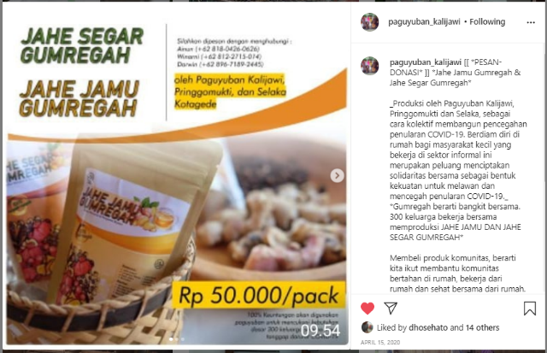
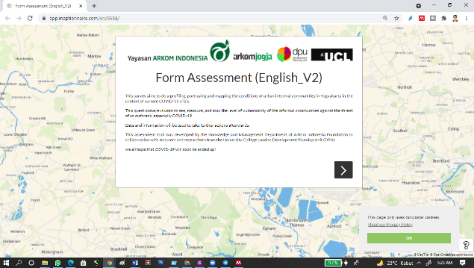
Another thing that needs to be mentioned is the way they gather and communicate. Previously, conventional meeting activities through a routine and regular schedule are done by an offline meeting. During this pandemic, they can adapt to an online group meeting and chat application that allows them to communicate and make participative decisions. Adopting this new habit is not that easy; it also raises new power distribution and relations challenges. However, this technical shift is one of many good things that ARKOM and Kalijawi experienced during this pandemic situation.
Figure 1. Maptionnaire View
Source: (Arkom Indonesia, 2020b)

Organizational Dimensions
Paguyuban Kalijawi is a community-based organization that lives along the banks of the Gajahwong and Winongo rivers. This community consists mostly of women who form small groups, and each group consists of a maximum of ten people. The history behind Kalijawi is based on the similar problems they feel, such as; the legality of the land they build for settlements, poor sanitation and drainage, economic vulnerabilities, health, and environmental issues (Utama, 2016). As a community-based organization, they have activities like saving, revolving funds, community mapping-planning-implementation, and regular group meetings. They also proposed their community planning result to their settlement to the Yogyakarta City Government in 2013 (Iqbal, 2017) and continuously advocated efforts to the local government related to their conditions.
Since 2019, communities have been working to establish a cooperative form, which was finally accomplished during the pandemic. The cooperative had a similar structure to the saving groups, but it was a legal entity that was open to the general public. The main challenge of this change was informing the community about the changes and new rules that becoming a cooperative entailed. At the moment, the cooperative has 25 groups of around 10-15 people, each of which goes through an education process aimed primarily at creating capacity.
The main advantages of the cooperative are that they can save, get loans, get their basic needs met at a lower cost, and have

Figure 2. Communal Business Social Media Campaign
Source: (Kalijawi, 2020)

another option for a living through the various community businesses that the cooperative establishes. It will also provide access to work with other cooperatives and government programs. The cooperative grants them legal status, which allows them to build trust with the government and gain access to housing programs in the future.
By expanding the capacity of savings groups (Archer & Boonyabancha, 2011), this concept enables communities to develop large-scale actions to address their needs collaboratively and strengthens community cohesion by integrating disparate and divided urban poor groups. By allowing communities to run their own financial system, they gain a legal basis for advocating for and negotiating with the government.
One of the many upcoming agendas from cooperative form is the creation of the community business together. The main community businesses that the community has started during the pandemic are the reselling of basic goods at a lower price to cooperative members, urban farming (vegetables and fish), and ginger tea making. In order to sharpen its community business, they are not only connecting with other grassroots organizations across the country, but also launching product campaigns through the use of social media.

Social Dimensions
The Kalijawi Community and ARKOM were not established overnight. ARKOM has been working to strengthen Yogyakarta's informal settlement communities since 2009. ARKOM, as a member of the Asian Coalition for Community Action (ACCA), which was founded by the Asian Coalition for Housing Rights (ACHR), assists communities in identifying and resolving problems. This process evolved through a series of survey processes, mapping, communal savings, planning, and workshops designed to demonstrate the reality that informal communities are not a problem and can be moved to build decent settlements with solid community collaboration (ACHR, 2014).
Since then, ARKOM and Kalijawi have actively connected to other organization locally, nationally, and internationally. They have their own meeting mechanism with various scale of meetings that make the network solid and well connected. The networks outside organizations expand from universities, professional institution, and other NGO’s. It creates a fundamental effect especially to the knowledge and capacity development, bargaining power and negotiation, up to funding opportunities.
In the time of pandemic, the use of technology makes a different form of social connection. Even, it is a challenge to full fil the government health protocols, they are able to push their limitation by vastly adapting the technology. Previously they usually meet in a traditional setting physically, but at the moment they are used to utilize online platforms to discuss and collect the data. ARKOM also started their Youtube channel during this pandemic situation to document and share their movement, agenda, and knowledge to the public widely. Further, this situation also makes them able to expand their connection to other parties. For example, Benih Baik as a crowdfunding platform that help them to obtain a donation to help the communities at the beginning of pandemic. Moreover, they also could have a series of discussion directly with the government official. It was something difficult to have a government official on a discussion table, but right now they are able to reach and discuss with them virtually. However, we still keep waiting how this connection could make an advanced improvement on the community agenda in the future.
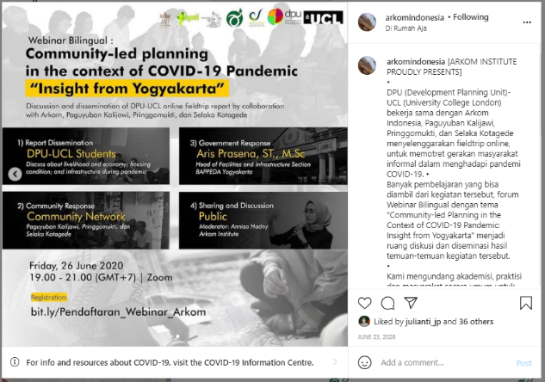
Figure 3. One of Webinar Arkom’s Webinar Series
Source: (Arkom Indonesia, 2020)

Strategic Dimensions
Being aware of the community's capacities and vulnerabilities aids in shaping the space where action is required. At the height of the pandemic, ARKOM, with the assistance of its CBOs and the community, declared a state of emergency, estimating that the pandemic would last until 2021 or more. While physical spaces for face-to-face activities are becoming more limited as a result of COVID-19, ARKOM and Kalijawi are utilizing digital spaces (online) as new spaces for discussion. They used online discussions and surveys, for example, to identify urgent community needs. The emergency response plan was divided into three sections: emergency, mitigation, and advocacy. During pandemic, they are also attempting to connect with local power structures by participating in local officials into series of online webinars. Their strategic response plan is divided into three parts: short-term, medium-term, and long-term actions.

Figure 4. Arkom’s Pandemic Responses
Source: (Arkom Indonesia, 2020)

During the emergency response and rising awareness phase, the primary goals were to meet basic needs, assess the community, and initiate early livelihoods. In terms of assessment, ARKOM and its CBOs created an online mapping survey by collecting data online through the Maptionnaire platform. The survey tools were distributed through Whatsapp groups with the Kalijawi and other communities. Over 200 families took part in the survey and data collection process. The survey reveals critical information for future strategies, such as the number of informal workers, housing conditions, access to services such as water and sanitation, physical distance, and job loss, among other things.
Arkom and the community took several actions in a systematic and planned manner. The first was to concentrate on understanding the community's risks and opportunities. They created an online mapping survey with the help of Development Planning Unit (DPU), University College London to collect data on health risks, age, physical distancing and hygiene, main skills, and income loss. With this information, various alternatives to physical distance were taken collectively, with the installation of hygiene areas around the Kampungs being the most important thing to do, as well as delivering staples to those in need.
This strategy is critical for moving forward, especially in a pandemic situation. ARKOM and its community presented a context-based strategy that involves the community in their actions. As a result, it may be possible to reduce the impact of a pandemic, particularly in terms of economic conditions. Pandemic also introduces a new community driver that was not anticipated, and it suddenly becomes a communal driver to move forward. Previously, they attempted to use planning or land tenure background as an important factor in moving forward, but in the end, an economic approach could be considered as a potential driver of community-based planning and disaster resilience.
4. CONCLUSION
Planning systems, according to Safier, are "social constructions" that cannot be separated from their context in both time and space (Safier, 2002). In this way, this research attempted to investigate how this specific moment in time, during the COVID-19 crisis, could be used to in-crease the 'room for maneuver' in community activism over the long term. ARKOM and com-munities have proven to adapt four dimensions of action spanning from technical, organizational, social, and strategy to make a maneuver during the pandemic time. It is noted that technological advancement and penetration are critical to ensuring the maneuver's success. Another important aspect is the involvement of ARKOM; as an architecturally based organization, to prove that an-other way of doing architecture is possible (Boano & Talocci, 2014). They may be able to deconstruct the image of the architect as an individual hero, replacing it with the notion of the architect as an agent, acting and collaborating with, and on behalf of others. Their long-term involvement in the community could be expanded, scaled, and replicated to other locations and settings. This will be our major assignment in order to make it more happening in the future.
ACKNOWLEDGMENT
This work was financially supported by LPPM ITN Malang through “Pendanaan Litabnas 2021”. Therefore, we are grateful for this funding and support of this research.

REFERENCE
ACHR. (2014). ACCA Fifth Year Report. Thailand: ASian Coalition for Housing Rights.
Agustino, L. (2020). Analisis Kebijakan Penanganan Wabah Covid-19: Pengalaman Indonesia. Jurnal Borneo Administrator, 16(2), 253–270. https://doi.org/10.24258/jba.v16i2.685
Akbar, Z. (2019). Community Resilience: Lesson Learnt from Disaster Survivors in Yogyakarta Province Indonesia. IOP Conference Series: Earth and Environmental Science, 273(1). https://doi.org/10.1088/1755-1315/273/1/012036
Archer, D., & Boonyabancha, S. (2011). Seeing a disaster as an opportunity - harnessing the energy of disaster survivors for change. Environment and Urbanization, 23(2), 351–364. https://doi.org/10.1177/0956247811410011
Arkom Indonesia. (2020a). A GLIMPSE OF ORGANIZATION AND EMERGENCY RESPONSE OF COVID-19 Organization.
Arkom Indonesia. (2020b). Masyarakat Miskin Kota Menghadapi COVID-19.
Bhan, G., Caldeira, T., Gillespie, K., & Simone, A. (2020, August 3). The Pandemic, Southern Urbanisms and Collective Life. Society and Space. https://www.societyandspace.org/articles/the-pandemic-southern-urbanisms-and-collective-life
Boano, C., & Talocci, G. (2014). The (in)operative power: architecture and the reclaim of social relevance. Studio Magazine, 6, 108–115.
BPS. (2019). Badan Pusat Statistik. https://www.bps.go.id/indikator/indikator/view_data_pub/0000/api_pub/bEVXU252SU9hTjBxWEU3Z2NpS1ZPQT09/da_02/1
Cutter, S. L., Barnes, L., Berry, M., Burton, C., Evans, E., Tate, E., & Webb, J. (2008). A place-based model for understanding community resilience to natural disasters. Global Environmental Change, 18(4), 598–606. https://doi.org/10.1016/j.gloenvcha.2008.07.013
Folke, C., S. R. Carpenter, B. Walker, M. Scheffer, T. Chapin, and J. R. (2010). Resilience Thinking: Integrating Resilience, Adaptability and Transformability. Ecology and Society, 15(4). https://doi.org/10.1038/nnano.2011.191
French, M., Ramirez-Lovering, D., Sinharoy, S. S., Turagabeci, A., Latif, I., Leder, K., & Brown, R. (2020). Informal settlements in a COVID-19 world: moving beyond upgrading and envisioning revitalisation. Cities & Health, 00(00), 1–4. https://doi.org/10.1080/23748834.2020.1812331
Iqbal, M. N. M. (2017). Diversity and Opportunity in a Good City Making, Learning from Informal Settlement in Yogyakarta-Indonesia. International City Planning and Urban Design Conference. https://doi.org/10.31227/osf.io/rxg8f
Iqbal, M. N. M. (2018). Advancing Social Capital through Participatory Approaches. EMARA: Indonesian Journal of Architecture, 4(1), 1–12. https://doi.org/10.29080/emara.v4i1.174
Jana, F., Susanne, K., Stefan, N., Tim, S., Nils, U., Kilian, H., Leonhard, H., Simon, K., Fabian, S., Simone, S., & Karl-michael, H. (2016). Towards Urban Resilience : Assessment of Community-based Risk Reduction Strategies in Yogyakarta , Indonesia. February.
Kalijawi Community. (2015). Kalijawi’s Profile.
Rahman, M. B., Nurhasanah, I. S., & Nugroho, S. P. (2016). Community Resilience: Learning from Mt Merapi Eruption 2010. Procedia - Social and Behavioral Sciences, 227(November 2015), 387–394. https://doi.org/10.1016/j.sbspro.2016.06.090
Roitman, S. (2019). Urban poverty alleviation strategies in Yogyakarta, Indonesia: Contrasting opportunities for community development. Asia Pacific Viewpoint, 60(3), 386–401. https://doi.org/10.1111/apv.12229
Safier, M. (2002). On Estimating “Room For Manouvre.” City, 6(1), 117–132.
Sugiyono. (2017). Metode Penelitian Kualitatif. Alfabeta.
Utama, Y. S. (2016). PEMBANGUNAN PERKOTAAN BERBASIS KOMUNITAS STUDI KASUS PAGUYUBAN KALIJAWI, YOGYAKARTA. Seminar Nasional Kota Kratiff, 105–115.

