
ARSITEKTURA
Jurnal Ilmiah Arsitektur dan Lingkungan Binaan
ISSN 2580-2976 E-ISSN 1693-3680
https://jurnal.uns.ac.id/Arsitektura/issue/archive

Volume 20 Issue 2 October 2022, pages: xxx-yyy
DOI https://doi.org/zzzzzzzzzzzzzzzzz

Systematic Literature Review (SLR) of Urban Temporality in Architecture and Urban Design: Clustering and Trend Analysis

Khansa Aulia Ekaputri¹, Arnis Rochma Harani^{1*}, Asrul M. R. Aminuddin²
¹Department of Architecture, Faculty of Engineering Universitas Diponegoro, Semarang, Indonesia
²Department of Architecture, Faculty of Built Environment, Universiti Malaya, Kuala Lumpur
*Corresponding author email address: arnisrochmaharani@lecturer.undip.ac.id

Article history  Received: dd mm yyyy  Accepted: dd mm yyyy  Published: dd mm yyyy | Abstract  Urban temporality has become an emerging field of study in architecture and urban design, offering new perspectives on understanding urban space. However, systematic reviews of the evolution of this discourse remain limited. This study applies a Systematic Literature Review (SLR) using the PRISMA methodology to analyze the development of the concept of urban temporality in academic literature over the past decade. A total of 200 publications containing the keywords "urban" and "temporality" were screened and assessed for eligibility, resulting in 25 studies analyzed bibliometrically. The findings identify six main themes, including Space Experience by Body Sense, Mobilities, Space Development, Spatial Dynamics, Infrastructure and Social Development, and Smart City. Trend analysis reveals a shift in focus from "rhythm" (2014–2019) to "social behavior" (2019–2024), reflecting a change in research orientation. This study contributes to mapping the thematic development and provides a foundation for future research into urban temporality.  Keywords: urban temporality; architecture; urban design; systematic literature review; bibliometric
__________
Cite this as: Last name 1st . initial first and middle name, Last name 2nd . initial first and middle name, Last name 3rd . initial first and middle name, ect. (year). Tittle. Article. Arsitektura : Jurnal Ilmiah Arsitektur dan Lingkungan Binaan, 20(2), pp-pp. doi: https://doi.org/zzzzzz/arst.rrsssssttt

1. INTRODUCTION
The increasing complexity of urban challenges, such as climate change, population growth, and digital transformation (Helbling and Meierrieks 2023; Chai et al. 2022). This statement highlights the importance of exploring how the concept of temporality can be applied to create more sustainable and adaptive cities. This argument is strengthened by (Redyantanu and Damayanti 2017; Harani, Atmodiwirjo, and Yatmo 2023b), where temporality is introduced through flexible and adaptive spaces that can withstand dynamic changes. Therefore, exploring the concept of urban temporality is becoming increasingly relevant in architectural and urban design studies.

Urban spaces can adapt to socio-economic and environmental changes (Sepe 2014; Ernst et al. 2016; Kowalczyk 2014). In architecture, the concept of urban temporality is often applied through flexible and transformative spatial design strategies (Harani, Atmodiwirjo, and Yatmo 2023a; Rahmah and Putrie 2021). Meanwhile, from an urban design perspective, this concept is becoming increasingly relevant in responding to the emergence of various dynamic needs (Farooq and Pfaffenbach 2025). Thus, a deeper understanding of temporality can provide insights into creating spaces that are more responsive to societal needs.

The urgency of this research lies in the need to establish a connection between temporality, architecture, and urban design by conducting a systematic review of how this concept has evolved in academic literature. Therefore, this study aims to identify the context of temporality within the domains of architecture and urban design over the past decade. Furthermore, it seeks to analyze the development of urban temporality discourse in academic literature.

This research aims to conduct a more specific exploration using the Systematic Literature Review (SLR) approach to examine the relationship between the concept of temporality and architecture and urban design. Previously, the context of temporality had been systematically discussed in urban planning literature. This study focuses on the concept of temporality within the domains of architecture and urban design. Although Systematic Literature Review (SLR) studies have been conducted before, no research has specifically focused on developments based on Scopus publication data over the past decade. Therefore, this study is expected to serve as an essential reference for academics, practitioners, and urban planners in addressing continuously evolving urban challenges.
2. METHODS
The synthesis in this study uses the Preferred Reporting Items for Systematic Reviews and Meta-Analyses (PRISMA) as the methodological foundation. By using this method, the quality of the systematic review protocol can be improved, ensuring completeness and detecting selective reporting to support a more consistent and fully reported review, thereby ensuring its accuracy and transparency (Siddaway, Wood, and Hedges 2019; Selcuk 2019; PRISMA-P Group et al. 2015). PRISMA consists of a four-phase flow diagram: identification, screening, eligibility criteria, and inclusion of reports within the scope of the review (Selcuk 2019).

In the identification phase, a search using the keywords "urban" and "temporality" was defined to find urban studies that explore temporality in the urban context. The detailed process is illustrated in Figure 1 below.

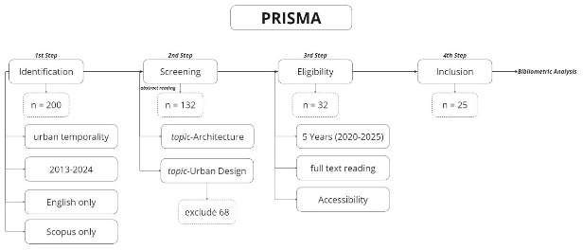
Figure 1. PRISMA Flow Diagram: Systematic Literature Review Process on Urban Temporality

A total of 200 publications were identified in the identification phase using Publish or Perish with the search keywords "urban" and "temporality." In addition to keyword-based searches, the selection also included only English-language publications that were accredited within the Scopus database. In the next phase, screening, a comprehensive review was conducted to determine the relevance of the publications to the main topic related to architecture and urban design or urban planning. To ensure accuracy, an evaluation was carried out based on the titles and abstracts of all articles, resulting in the exclusion of 68 articles due to their lack of focus on architecture, urban design, or urban planning.
The next stage, eligibility, involved a further review of 132 selected publications based on content accessibility and publication year. Due to limited access to some Scopus documents, missing documents, and selection criteria that included only publications from the past five years, 100 articles were excluded, leaving 32 articles. Ultimately, out of the 200 initial articles, only 25 documents were selected for further analysis.

3. RESULT AND DISCUSSION
3.1 Frequency Analysis Based on Nodes Size
The author attempts to identify clusters and their constituent elements using network analysis. With the help of VOSviewer, the author generates visualizations that illustrate the relationships between entities such as authors, keywords, citations, institutions, and research topics. In this study, the visualization focuses on keyword-based clustering, allowing for easier identification of research opportunities related to urban temporality.

A total of 25 articles were obtained through a Publish or Perish search, with sources limited exclusively to Scopus. These articles had previously been selected through the PRISMA stages and were then exported into RIS format for analysis using VOSviewer (Figure 2). In Figure 2, nodes of varying sizes represent the frequency of occurrence or level of significance. For example, the "temporality" node appears significantly larger than others, indicating its frequent mention or greater influence within the network. The figure also shows that "urban development," "gentrification," and "urban area" are keywords with large node sizes, alongside "temporality."

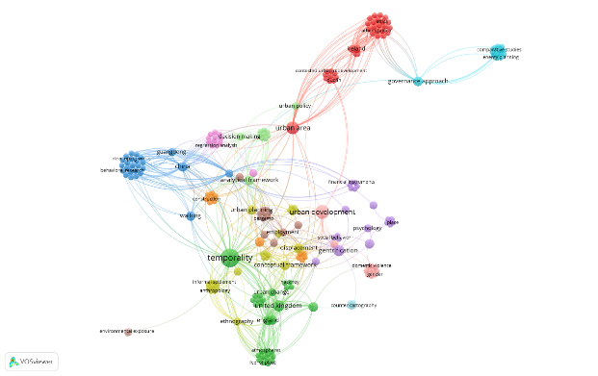
Figure 2. Keyword Network Visualization of Urban Temporality Studies

3.2 Mapping clusters based on proximity and relationship between nodes
Based on the same 25 articles, the visualization in Figure 2 not only displays node sizes but also the relationships between items, indicating the degree of association between them, as represented by the distance between items. The closer two items are, the stronger their connection; conversely, a greater distance between items suggests a weaker relationship. For example, while the keywords "temporality" and "gentrification" have large node sizes, they do not appear significantly close to each other, suggesting that these two keywords may not be strongly related. This degree of association between items serves as the basis for forming diverse clusters.

Each cluster consists of interconnected nodes, representing thematic areas distinguished by different colors. The network analysis resulted in 17 clusters from a total of 238 keywords. However, only 6 of the 17 clusters are related to architecture and urban design, with clusters 2, 5, and 7 as key examples (see Figure 3). Cluster 2 includes keywords such as "atmosphere," "feel of place," "felt body," "home," "public space," "sense of place," "lighting quality," and "lighting". Cluster 5 includes keywords such as "housing," "place," "residential development," and "spatiotemporal analysis." Cluster 7 includes keywords such as "everyday life," "rhythm," "temporal analysis," and "urban space".

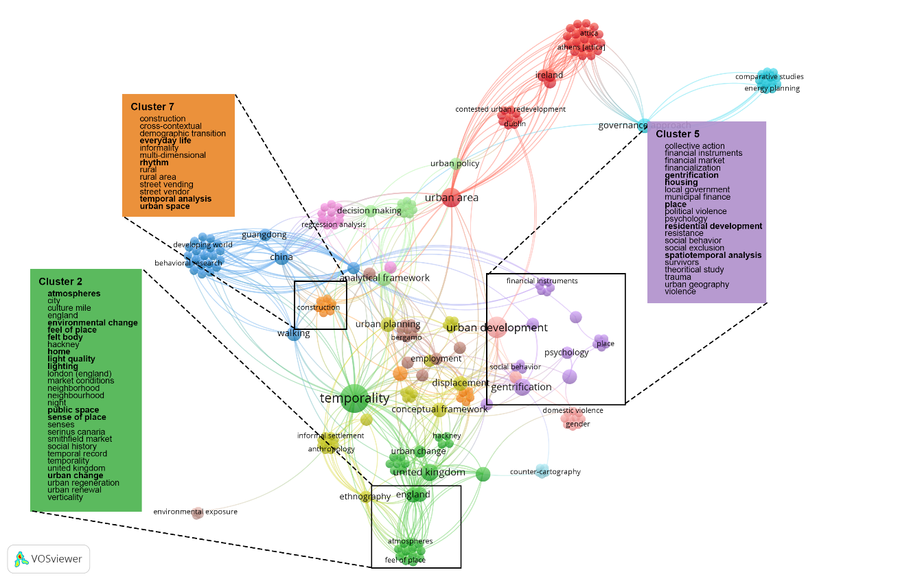
Figure 3. Cluster Mapping of Urban Temporality Research Topics

Next, the author attempts to identify the six clusters and assign appropriate names based on the focus of each cluster, derived from the keywords within them (see results in Table 1). By doing so, the author can more easily identify architecture-related topics that are frequently discussed within the urban temporality discourse. The identified topics include: Space Experience by Body Sense, which focuses on sensory perception in spatial experiences (Degen and Lewis 2020; Ebbensgaard and Edensor 2021; Blunt, Ebbensgaard, and Sheringham 2021). Urban Mobility, which explores movement patterns and mobility within urban environments (Chan et al. 2020). House and Space Development, which examines housing and spatial planning (Blunt, Ebbensgaard, and Sheringham 2021; Elliott-Cooper, Hubbard, and Lees 2020; Pain 2021; Aalbers 2020). Urban Rhythm and Spatial Dynamics, which investigates temporal and spatial changes in cities (Sun 2022; Phillips et al. 2021; Blunt, Ebbensgaard, and Sheringham 2021). Urban Infrastructure and Social Development, which looks at the interplay between infrastructure and social structures (Datta and Ahmed 2020; Phillips et al. 2021; Ebbensgaard and Edensor 2021; Moore-Cherry and Bonnin 2020; Cooke, Landau-Ward, and Rickards 2020; Aalbers 2020). Smart City and Innovation, which discusses technological advancements and innovation in urban development (Kandt and Batty 2021).

Table 1. Thematic Clusters in Urban Temporality Studies
Space experience by body sense | Urban mobilities | House and space development | Urban rhythm and spatial dynamics | Urban infrastructure and social development | Smart city and Innovation
Atmospheres | Behaviorial Research | Collective Action | Construction | Domestic Violence | Analytical Framework
City | Built Environment | Financial Instruments | Cross-Contextual | Gender | Big Data
Culture Mile | China | Financial Market | Demographic Transition | Gender Relations | Data Mining
England | Developing Cities | Financialization | Everyday Life | India | Database
Environmental Change | Developing World | Gentrification | Informality | Infrastructure | Decision Making
Feel Of Place | Environmental Features | Housing | Multi-Dimensional | Intimate | Mobilities
Felt Body | Exploratory Studies | Local Government | Rhythm | Kerala | Mobility
Hackney | Guangdong | Municipal Finance | Rural | Safety | Smart Cities
Home | Level Of Satisfaction | Place | Rural Area | Urban | Smart City
Light Quality | Local Residents | Political Violence | Street Vending | Urban Development | Urban Analytics
Lighting | Meaning | Psychology | Street Vendor | Urban Society | Urban Policy
London (England) | Pedestrian | Residential Development | Temporal Analysis | Womens Status
Market Conditions | Place Attachment | Resistance | Urban Space
Neighborhood | Public Transport | Social Behavior
Neighbourhood | Research Work | Social Exclusion
Night | Shenzhen | Spatiotemporal Analysis
Public Space | Social And Cultural Context | Survivors
Sense Of Place | Sustainable Transport | Theoritical Study
Senses | Transportation Development | Trauma
Serinus Canaria | Transportation Planning | Urban Geography
Smithfield Market | Transportation System | Violence
Social History | Urban China
Temporal Record | Walking
Temporality | Walking Environments
United Kingdom | Walking Experience
Urban Change
Urban Regeneration
Urban Renewal
Verticality

3.3 The Development of Urban Temporality Discourse in Temporal Maps (2014-2024)
At this stage, the author utilizes a total of 132 articles that have been carefully selected through the screening phase, ensuring their relevance and alignment with the research objectives. These articles are then subjected to further analysis using VOSviewer, specialized software designed for bibliometric mapping and network visualization. Through this analysis, the author aims to generate a comprehensive visualization (see Figure 4) that illustrates the progression, shifts, and key themes within the urban temporality discourse over the past decade, spanning from 2014 to 2024. This visualization not only helps in identifying recurring patterns but also highlights emerging trends and evolving areas of interest within the discourse.

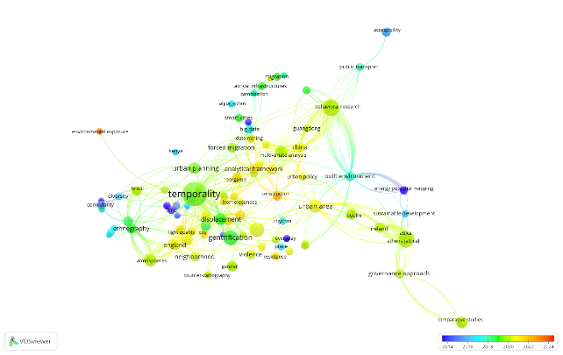
Figure 4. Temporal Evolution of Urban Temporality Discourse (2014-2024)

The results of this analysis consist of systematically compiled keyword data that covers an entire decade, which is further categorized into two distinct time periods for a more structured comparison. The first period encompasses the five-year span from 2014 to 2019, while the second period focuses on the most recent five years, from 2019 to 2024. These keyword distributions, along with their frequencies and associations, are presented in a detailed manner in Table 2 to provide a clearer picture of the changing dynamics within the urban temporality discourse. Based on the findings obtained from this analysis, it becomes evident that there are notable differences in the keywords that frequently appeared during the initial five-year period compared to those that have gained prominence in the more recent five-year period. These differences suggest shifts in research focus, theoretical approaches, and key discussions that have shaped the discourse over time.

Table 2. Temporal Keyword Distribution in Urban Temporality Research (2014-2024)
2014 - 2019 | 2019 - 2024
"Time"  "Chronology"  "Urbanization"  "Place"  "Rhythm"  "Built environment"  "Place Attachment"  "Smart cities"  "Urban Planning"  "Temporality"  "Gentrification"  "Housing"  "Displacement"  "Public space"  "Architecture" | "Atmosphere"  "Demography"  "Behavioral research"  "Urban development"  "Temporal analysis"  "Urban housing"  "Walking"  "Collective action"  "Spatiotemporal analysis"  "Social behavior"  "Greenspace"  "Mobilities"

4. DISCUSSION
Based on the exploration conducted by the author, the obtained results need to be discussed in this section to achieve the research objectives, namely identifying architectural topics related to and frequently discussed in the urban temporality discourse, as well as examining the development of the urban temporality discourse over the past decade (2014–2024). By understanding the trends in the development of this discourse, the author can identify how the concept of temporality in architecture and urban design has evolved and how various related aspects have changed over time.
From the results of frequency analysis and cluster mapping, the author can observe architectural and urban design topics that are closely related to and frequently discussed in the urban temporality discourse. For instance, the frequency analysis indicates that four keywords have larger node sizes compared to others, signifying that these four keywords have been the most frequently discussed in the last five years of urban temporality discourse. Furthermore, six clusters of keywords related to architecture and urban design have been identified and named based on their respective focus. This classification also helps the author understand the recurring themes in urban temporality discourse, providing a more structured overview of the interconnections between various concepts emerging from previous studies. Additionally, this analysis enables the identification of new research opportunities that can further explore specific aspects of urban temporality that have not been extensively examined.
The topics related to architecture and urban design include "temporality," "urban area," "urban development," and "gentrification," while the themes discussed in the urban temporality discourse are space experience by body sense, urban mobility, house and space development, urban rhythm and spatial dynamics, urban infrastructure and social development, and smart city and innovation. By categorizing these themes, the author can better understand how the concept of temporality is applied in various aspects of urban planning and how different approaches and strategies can be used to address challenges associated with temporary changes in the urban context.
Meanwhile, through an exploration of the development of urban temporality discourse, the author has identified differences in keywords over the past decade. For example, the keyword "rhythm" frequently appeared in the first five years (2014–2019), indicating its prominence during that period. However, in the last five years (2019–2024), the keyword "social behavior" has become more dominant, replacing "rhythm" as the more frequently discussed topic in recent research. This shift suggests that the focus in urban temporality studies may be transitioning from rhythm to more complex patterns of social behavior, potentially reflecting changes in how society interacts with urban spaces and adapts to evolving social and environmental conditions.
However, the author has identified similarities between these two keywords, referring to Wunderlich's (2013) theory, which states that rhythm is one of the key components of place-temporality, playing a crucial role in how people experience the city. Wunderlich also explains that rhythm is formed based on daily life patterns, which emerge through repetition. The term "social behavior" consists of "social" and "behavior" in English, referring to human social habits that tend to be rhythmic and repetitive. Therefore, while there may be a shift in focus from "rhythm" to "social behavior," both concepts remain closely interconnected within the urban temporality discourse. This shift may indicate an expanded understanding of how social factors influence urban temporality not only shaped by recurring activity patterns but also by how communities collectively interact, adapt, and create social dynamics in their urban environments. As a result, the author concludes that the keywords "rhythm" and "social behavior" may have a strong connection and play a significant role in urban temporality, further demonstrating the potential transition from rhythm to social behavior as a primary factor in shaping urban temporality.
5. CONCLUSION
This study highlights the importance of the concept of urban temporality in designing and managing more adaptive and sustainable cities. Temporality in the urban context reflects how space and time interact in shaping continuously evolving social, economic, and environmental dynamics. Cities are not static entities; rather, they are systems undergoing continuous transformation due to social interactions, technological advancements, and implemented policies. Therefore, understanding temporality becomes a crucial aspect of urban planning, enabling more flexible and responsive strategies to address future challenges.
The systematic review in this study reveals that the concept of urban temporality in architecture and urban design can be applied through flexible and adaptive spatial design strategies. Spatial flexibility allows spaces to adapt to changing needs, both in function and usage patterns, enabling a more effective response to urban dynamics.
Through keyword frequency analysis, this study identifies four main topics that frequently appear in discussions on urban temporality: temporality, urban areas, urban development, and gentrification. Additionally, through keyword clustering analysis, six main themes related to urban temporality in architecture and urban design were identified: spatial experience through bodily senses, urban mobility, housing and spatial development, rhythms and spatial dynamics of urban areas, urban infrastructure and social development, as well as smart cities and innovation.
The findings of this study highlight the development of discourse on urban temporality, particularly the shift in focus from rhythm (2014–2019) to social behavior (2019–2024). This shift reflects how the study of urban temporality has gradually evolved from the concept of urban rhythms to a deeper understanding of human interactions.
This research serves as a foundation for further studies exploring how temporality influences spatial adaptation, socio-technical dynamics, and urban policies. However, this study has limitations, as it is based solely on Scopus-indexed publications and focuses only on keyword clustering. As a result, it does not fully capture the contextual concept of temporality. Future research could be conducted through comparative case studies or an exploration of the tangible manifestations of temporality in response to the continuously evolving dynamics of urban temporality.
REFERENCES
Aalbers, M.B. 2020. “Financial Geography III: The Financialization of the City.” Progress in Human Geography 44 (3): 595–607. https://doi.org/10.1177/0309132519853922.
Blunt, A., C.L. Ebbensgaard, and O. Sheringham. 2021. “The ‘Living of Time’: Entangled Temporalities of Home and the City.” Transactions of the Institute of British Geographers 46 (1): 149–62. https://doi.org/10.1111/tran.12405.
Chai, Kuang-Cheng, Xin-Rui Ma, Yang Yang, Yu-Jiao Lu, and Ke-Chiun Chang. 2022. “The Impact of Climate Change on Population Urbanization: Evidence from China.” Frontiers in Environmental Science 10 (August):945968. https://doi.org/10.3389/fenvs.2022.945968.
Chan, E.T.H., T.E. Li, T. Schwanen, and D. Banister. 2020. “People and Their Walking Environments: An Exploratory Study of Meanings, Place and Times.” International Journal of Sustainable Transportation, 1–12. https://doi.org/10.1080/15568318.2020.1793437.
Cooke, B., A. Landau-Ward, and L. Rickards. 2020. “Urban Greening, Property and More-than-Human Commoning.” Australian Geographer 51 (2): 169–88. https://doi.org/10.1080/00049182.2019.1655828.
Datta, A., and N. Ahmed. 2020. “Intimate Infrastructures: The Rubrics of Gendered Safety and Urban Violence in Kerala, India.” Geoforum 110:67–76. https://doi.org/10.1016/j.geoforum.2020.01.016.
Degen, M., and C. Lewis. 2020. “The Changing Feel of Place: The Temporal Modalities of Atmospheres in Smithfield Market, London.” Cultural Geographies 27 (4): 509–26. https://doi.org/10.1177/1474474019876625.
Ebbensgaard, C.L., and T. Edensor. 2021. “Walking with Light and the Discontinuous Experience of Urban Change.” Transactions of the Institute of British Geographers 46 (2): 378–91. https://doi.org/10.1111/tran.12424.
Elliott-Cooper, A., P. Hubbard, and L. Lees. 2020. “Moving beyond Marcuse: Gentrification, Displacement and the Violence of Un-Homing.” Progress in Human Geography 44 (3): 492–509. https://doi.org/10.1177/0309132519830511.
Ernst, L., R.E. De Graaf-Van Dinther, G.J. Peek, and D.A. Loorbach. 2016. “Sustainable Urban Transformation and Sustainability Transitions; Conceptual Framework and Case Study.” Journal of Cleaner Production 112 (January):2988–99. https://doi.org/10.1016/j.jclepro.2015.10.136.
Farooq, Aysha, and Carmella Pfaffenbach. 2025. “Coping with Temporariness: Space Appropriation of South Asian Migrants in Muscat, Oman.” Population, Space and Place 31 (1): e2852. https://doi.org/10.1002/psp.2852.
Harani, Arnis Rochma, Paramita Atmodiwirjo, and Yandi Andri Yatmo. 2023a. “Makeshift as Spatio-Temporal Mechanism Tactics of Urban Interior in Kampung Bustaman Semarang, Indonesia.” URBAN DESIGN International, December. https://doi.org/10.1057/s41289-023-00232-1.
———. 2023b. “URBAN KITCHEN: A FORM OF URBAN SYSTEM BASED ON COLLECTIVE OPERATION.” JOURNAL OF ARCHITECTURE AND URBANISM 47 (2): 96–105. https://doi.org/10.3846/jau.2023.17723.
Helbling, Marc, and Daniel Meierrieks. 2023. “Global Warming and Urbanization.” Journal of Population Economics 36 (3): 1187–1223. https://doi.org/10.1007/s00148-022-00924-y.
Kandt, J., and M. Batty. 2021. “Smart Cities, Big Data and Urban Policy: Towards Urban Analytics for the Long Run.” Cities 109. https://doi.org/10.1016/j.cities.2020.102992.
Kowalczyk, Cezary. 2014. “Dynamics of Changes in The Urban Space.” In The 9th International Conference “Environmental Engineering 2014.” Vilnius, Lithuania: Vilnius Gediminas Technical University Press “Technika” 2014. https://doi.org/10.3846/enviro.2014.124.
Moore-Cherry, N., and C. Bonnin. 2020. “Playing with Time in Moore Street, Dublin: Urban Redevelopment, Temporal Politics and the Governance of Space-Time.” Urban Geography 41 (9): 1198–1217. https://doi.org/10.1080/02723638.2018.1429767.
Pain, R. 2021. “Geotrauma: Violence, Place and Repossession.” Progress in Human Geography 45 (5): 972–89. https://doi.org/10.1177/0309132520943676.
Phillips, M., D. Smith, H. Brooking, and M. Duer. 2021. “Re-Placing Displacement in Gentrification Studies: Temporality and Multi-Dimensionality in Rural Gentrification Displacement.” Geoforum 118:66–82. https://doi.org/10.1016/j.geoforum.2020.12.003.
PRISMA-P Group, David Moher, Larissa Shamseer, Mike Clarke, Davina Ghersi, Alessandro Liberati, Mark Petticrew, Paul Shekelle, and Lesley A Stewart. 2015. “Preferred Reporting Items for Systematic Review and Meta-Analysis Protocols (PRISMA-P) 2015 Statement.” Systematic Reviews 4 (1): 1. https://doi.org/10.1186/2046-4053-4-1.
Rahmah, Sukmayati, and Yulia Putrie. 2021. “Spasialitas Dan Temporalitas Arsitektur Bambu Dalam Konteks Masyarakat Tradisional Dan Kontemporer.” JURNAL LINGKUNGAN BINAAN INDONESIA, September. http://.doi.org/10.32315/jlbi.v10i3.65.
Redyantanu, Bramasta Putra, and Rully Damayanti. 2017. “TEMPORALITY IN A DISCUSSION OF SUSTAINABLE ARCHITECTURE.” DIMENSI (Journal of Architecture and Built Environment) 44 (2): 163–70. https://doi.org/10.9744/dimensi.44.2.163-170.
Selcuk, Ayse Adin. 2019. “A Guide for Systematic Reviews: PRISMA.” Turkish Archives of Otorhinolaryngology 57 (1): 57–58. https://doi.org/10.5152/tao.2019.4058.
Sepe, Marichela. 2014. “Urban Transformation, Socio-Economic Regeneration and Participation: Two Cases of Creative Urban Regeneration.” International Journal of Urban Sustainable Development 6 (1): 20–41. https://doi.org/10.1080/19463138.2013.866560.
Siddaway, Andy P., Alex M. Wood, and Larry V. Hedges. 2019. “How to Do a Systematic Review: A Best Practice Guide for Conducting and Reporting Narrative Reviews, Meta-Analyses, and Meta-Syntheses.” Annual Review of Psychology 70 (1): 747–70. https://doi.org/10.1146/annurev-psych-010418-102803.
Sun, Z. 2022. “A Rhythmanalysis Approach to Understanding the Vending-Walking Forms and Everyday Use of Urban Street Space in Yuncheng, China.” Urban Studies 59 (5): 995–1010. https://doi.org/10.1177/0042098021997044.

